Name: Ghani Muratbaev
Group: SE-2403
Assignment 1
Advanced Solidity Patterns & Security Fundamentals
This assignment covers Weeks 1–2 of the Blockchain Technologies 2 course. You will demonstrate mastery of advanced Solidity development patterns, gas optimization, inline assembly, and foundational smart contract security auditing
GitHube: https://github.com/AITUGhany/Assignment1_BC.git
This project implements a complete set of advanced Solidity patterns and security practices using a banking vault concept. The implementation demonstrates contract deployment patterns, upgradeability, gas optimization, inline assembly usage, and practical security vulnerabilities along with their mitigation.
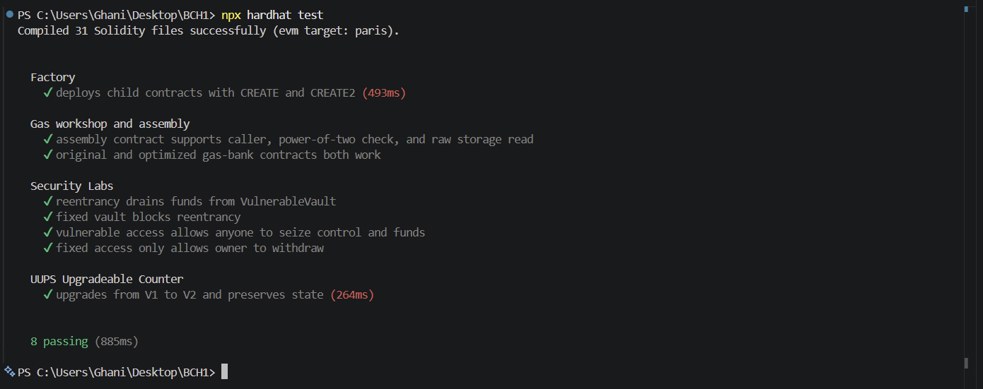
The factory pattern is implemented to deploy multiple child contracts dynamically. A factory contract creates instances of child contracts using both CREATE and CREATE2 opcodes. The deployed addresses are stored and can be retrieved for verification. The CREATE2 deployment allows deterministic contract addresses, which can be predicted before deployment. Gas consumption between CREATE and CREATE2 was compared during testing, showing that CREATE2 introduces slightly higher overhead due to hashing but provides deterministic behavior useful in advanced systems.
The proxy pattern is implemented using the UUPS upgradeable standard. The initial contract version provides a simple counter with increment functionality. A second version extends the logic with additional features such as decrement and reset. The upgrade process is executed without losing the stored state, demonstrating correct storage layout preservation. The proxy delegates calls to the implementation contract, meaning logic can be upgraded while data remains intact. This approach reduces redeployment cost and allows iterative development. However, it introduces risks such as storage collisions if layout is modified incorrectly. Initializers are used instead of constructors because proxy contracts do not execute constructors of implementation contracts.
Gas optimization techniques were applied to reduce execution cost. Storage packing was achieved by arranging variables efficiently. Immutable and constant variables were used where appropriate. Calldata was used instead of memory for external function parameters to reduce copying overhead. Storage reads were cached in local variables to avoid repeated expensive access. Conditional checks were structured to fail early, improving efficiency. Unchecked arithmetic was used in safe contexts to skip overflow checks. Some state updates were replaced with events to reduce storage writes. These optimizations were validated through gas reporting before and after modifications.
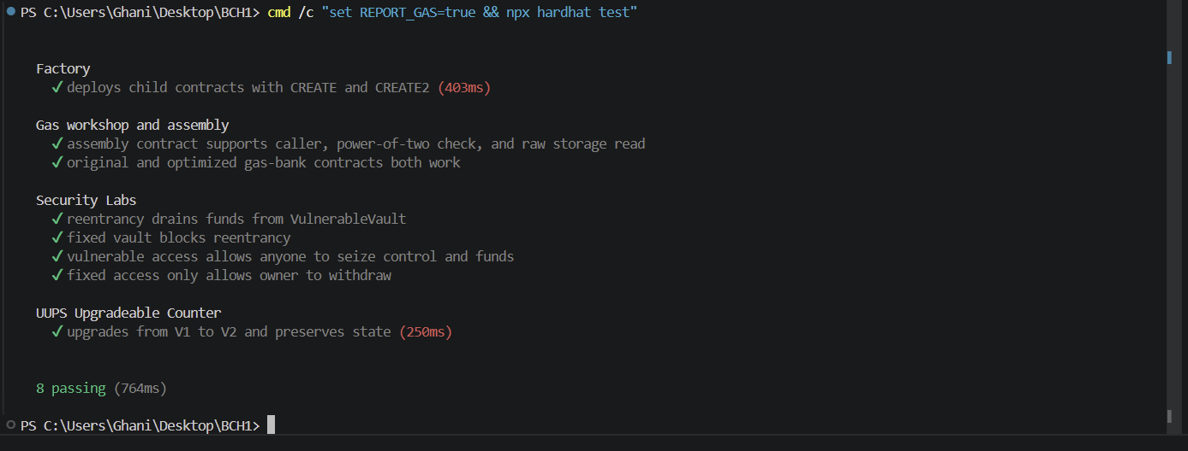
Inline assembly was used to demonstrate low-level control over the EVM. The contract directly accessed msg.sender using the caller opcode. A power-of-two check was implemented using bitwise operations for efficiency. Direct storage access was performed using sload and sstore instructions. These operations reduce gas usage but introduce risks due to lack of safety checks and readability. Assembly should only be used in performance-critical sections where high-level Solidity is insufficient.
The security section demonstrates critical vulnerabilities and their fixes. A vulnerable vault contract was created with a reentrancy flaw in the withdraw function. The contract sends Ether before updating user balance, allowing an attacker contract to recursively withdraw funds. The attack contract exploits this behavior and drains the vault during testing. The issue is resolved using the Checks-Effects-Interactions pattern and ReentrancyGuard, ensuring state updates occur before external calls and preventing reentrant execution.

Another vulnerability demonstrates improper access control. A contract allows any user to change ownership or withdraw funds due to missing restrictions. This flaw is exploited during testing. The issue is fixed using OpenZeppelin’s Ownable pattern, restricting sensitive functions to authorized users only. Post-fix tests confirm that unauthorized access is no longer possible.
Static analysis was performed using Slither. The tool identified multiple issues across contracts, including potential reentrancy risks, missing access control, and optimization opportunities. Each finding was reviewed to determine whether it was a true positive or false positive. All confirmed issues were fixed, and the analysis was rerun to verify improvements.
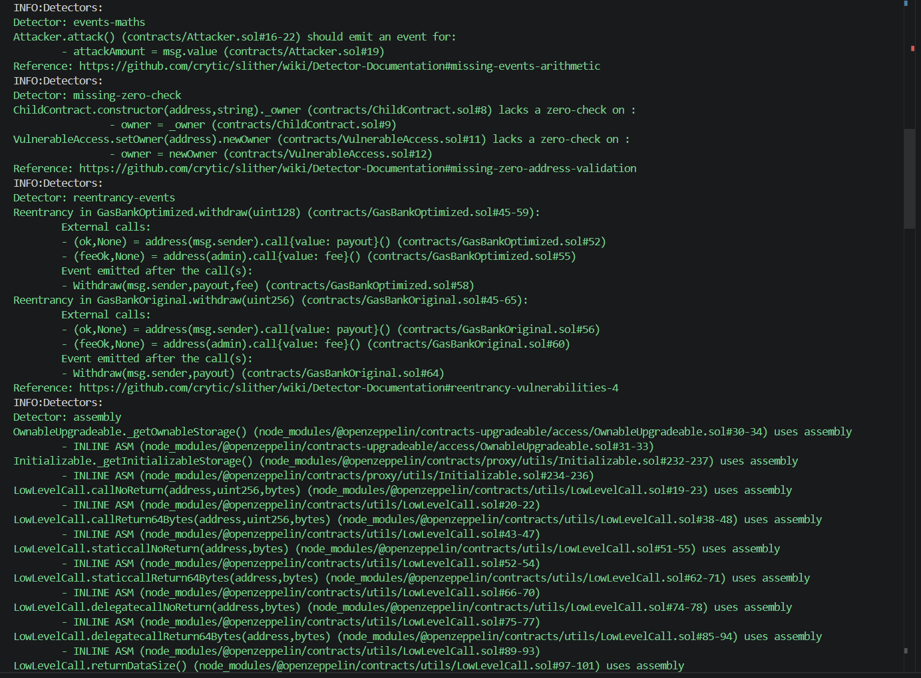
The proxy pattern comparison highlights differences between Transparent Proxy, UUPS, and Diamond patterns. Transparent proxies separate admin and user calls, reducing risk but increasing gas overhead. UUPS proxies are more lightweight and efficient, placing upgrade logic inside the implementation contract. Diamond pattern allows modular upgrades with multiple facets, enabling complex systems but increasing implementation complexity. UUPS is preferred for lightweight upgradeable contracts, while Diamond is suited for large-scale modular protocols.
The smart contract security landscape includes common vulnerabilities such as reentrancy, access control misconfiguration, integer overflows, front-running, and denial of service. Historical incidents such as the DAO hack and exploits in Wormhole and Euler Finance demonstrate the financial impact of these vulnerabilities. Automated tools like Slither, Mythril, and Echidna help detect issues but cannot replace manual auditing. A proper security lifecycle includes code reviews, automated testing, static analysis, formal verification where applicable, and external audits before deployment.
This project demonstrates both theoretical understanding and practical implementation of advanced Solidity concepts. The combination of patterns, optimizations, and security analysis reflects real-world smart contract development practices.

