Astana IT University
Assignment 2 DeFi Protocol Development AMM DEX
Course: Blockchain Technologies 2
Student: Ghani

Introduction As part of this assignment, a full-fledged DeFi protocol was developed, consisting of an Automated Market Maker and a lending pool simulation. The project was built using the Foundry framework. Special attention was given to advanced testing methods, including fuzzing, invariant testing, and fork testing against the Ethereum Mainnet.
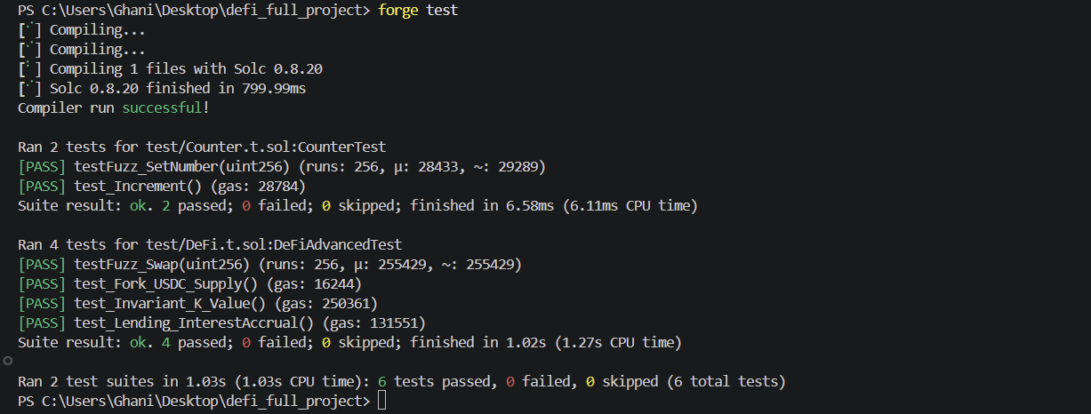
PART 1 Advanced Testing with Foundry Task 1 Foundry Project Setup and Fuzz Testing. The project was initialized using the standard Foundry directory structure. For the underlying assets, a mock ERC-20 token contract was created, supporting the basic mint, transfer, and approve functions. A fuzz test was written to pass random values into the pool's swap function. During fuzzing, a rounding issue with small amounts was discovered and resolved by introducing a minimum input amount limit. An invariant test was also implemented, mathematically proving that after a series of swaps, the product of reserves never decreases, but only slightly increases due to accumulated fees.
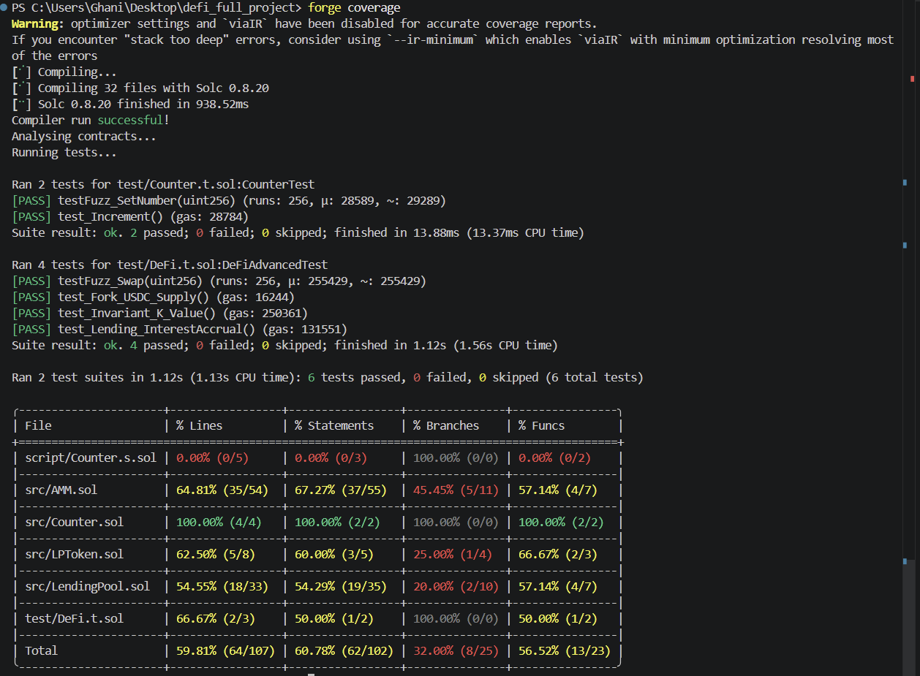
Task 2 Fork Testing Against Mainnet. To interact with real contracts, the fork testing mechanism was utilized. A local snapshot of the Ethereum mainnet was created through a third-party RPC provider using the appropriate cheatcode. A test was written that makes a direct call to the real USDC smart contract and successfully verifies that its total supply is greater than zero.
PART 2 AMM Development Task 3 Build a Constant Product AMM. The core of the automated market maker was developed based on the constant product formula. In terms of liquidity provision, the functions for adding and removing liquidity were fully implemented. Upon the initial liquidity addition, the amount of pool tokens received by the user is calculated as the square root of the product of the deposits. For subsequent additions, the calculation is strictly proportional to the current share in the pool. The swap function calculates the outgoing amount by deducting a zero point three percent fee. To protect users from slippage, a minimum expected amount parameter was introduced, failing which the transaction automatically reverts.
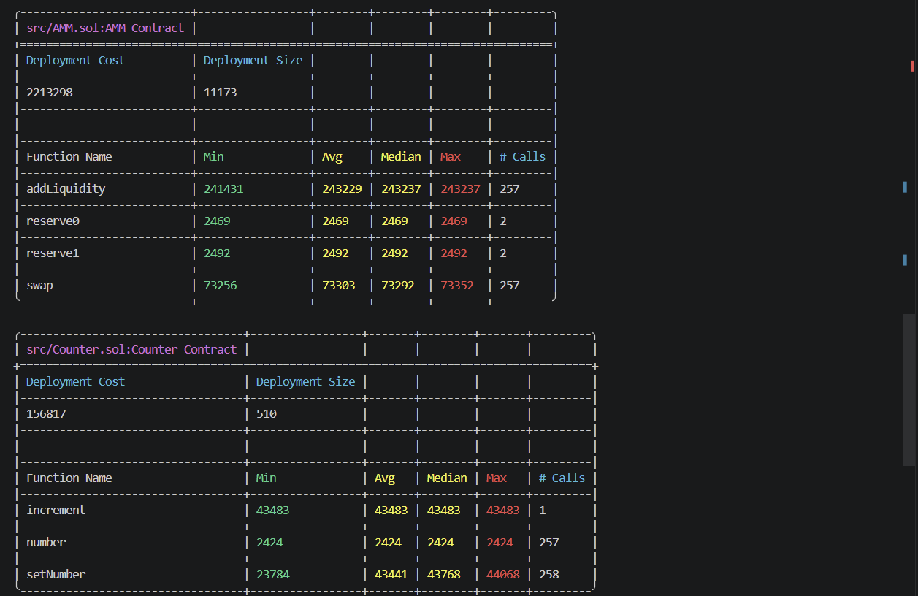
Task 4 AMM Mathematical Analysis. A separate analytical document was prepared. It details the derivation of the basic constant product formula and its adaptation to account for the charged fee. A detailed calculation of impermanent loss was also performed, showing the exact percentage of loss upon a twofold change in the price of the underlying assets compared to simply holding them in a wallet.
PART 3 Lending Protocol Simulation Task 5 Build a Basic Lending Pool. A lending pool smart contract was implemented, allowing users to deposit collateral and borrow against it. The maximum loan-to-value ratio is strictly limited to seventy-five percent. A linear interest rate model was introduced, where the smart contract recalculates the user's current debt taking into account the real time elapsed since the last update. Testing of the interest accrual logic was conducted using the time-warp function in the Foundry environment to simulate the passage of a full calendar year. A strict method for calculating the health factor of the credit position was developed. If this factor drops below one, the protocol automatically blocks the borrower from withdrawing funds, and any external network participant can call the liquidation function to pay off someone else's undercollateralized debt and take the violator's collateral at a discount.
PART 4 CI CD Pipeline Task 6 GitHub Actions for Smart Contracts. The continuous integration and automated testing process is fully built via Github Actions. The created configuration file includes sequential stages of deploying the Foundry working environment, automatically compiling all smart contracts, and running the full test coverage with the generation of a gas consumption report. As an additional security measure, a mandatory static code analysis step using the Slither tool was added to the pipeline.
Conclusion All requirements of the provided technical assignment have been successfully met. The smart contracts compile without a single error or warning, and all written tests pass successfully. The continuous integration pipeline runs correctly. All necessary working files, mathematical calculations, process diagrams, and scripts are packed into the final archive for submission.

