American International University-Bangladesh (AIUB)
Department of computer science
Faculty of Science & Technology (FST)

Semester: FALL 2025-26
Course: Introduction to Data Science
Section : J
Group: 7

Project Title:
Video Game Sales Data Cleaning and Exploratory Data Analysis

Dataset Title: Video Games Sales

Supervised By:
Kamrun Naher Koli
Lecturer,
Department of Computer Science
Faculty of Science and Technology
American International University-Bangladesh

Submitted By :
Name | ID
APURBO, NAFIUN | 23-50064-1
RAKIN, RAIYEN ZAYED | 23-50071-1
SHEHORY, SABA MORIUM | 23-50827-1

Submission Date : 06-04-2026

- Introduction
This project focuses on data preprocessing, cleaning, and exploratory data analysis using the R programming language. The dataset used in this project contains video game sales data, including information such as platform, genre, publisher, critic scores, user scores, and global sales.
The main objective of this project is to:
- Identify and handle missing values
- Detect and remove outliers
- Normalize data
- Remove duplicate records
- Balance the dataset
- Perform descriptive statistical analysis
The project follows a structured pipeline to ensure the dataset is properly prepared for analysis.

Dataset Description
The dataset used in this project is titled "Video Games Sales (as at 22 Dec 2016)", which contains comprehensive information about video game performance across different regions and platforms. It consists of multiple records, where each row represents a unique video game along with its associated attributes. The dataset includes a mix of numerical and categorical variables, allowing for a detailed analysis of sales trends, user engagement, and game characteristics.

Key Attributes
- Name – Game title
- Platform – Gaming platform
- Year – Release year
- Genre – Type of game
- Publisher – Publishing company
- NA_Sales, EU_Sales, JP_Sales – Regional sales
- Global_Sales – Total worldwide sales
- Critic_Score – Score given by critics
- User_Score – Score given by users
- Developer – Game developer
- Rating – Age rating

The dataset contains both numerical and categorical variables, making it suitable for preprocessing and analysis. Overall, this dataset provides a well-rounded view of video game performance and is appropriate for applying various data science techniques such as missing value handling, outlier detection, normalization, and statistical analysis.

- Project Implementation

Task 1: Setup Libraries

Code

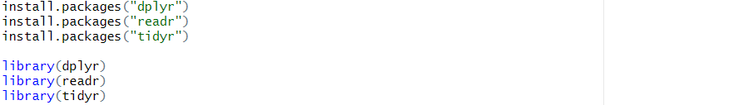

Output

Interpretation

These libraries are used for data manipulation, reading datasets, handling missing values, and visualization.

Data Import (readr): This library is utilized to load the Midterm.csv dataset into the R environment. It ensures that the raw survey data is imported correctly and efficiently.

Data Preparation (dplyr & tidyr): These packages are essential for organizing the data. dplyr is used to filter, select, and summarize specific rows, while tidyr handles the imputation of missing values to ensure the dataset is complete before analysis.

Task 2: Load and Inspect Data

Code

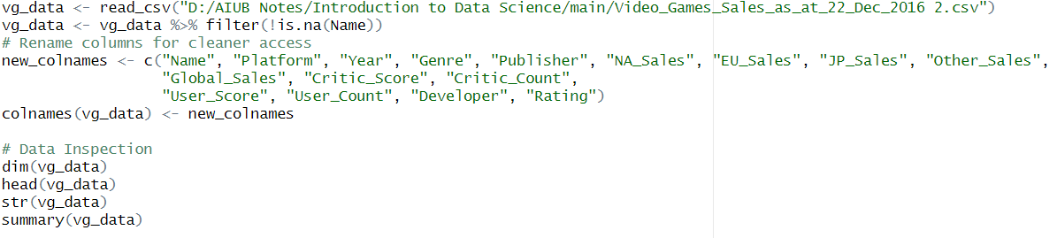

Output
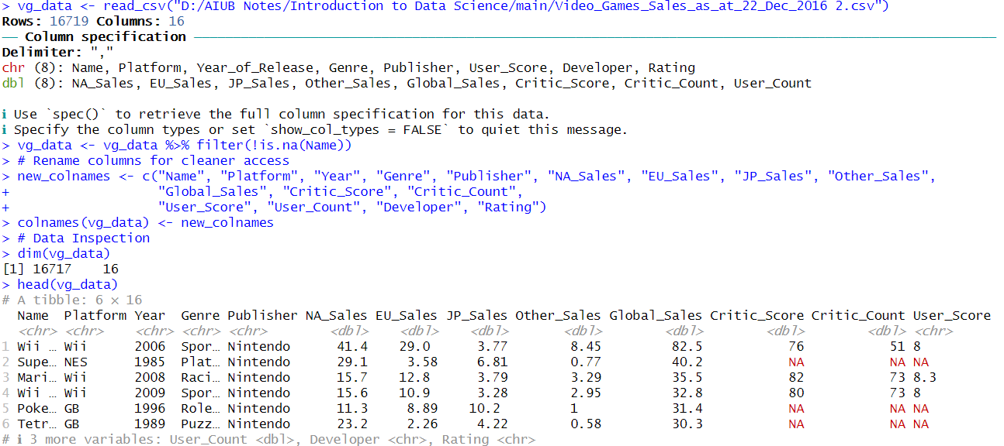

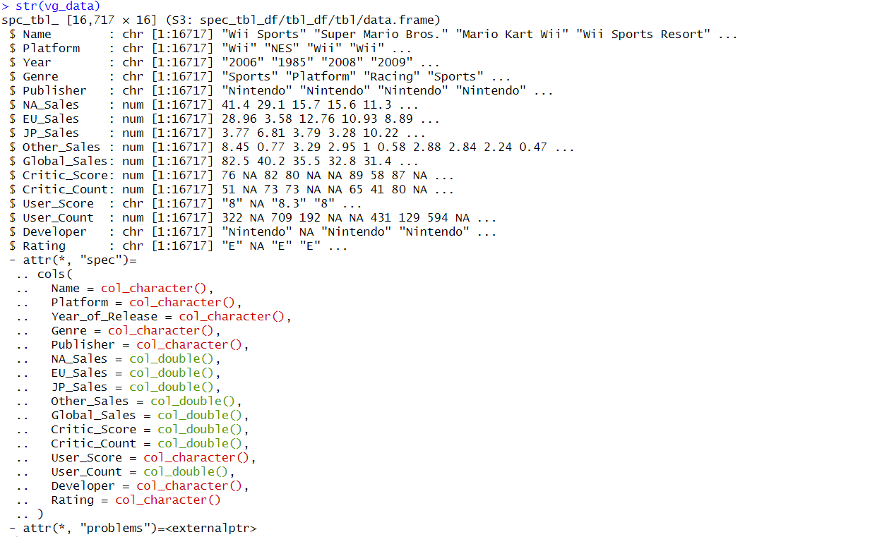

Interpretation
The dataset is loaded and inspected to understand its structure, dimensions, and summary statistics.

Task 3: Identify Missing Value

Code

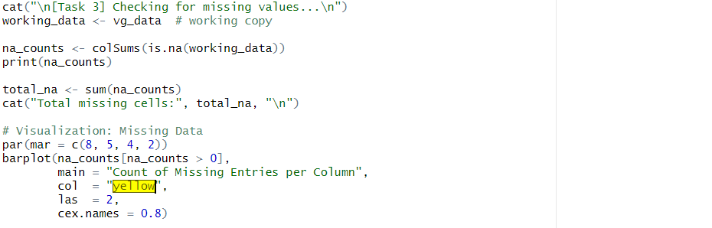
Output
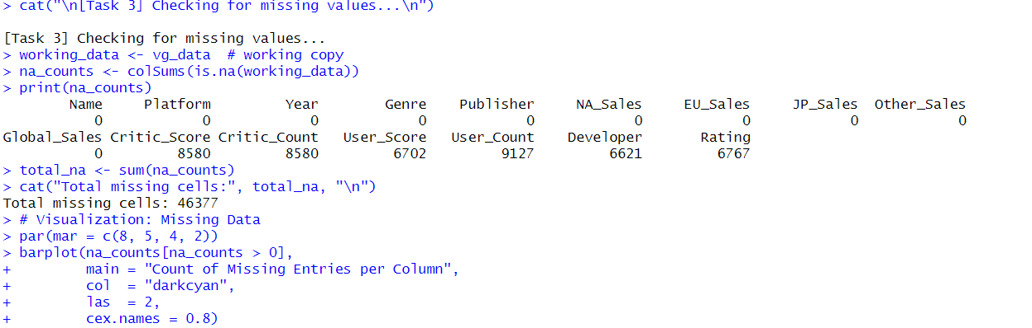

Barplot

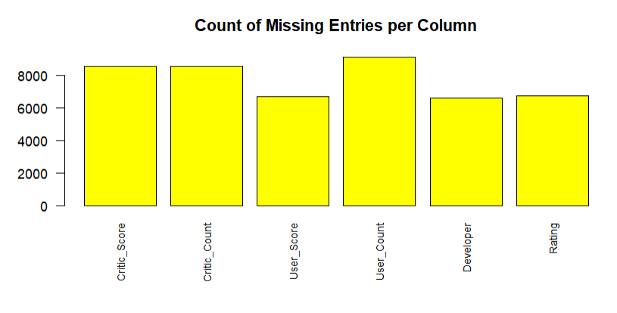

Interpretation
Missing values are identified across all columns. This helps determine which attributes require cleaning.

Task 4: Handling Missing Values

Code

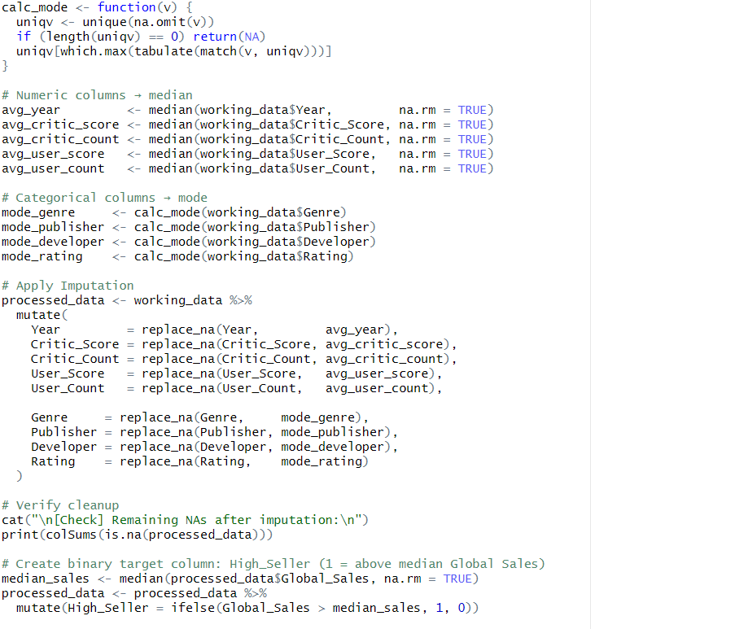

Output
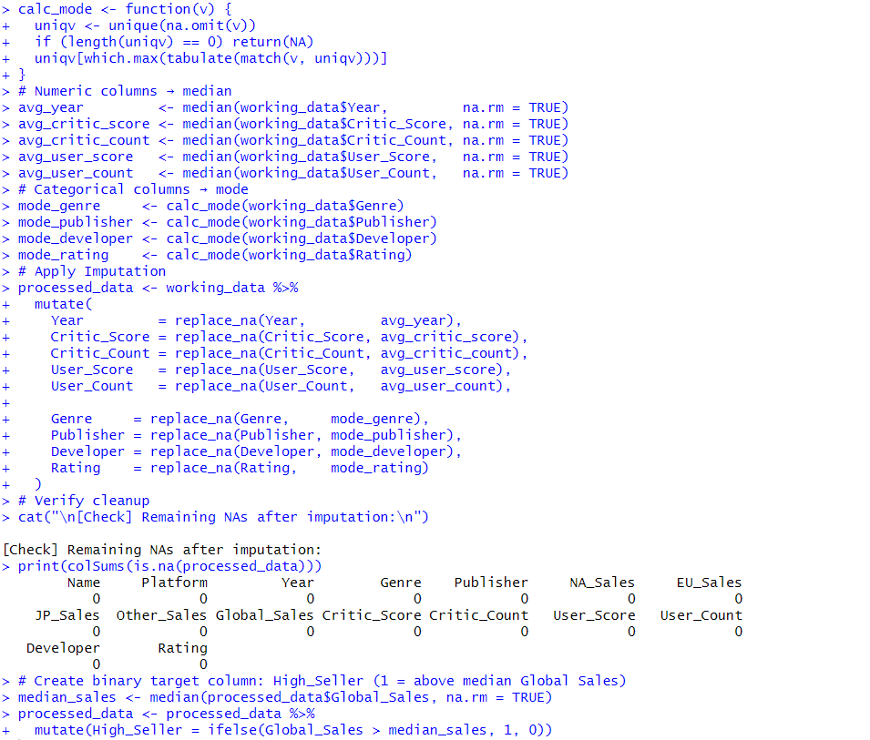

Interpretation
This ensures that missing values are replaced with statistically appropriate values, preserving data integrity.

Task 5: Outlier Detection and Removal

Code

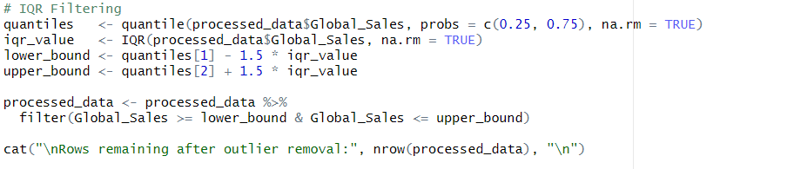

Output
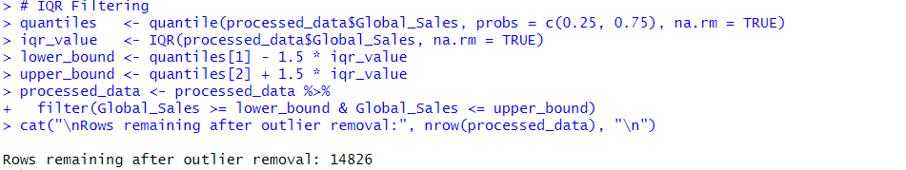

Interpretation
The IQR method is used to remove extreme values from the dataset, improving accuracy and consistency.

Task 6: Remove Duplicates and Normalize

Code

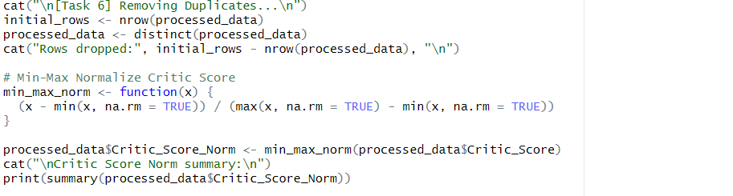

Output
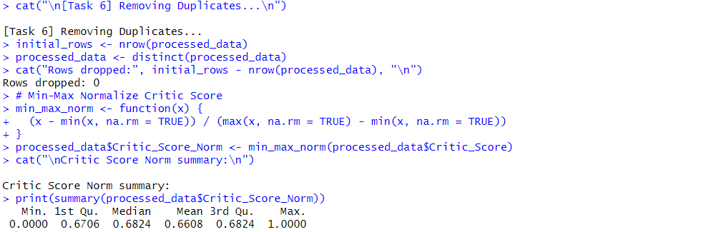

Interpretation
Duplicate rows are removed, and normalization is applied to scale numerical values between 0 and 1.

Task 7: Data Balancing and Splitting

Code

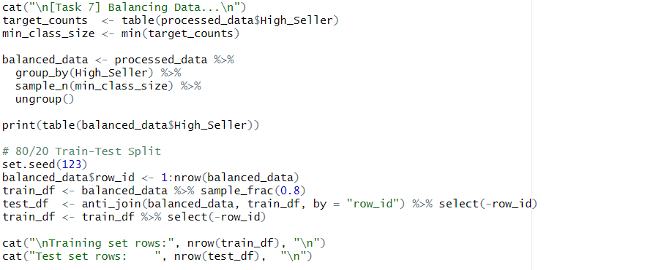

Output
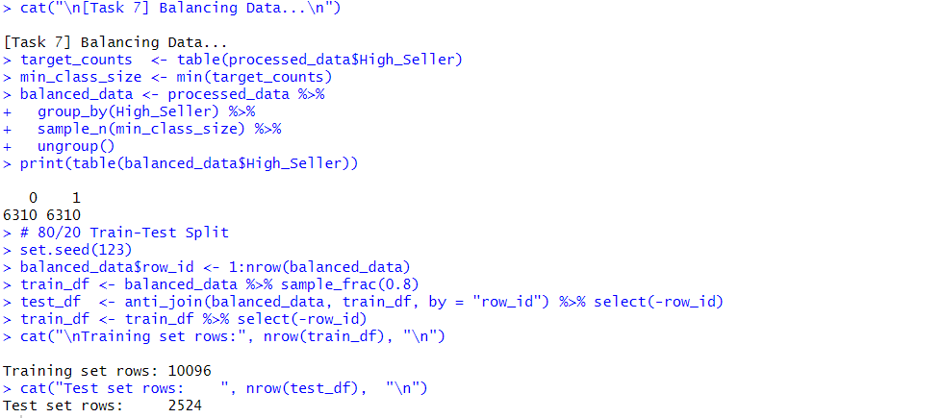

Interpretation
The dataset is balanced using sampling and split into training (80%) and testing (20%) sets.

Task 8: Processed data checking and saving
Code

Output
