Regulations for the ANAC AIWolf Competition

2019/02/09 Ver 1.0.0

## 1. Werewolf Game Rules for the COmpetition

### 1.1 Number and Types of Roles

In this competition, games will be composed of 15 players or 5 players. For each game, the role distribution will be as follows:

15 player game: 8 Villagers, 1 Seer, 1 Medium, 1 Bodyguard, 3 Werewolves, 1 Possessed

5 player game: 2 Villagers, 1 Seer, 1 Werewolf, 1 Possessed

### 1.2 Description of Roles

#### 1.2.1 Roles of the Villager Team:

The Roles of the villager team are as follows: Villager, Seer, Medium, Bodyguard.

**Villager:** Has no particular special abilities.

**Seer:** At the end of each day, the seer can choose one player to “Divine”. The seer will know whether this player is a werewolf or a human.

**Medium:** When a player is voted and eliminated from the game, the Medium will know whether this player is a werewolf or a human. (Otherwise, players who are voted are not revealed until the end of the game)

**Bodyguard:** At the end of each day, the bodyguard can choose one other player to “Guard”. This player will not be affected by the werewolves attack. The Bodyguard will not be told if his guard was successful or not.

#### 1.2.2 Roles of the Werewolf Team:

**Werewolf:** At the end of every day, the werewolves will vote to “attack” and eliminate a human player. Also, The werewolves have access to the “whisper” channel that can only be heard by other werewolves.

**Possessed:** The possessed has the same abilities as a Villager (i.e. none), but is aligned with the Werewolf Team. Seers and Mediums will identify the possessed as Human.

### 1.3 Conversation between agents

#### 1.3.1 Turn system

The conversation happens in turns. Each player is able to broadcast one message at each turn. However, the player can also choose to not broadcast a message (SKIP or OVER). The server will collect the messages from each player and send it to all other players. The order of the messages is random, therefore the order of the messages in a single turn has no meaning.

Each player can broadcast a maximum of 10 messages each day. However, SKIP and OVER are not counted against this limit.

The server will end the day phase when all players broadcast the OVER message, when all players broadcast the SKIP message three turns in a row, or when 20 turns have passed.

#### 1.3.2 Conversation on the first day

There is no conversation phase on the first day. (Also known as Night Start rule)

#### 1.3.3 Werewolf Whisper

The werewolves can use whisper after the Day Phase voting, and before the Attack voting. The whisper happens using a turn system similar to the Day Phase conversation. Although there is no attack on the first day of the game, the Werewolves can use whisper to discuss strategies.

If there is only one werewolf, there will be no whisper stage. Please be careful that you cannot call the whisper method in this situation.

### 1.4 Voting and Re-Voting

To eliminate a player, voting happens at the end of the Day phase. The voting result is available for use of the Seer, Bodyguard, and Werewolves, so they can make their night phase decisions.

If the voting results in a simple majority, that player is eliminated. In case of a tie, a single re-vote will be performed. No conversation happens before the re-voting. Any player can be voted at during the revote, not just the tied players. If there is still a tie after the re-vote, one player will be chosen from the tied players at random.

The werewolf attack target will be decided by a similar voting process, including a single re-vote in case of a tie.

### 1.5 Special Abilities

#### 1.5.1 Seer

The seer can choose a player during the night phase, and will receive information about whether that player is a human or a werewolf. The seer will be informed of the results of the voting stage before being asked to choose a divination target. The seer is able to perform divination during the first day.

#### 1.5.2 Medium

The medium receives information about whether the player eliminating by the voting stage was a human or a werewolf. As there is no voting on the first day, the medium will receive no information on that day.

#### 1.5.3 Bodyguard

The bodyguard can choose a player during the night phase, and that player will not be affected by the werewolf’s attack. The bodyguard can choose an eliminated player, but nothing will happen in that situation. The bodyguard will be informed of the results of the voting stage before being asked to choose a protection target.

## 2. Preliminary Contest and Final Contest

The competition will happen in two stages: The preliminary contest and the final contest.

### 2.1 Preliminary Contest:

In the preliminary contest, the organizers will execute numerous repetitions of the “challenge” described below, until each player has played a minimum number of challenges. The average score of each player in all challenges will be used to select 15 finalists.

(Note: the minimum number of challenges will be chosen as the largest possible in the available time)

**Challenge:** 5 or 15 players are chosen at random from the competition participants. Using these players, 100 games are executed. In each game, the roles of the players are randomized. For each game, the players in the winning team receive 1 point.

Participants in the preliminary contest must submit source code that allows the agent to play as any role (see section 3 for more information about submission). Also, a participating team may be composed of multiple people.

### 2.2 Final Contest:

The 15 players selected in the preliminary contest will participate in a final Challenge. In this challenge, not only the roles will be randomized, but the order of players in the table will also be randomized for each game. The player with the highest number of points by the end of the challenge will win the contest.

## 3. How to submit an agent

### 3.1 Team Registration:

To register a team in this competition, please make an account in the competition webpage: <http://contest.aiwolf.org/en>

### 3.2 Player Submission

Submit the source code that implements an agent capable of playing as any of the roles described in section 1 of this document. The files to be submitted depend on the programming language used.

#### 3.2.1 Java Agent

File to submit: jar archive

For teams creating a Java agent, you may submit a single jar file containing all your code. If you are using libraries for machine learning or other things, please include them in your jar file. It will automatically create the necessary classpaths.

Also, include any data files that you may need in the jar archive, and read them from there. For example, if you need to read the file /data/foo.txt inside the jar archive, you can use “InputStream is = getClass().getClassLoader().getResourceAsStream(“data.foo.txt”)” to create an input stream that reads your data.

Please be aware that there may be conflicts if you try to include or read the filenames “aiwolf-client.jar”, “aiwolf-server.jar”, “aiwolf-common.jar”, “aiwolf-viewer.jar”, “jsonic-xxxx.jar”. Avoid using these names.

#### 3.2.2 C# Agent

File to submit: dll file, zip archive

If you create a single dll file, please register your dll file directly. If you create multiple dll files, please submit all of them as a single zip archive.

However, if you submit a zip archive, make sure to name the file with your player class as “teamname.dll”. For example, if your team name is “tori”, your player class needs to be inside a file named “tori.dll”, or it will not run. If you are including a single dll, there are no restrictions on the filename.

#### 3.2.3 Python Agent

If you submit a python agent, please submit it as a zip archive. Please make sure that your python agent will run with the correct paths when your archive is extracted by the contest server. When registering your agent, please indicate which script should be run to execute your agent.

## 4. Forbidden activities

During the competition, the following activities are forbidden to the agents. Agents that do not follow these restrictions, or agents that cause errors during the contest, may be eliminated, or the organizers might contact the team directly to find a solution, at the organizer’s discretion.

* Broadcasting a message that cannot be created by the ContentBuilder
* Writing to files (reading files is permitted under certain conditions)
* Connecting to a network
* Creating new threads
* Executing a program as a separate process
* Taking more than 100ms to respond to a request from the server (small deviations from this time limit might be tolerated)

**About reading data from files:** In principle, reading data from files is not permitted to the agents. However, we permit reading files that are included in jar or dll archives as resources.

## 5. About running player programs

In this competition, we will use the aiwolf-ver0.5.x server available at <http://aiwolf.org/en/server>. We will use the instructions listed under “Running AIWolf Server” in the same webpage. To create a player that can join the game, prepare a program that inherits the *org.aiwolf.common.data.Player* Interface inside *AIWolfCommon.jar*. Or prepare a program in .NET or Python that can communicate with the server in the same manner as the Interface above.

### 5.1 Methods that need to be implemented in the Player Interface (Java)

A class inheriting the Player interface needs to implements 11 methods. These methods are divided in the following 4 groups:

* Methods for organizing information: *initialize, update, dayStart, finish*
* Methods for targeted actions: *vote, attack, guard, divine*
* Methods for dialogue: *talk, whisper*
* Methods for naming: *getName*

#### 5.1.1 Methods for organizing information (initialize, update, dayStart, finish)

These methods are used to process information, and do not need to return anything.

*initialize(GameInfo, GameSetting)*: This method is called once at the start of the game. The arguments are the current state of the game *GameInfo*, as well as the information about the setup of the game (number of players and roles) *GameSetting*.

*update(GameInfo)*: Is called before each invocation of all other methods (except *initialize*), to update the agent’s information about the game state. When called before *finish* it will also provide the full list of players and their roles.

*dayStart()*: It is called once before each day phase.

*finish()*: It is called after the game is finished.

#### 5.1.2. Methods for targeted actions (vote, attack, guard, divine)

Methods that must return the ID of the agent to be targeted by the action. In the case of *Attack, Guard, Divine*, these methods will only be called on agents with the respective roles.

*vote()*: Return the player to be voted out of the game on that day phase.

*attack()*: Only for werewolves. Return the player to be voted for attack on that night phase.

*guard()*: Only for the bodyguard. Return the player to be protected on that night phase.

divine(): Only for the seer. Return the player to be investigated on that night phase.

#### 5.1.3. Methods for dialogue (talk, whisper)

These methods must return the message to be broadcast (in String format). *whisper* is only called for werewolf players.

*talk()*: Returns a message that will be broadcast for all active players. In this competition, the message must be constructed using the class org.aiwolf.client.lib.ContentBuilder, which will guarantee that it follows the defined protocol. (See section 5.3)

*whisper()*: This method is only called for werewolf agents. The messages returned for this method are not displayed to the non-werewolf players. In this competition, the message must be constructed using the class org.aiwolf.client.lib.ContentBuilder, which will guarantee that it follows the defined protocol. (See section 5.3)

#### 5.1.4. Naming Methods (getName)

*getName()*: Returns the name of the player (in String format). The name of the player is displayed on the Game’s log. Please return the team name that you registered during your registration for the competition. If you return a different name, this may result in disclassification.

### 5.2. Timing for invoking each method.

The methods described in the previous section (except for getName) are called following the flow described below. While the flow does not include the “update” method, it is called before every other method, with the exception of initialize.

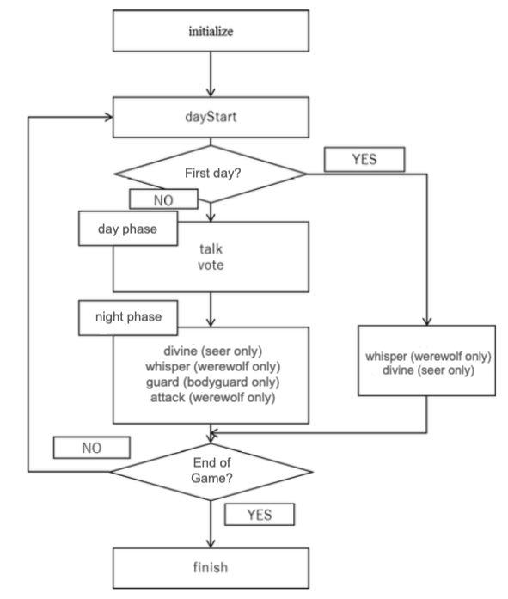

### 5.3. Valid Broadcast Strings

In this competition, all dialogue among agents must be composed of strings that can be created by the org.aiwofl.client.lib.ContentBuilder class. The details of the possible messages and sentences, and how the agents should interpret them, are explained in the **protocol** file.

### 5.4. About the Player class package

Please create an unique Player class. Avoid just rewriting the sample classes such as org.aiwolf.sample.player.SampleRoleAssignPlayer. Also, please include your Player Class in an independent package. The recommended package naming convention is to use the reverse order of your e-mail’s address. (For example, if your e-mail address is [contestant@example.com](mailto:contestant@example.com), and your Player class is MyPlayer, the header of your class would probably look like this:

package com.example.contestant;

Import org.aiwolf.sample.lib.AbstractRoleAssignPlayer;

public class MyPlayer extends AbstractRoleAssignPlayer {

}

## 6. Using other Programming Languages

Besides Java, we will consider entries in Python and .NET. When using these languages, please check their respective libraries. Using TCP-IP libraries for socket communication, and making sure that the correct messages are passed back and forth between server and client, it is possible to participate in the game. When in doubt, please contact the organizing comittee: [gm@googlegroups.com](mailto:gm@googlegroups.com)

However, please note that the contest will be executed in a linux machine, so if you do your development in a different environment, make sure that your code is portable. Clients that cannot run on the server environment will be automatically disclassified. We strongly recommend that you organize preliminary games to test your code.

## 7. Changes

These regulations are subject to change at any time. Changes will be announced at the project page (<http://aiwolf.org/en>), the development mailing list ([aiwolfdev@googlegroups.com](mailto:aiwolfdev@googlegroups.com)) or our Twitter account (@aiwolf_org).

## 8. Change History

2019/02/09 -- ver 1.0.0 -- Translated from the 4th AI Wolf competition rules by Claus Aranha