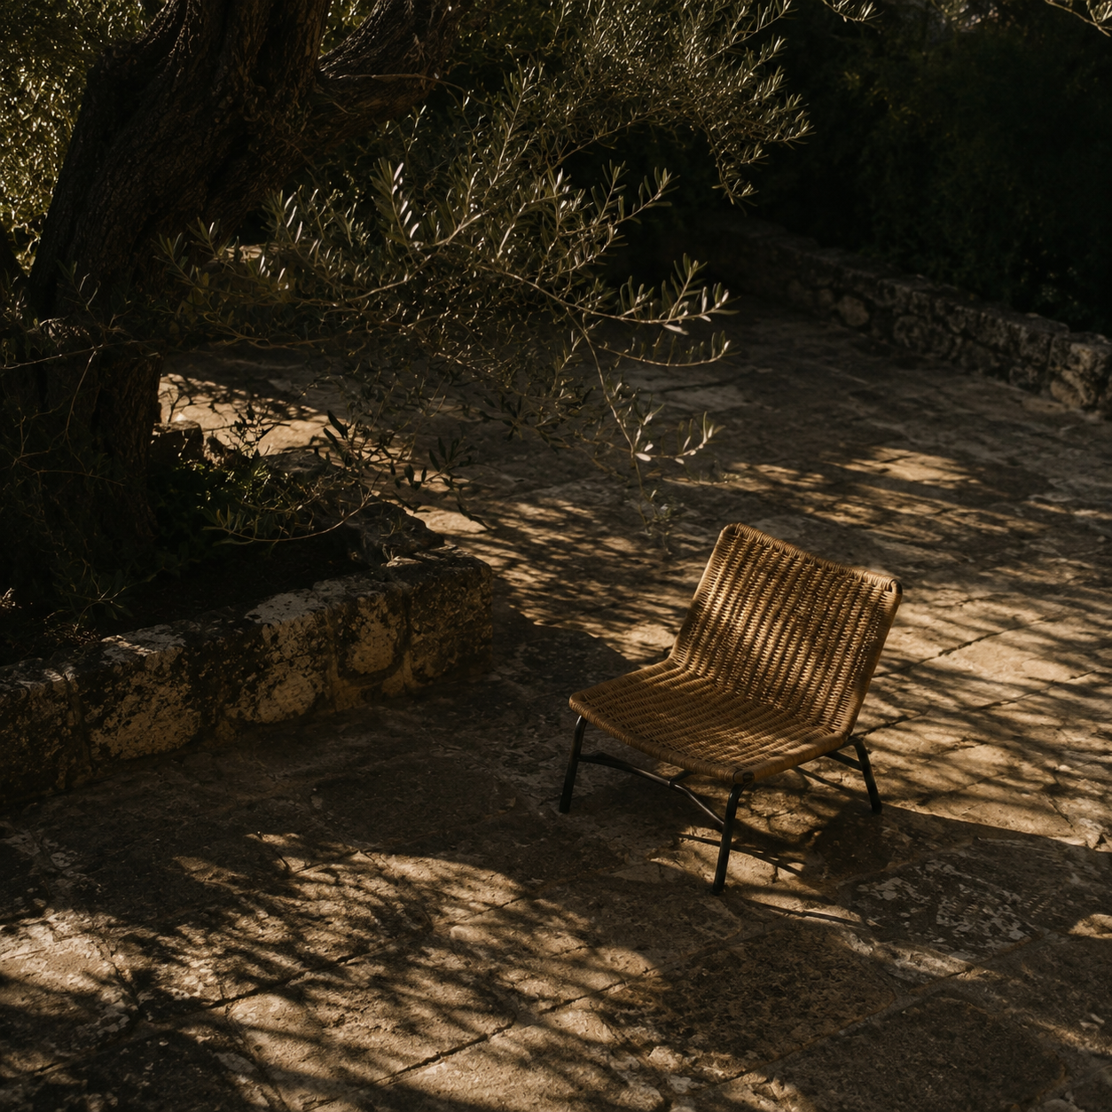

A Clock You Can Fill
A Clock You Can Fill |  | Prepared for Focus Clock  10 November 2026

Contents

Executive summary 2
At a glance 2
Introduction 2
Key findings 3
Context and conditions 3
Patterns in the evidence 3
Implications 3
Recommendations 4
Conclusion 4
Appendix 6
Notes 6
Sources 6

Executive summary
Focus Clock should feel like an open map of the day that fills only when the person chooses. Keep the familiar analog dial, the warm bookpaper colors, and the goal cue. The screen should make the next action visible without turning planning into a chore.
The current Flutter code confirms a simple friction point: tapping empty clock space does nothing, while drawing a block requires a drag and a second picker. Dismissing that picker used to save a generic “Fokus Xm” block. The working change adds tap-to-place, a short name-and-duration composer, and genuine cancellation. This is a design recommendation and a prototype slice, not yet a device-tested release.

At a glance
- Keep the analog face as the visual map. The current warm bookpaper palette remains the approved visual language.
- Let a tap choose the start time. A name field and a small set of durations complete a block without precision dragging.
- Start with an empty day. Show the goal and now/next cue; let the user decide what enters the clock.

Introduction
The owner’s central intent is “visualize”: a glance at the phone or clock should reconnect a person to the goal and show what they are doing now or could do next. The dial represents lived time spatially; it is not decoration or a stopwatch dashboard. A person may be forgetful, interrupted, or low on energy, so the interface should help them resume without shame.
This review inspected `FocusClockTab`, `AnalogClockFace`, `NowNextCard`, the activity repository, the product handoff, and the approved product documents in the Focus Clock repository. It pairs those code facts with current platform guidance and one recent date-entry study. The proposed interaction is an inference from that evidence and the owner’s stated preference.

Key findings
The clock already has the right primary metaphor: an analog face with activity arcs. `NowNextCard` already carries the main goal and the current/next activity. The problem is the path for putting the first activity on the canvas, not a lack of visual effects or another dashboard.

Context and conditions
An empty-time tap currently returns without action. A drawn span opens a preset/custom picker; the old dismissal path wrote a generic activity. The view also has instant placement, long-press movement, precision mode, voice, and menu actions. This leaves the most human task—naming the thing—behind several modes.

Patterns in the evidence
Apple recommends sensible defaults and more than one input method; Material says mobile time entry should not rely on a clock dial alone. A 2026 Census study with 1,000 participants found a calendar interface more effective and efficient than text or dropdowns for several near-date entry tasks. That study is about dates, not time-block drawing. The direct recommendation here is an inference: use the clock for spatial placement, a text field for the activity name, and explicit duration choices for a low-friction first block.

Takeaway. The clock should invite a person to place one meaningful block, then get out of the way. Direct tap is the easy path; drawing is an optional expressive path.

Implications
The first screen needs three layers only: the personal goal, the empty-or-filled day dial, and one calm now/next cue. A composer should appear only when the user taps a free time. It should prefill a 30-minute duration, accept a short activity name, and leave all other hours blank. A future agent may suggest a schedule from a goal, but each suggestion should be reviewed before it reaches the clock.
Theme | Observation | Implication
Empty-first | The day begins with an honest blank dial. | Show readiness without prescribing a full schedule.
Tap-to-place | Naming and duration follow the selected clock time. | Make planning work without careful dragging.
User confirmed | Cancellation writes nothing; placement is explicit. | Keep control, trust, and reversibility.

Recommendations
Build the first interaction around the blank day, then validate that it feels easy before adding more scheduling logic.
- Make the empty state honest. Do not seed a sample schedule or imply that every hour needs a block. Keep the goal and next cue visible without guilt or streak language.
- Make placement forgiving. A tap on free clock space opens the activity composer at that time. Prefill 30 minutes and offer a few durations. Keep drag-to-draw for people who prefer it; never make it the only way to plan.
- Keep intent in the user’s hands. Save only after a name and explicit confirmation. Cancel means no record. Use the existing activity repository and sync path; do not introduce an AI or account dependency.

Conclusion
The strongest direction is not a new calendar or a more elaborate spiral. It is a calm, empty-first clock that users can fill as life unfolds. The clock keeps the day visible; one tap bridges intention to a real block.
Treat the new composer as a hypothesis. The next evidence should come from a short task-based usability session: can a person add one block, adjust its duration, and return to the day view without asking how to drag?

Appendix

Notes
These are design findings from source inspection, not results from a user study. The changed flow has widget and time-mapping tests, but the device interaction has not yet been validated on Android or in a live browser.
Suggested first usability check: ask five people to add “Study LKS for 30 minutes” at a chosen time, then change it to 45 minutes. Record completion time, wrong placements, abandoned attempts, and whether they notice that an empty dial is still ready to use.

Sources
- Focus Clock owner intent and product history handoff. Project file, 21 October 2026.
- Apple. “Entering Data.” Human Interface Guidelines. https://developer.apple.com/design/human-interface-guidelines/entering-data
- Apple. “Pickers.” Human Interface Guidelines. https://developer.apple.com/design/human-interface-guidelines/pickers; Material Design. “Time Pickers.” https://m2.material.io/components/time-pickers/web
- Rivas, A. G., Nichols, E. M., and Horwitz, R. T. “Differences in Usability Between Three Date-entry Designs.” U.S. Census Bureau Survey Methods Working Paper RSM2026-08, August 2026. https://www.census.gov/library/working-papers/2026/adrm/rsm2026-08.html

