Employee performance analysis

1. Project summary

This project is an oversight of INX Future Inc. employee performance and factor affecting the same. This analysis focuses on employee efficiency development areas that are to be identified and provide suitable recommendations ensuring improved employee performance, thus improving the service delivery and customer satisfaction.

An algorithm of Random Forest has been implemented in this project. The data is randomly permuted at each split using Random Forest to make desired analysis.

This project has been implemented in Python which yields better visualization, Tableau has been effectively utilized.

# 1.1 Requirement

* Employee Performance Data from INX Future Inc.
* Identifying the objectives of INX Future Inc.

# 1.2 Analysis

* Random Forest Algorithm has been used to analyze the data received from INX Future Inc.
* **Department Wise Performances:**
* From the insight into the data, below are the Department-Wise employee performance.

|  |  |  |  |  |  |  |
| --- | --- | --- | --- | --- | --- | --- |
| Employee Department | Count of Employees Based on Performance Rating | | | |  |  |
|  | **Good**  **(2)** | **Excellent**  **(3)** | **Outstanding**  **(4)** | **Grand Total** | **% of 3 Ratings** | **% of 4 Ratings** |
| Data Science | 1 | 17 | 2 | 20 | 85 | 10 |
| Development | 13 | 304 | 44 | 361 | 84.21052632 | 12.18836565 |
| Finance | 15 | 30 | 4 | 49 | 61.2244898 | 8.163265306 |
| Human Resources | 10 | 38 | 6 | 54 | 70.37037037 | 11.11111111 |
| Research & Development | 68 | 234 | 41 | 343 | 68.22157434 | 11.95335277 |
| Sales | 87 | 251 | 35 | 373 | 67.2922252 | 9.383378016 |
| Grand Total | 194 | 874 | 132 | 1200 |  |  |

* From the above data and analysis, it is evident that Development, Human resources and Research & Development are the top employee performing Departments.
* Even though, the Department of Data science has a high percentage of 3 ratings, its percentage of 4 ratings are comparatively, barring it from top 3 Performing Departments.
* **Top 3 Important Factors Affecting Employee Performance:**
  1. Training
     + The Department in which Employees have completed at least two trainings and a fair amount of the Employees have also completed three trainings, has a better performance ratings.
  2. Employee Work Life Balance
     + Employees work life balance has given Accurate Ratings.
  3. Employee Experience in Current Role
     + Employees having at least 2 years of experience in current role have done an “Excellent”/”Outstanding” performance.

# 1.3 Summary

Random Forest trained Model is an efficient model to predict the employee performance based on the factors as inputs and the same can be used to hire the employees.

The percentage of trained model efficiency resulted as 97.2222% and helping to identify if the employee being hired will be a “Good”, “Excellent” or “Outstanding” performer.

Recommendations:

1. The Department of Data Science and Finance can hire more employees with relevant education background.
2. Employees in all Departments must be given an adequate amount of training. 4 trainings for all employees in every department per year can help in increasing Employee Performance.
3. Minimum 3 years of experience is required by each employee in a Department for better performance.

# 2.1 Visualization

1.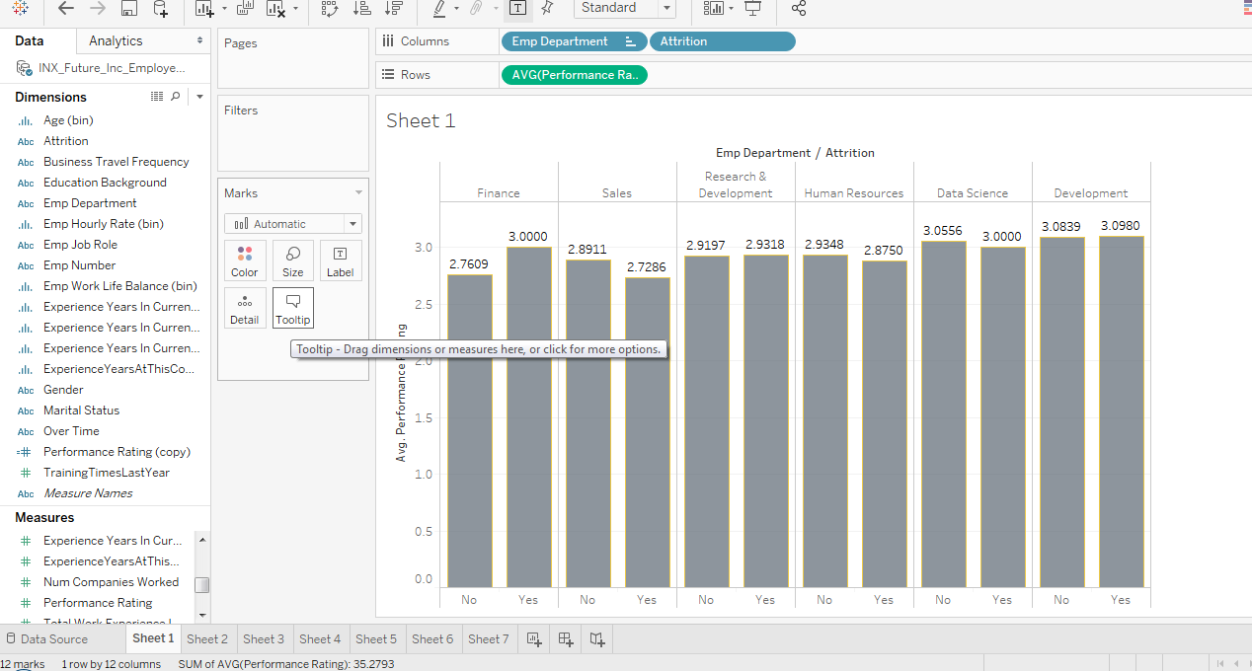

Graph showing Department-wise Performance Rating

**2.2 Top 3 Important Factors Effecting Employee Performance1.**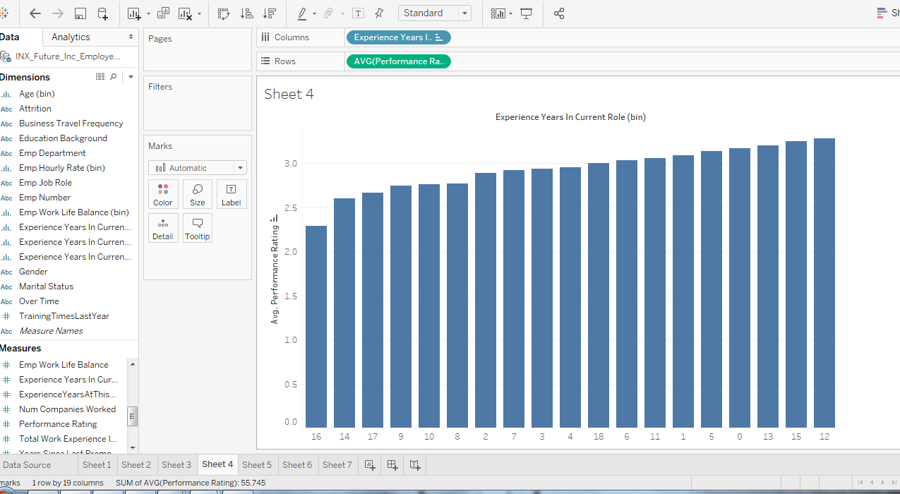

Graph showing Experience in Current Role v/s Avg performance Rating

2. 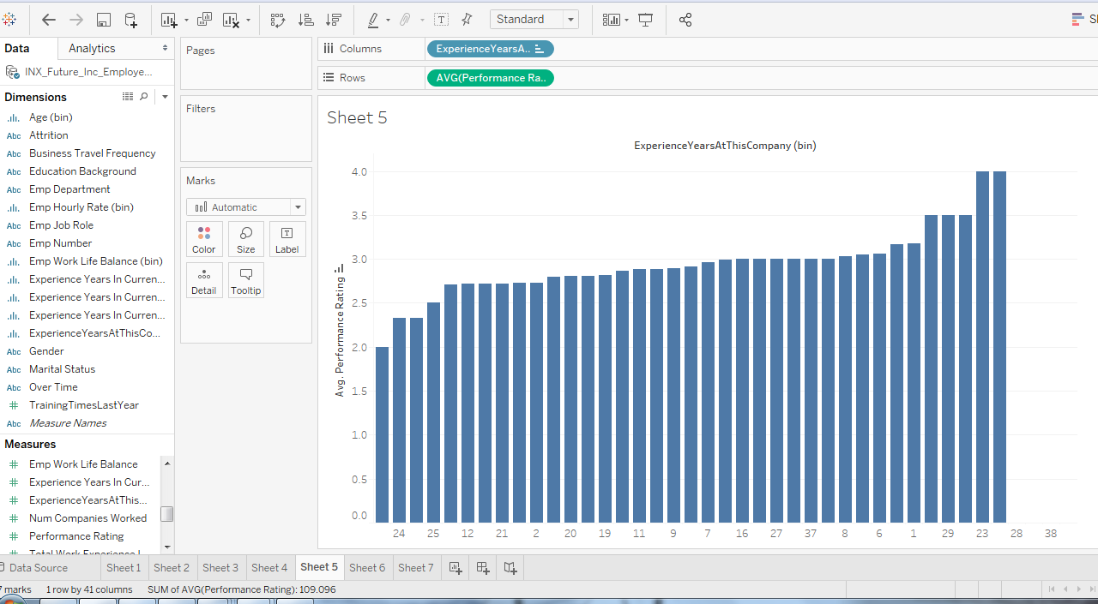

Graph showing Experience years in current company v/s Avg performance Rating

3. 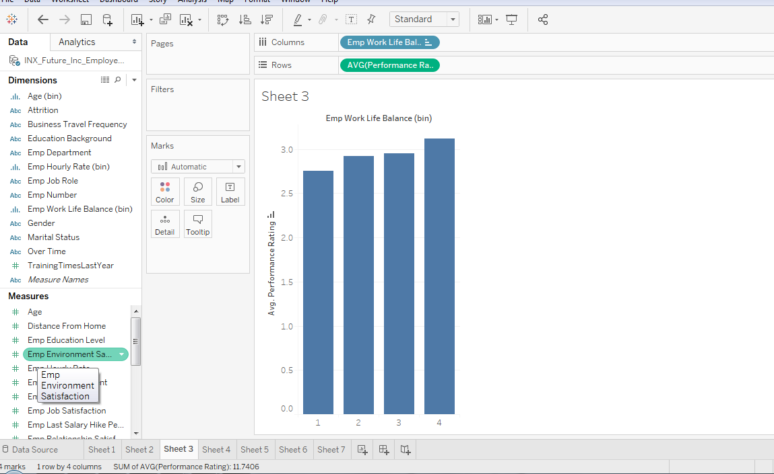

Graph showing Employee Work Life Balance v/s Avg performance Rating

# 3.4 References

Not available/Applicable.

**1. Department wise performances**

