Git/GitHub 기반 SW 공개

Curling Strategy Classification SW: Source Code

https://github.com/SAILCurling/Curling-Strategy-Classification

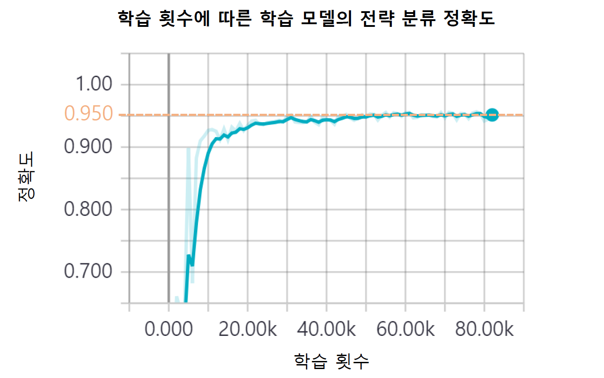

[학습 횟수에 따른 전략 분류 정확도. (Draw, Guard, Come-Around, Freeze, Throw-Away, Peel, Takeout, Double-Takeout, Triple-Takeout) 전략에 대해 수행. ]