**Introduction**

In this project we are analyzing the parks in wake county, NC. This is also the where county I live in. The objective is to present attractive parks to potential visitors with to wake counties park outdoors. The ultimate goal is for visitors to have good experience.

Wake County parks have many facilities ranging from biking, boat ride, playgrounds and many to choose from and enjoy. There are many parks to chose from and it’s also hard to know what facilities each park has to make choices. This where this project comes with a suggested list of top 10 parks.

In addition to listing Wake County parks and their facilities, we will also add top 10 venues near each park in our top 10 list using Foursquare API. It is expected that visitors will look for other venues from each park they visit.

**Data source and cleaning**

The data set was obtained from [Wake County](http://data-wake.opendata.arcgis.com/datasets/parks-in-wake-county/data?geometry=-80.744%2C35.413%2C-76.951%2C36.192) North Carolina website. There are many data sets with the same contents but the one used for this project had coordinate values for the parks. The initial data has many columns that were deemed not essential and were removed.

There were many rows for parks data that had no Longitude and latitude coordinates. Fortunately, their addresses were available. We had to loop through the data to get the correct coordinate values using geopy and corresponding addresses. Some locations had no address or coordinates; using the name of the park and state was enough for geopy to get the coordinates and address.

**Methodology and Results**

We used pandas manipulation techniques to get useful information from our data. After which we used geopy for mapping and Foursquare API to get venues.

After cleaning, we sorted the table to return the count of all facilities in all parks. This table show that playgrounds has the most count among facilities, followed by picnic shelters. This makes sense since people are more likely to visits parks with kids and to have picnics. Our final data had 263 rows or 263 parks. The data from the table on left implies that roughly 56% of all parks in Wake County have a playground and only 48% have picnic shelters.

After cleaning, we sorted the table to return the count of all facilities in all parks. This table show that playgrounds has the most count among facilities, followed by picnic 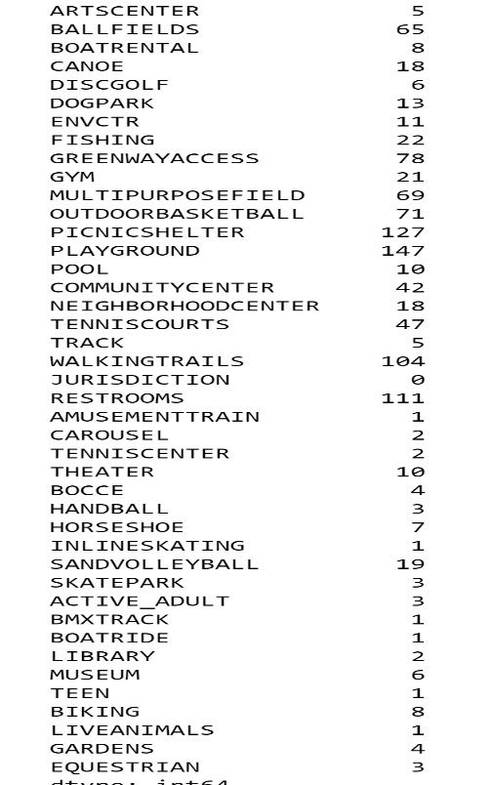shelters. This makes sense since people are more likely to visits parks with kids and to have picnics. Our final data had 263 rows or 263 parks. The data from the table on left implies that roughly 56% of all parks in Wake County have a playground and only 48% have picnic shelters.

.

It would have been great if we can find parks with all facilities. However, we can manipulate the data and sort it to show parks with the most facilities count. For simplicity, we decided to showcase the top 10 parks with most facilities:

|  |  |  |
| --- | --- | --- |
| **NAME** | **ADDRESS** | **Total_facilities** |
| **Millbrook Exchange Park** | **1815 Spring Forest Rd, Raleigh, NC** | **14** |
| **Pullen Park** | **410 Park Ave, Raleigh, NC** | **12** |
| **John Chavis Memorial Park** | **505 Martin Luther King Jr Blvd, Raleigh, NC** | **11** |
| **Lake Crabtree County Park** | **1400 Aviation Pkwy., Morrisville, NC 27560** | **11** |
| **Shiloh Park/Luther Green Center** | **922 Church Street** | **10** |
| **Middle Creek School Park** | **151 Middle Creek Park Avenue, Cary, NC** | **10** |
| **Wendell Park** | **601 W. Third Street, Wendell, NC** | **10** |
| **Biltmore Hills Park** | **2615 Fitzgerald Dr, Raleigh, NC** | **10** |
| **Apex Community Park** | **2200 Laura Duncan Rd., Apex, NC** | **10** |
| **Green Road Park** | **4201 Green Rd, Raleigh, NC** | **10** |

This is a portion of our top 10 table. Please refer to the dataset for the full table which has names of specific facilities for each park. The top 10 table also happen to list the most popular parks in the Wake County that I’m familiar with. Pullen Park for instance is very popular in the county and is even visited by people from other cities in North Carolina. It's the only park in Wake County with amusement train ride which is what children like. However, we should mention that the number of facilities does not an indicator of performance. It all depends on personal taste. We promise this short list has parks that are good enough for anyone to enjoy.

**Observations and Recommendations**

#### Not all parks have food services or other venues and visitors are likely to go nearby a park to get food or entertain themselves. To help with that, we looked at the top 10 most popular venues from each park in our top 10 list. A radius of 10 miles is deemed reasonable distance from each park[.](http://localhost:8888/notebooks/Untitled-Copy1.ipynb#Not-all-parks-have-food-services-and-visitors-are-likely-to-go-nearby-a-park-to-get-food-or-entertain-themselves.-To-help,-we-will-look-at-the-top-20-most-popular-venues-for-our-visitors--not-too-far-from-each-park-in-our-Top10-list.-A-radius-of-10-miles-is-deemed-reasonable-distance-from-each-park) Foursquare API was used for this purpose.

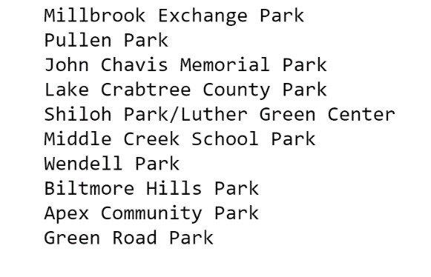The data on the left is what was returned by Foursquare for the most 10 popular venues, 10 miles from each park. The dataframe as a size of (100,7) or 100 venues in total, 10 for each park.

Coincidently, our top 10 list (Top10) matches the most popular venues returned by Foursquare data on the left. Please refer to the dataset

Returned venues are mostly parks themselves which make sense since many are in isolated locations and most of them offer popular venues themselves. What happened here is that Foursquare returned the top 10 venues from within parks themselves. Millbrook Exchange Park for instance offers diner, fast food, butcher, gym and you name it. Since our top venues are within the parks, there is no need to map them.

**Conclusion**

Our final table with top 10 parks are their venues is the table below. Please refer to the notebook for a complete list:

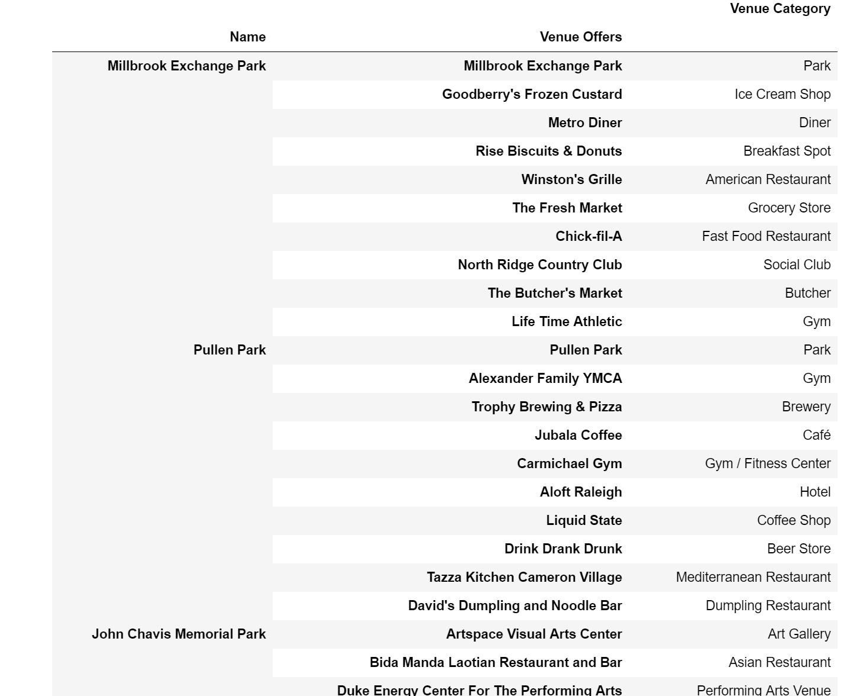

This table above provides a very useful list of the top 10 venues generated by Foursquare in each park and what the category it belongs to. If you need coffee, you can look easily look at the list for parks with coffee. If you have a family with small children for instance, parks with sell Ice Cream Shops will be a good choice, especially in hot summer.

I hope you will enjoy a wonderful adventure in Wake County parks.