4

[Based on Python data types, conditional statements & Loops]

Q1: Write a python program to add all the odd numbers from 0 to 20.

num=int(input("Enter number to be added upto: "))
def addodd(num):
sum=0
for i in range(num+1):
if (i%2!=0):
sum=sum+i
print(f"sum of odd numbers from 0 to {num}: {sum}")
addodd(num)

Enter number to be added upto: 20
sum of odd numbers from 0 to 20: 100
Q 2: Write a python program to find the sum of all integers greater than 100 and less than 200.

num1=int(input("Enter lower range number: "))
num2=int(input("Enter upper range number: "))
def addition(num1,num2):
sum=0
for i in range(num1+1,num2):
sum=sum+i
print(f"sum of numbers from {num1} to {num2}: {sum}")
addition(num1,num2)

Enter lower range number: 100
Enter upper range number: 200
sum of numbers from 100 to 200: 14850

Q3: Write a program to display the sum of square of the first ten even natural numbers

Q4: Write a python program to display ascii characters from 65 to 90
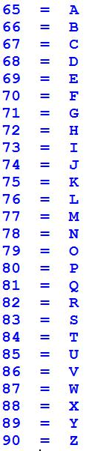

for i in range(65,91):
print(f"{i} = {chr(i)}")

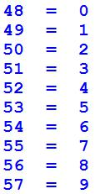
Q5: Display ascii characters from 48 to 57.

for i in range(48,58):
print(f"{i} = {chr(i)}")

Q6: Display the following output with the help of Ascii character.
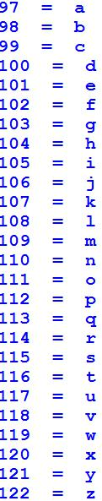

for i in range(97,123):
print(f"{i} = {chr(i)}")

Q7: Write a python program for given a Python list you should be able to display Python list in the following order

L1 = [100, 200, 300, 400, 500]

Expected output: [500, 400, 300, 200, 100]
def reverselist(L1):
L1=L1[::-1]
print(L1)
reverselist(L1)
[500, 400, 300, 200, 100]
Q8: Write a Python program to concatenate following dictionaries to create a new one.
Sample Dictionary :
dic1={1:10, 2:20}
dic2={3:30, 4:40}
dic3={5:50,6:60}
Expected Result : {1: 10, 2: 20, 3: 30, 4: 40, 5: 50, 6: 60}
resultdict={}
resultdict.update(dic1)
resultdict.update(dic2)
resultdict.update(dic3)
resultdict

Q9: Write a Python program to add key to a dictionary.
Sample Dictionary : {0: 10, 1: 20}
Expected Result : {0: 10, 1: 20, 2: 30}

SampleDictionary[2]=30
SampleDictionary

Q10: Write a Python program to print out a set containing all the colors from a list which are not present in another list
Test Data :
color_list_1 = set(["White", "Black", "Red"])
color_list_2 = set(["Red", "Green"])
output: set(["White", "Black"])

color_list_1 = {"White", "Black", "Red"}
color_list_2 = {"Red", "Green"}
set=color_list_1-color_list_2
set

Q11: Given a Python list. Write a python program to turn every item of a list into its square
List1 = [1, 2, 3, 4, 5, 6, 7]
Expected output:
[1, 4, 9, 16, 25, 36, 49]
def squareOfList(List1):
for i in range(len(List1)):
List1[i]=List1[i]*List1[i]
print(List1)
squareOfList(List1)

Q12: Program to count the number of each vowel in a string.
s=input("Enter String for counting vowels in it: ")
def countVowels(s):
vowels=['a','e','i','o','u','A','E','I','O','U']
count=0
for i in s:
if i in vowels:
count+=1
print(f"Total vowels in given string '{s}' is {count}")
countVowels(s)

Enter String for counting vowels in it: aeroplane
Total vowels in given string 'aeroplane' is 5

Q13:Write a python program to Access the value of key ‘history’ from the following dictionary-sampleDict = {"class":{"student":{"name":"Mike","marks":{"physics":70,"history":80}}}}

sampleDict["class"]["student"]["marks"]["history"]

Q 14: write a Program to Remove Punctuations from a String provided by the user. [Hint: use punctuation attribute of string module to get all punctuations (i.e. !"#$%&\'()*+,-./:;<=>?@[\\]^_`{|}~ ) ]
s=input("Enter String for removing punctuations in it: ")
def punctuationsRemoval(s):
punctuations=""" !"#$%&\'()*+,-./:;<=>?@[\\]^_`{|}~ ) """
for i in s:
if i in punctuations:
s=s.replace(i,'')
print(f"string after removing punctuations is: {s}")
punctuationsRemoval(s)

Enter String for removing punctuations in it: 1!f@h#I$j{K)
string after removing punctuations is: 1fhIjK

Q15: write a Program to sort alphabetically the words form a string provided by the user. [You can use split() method to split string into a list of words. ]
s=input("Enter String: ")

def alphabeticallySortingString(s):
s=s.split(",")
s.sort()
print(f"after sorting string alphabetically: {s}")
alphabeticallySortingString(s)

Enter String : orange, banana, apple
after sorting string alphabetically: [' apple', ' banana', 'orange']

[Nested Loops]

Q16: Write a python program to print the Following:

1
2 1
3 2 1
for i in range(1,4): #number of rows
for j in range(i):
print(i-j,end=" ")
print()

1
2 1
3 2 1

Q17: WAP to print the following asterisk pattern:
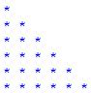

for i in range(7): #for rows
for j in range(i): # for columns
print("*",end=" ")
print()

*
* *
* * *
* * * *
* * * * *
* * * * * *
Q18: WAP to create a function traiangle to print the following asterisk triangle pattern:
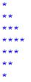

for i in range(5):
for j in range(i):
print("*",end=" ")
print()
for j in range(4):
for j in range(1,i-j):
print("*",end=" ")
print()

Q19: Write a python program to print following multiplication table on the screen

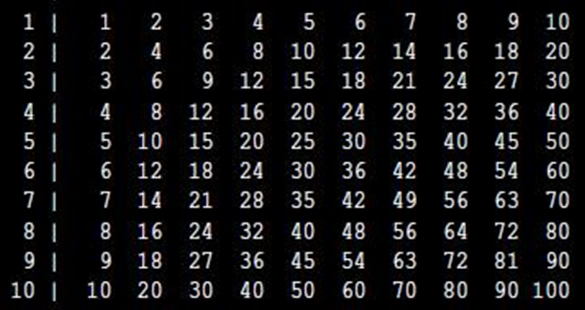

for i in range(1,11):
if i <10:
print(" ",end="")
print(f"{i} |",end="")
for j in range(1,11):
print(i*j,end="\t")
print()

1|1 2 3 4 5 6 7 8 9 10
2|2 4 6 8 10 12 14 16 18 20
3|3 6 9 12 15 18 21 24 27 30
4|4 8 12 16 20 24 28 32 36 40
5|5 10 15 20 25 30 35 40 45 50
6|6 12 18 24 30 36 42 48 54 60
7|7 14 21 28 35 42 49 56 63 70
8|8 16 24 32 40 48 56 64 72 80
9|9 18 27 36 45 54 63 72 81 90
10|10 20 30 40 50 60 70 80 90 100

