1. **When we compare the city with total sales:**
2. **New York City has maximum sales : 256368**
3. **Los Angles has 175851 sales which is second highest**

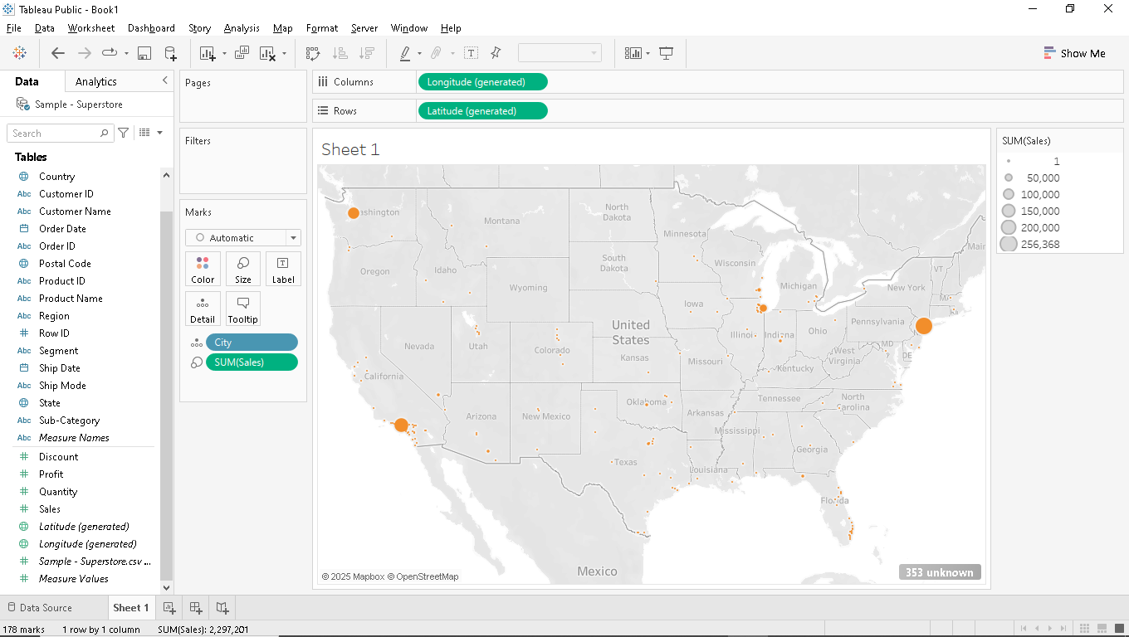

1. **City Arlington with product id : TEC-MA-10001127 has maximum sales.**

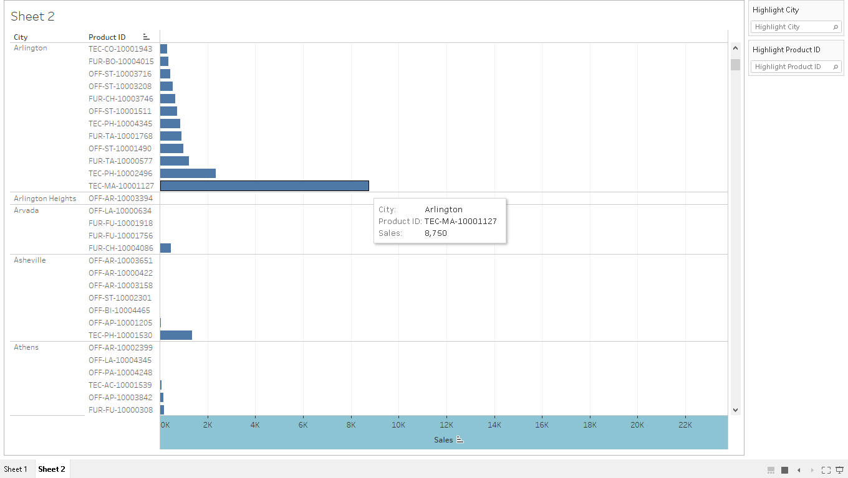

1. **Sales vs Postal code**

**Postal code : 10024 has maximum sales 78697**

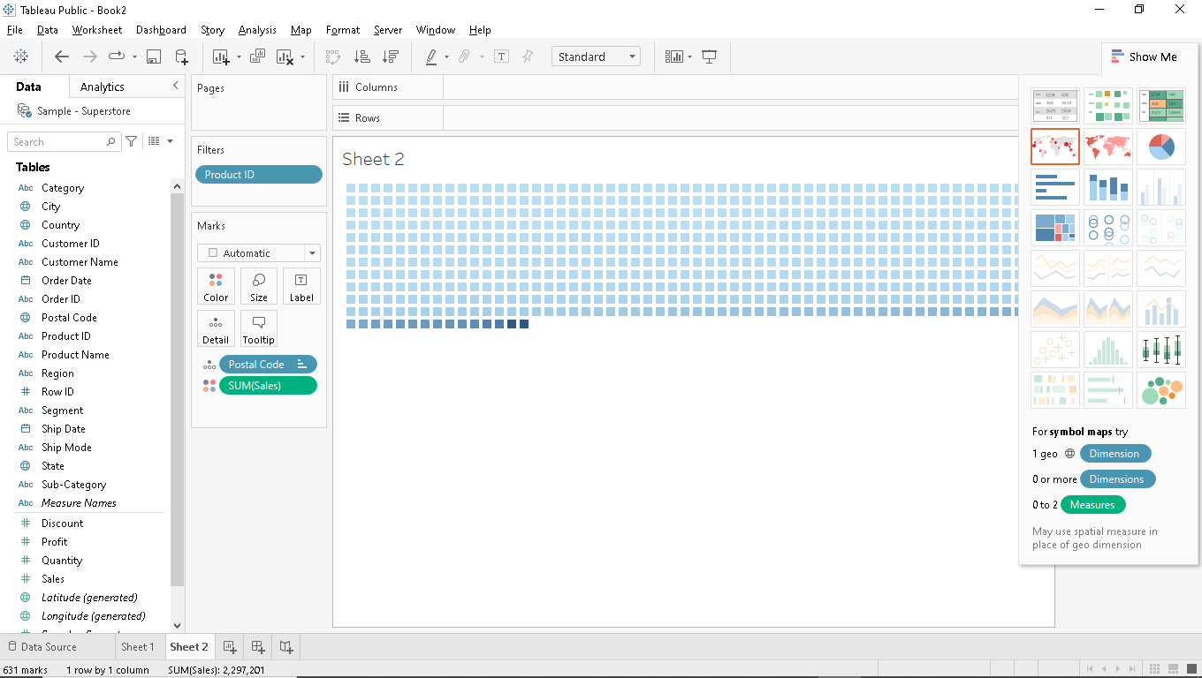

1. **Product ID: TEC-CO-10004722**

**Sales: 61,599.82 above product ID has maximum sales.**

