**#a.Use EXTRACT(MONTH FROM order_a. date) for month.**

SELECT

*,

EXTRACT(MONTH FROM ORDERDATE) AS ORDER_MONTH

FROM

sales_order;

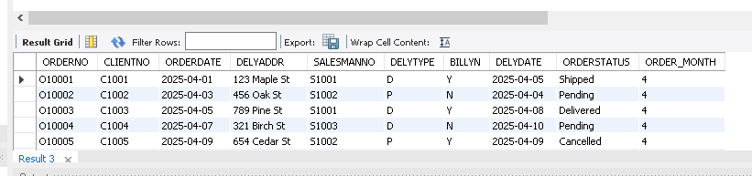

**# b.GROUP BY year/month.**

Select

year(ORDERDATE) as order_year,

month(ORDERDATE) as order_month,

count(*) as total_orders

from sales_order

group by

year(orderdate),

month(orderdate)

order by

order_year,order_month;

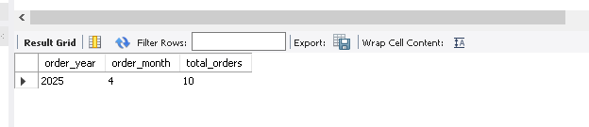

**#c.Use SUM() for revenue.**

select sum(revenue) as total_revenue from sales_order;

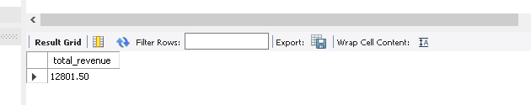

**#d.COUNT(DISTINCT order_id) for volume.**

select distinct ORDERNO from sales_order;

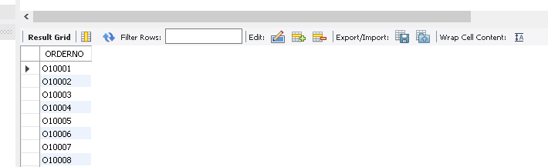

**#e.Use ORDER BY for sorting.**

select * from sales_order

order by revenue desc;

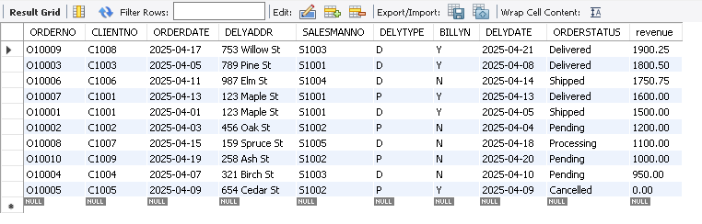

**#f.Limit results for specific time periods.**

SELECT *

FROM sales_order

WHERE DAY(ORDERDATE) < 10

ORDER BY revenue desc;

