1. Write a function that checks whether a given number is prime. Use a loop to test for factors, and return true or false based on the result.
2. package assignment_1;
3. import java.util.Scanner;
4. //1) Write a function that checks whether a given number is prime. Use a loop to test for factors,
5. //and return true or false based on the result.
6. public class Que_1 {
7. void prime(int a) {
8. int flag=0;
9. if(a==0 || a==1 || a<0) {
10. flag=0;
11. }
12. for(int i=2;i<a/2;i++) {
13. if(a==2) {
14. flag=1;
15. break;
16. }
17. else if(a%i==0) {
18. flag=0;
19. break;
20. }
22. else {
23. flag=1;
24. }
25. }
26. if(flag==0) {
27. System.***out***.println(a+" is not a prime number");
28. }
29. else if(flag==1){
30. System.***out***.println(a+" is a prime number");
31. }
32. }
33. public static void main(String[] args) {
34. // **TODO** Auto-generated method stub
35. System.***out***.println("Enter value to be checked as prime: ");
36. Scanner s=new Scanner(System.***in***);
37. int b=s.nextInt();
38. Que_1 q= new Que_1();
39. q.prime(b);
40. }
41. }

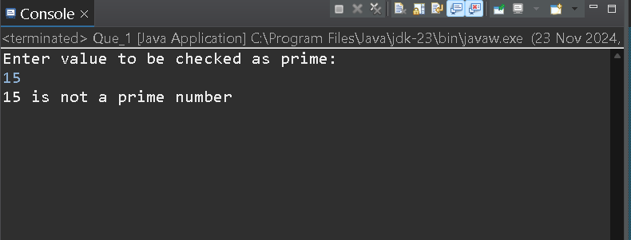

**2) Write a function that takes a student's score as an argument and returns a letter grade based on the following scale:**

**90-100: A**

**80-89: B**

**70-79: C**

**60-69: D**

**Below 60: F**

**Use if-else statements to determine the grade.**

package assignment_1;

//2) Write a function that takes a student's score as an argument and returns a letter grade based on the following scale:

//90-100: A

//80-89: B

//70-79: C

//60-69: D

//Below 60: F

//Use if-else statements to determine the grade.

import java.util.Scanner;

public class Que_2 {

void grade(float x) {

if(x>100 || x<0 ) {System.***out***.println("Invalid input. Student 's score should be >=0 and <=100.");}

else if(x>=89 && x<=100) {System.***out***.println("congratulations! You got grade A");}

else if(x>=79 && x<89) {System.***out***.println("congratulations! You got grade B");}

else if(x>=69 && x<=79) {System.***out***.println("congratulations! You got grade C");}

else if(x>=60 && x<69) {System.***out***.println("congratulations! You got grade D");}

else {System.***out***.println("Sorry. You failed in the exam. The Minimum criteria of score is >=60.");}

}

public static void main(String[] args) {

Scanner s=new Scanner(System.***in***);

System.***out***.print("enter student score: ");

float student_score=s.nextFloat();

Que_2 s1=new Que_2();

s1.grade(student_score);

}

}

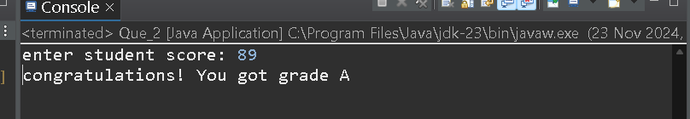

**Q 3 Create a function that takes an integer and returns the sum of its digits. Use a loop to extract each digit and perform the sum.**

package assignment_1;

import java.util.Scanner;

import java.lang.Math;

//Q 3 Create a function that takes an integer and returns the sum of its digits.

//Use a loop to extract each digit and perform the sum.

public class Que_3 {

void sumOfDigitsOfInteger(int x) {

int sum=0;

while(x>0) {

int digit=x%10;

System.out.println("The digit of the number: "+digit);

sum=sum+digit;

x=x/10;

}

while(x<0 && x>-2147483648) {

int digit=Math.abs(x%10);

System.out.println("The digit of the number: "+digit);

sum=sum+digit;

x=x/10;

}

System.out.println("The sum of digits of the number: "+sum);

}

public static void main(String[] args) {

try {

Scanner s=new Scanner(System.in);

System.out.println("Enter the inter number whose sum of digits to be found out: ");

int integer_input=s.nextInt();

Que_3 integer=new Que_3();

integer.sumOfDigitsOfInteger(integer_input);

}

catch(Exception e) {System.out.println("Error occured: "+e);}

}

}

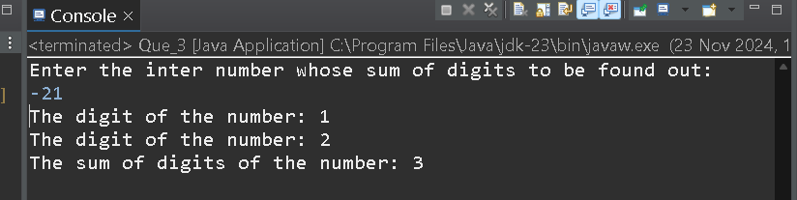

**Q 4 Write a function that takes an integer n and prints the multiplication table for that number (from 1 to 10) using a loop.**

package assignment_1;

import java.util.Scanner;

public class Que_4 {

void table_function(int n) {

for(int i=1;i<11;i++) {

System.***out***.println(n+" x "+i+"\t="+ n*i);

}

}

public static void main(String[] args) {

try {

Scanner s=new Scanner(System.***in***);

System.***out***.print("Enter number for table: ");

int number=s.nextInt();

Que_4 Table=new Que_4();

Table.table_function(number);

}

catch(Exception e) {

System.***out***.println("error is occures: "+e);

}

}

}

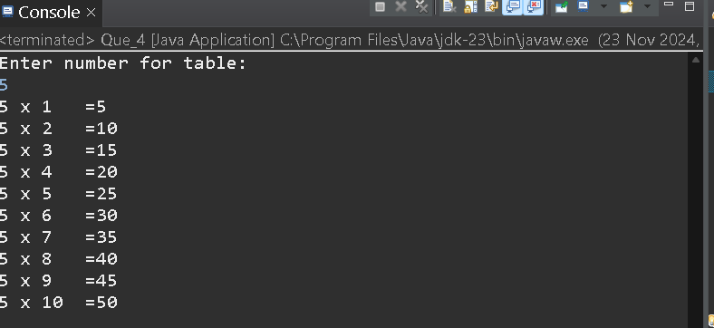

**5 Write a function that takes an array of integers and returns both the maximum and minimum values using a loop. Print the results in the main program.**

package assignment_1;

//5 Write a function that takes an array of integers and returns both the maximum and minimum values using a loop.

//Print the results in the main program.

public class Que_5 {

void minMax_function(int array[]) {

int min=array[0];

int max=array[0];

for(int i=0;i<array.length;i++) {

if(min>array[i]) {

min=array[i];

}

if(max<array[i]) {

max=array[i];

}

}

System.***out***.println("The minimum and maximum values of given array: "+min+","+max);

}

public static void main(String[] args) {

try {

int arr[]= {1,5,22,2,3,55,-1,76};

Que_5 a1=new Que_5();

a1.minMax_function(arr);

}

catch(Exception e) {System.***out***.println("Error: "+e);}

}

}

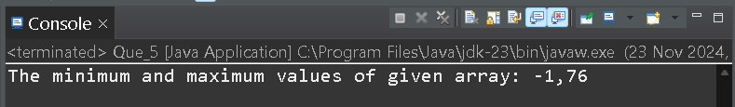

**6 Write a function that takes an 10 integer and returns the sum of all even and odd numbers**

package assignment_1;

//Q 6 Write a function that takes an 10 integer and returns the sum of all even and odd numbers

import java.util.Scanner;

public class Que_6 {

void sumEvenOdd_function(int array[]) {

int sumEven=0;

int sumOdd=0;

for(int i=0;i<array.length;i++) {

if(array[i]%2==0) {

sumEven+=array[i];

}

else {

sumOdd+=array[i];

}

}

System.***out***.println("Sum of even numbers and \n sum of odd mnumbers \n in the array are respectively :\n"+sumEven+" , "+sumOdd);

}

public static void main(String[] args) {

try {

int arr[]= {1,2,3,5,6,78,9,9,90,88};

Que_6 a1=new Que_6();

a1.sumEvenOdd_function(arr);

}

catch(Exception e) {System.***out***.println("Error: "+e); }

}

}

