//Q 1 Take two integers and as input, you have to compute x/y .

//If x and y are not integers or if is zero , exception will occur

//and you have to report it.

//Read sample Input/Output to know what to report in case of exceptions.

package com.Assignments;

import java.util.Scanner;

public class Assignment4_1 {

public static void main(String[] args) throws RaisingException {

try {

Scanner s=new Scanner(System.***in***);

System.***out***.print("Enter value of x: ");

int x=s.nextInt();

System.***out***.print("Enter value of y: ");

int y=s.nextInt();

if(x==0 && y==0) {

throw new RaisingException();

}

int z=x/y;

System.***out***.println("value of x/y: "+z);

}

catch (Exception e) {

System.***out***.println("error: "+e);;

}

}

}

package com.Assignments;

public class RaisingException extends Exception{

public RaisingException() {

System.***out***.println("error: x and y should not be zero.");

}

public static void main(String[] args) {

// **TODO** Auto-generated method stub

}

}

Enter value of x: 0

Enter value of y: 0

error: x and y should not be zero.

error: com.Assignments.RaisingException

Q 2)

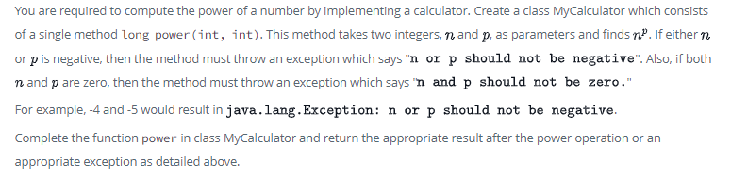

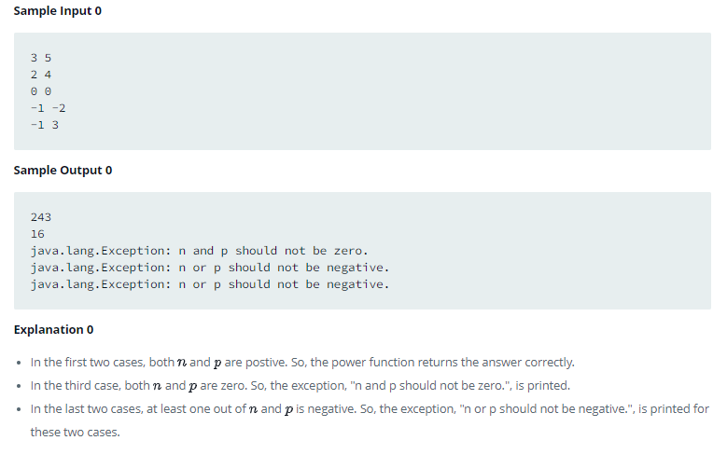

package com.Assignments;

import java.util.Scanner;

class MyCalculator {

public static long power(int n, int p) throws Exception {

if (n < 0 || p < 0) {

throw new Exception("n or p should not be negative");

} else if (n == 0 && p == 0) {

throw new Exception("n and p should not be zero");

}

long result = 1;

for (int i = 1; i <= p; i++) {

result *= n;

}

return result;

}

}

public class Assignment4_2 {

public static void main(String[] args) {

Scanner s=new Scanner(System.***in***);

MyCalculator c = new MyCalculator();

System.***out***.print("enter n: ");

int n=s.nextInt();

System.***out***.print("Enter p: ");

int p=s.nextInt();

try {

long result = c.*power*(n, p);

System.***out***.println("Result: " + result);

} catch (Exception e) {

System.***out***.println(e);

}

}

}

enter n: -1

Enter p: -3

java.lang.Exception: n or p should not be negative

//Q 3 Write a program for user defined Exception that checks the external and

//internal marks if the internal marks is greater than 40 it raise the exception

//internal mark is exceed, if the external mark is greater than 60 exception is

//raised and display the message the external marks is exceed,

//create the above exception and use it in your program.

package com.Assignments;

import java.util.Scanner;

class marks{

void check(float i,float e)throws Exception {

if(i>40) {

throw new Exception("internal mark is exceed 40");

}

else if(e>60) {

throw new Exception("external marks is exceed 60");

}

else {

System.***out***.println("Total marks: "+(i+e));

}

}

}

public class Assignment4_3 {

public static void main(String[] args) {

Scanner s=new Scanner(System.***in***);

marks m=new marks();

try {

System.***out***.print("enter internal marks: ");

float internal=s.nextFloat();

System.***out***.print("enter external marks: ");

float external=s.nextFloat();

m.check(internal, external);

}

catch (Exception e) {

System.***out***.println(""+e);

}

}

}

enter internal marks: 45

enter external marks: 62

java.lang.Exception: internal mark is exceed 40

//Q 4 Create a class Student with attributes roll no, name, age and course.

//Initialize values through parameterized constructor.

//If age of student is not in between 15 and 21 then generate user-defined

//exception “AgeNotWithinRangeException”.

//If name contains numbers or special symbols raise exception” NameNotValidException ”.

package com.Assignments;

import java.util.Scanner;

class Student{

Scanner s=new Scanner(System.***in***);

int rollNo;

String name;

int age;

String course;

Student(int rollNo,String name,int age,String course){

System.***out***.println("Enter rollNo: ");

rollNo=s.nextInt();

this.rollNo=rollNo;

System.***out***.println("Enter name: ");

name=s.next();

this.name=name;

System.***out***.println("Enter age: ");

age=s.nextInt();

this.age=age;

System.***out***.println("Enter course: ");

course=s.next();

this.course=course;

}

void display() {

System.***out***.println("rollNo: "+rollNo);

System.***out***.println("name: "+name);

System.***out***.println("age: "+age);

System.***out***.println("course: "+course);

}

void check(int age,String name) throws Exception{

if(age<=15 || age>=21) {

throw new Exception("AgeNotWithinRangeException");

}

if(name.matches("[a-zA-Z]+")) {

throw new Exception("ANameNotValidException");

}

}

}

public class Assignment4_4 {

public static void main(String[] args){

try{

int rollNo = 0;

String name = null;

int age=0;

String course = null;

Student s1=new Student(rollNo,name,age,course);

System.***out***.println(s1.age);

s1.display();

s1.check(s1.age,s1.name);

}

catch(Exception e) {System.***out***.println(e);

}

}

}

Enter rollNo:

1

Enter name:

$

Enter age:

15

Enter course:

p

15

rollNo: 1

name: $

age: 15

course: p

java.lang.Exception: AgeNotWithinRangeException

Q 5 Write a program to check all the three number entered by command line argument are greater than 10 , then print sum of those numbers . If any number is less then 10 then throw user defined exception “MyException” which print message number is lesser then 10 “

//Q 5 Write a program to check all the three number entered by command line argument

//are greater than 10 , then print sum of those numbers . If any number is less then

//10 then throw user defined exception “MyException” which print message

//number is lesser then 10 “

package com.Assignments;

import java.util.Scanner;

class GreaterThan10{

Scanner s=new Scanner(System.***in***);

public int[] num;

void setData(float num[]){

for(int i=0;i<3;i++) {

System.***out***.println("Enter numbers" );

num[i]=s.nextFloat();

}

}

void sum(float num[]) {

float s=0;

for(float x:num) {

s+=x;

}

System.***out***.println("Sum is: "+s);

}

}

public class Assignment4_5 {

public static void main(String[] args)throws RaisingException{

float num[]=new float[3];

GreaterThan10 g=new GreaterThan10();

try{

g.setData(num);

for(int i=0;i<3;i++) {

if(num[i]<10) {

throw new RaisingException(num[i]);

}

else {

}

}

g.sum(num);

}

catch(RaisingException e) {

System.***out***.println(e);

}

}

}

package com.Assignments;

public class RaisingException extends Exception{

public RaisingException() {

System.***out***.println("error: n and p should not be zero.");

}

public RaisingException(int p,int q) {

System.***out***.println("n or p should not be negative.");

}

public RaisingException(float n) {

System.***out***.println("number is lesser then 10");

}

}

Enter numbers

9

Enter numbers

10

Enter numbers

20

number is lesser then 10

com.Assignments.RaisingException

package com.Assignments;

public class Assignment4_6 {

Assignment4_6(){

this(10);

System.***out***.println("non parameterized constructor calling 1 parameter const");

}

Assignment4_6(int x){

this(6,7);

System.***out***.println("non parameterized constructor calling 2 parameter const");

}

Assignment4_6(int x,int y){

System.***out***.println(x*y);

}

public static void main(String[] args) {

// **TODO** Auto-generated method stub

new Assignment4_6();

}

}

42

non parameterized constructor calling 2 parameter const

non parameterized constructor calling 1 parameter const

Q 7 Write a program that define interface Admission having abstract method registration

Create another class Student in separate file having method Addstudent ()

1. In Addstudent create local class Mtech student that inherits Admission interface
2. In same method also create anonymous class that also inherits Admission interface

In both above classes implement registration method

In main call AddStudent method of student class.

// Q 8 Implement a Java program to read an integer from the user and

// calculate its square root. Handle the InputMismatchException

// if the user enters a non-integer value.

package com.Assignments;

import java.util.Scanner;

public class Assignment4_8 {

void square(int x) {

int y=x*x;

System.***out***.println("Square: "+y);

}

public static void main(String[] args) throws Exception{

Scanner s=new Scanner(System.***in***);

Assignment4_8 a=new Assignment4_8();

try {

System.***out***.println("enter integer: ");

int x=s.nextInt();

a.square(x);

}

catch(Exception e){System.***out***.println(e);}

}

}

enter integer:

h

java.util.InputMismatchException

//Q 9 Write a Java program to read an integer array from the user and calculate

//the average of its elements. Handle the InputMismatchException

//if the user enters a non-integer value.

package com.Assignments;

import java.util.Scanner;

class IntArray{

Scanner s=new Scanner(System.***in***);

void setData(int num[]){

for(int i=0;i<num.length;i++) {

System.***out***.println("Enter numbers" );

num[i]=s.nextInt();

}

}

void avg(int num[]) {

int s=0;

for(int x:num) {

s+=x;

}

double average=s/num.length;

System.***out***.println("Average is: "+average);

}

}

public class Assignment4_9 {

public static void main(String[] args){

int num[]=new int[3];

IntArray I=new IntArray();

try{

I.setData(num);

I.avg(num);

}

catch(Exception e) {

System.***out***.println(e);

}

}

}

Enter numbers

9

Enter numbers

6

Enter numbers

2.6

java.util.InputMismatchException

//Q 10 Develop a Java program to read a string from the user and convert it

//into an integer. Handle the NumberFormatException if the string cannot

//be converted to an integer.

package com.Assignments;

import java.util.Scanner;

public class Assignment4_10 {

void convert(String si) {

int stringInt=Integer.*valueOf*(si);

System.***out***.println("Converted to integer: "+stringInt);

}

public static void main(String[] args) {

Scanner s=new Scanner(System.***in***);

Assignment4_10 a=new Assignment4_10();

System.***out***.println("Enter string to be converted into Integer: ");

String input=s.next();

try {

a.convert(input);

}

catch(Exception e) {

System.***out***.println(e);

}

}

}

Enter string to be converted into Integer:

123ab

java.lang.NumberFormatException: For input string: "123ab"

//Q 11 You are tasked with implementing a Java program to manage bank accounts.

//Each bank account has an account number, balance, and account holder name.

//The program should support deposit, withdrawal, and balance inquiry operations.

//Input

//createAccount 123 John 1000

//deposit 123 500

//withdraw 123 200

//balance 123

//output

//Balance for account 123: 1300

package com.Assignments;

import java.util.Scanner;

class BankAccount1{

Scanner s=new Scanner(System.***in***);

static int *accountNumber*;

static String *name*;

static float *InitialbalanceAmount*;

static float *balanceAmount*;

void createAccount() {

System.***out***.println("Enter Account number of account holder: ");

*accountNumber*=s.nextInt();

System.***out***.println("Enter name of account holder: ");

*name*=s.next();

System.***out***.println("Enter initial balance: ");

*InitialbalanceAmount*=s.nextFloat();

}

void depositAmount() {

int choice=0;

System.***out***.println("Do you want to deposit(Enter 1 to deposit amount or other than 1 to exit): ");

choice=s.nextInt();

if(choice==1) {

System.***out***.println("Enter Amount to be deposited: ");

*balanceAmount*=s.nextFloat()+*InitialbalanceAmount*;

System.***out***.println("Balance Amount after deposit: "+*accountNumber*+" "+*balanceAmount*);

}

}

void withdrawAmount() {

int choice=0;

System.***out***.println("Do you want to withdraw (Enter 1 to withdraw amount or other than 1 to exit): ");

// System.out.println("Balance Amount after withdrawal: "+accountNumber+" "+balanceAmount);

choice=s.nextInt();

if(choice==1) {

System.***out***.println("Enter Amount to be withdrawn: ");

float withdraw=s.nextFloat();

if(withdraw<=*balanceAmount*) {

*balanceAmount*-=withdraw;

System.***out***.println("Balance Amount after withdrawal: "+*accountNumber*+" "+*balanceAmount*);

}

else {

System.***out***.println("You can not withdraw more than Balance Amount. ");

}

}

}

void accountDetailsDisplay() {

System.***out***.println("Account details of account holder: "+*accountNumber*+" "+*balanceAmount*);

}

}

public class Assignment4_11 {

public static void main(String[] args) {

BankAccount1 b1= new BankAccount1();

b1.createAccount();

b1.depositAmount();

b1.withdrawAmount();

b1.accountDetailsDisplay();

}

}

Enter Account number of account holder:

123

Enter name of account holder:

john

Enter initial balance:

1000

Do you want to deposit(Enter 1 to deposit amount or other than 1 to exit):

1

Enter Amount to be deposited:

500

Balance Amount after deposit: 123 1500.0

Do you want to withdraw (Enter 1 to withdraw amount or other than 1 to exit):

1

Enter Amount to be withdrawn:

200

Balance Amount after withdrawal: 123 1300.0

Account details of account holder: 123 1300.0