/*Q 1 Given pairs of rectangles, where each pair denotes the length and breadth of the rectangle. The task is to return the maximum area of the rectangle.

N = 3

rect[] = {{1,2},{3,4}, {5,6}}

30

1. Total area of Rect. 1 = 1 * 2 = 2

2. Total area of Rect. 2 = 3 * 4 = 12

3. Total area of Rect. 3 = 5 * 6 = 30

4. Out of all rectangles, Rectangle 3 has the maximum area.

Your task is to complete the function () which returns maximum area. Use () function in Rectangle class.*/

import java.util.Scanner;

class Rect{

    int size;

    Scanner sc=new Scanner(System.in);

    void rectang(){

        Scanner sc=new Scanner(System.in);

        System.out.print("enter number of rectangles: ");

        int size= sc.nextInt();

        int rect[][]=new int[size][size];

        int area[]=new int[size];

    for(int i=0;i<size;i++) {

        System.out.print("enter length of rectangles-"+(i+1)+": ");

        int length= sc.nextInt();

        System.out.print("enter breadth of rectangles-"+(i+1)+": ");

        int breadth= sc.nextInt();

        rect[i][0]=length;

        rect[i][1]=breadth;

        area[i]=length*breadth;

    }

    for(int i=0;i<size;i++) {

            System.out.println("Area of rectangle-"+ (i+1)+" :"+area[i]);

        }

    int max=0;

    int index=0;

    for(int i=0;i<size;i++) {

        if(max<area[i]) {

            max=area[i];

            index=i+1;

    }

    }

    System.out.println("Out of all rectangles, Rectangle "+index+ " has the maximum area= "+max);

}

    public static void main(String[] args) {

        Rect r1=new Rect();

        r1.rectang();

    }

}

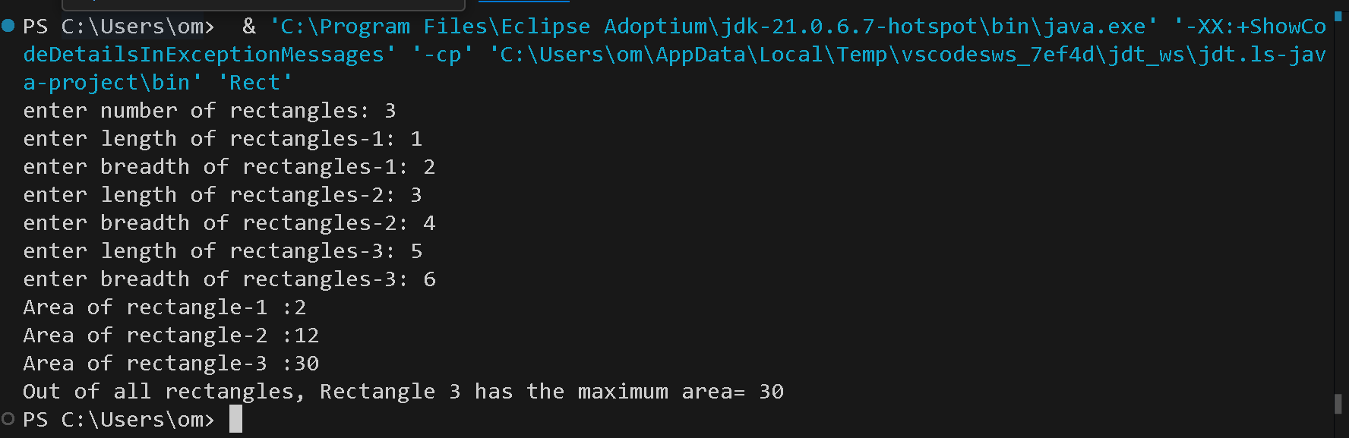

**/*Q 2 Create a class named Student with the following attributes:**

**1)      name (String): to store the name of the student.**

2)      id (int): to store the student ID.

3)      grade (double): to store the grade of the student.

Implement a constructor to initialize these attributes

è In the main method, create an array named studentArray that can hold up to 10 Student objects.

è Initialize the studentArray array with different Student objects. You can use fictional student data for this.

è Write a method named displayStudents that takes the studentArray array as a parameter and displays the details of each student in the array.

è Write a method named sortStudents that takes the studentArray array as a parameter and sorts the array based on the grades of the students

in ascending order. You can use any sorting algorithm of your choice (e.g., bubble sort )*/

import java.util.Scanner;

class Student{

    String name="s1";

    int id=0;

    double grade=0.0;

    Student(String name,int id,double grade){

        this.name=name;

        this.id=id;

        this.grade=grade;

    }

    public static void display(Student s[]){

        for(int i=0;i<10;i++){

            System.out.println("name: "+s[i].name+ " id: "+s[i].id+" grade: "+s[i].grade);

        }

    }

}

public class Q2{

public static void main(String[] args) {

    Scanner sc=new Scanner(System.in);

    String name="a";int id=0;double grade=0.0;

    Student[] s=new Student[10];

    for(int i=0;i<10;i++){

        System.out.println("enter student-"+(i+1) + " name: ");

        System.out.println("enter student- "+(i+1) + " id: ");

        System.out.println("enter student grade- "+(i+1) + ": ");

        s[i]= new Student(sc.next(),sc.nextInt(),sc.nextDouble());

    }

    System.out.println("Before sorting: ");

    for(int i=0;i<10;i++){

        System.out.println("name: "+s[i].name+ " id: "+s[i].id+" grade: "+s[i].grade);

    }

    for (int i = 0; i < s.length - 1; i++) {

        for (int j = 0; j < s.length - 1 - i; j++) {

            if (s[j].grade > s[j + 1].grade) {

                // Swap the students if they are in the wrong order

                Student temp = s[j];

                s[j] = s[j + 1];

                s[j + 1] = temp;

            }

        }

    }

    System.out.println("After sorting: ");

    for(int i=0;i<10;i++){

        System.out.println("name: "+s[i].name+ " id: "+s[i].id+" grade: "+s[i].grade);

    }

}

}

**Output:**

Before sorting:

name: a id: 1 grade: 10.0

name: b id: 2 grade: 30.0

name: c id: 3 grade: 40.0

name: d id: 4 grade: 10.0

name: e id: 5 grade: 5.0

name: f id: 6 grade: 6.0

name: g id: 7 grade: 77.0

name: h id: 8 grade: 8.0

name: i id: 9 grade: 25.0

name: j id: 10 grade: 1.0

After sorting:

name: j id: 10 grade: 1.0

name: e id: 5 grade: 5.0

name: f id: 6 grade: 6.0

name: h id: 8 grade: 8.0

name: a id: 1 grade: 10.0

name: d id: 4 grade: 10.0

name: i id: 9 grade: 25.0

name: b id: 2 grade: 30.0

name: c id: 3 grade: 40.0

name: g id: 7 grade: 77.0

**/*Q 3 Write a Java class Car with the following attributes: make, model, year, and color.**

Implement a constructor that initializes these attributes when an object of the Car

class is created. Write a main method to create an instance of Car and display its attributes.

Enhance the Car class from the previous question by adding a parameterized constructor that

takes values for make, model, year, and color as arguments.

 Demonstrate the use of this constructor in the main method*/

class Car{

    String make; String model; int year; String color;

    Car(){

        this.make=make;

        this.model=model;

        this.year=year;

        this.color=color;

    }

    Car(String make,String model,int year,String color){

        this.make=make;

        this.model=model;

        this.year=year;

        this.color=color;

    }

    void display(Car c){

        System.out.println("car make: "+c.make+" ,model: "+c.model+ ", year:  "+year+" and color: "+c.color);

    }

}

public class Q3 {

    public static void main(String[] args) {

        String make="tata"; String model="tiago"; int year=2012; String color="white";

        Car c1=new Car();

        c1.make=make;

        c1.model=model;

        c1.year=year;

        c1.color=color;

        c1.display(c1);

        Car c2=new Car("maruti","swift",2015,"red");

        c2.display(c2);

    }

}

**OutPut:**

car make: tata ,model: tiago, year: 2012 and color: white

car make: maruti ,model: swift, year: 2015 and color: red