TFLiteTraining App Manual: Car License Project (3-Char)

A) Objective & Briefing:
1. To get familiar with the TFLiteTraining desktop app.
2. To collect character samples, preprocess images with ROI and Darkness/Luminosity thresholds, and train an AI model.
3. To test 3-character car license / sign recognition (🟢 YES — MATCH / 🔴 NO — NOT MATCH) and export the trained model.
Briefing:
In this task, you will learn how to train and export a TensorFlow Lite model through data collection, image preprocessing, model training, and performance preview. Specifically, you will train a model that can read a 3-character car license / sign in sequence (such as A 1 2) and tell you whether the sign in front of the camera matches your target (🟢 YES — MATCH or 🔴 NO — NOT MATCH). Please remember to save your project regularly (File ▾ → Save) to avoid losing your work.

1. Opening the Project & the Four Main Areas
Open the app. On the Start Page, find the 🚗 Car License Project card and click Get Started to start a new project, or click Open Project (.tmproj) to open a saved template/project file.
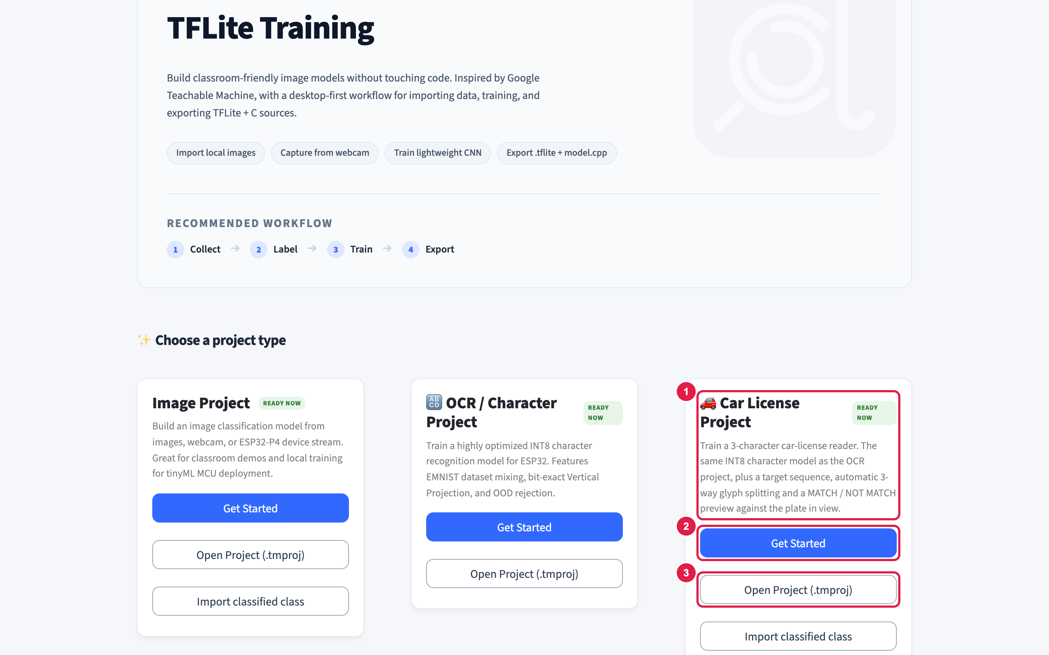
Figure 1 — Start Page: choose the 🚗 Car License Project card.
After opening the project, you will see four main areas:
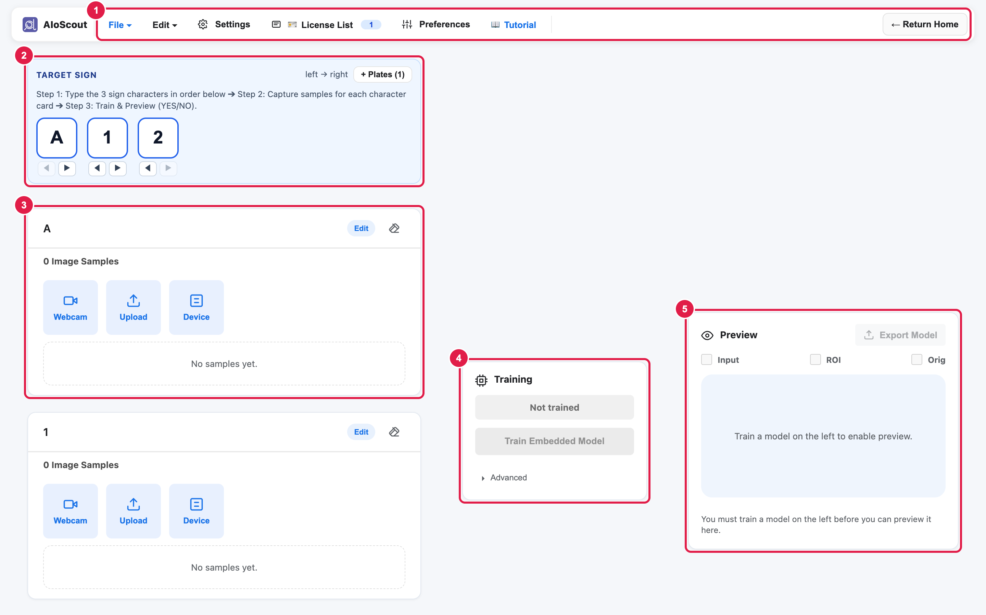
Figure 2 — The workspace: the four main areas.
- Target Sign Bar (Top Left) – for typing the 3 letters or numbers on your car license in order (e.g., A, 1, 2).
- Sample Area (Left) – for collecting and preprocessing single-character photos for each character card.
- Train Area (Middle) – for training the AI model by adjusting hyperparameters.
- Preview Area (Right) – for testing the trained model on a 3-character sign and checking the 🟢 YES / 🔴 NO result.

2. Sample Area — Part A: Setting the Target License & Collecting Samples
Setting the Target License (single plate):
- Click each of the three boxes in the Target Sign Bar and type your 3 characters (for example, A, 1, 2). Use the ◀ / ▶ buttons beneath a slot to swap neighbouring characters.
- If your license uses the same character twice (like A 1 A), the app automatically keeps just one A card with a “Slots 1 & 3” badge so you only need to collect samples for A once!
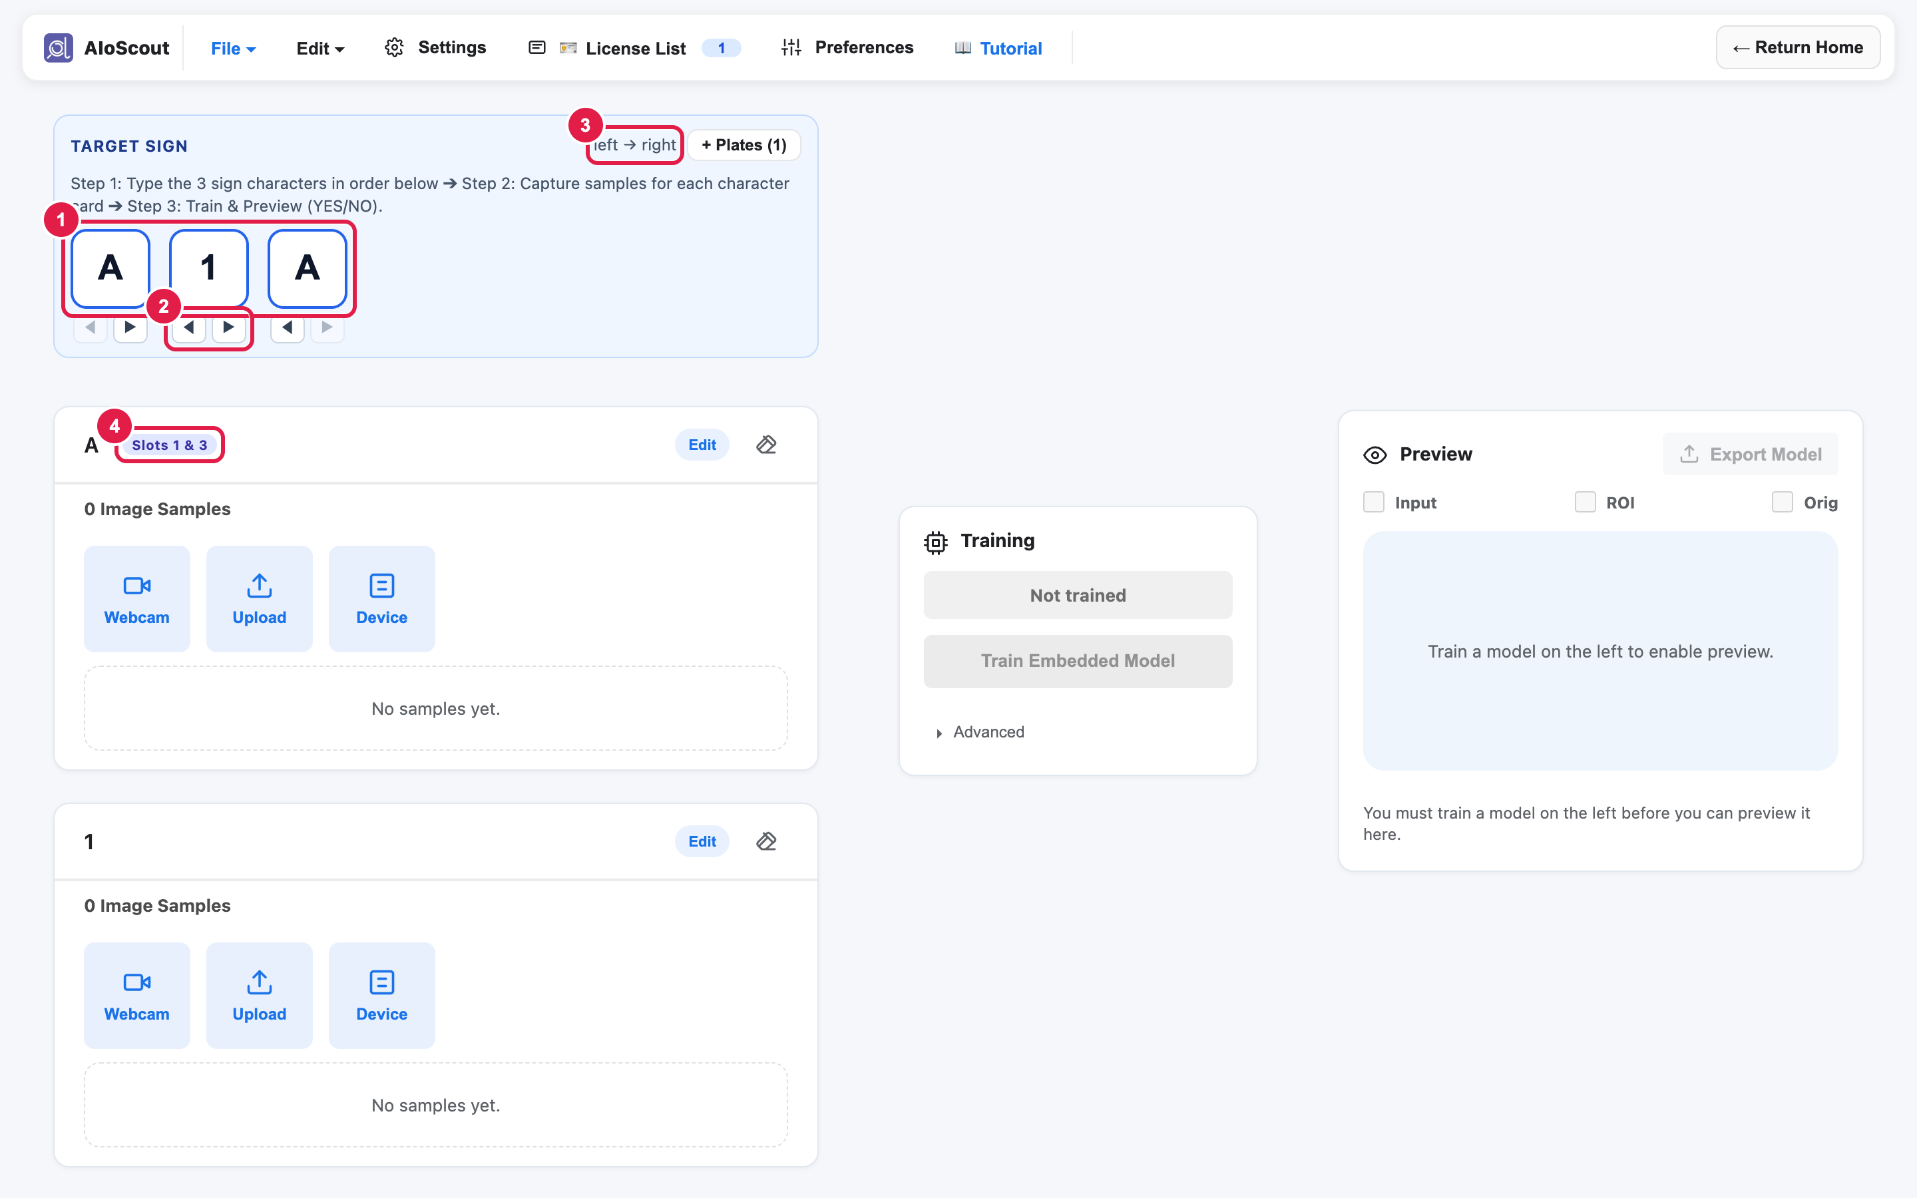
Figure 3 — The Target Sign Bar: typing characters, the ◀ / ▶ swap buttons and the duplicate-character badge.
Want your AI “gatekeeper” to accept more than one license plate?
- Click the 🪪 License List button next to ⚙ Settings in the top bar and add several allowed plates — for example both A 1 2 and B 1 8!
- The app automatically combines the unique letters/numbers of all your plates into the Sample Area cards, so a repeated character like 1 is only collected once.
- In Preview, the app shows 🟢 YES — MATCH whenever ANY plate on your allowed list is seen!
Collecting Samples for Each Character Card:
💡 Key rule: one card = one character
Each character card collects photos of ONE single letter/number (not the whole 3-character license at once). This way the AI learns each character separately, and during Preview the app slices the whole license into 3 boxes and checks each one by itself.

- Click “Webcam” — uses your laptop or USB camera. Capture single photos by clicking “Capture”, or take photos continuously by holding “Hold to Capture” (or holding the Space bar). Click “Close” to fold the panel.
- Click “Upload” — choose one or more image files from your computer.
- Click “Device” — captures images streamed from the smart car camera over USB serial (select the serial port in ⚙ Settings).
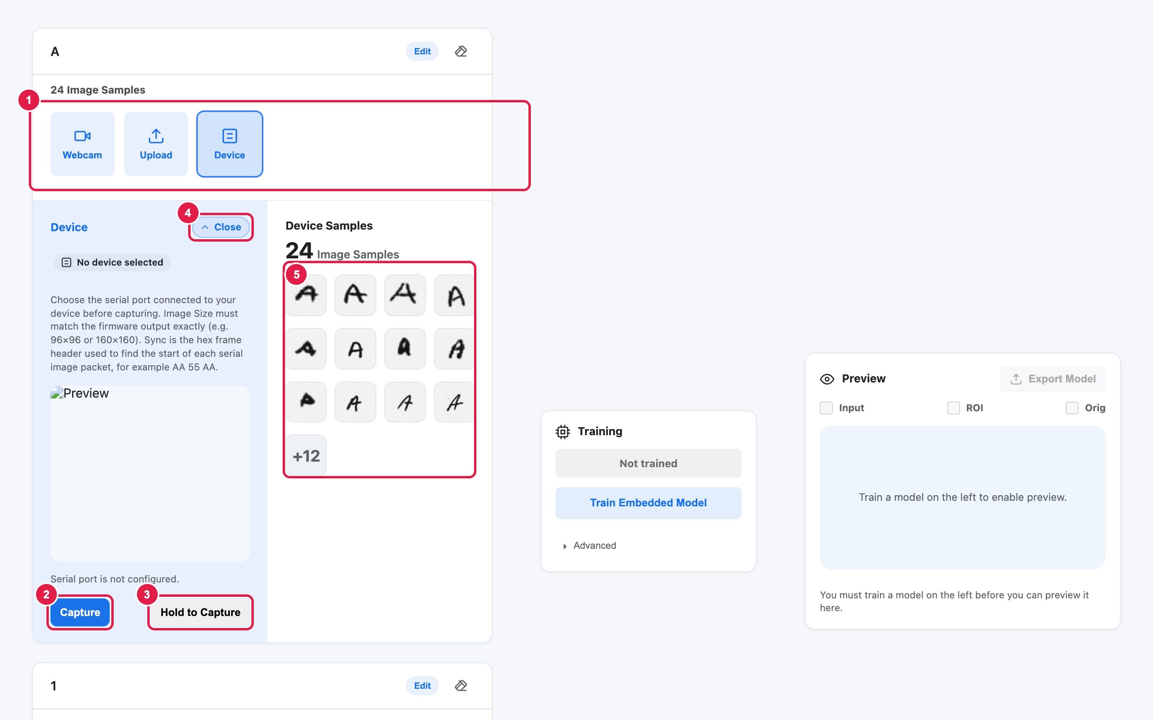
Figure 4b — The capture drawer on a character card: Webcam / Upload / Device tiles, Capture / Hold to Capture and Close.
- Quick Auto-Fill Option (⚙ Settings): If you want to test the software right away without a camera, click ⚙ Settings in the top bar, expand ▸ Advanced Settings, and check Auto-fill empty classes with EMNIST template samples (24 / class) (or click Fill Empty Classes with EMNIST Samples Now), then click Save changes. Each empty character card immediately gets 24 handwriting samples!
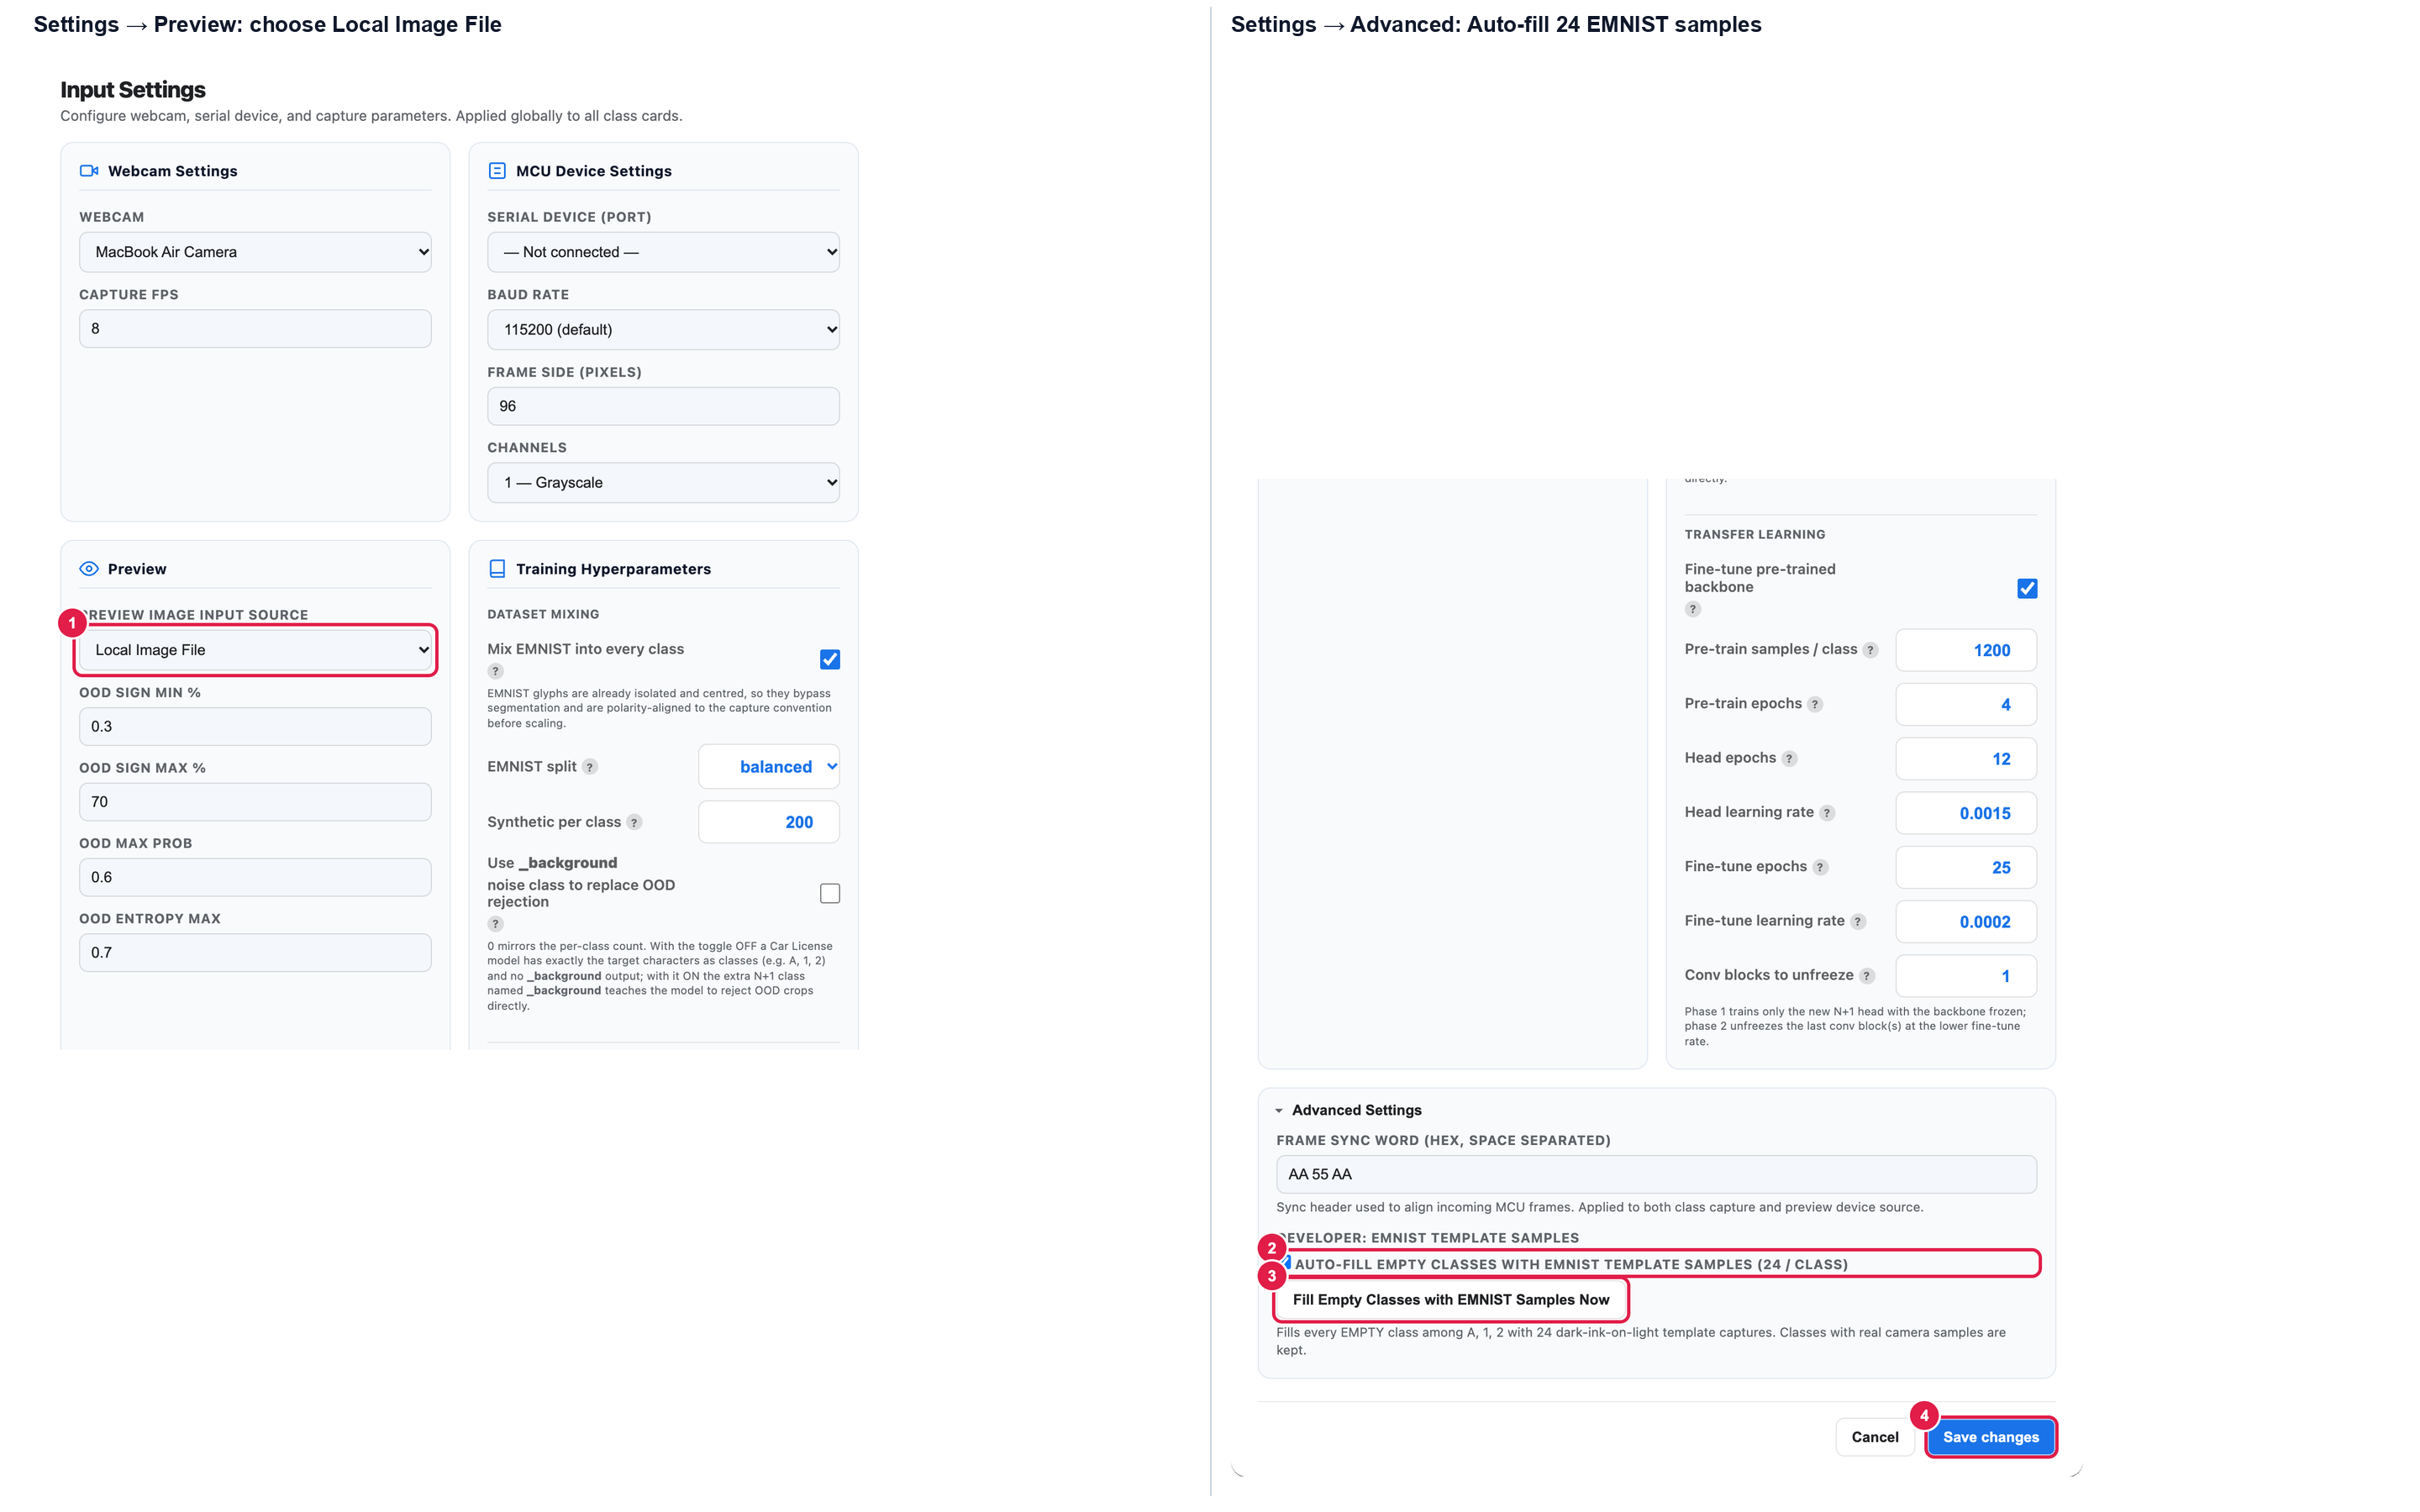
Figure 4a — ⚙ Settings: the Auto-fill 24 EMNIST samples option (left: Preview source, right: Advanced Settings).

3. Sample Area — Part B: Preprocessing the Samples (Edit Page)
On each character card header there are small icons: the Edit button opens the image processing page, and the eraser icon clears all the samples on that card.
The “Edit” page is composed of two parts: Image Viewer (Left) and Sample Worktable (Right):
- In the Image Viewer, we can see two images: Original Sample and Processed Preview.
- For the Original Sample: A green (Auto) or blue (Manual ROI) ROI (Region of Interest) box is shown. This ROI defines the area that will be cropped and passed for further processing.
- For the Processed Preview: Pixels in the original image whose brightness falls below the Darkness Threshold (Dark Thr) or above the Luminosity Threshold (Lum Thr) are converted to pure white (Brightness: 255), leaving the dark character cleanly isolated on a white background.
- In the Sample Worktable, you can adjust the parameters to fine-tune the processing effect and minimize background noise:
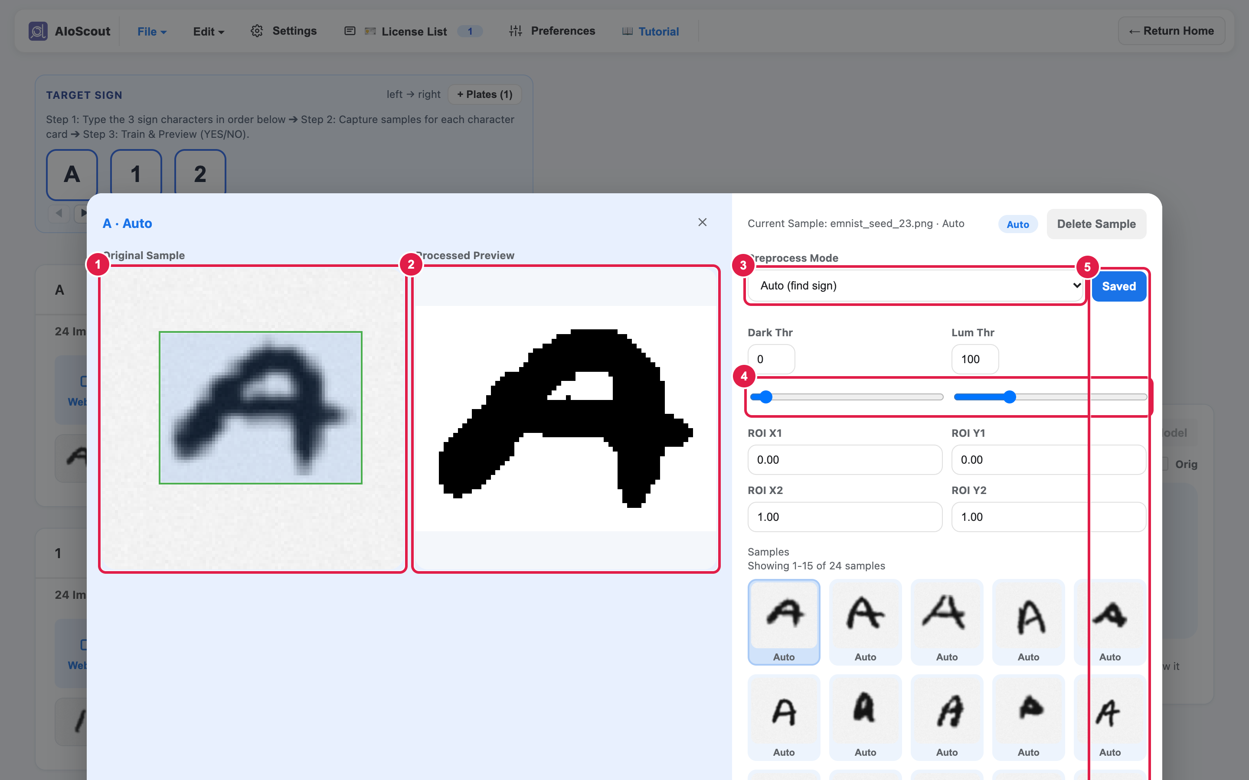
Figure 5 — The Edit page: Image Viewer (left) and Sample Worktable (right), with the dark letter on a pure white (255) Processed Preview.
Parameter | Effects
Preprocess Mode | 1. Auto (find sign): automatically finds and crops the character in the image. 2. Manual ROI: crop the ROI manually by dragging your mouse on the original image.
Dark Thr (Darkness Threshold) | Any pixel whose brightness is less than Dark Thr turns into pure white (255).
Lum Thr (Luminosity Threshold) | Any pixel whose brightness is greater than Lum Thr turns into pure white (255).
ROI X1, Y1, X2, Y2 (Only for Manual ROI usage) | The relative position (0.00 to 1.00) of the top-left (X1, Y1) and bottom-right (X2, Y2) corners of the crop box.
Keyboard shortcuts:
- Arrow keys — select the sample you want to process or check (move to the next/previous sample).
- Shift + Arrow keys — move the ROI box in Manual ROI mode.
- F1 — choose Auto preprocess mode. F2 — choose Manual ROI mode.
- D — delete the sample. Esc — exit the “Edit” view. S — save the change.
Please remember to save after any changes!

4. Train Area — Setting Hyperparameters & Training
Next, move to the Train Area. After image processing is complete, click ▸ Advanced to view or adjust the training hyperparameters. Below is the table for each hyperparameter:
About the Image Size: even if the smart-car camera captures frames at 160×160 (set in ⚙ Settings), the app automatically scales every camera frame to match the model's input size — 96×96 for the picture preprocessing and 28×28 for each character slot. The exported model carries its img_size with it (in model_settings.h), so the car always scales the camera frames to exactly the size the model was trained on.
# | Hyperparameter | Default | Range | What it does
1 | Ink Polarity | 0 — Dark ink on bright bg | 0 / 1 | Which way round your letters are: normal dark-on-light writing (0), or bright letters on a dark sign (1).
2 | Sign Reading Direction | Left to Right | L ➔ R / R ➔ L | The order the app reads the three boxes of your sign.
3 | Image Size | 28 | 8–512 | How many pixels wide the small letter picture is. 28×28 fits one letter perfectly — leave it. Whatever the camera sends (even 160×160), the app scales it to this size automatically.
4 | Batch Size | 32 | 1 or more | How many photos the AI practices with in one go.
5 | Epochs | 20 | 1 or more | How many times the AI reads through all your photos. For this project the app follows its own smart two-phase plan.
6 | Validation Split | 0.25 | 0–0.5 | The part of your photos kept secret for testing.
7 | Learning Rate | 0.0016 | 0 or more | How big each learning step is. Small steps = careful but slow.
8 | Mix EMNIST into every class | On | on / off | Mixes built-in handwriting examples with your photos so the AI learns from more variety.
9 | Use _background noise class to replace OOD rejection | Off | on / off | Default is Off for the Car License Project so the AI focuses purely on your 3 characters and uses standard OOD/confidence checks; turn On only if you want an extra “no letter” class to replace OOD.
10 | Fine-tune pre-trained backbone | On | on / off | Starts from a smart pre-learned letter reader so your model trains fast and accurately even with just 20 photos!
What to do, step by step:
1. Click 💡 Use recommended to automatically fill in recommended settings for your dataset size.
2. Click Train Embedded Model and wait for training to finish.
3. Click Model Trained · tap for accuracy to view the per-class accuracy popup.
4. If you change the target characters later, a ⚠ Stale badge reminds you to click Train Embedded Model again.
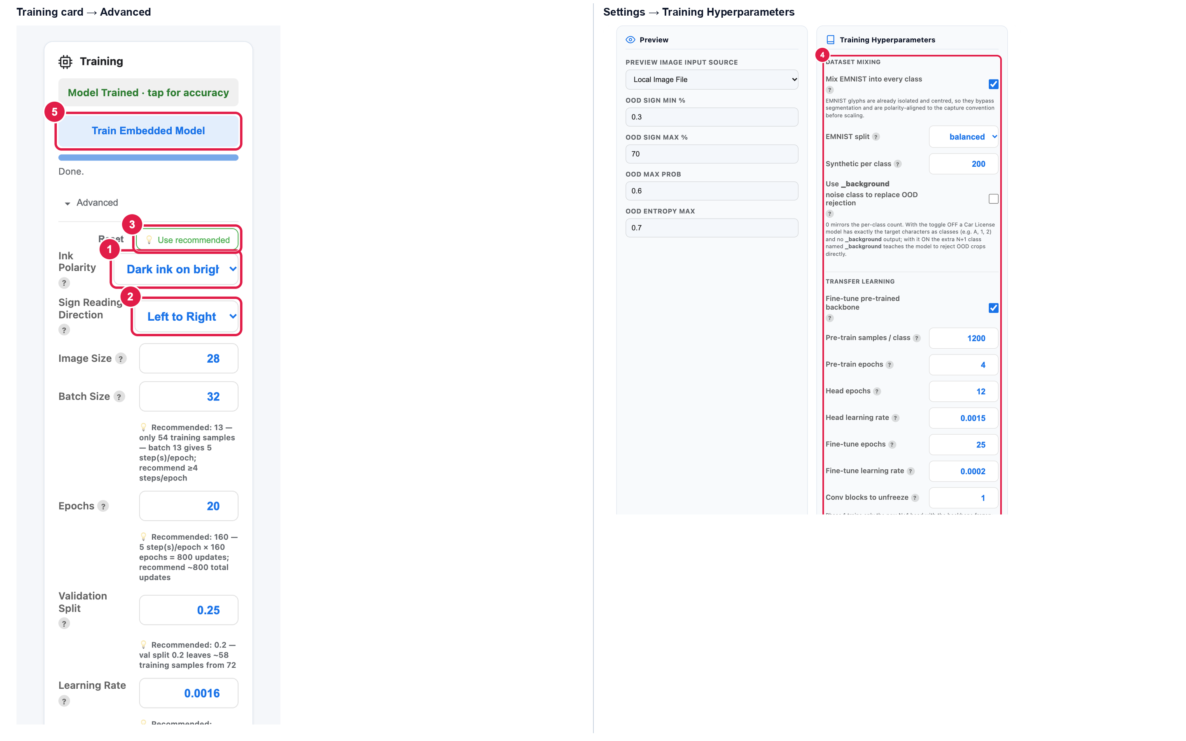
Figure 6 — The Train Area → Advanced (left) and ⚙ Settings → Training Hyperparameters (right).

5. Preview Area — Testing 3-Slot Matching & Exporting
Select the Preview Image Input Source in ⚙ Settings → Preview:
- Device (MCU) — live pictures from the smart car camera.
- Webcam — your laptop camera.
- Local Image File — for uploaded images and the 3 quick-test buttons 🧪 Synth Match, 🔀 Synth Reversed, ❌ Synth Mismatch.
The toggles and sliders on the Preview card:
- Toggle Input ON to start live prediction.
- Toggle ROI: when unchecked, it shows the full image with the green ROI box drawn on it; when checked, it zooms in to show only the cropped image inside the ROI box.
- Toggle Orig: switches between the threshold-cleaned black-on-white view and the original raw grayscale image.
- Dark / Lum sliders: adjust brightness thresholds live so the sign letters stand out cleanly on a white background.
Reading the 3-Slot Sign Match Output:
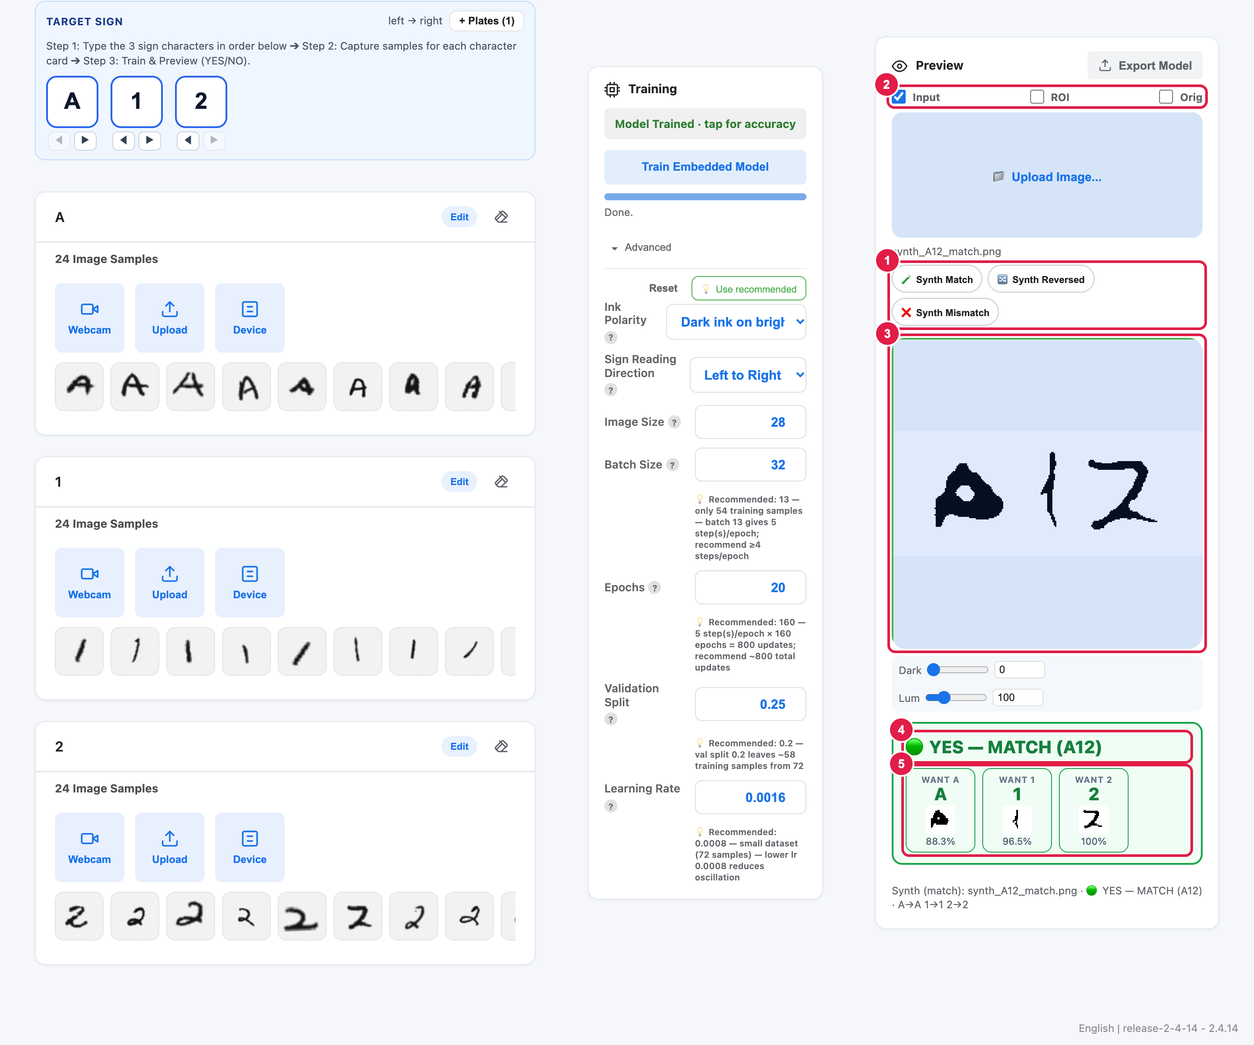
Figure 7a — 🧪 Synth Match: all three slots agree → 🟢 YES — MATCH.
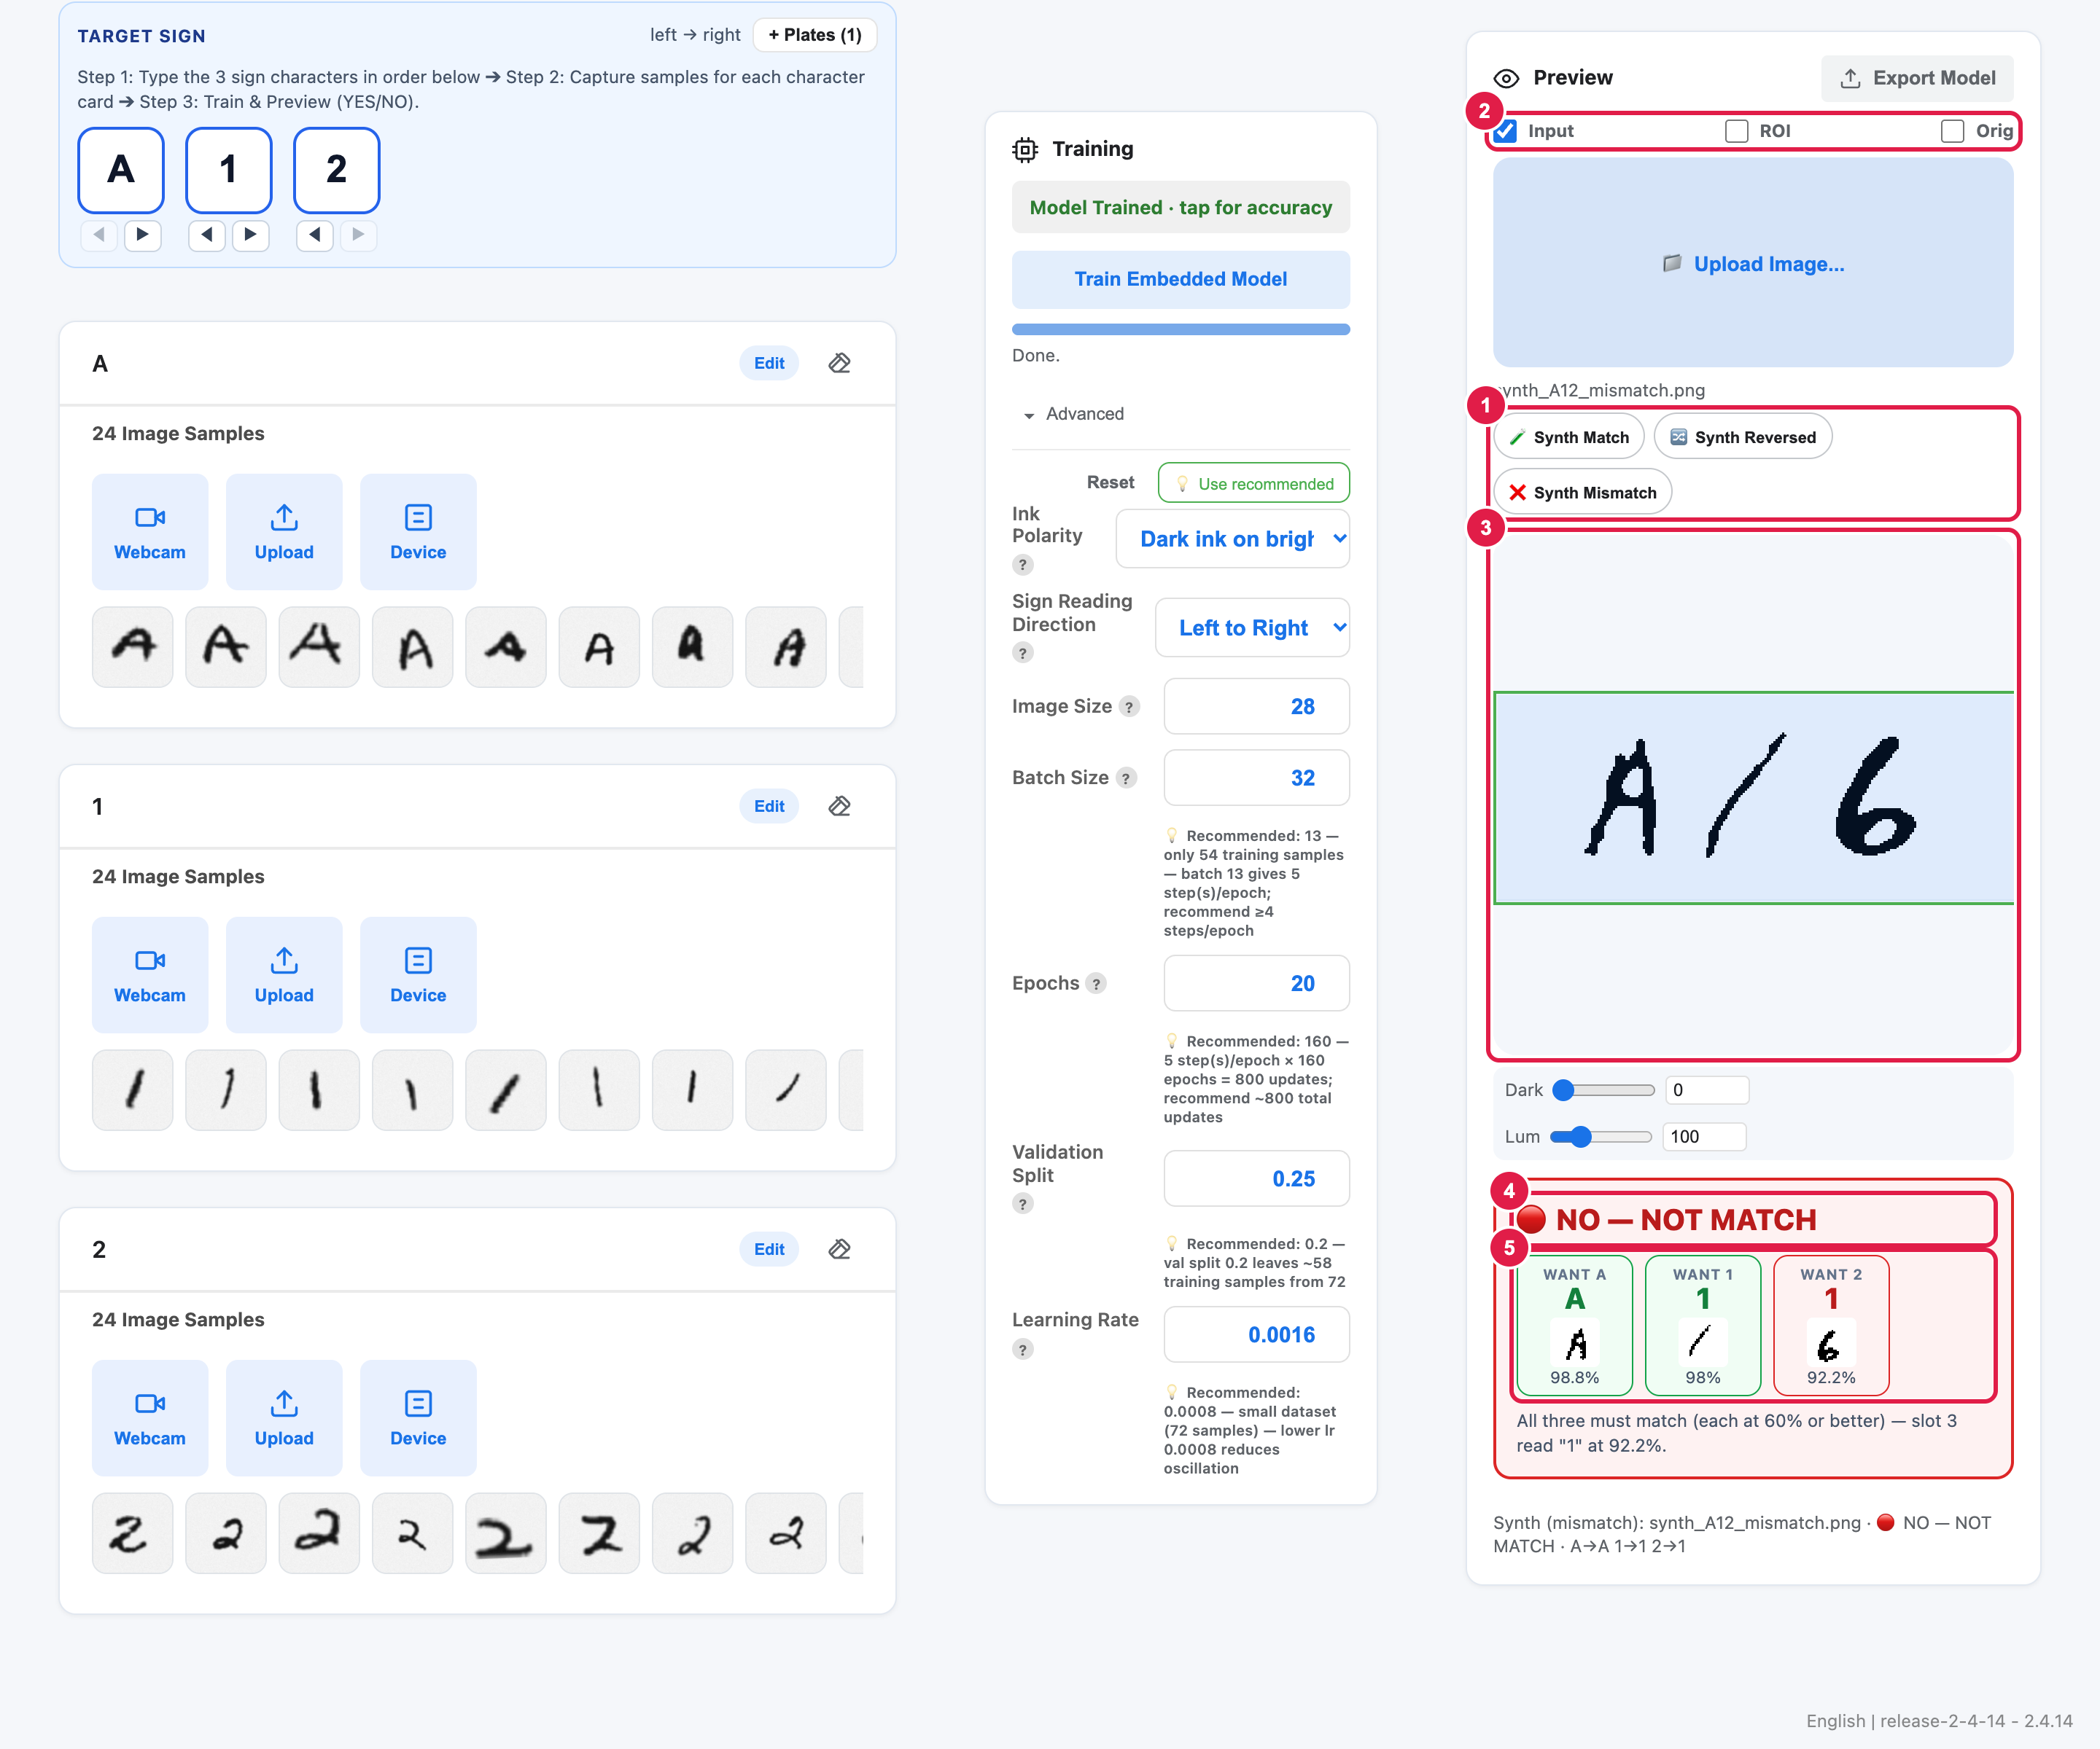
Figure 7b — ❌ Synth Mismatch: one slot disagrees → 🔴 NO — NOT MATCH.
- The app slices the detected license horizontally into 3 character slots in your chosen reading direction.
- Each slot card shows WANT <character>, the character read by the AI, the 28×28 image fed to the model, and the confidence percentage (%).
- When all 3 slots match your target characters with at least 60% confidence, the banner turns green: 🟢 YES — MATCH. If any slot reads a different character, is below 60%, or is blank (_background), the banner turns red: 🔴 NO — NOT MATCH and explains which slot failed.
Exporting the Model & Saving Your Project:
- Click Export Model at the top-right of the Preview card to export the C/C++ model files (tm_model_data.cpp/.h, model_resolver.h, model_settings.cpp/.h, tm.tflite, labels.txt).
- The export packs in everything the car needs: the trained weights, the img_size scaling parameters, the _background / OOD settings, and the full list of your allowed license plates — all into model_settings.h. When the car sees a plate, the ESP32-P4 checks it against the list and tells the ESP32-S3 which specific plate number matched!
- Click File ▾ → Save (or Save as) at the top-left menu to save your project as a .tmproj file.
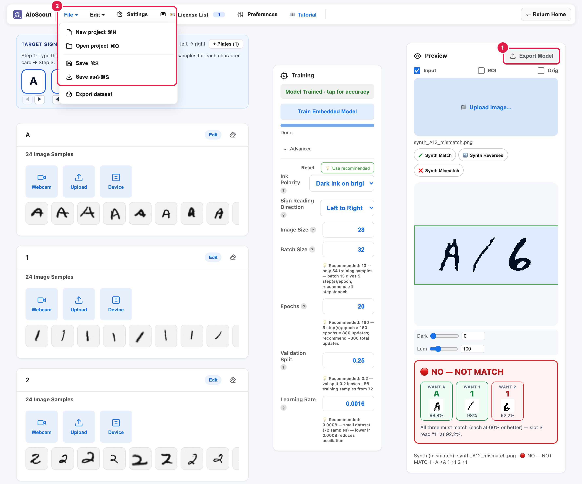
Figure 8 — Export Model on the Preview card and File ▾ → Save / Save as.
That's it — you collected letters, trained an AI to read them, tested a whole license, and exported your model. Well done!

