Edge AI Vision Workshop — Project Lab Manual
Project objective: train a digit recognizer (0–9) and run it on the ESP32-P4. Work through the steps in order; each required action is written out. The project is designed for 75–90 minutes. If the software behaves differently from what this manual describes, consult an instructor before continuing.
0. The Project at a Glance
Objective — train a CNN that recognizes handwritten digits 0–9 presented on paper, and runs live on the ESP32-P4 board.
Success criteria (assessed at the final demonstration):
- The model is deployed on the board and classifies live camera images
- It classifies at least 8 of 10 digits correctly on a set of unseen test digits written by someone other than the team
- The team can explain one change made to improve the model and its observed effect
Rules — the model must be trained in this session, using samples collected in this session. Pre-trained networks are not permitted.
Workflow (identical to the road-sign demonstration in the lesson): Collect → Preprocess → Train → Test → Iterate → Export → Deploy.
Provided Materials
The following kit is provided to each team. Verify it against this list before starting Part A.
# | Item | Purpose
1 | Smart car | The robot car carrying the ESP32-P4 board and camera module — the platform used for training and deployment
2 | Map | The AIoScout playfield map — the surface on which the car and the road signs are set up
3 | Road sign stand | Stand with 3 changeable signs, used in the lesson demonstration
4 | USB-C data cable | Connects the board to the laptop for programming and image transfer
5 | Batteries ×2 | Power for the smart car

Thick markers and blank paper for writing the digits in Part C are also provided.
Teams bring only a laptop with the pre-lab software installed (see the pre-lab manual).
Part A — Setup Verification (5 min)
With the pre-lab installation complete, this part requires only a few minutes.
A1. Connect the board with the USB-C cable.
A2. In the Arduino IDE, select Tools → Board → ESP32_mannual → ESP32P4 Dev Module, and enter the board settings provided by the instructor (leave the Port unset at this stage).
A3. Open the provided camera-stream sample sketch, select the Port, and click Upload.
A4. Open the Serial Monitor. A continuous stream of garbled characters is the binary camera data; it indicates a successful upload.
A5. Close the Serial Monitor. The Serial Monitor occupies the port that the TFLiteTraining application requires. (A "port busy" error in the application later in the session is caused by leaving it open.)
Part B — Create the Project (3 min)
B1. Open the TFLiteTraining application → Open Project → template.tmproj.
B2. Save an independent copy immediately: top-left menu → Save Project → name it digits.tmproj. Save the project at regular intervals from this point onward.
B3. Note the three areas of the workspace: Sample (left), Train (right), Preview (bottom).
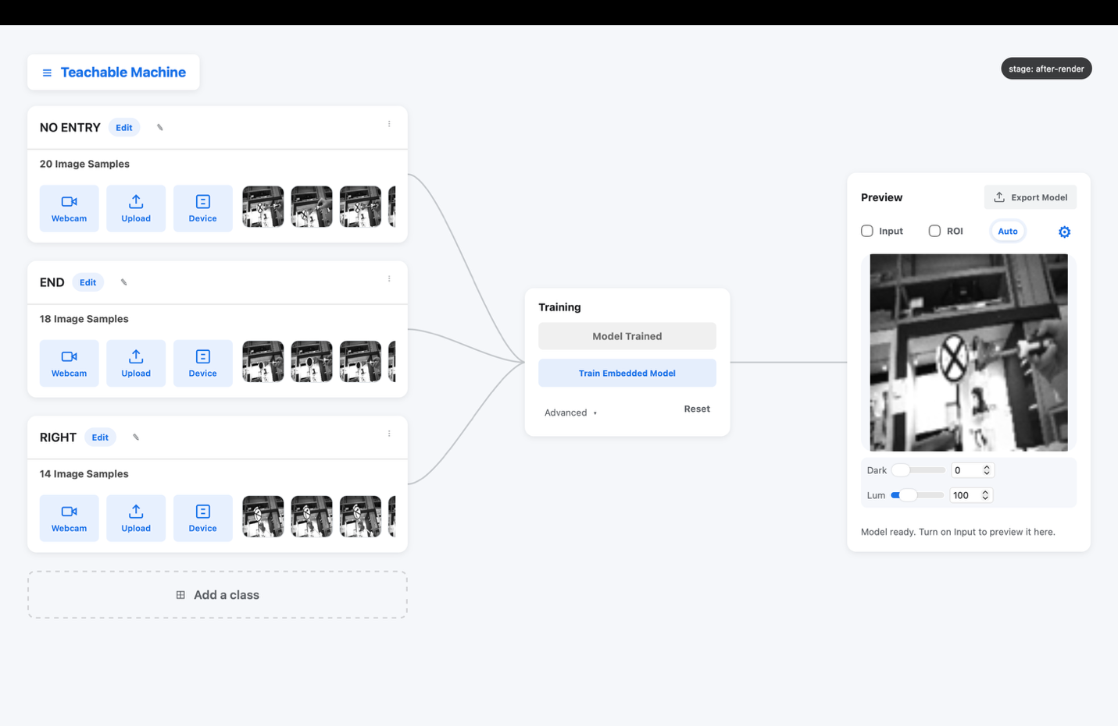
The three areas of the workspace
Part C — Collect the Data (20 min)
The dataset is the single largest factor in the quality of the final model. Follow this procedure.
C1. Prepare the paper digits. Use the provided thick marker and blank paper. Write each digit large and bold (about 8–10 cm tall), one digit per sheet; the sheets are held up to the camera.
C2. Connect the camera. In the Sample Area click Device, select the board's port, and open the Gear settings. Keep the defaults unchanged: 96×96 · Grayscale · 115200 · sync header AA 55 AA. These values match the flashed sample code.
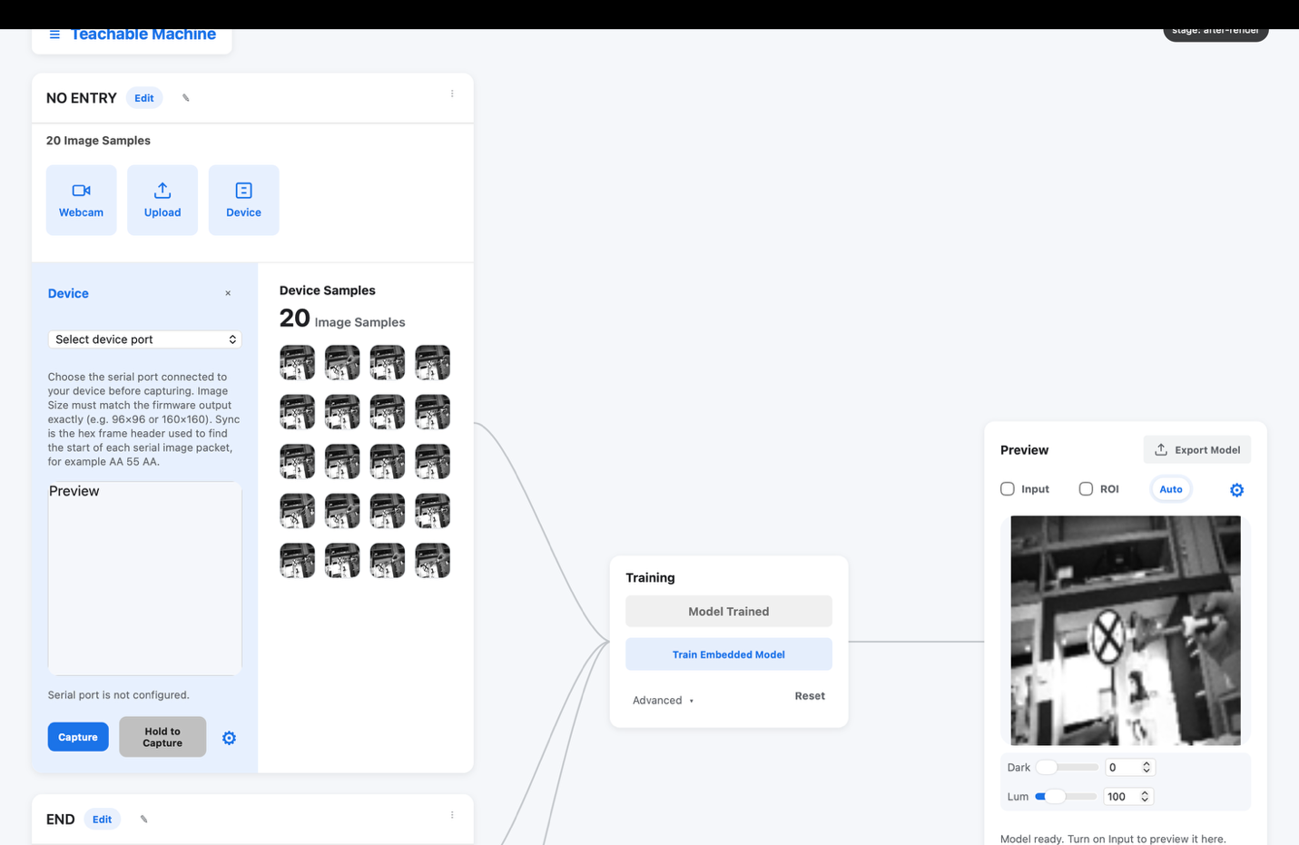
Capture / Hold-to-Capture and the Gear settings — the defaults remain as shown
C3. Create the classes. Create one class per digit: 0, 1, … 9. If time is limited, begin with 1, 2, 3, 7 (see Part D) and add the remaining classes once the first version works — four reliable classes produce better results than ten unreliable ones.
C4. Capture with variety. For each class, capture 30–50 samples using Capture (single image) or Hold to Capture (continuous). While capturing, vary the following between groups of shots:
- Distance — near, middle, far
- Angle — straight on, tilted left and right
- Position — centre and edges of the frame
- Lighting — orient toward different light sources
- Rotation — digits slightly rotated, as a driver would see them
Keep the sample counts approximately equal across classes. An unbalanced dataset biases the model toward the largest class.
C5. Remove poor samples. Hover over any blurry or accidental capture and click to delete it. Poor-quality samples degrade the trained model.
Why capture with Device rather than the laptop webcam? The model will run behind the board's camera. Training on images from that same camera — the same lens, the same angle, the same lighting — gives the model the best conditions to succeed. This principle is known as matching the deployment domain.
Part D — Preprocess (10 min)
D1. Click the Edit icon to enter the image-processing page. The left side is the Image Viewer (original and processed images); the right side is the Sample Worktable.
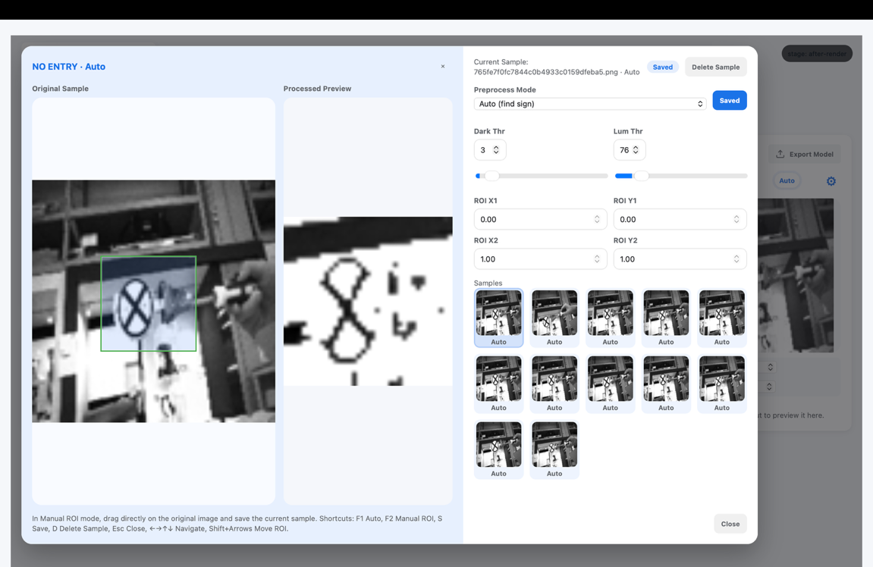
Edit page — Image Viewer with ROI, and the Sample Worktable
D2. Choose a mode:
- Auto (F1) — the application finds and crops the darkest region automatically. Use it when the digit is the darkest object in the frame.
- Manual ROI (F2) — the crop region is positioned manually (Shift + arrow keys move it). Use it when Auto selects shadows or the holding hand instead of the digit.
D3. Set the thresholds (they apply to the whole class):
- Dark Thr — pixels darker than this value become pure white; this removes dark shadows, sleeves, and background
- Lum Thr — pixels brighter than this value become pure white; this removes overexposed highlights
The target result: in the processed preview, the digit is black and almost everything else is white. Keep the thresholds moderate — if the digit itself begins to disappear, the thresholds are too aggressive.
D4. Move between samples with the arrow keys. Inspect several samples of every class and adjust the settings per class as needed.
D5. Press S to save. Unsaved preprocessing is discarded on exit; failure to save is the most common cause of lost work in this project.
D6. All processed images are resized automatically to image size × image size (default 96) before training. This is expected behaviour.
Part E — Train (5 min)
E1. In the Train Area, click the Advanced icon. Begin with the default configuration:
Parameter | Starting value
Image size | 96
Color mode | grayscale
Batch size | 16
Epochs | 20
Validation split | 0.25
Learning rate | 0.001
Conv1 / Conv2 filters | 8 / 16
Dense units | 32

E2. Click Train Embedded Model and wait for training to complete.
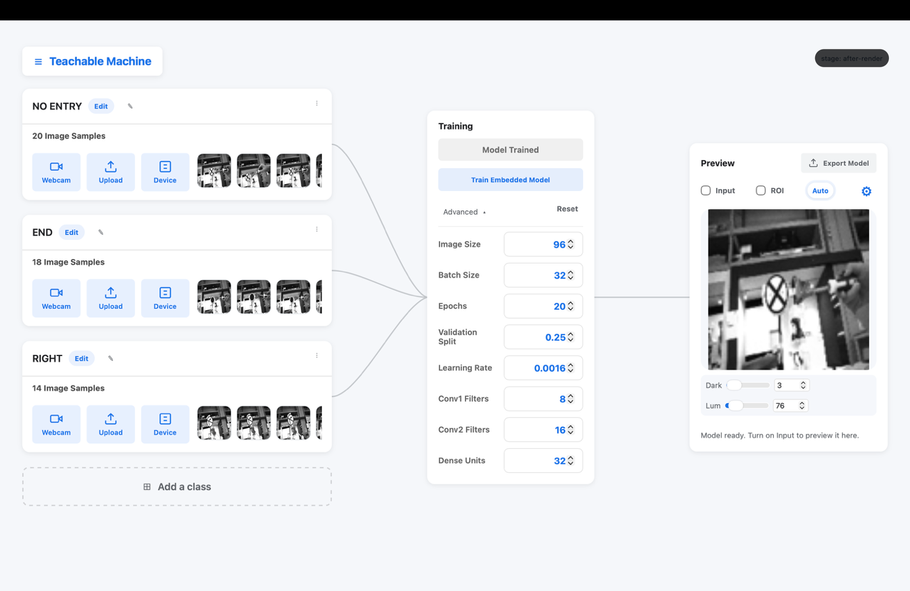
Advanced panel — set the hyperparameters, then Train Embedded Model
E3. Read the validation accuracy. For 4–10 digit classes, a first run at or above 90% is a sound result. A result of 60–70% indicates that the data — not the hyperparameters — is the limiting factor: return to C4 (more variety) or D3 (cleaner preprocessing).
Part F — Test on Unseen Data (10 min)
This step determines whether the model has learned the concept or has memorized the training set.
F1. In the Preview Area, click the Gear → source Device + the board's port.
F2. Toggle Input and present a digit written by another team member (not part of the training set).
F3. Read the confidence bar (toggle show %). The ROI display shows exactly what the model receives.
F4. Test the "No Sign" case. Remove the digit and present an empty scene (plain background). The model should report "No Sign": this is the OOD gate rejecting a frame that contains no digit, instead of forcing a confident answer. If an empty scene is classified as a digit, the OOD parameters are too loose (see the Lab 0 appendix).
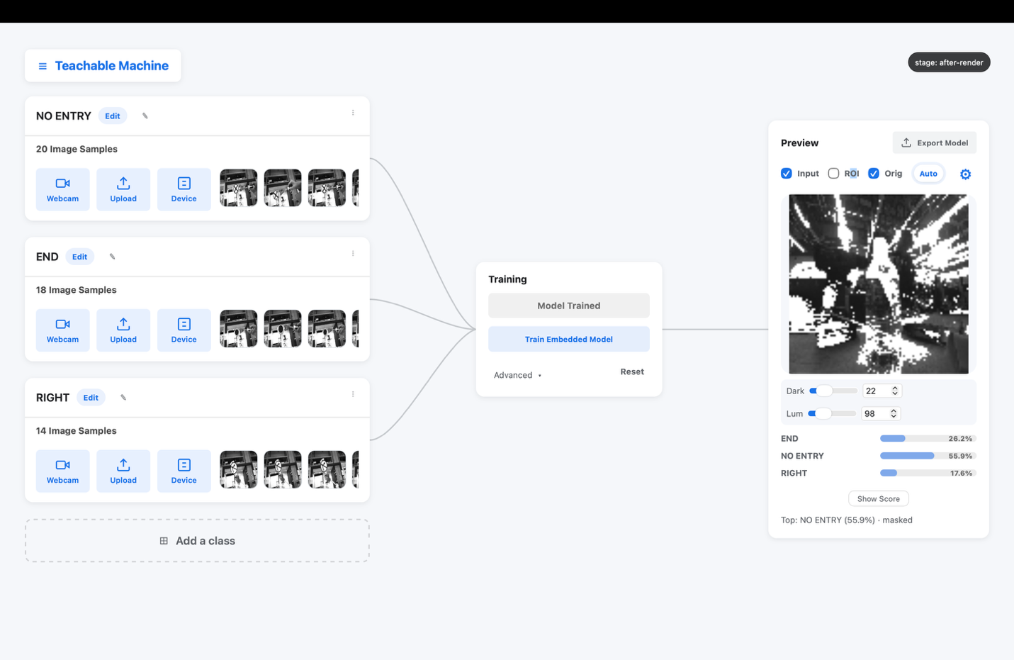
Interpretation view — live image, ROI, and the confidence bar
F5. Common confusions and their remedies:
Confusion | Usual cause | Remedy
1 ↔ 7 | thin strokes, similar shapes | more samples; thicker marker; larger ROI
3 ↔ 8, 9 ↔ 8 | loops closing up in gray | raise Dark Thr so faint loops vanish; add lighting variety
4 ↔ 9 | open vs. closed top | more rotated variants of both digits
everything → one class | unbalanced dataset | equalize the sample counts (C4)
strong on training data, weak live | overfitting / insufficient variety | more varied samples; sometimes fewer epochs
empty scene classified as a digit | OOD gate too loose | empty scene must report "No Sign" — see F4 and the Lab 0 appendix

F6. After each remedy, retrain (E2) and retest. Two or three iterations are a normal part of the process.
Part G — Export and Deploy (10 min)
G1. Click Export model and select a folder that is easy to locate. Then menu → Save Project.
G2. From the export folder, copy these five files into the TFLite.ino project folder, replacing the existing versions:
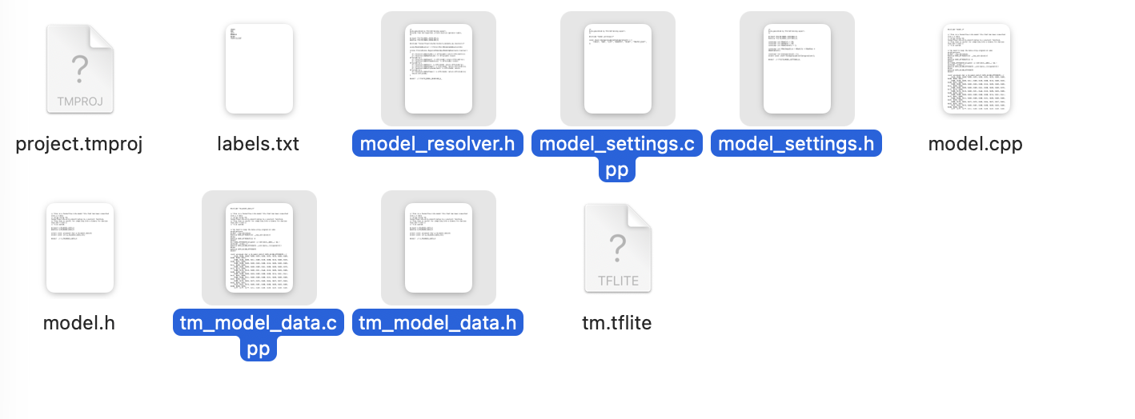
The five export files, ready to be copied into the project folder
tm_model_data.cpp // the quantized model
tm_model_data.h
model_resolver.h
model_settings.cpp
model_settings.h
G3. Open TFLite.ino and confirm that `IMG_SIZE` equals the image size used in training (default 96). A mismatch supplies wrongly sized images to the model and produces meaningless predictions.
G4. Upload to the board, open the Serial Monitor, and present a digit: the model now classifies the live camera stream on the board itself.
G5. In the Serial Monitor, commands can be typed to change the output mode and to inspect or adjust the OOD parameters: get ood reports the current values, and set ood 0.3 70.0 0.60 0.70 restores the defaults. Guidance for fine-tuning these parameters appears in the Lab 0 appendix.
Part H — Final Evaluation (10 min)
H1. Ask another team (or the instructor) to write 10 test digits that have never been shown to the model.
H2. Present each digit to the board and record the results:
# | True digit | Predicted | Confidence | Correct?
1
2
…
10

H3. A result of ≥ 8/10 correct completes the project. Present the results table and the live demonstration to the instructor.
Part I — Extensions (if time remains)
- Sample efficiency: delete samples until accuracy degrades — what is the minimum number of samples per class that still yields a working model?
- Speed versus size: set Conv1/Conv2/Dense to their maximum values and retrain; compare the inference rate on the serial output against the 4/8/16 configuration.
- New handwriting: have a member of another team add 10 samples of their handwriting to each class — does the model generalize better?
- Failure boundaries: present partial digits, distant digits, and digits at extreme angles, and document where the model begins to fail. This is its real-world operating boundary.
Troubleshooting
Symptom | Remedy
"Port busy" in the application | Close the Arduino Serial Monitor (A5)
No port in the Device list | Replug USB; use a data cable; confirm the board is powered
All predictions on one class, low confidence | Unbalanced or insufficient samples — see F4
Export missing files | Re-export with the default settings; all five files generate together
Upload fails in the IDE | Board settings mismatch — compare against the instructor's settings

