A Mobile app for Women’s Safety which provides Real-time SOS alerts and Location Sharing for emergency response.

Dr Ashutosh Lanjewar
Assistant Professor
JDCOEM
Nagpur,Maharashtra,India Ashutoshlanjewar39@gmail.com
Himanshu Yadav
B.Tech ,Artificial Intelligence
JDCOEM
Nagpur,Maharashtra,India
line 5: email address or ORCID
Himanshu Deshmukh
B.Tech ,Artificial Intelligence
JDCOEM
Nagpur,Maharashtra,India
line 5: email address or ORCID
Aditya Sanodiya
B.Tech ,Artificial Intelligence
JDCOEM
Nagpur,Maharashtra,India
line 5: email address or ORCID
Mohit Golait
B.Tech ,Artificial Intelligence
JDCOEM
Nagpur,Maharashtra,India
golaitmohit20@gmail.com

Abstract— Women's safety remains a worry in modern society where women face violence and harassment, which demands greater availability and effectiveness of safety interventions. Women are disproportionately vulnerable to physical and psychological harm, especially when alone or in strange locations. This research responds to this basic issue by exploring the development of a Women's Safety Application (WSA) that offers women an easy and effective way of alerting their emergency contacts and calling for assistance during emergencies. The WSA incorporates a straightforward, easy-to-perform shake gesture to transmit emergency messages, which enables women to send warnings quietly without the need to interact with their phones or unlock them. This feature is particularly vital in dangerous situations where timely response is critical. When it detects the shake, the application automatically sends the user's location to pre-set emergency contacts, including relatives, close friends, and the police. This feature guarantees timely deployment of assistance, raising the likelihood of early intervention. The application's effectiveness is also augmented by its integration with widely used messaging apps like WhatsApp, boosting its availability and quality of communication in the event of an emergency. The application also employs the smartphone sensors to differentiate between accidental and deliberate shakes, minimizing false alarms and increasing its dependability. Users can also personalize the application by setting specific emergency contacts and pre-set messages, which makes the application more attuned to their individual needs.
One of the principal aims of this research is to highlight the utilization of technology in empowering women through offering an accessible, simple-to-use device for use in an emergency situation. The WSA works in the background unobtrusively, not restricting typical smartphone usage but standing by to act when required. By adding instant personal contact notification and notification to authorities, the application offers a two-layered solution to safety. This research contributes to the existing literature that seeks to utilize technology as a mechanism for facilitating the improvement of women's safety. The WSA is an anticipatory solution to a common problem, offering a simple-to-use, effective device that promotes independence, security, and confidence in women while giving them instant access to assistance when they most need it.
Keywords— Women Safety, Emergency Alert System, Real-Time Location Sharing, Shake Gesture Activation, WhatsApp Integration

Introduction
Dr B. R Ambedkar sir once remarked, "I measure the progress of a community by the degree of progress which women have achieved." These remarks indicate the crucial role that the safety of women plays in the overall growth of society. Violence against women is a universal issue, with harassment, sexual violence, domestic violence, and gender-based violence continuing to affect millions of people all over the world [1]. Violence against women is defined by the United Nations as any kind of gender-based violence that leads to physical, sexual, or mental harm, and this problem is usually exacerbated by delayed enforcement of law, societal obstacles, or absence of legal protection [2].
In one recent case, a 31-year-old female physician was brutally raped and killed in Kolkata, India. The accused, a volunteer member of the Kolkata Police, has been arrested for the offense, which has led to mass protests and renewed debate over women's safety in the nation [3]. This event was not an isolated incident, with a plethora of violence against women cases arising on a daily basis, requiring immediate action and creative solutions to enhance security [4]. Therefore, there is a growing demand for affordable, effective, and responsive safety measures that enable women to access aid during critical periods [5].
In response to this, this paper explores the development of a mobile-based Women Safety Application (WSA) with the aim of providing women with an immediate, discreet, and trusted method of alerting their emergency contacts in distress. The application utilizes smartphone technology to ensure that women can trigger the system promptly without the need to open their phone or navigate complex menus, rendering it highly effective in danger zones. When the emergency alert is triggered through a simple shake action, the application sends a pre-defined emergency message, as well as the user's current GPS location, to pre-defined emergency contacts [6].
The use of the application on popular platforms like WhatsApp enhances its effectiveness, ensuring that the alerts are dispatched promptly and without hassle, even in SMS poor coverage zones. This feature eliminates the inconvenience of the user typing out a message or providing a location, which can be difficult under pressure circumstances [7]. With simplicity and ease of use in mind, the WSA is effective for all women regardless of age and background. The application works smoothly in the background, ensuring that it is always ready to respond without disrupting the normal use of the device. Additionally, users can pre-define emergency contacts and personalize their alert messages, ensuring that the application is tailored to their specific needs and requirements [8].
Finally, the aim of this Women Safety Application is to provide a sense of security and autonomy, allowing women to navigate public spaces confidently, knowing that assistance is at their fingertips. Utilizing proactive technology with social support, the WSA aims to make women's lives safer and more supportive
globally [9].

Literature Review
The increasing need for women's safety, particularly in public areas, has brought the development of a number of mobile applications that attempt to provide security and assistance during emergency situations. The majority of these applications offer real-time location tracking, emergency calling, and SOS messaging. These applications, however, are faced with the challenge of usability in high-pressure situations where the user cannot spare time to physically use their phone. Under emergency situations, accessing the phone, unlocking it, or accessing menus may be difficult or cumbersome, particularly when the user is threatened physically, anxious, or physically incapacitated. These usability constraints reflect the requirement for improved and quicker safety mechanisms under emergency situations.
To mitigate the usability constraint, alternative solutions like gesture interfaces have been researched. One such alternative solution is the Women Safety Application (WSA), which suggests a shake gesture of high intensity as the main initiation method for emergency calls. Shake-initiation is suggested to prevent manual phone operation, offering a covert and speedy mechanism to notify emergency contacts and broadcast the user's location. The solution is highly improved in terms of usability, especially in emergency situations where phone interaction is limited physically. The WSA location tracking and integration with WhatsApp messaging offers a potent communication system that ensures emergency messages are dispatched speedily to intended contacts.
Other existing women's safety apps offer valuable features but rely on manual activation, which may be tiresome in emergent situations. For example:
•bSafe: offers real-time location and an alarm button during an emergency but requires user intervention in an emergency, which may be unattainable under high-pressure situations [10].
•Circle of 6: allows users to send pre-defined emergency messages but also needs access to a phone, which could be difficult under duress [11].
•Raksha: allows for location-sharing and alerting but also needs manual initiation, which is an issue where the user's movement or access to the phone is under duress [12].
While these apps have enhanced women's safety, their reliance on manual inputs underscores the demand for more automated and easy solutions. The WSA fills this gap by presenting an accessible, shake-based method of sending distress alerts, reducing the reliance on complex phone interactions.
The technology advancement that has made it possible to develop such apps comes from the increased availability and functionality of smartphones and mobile technology. Android, a widespread mobile operating system developed by Google and the Open Handset Alliance, provides a robust platform for such apps. Android's openness and user-friendliness provide an ideal platform for creating safety apps, as it allows varied functionalities such as GPS tracking and real-time notification [13]. Additionally, Android's large community ensures that apps reach a large user base, thus maximizing their impact on women's safety across the world.
In addition, research has shown that technology can play a vital role in preventing violence against women. Research has shown that mobile technology can be an effective tool in ensuring women's safety, offering real-time alerts and location tracking functionality [14]. GPS-based safety solutions in safety apps enable users to send their location to their contacts of trust, with quicker response times in the event of an emergency [15]. Further, mobile apps have been increasingly used to empower women to report incidents of violence, to offer quicker responses from authorities and to offer support to survivors of violence [16].
Despite the advancement in women's safety apps, there are still limitations in ensuring the effectiveness of such apps in all situations. One of the aspects of enhancing such apps is reducing the requirement for manual activation, especially in emergency situations where the user may not be able to access his or her phone. The WSA's shake gesture activation is a step towards this enhancement, offering an even more intuitive and streamlined way of triggering an emergency response. By reducing user interaction, the WSA enhances the usability and effectiveness of safety apps, offering support even in the most stressful and critical situations.
Briefly, the use of technology, including gesture-based interfaces and location tracking, has greatly enhanced the efficacy of women's safety apps. There are still constraints, though, in getting the apps to function in every situation, especially in cases of severe stress. The Women Safety Application (WSA) is a new development in offering a shake-based activation mechanism, solving the issue of manual activation and improving the user experience. This development opens the door to further innovations in the design and functionality of women's safety apps, making them a vital tool in women's safety in public.

.

Problem Statement
Even with international efforts to address violence against women, it is a widespread problem in need of timely and evidence-based interventions. The Global Database on Violence against Women fills important gaps by focusing information on governmental actions, prevalence data, and global initiatives. There are still challenges:
1.\tData Gaps and Accessibility: Unsystematic and sporadic data collection frameworks make detailed prevalence statistics unavailable.
2. Monitoring of Policy Implementation: Effective and transparent assessment of government action is a major constraint to long-term improvement.
3. Adjustment in Evolving Contexts: Policy and interventions commonly fail to keep pace with developing socio-economic and cultural contexts.
4. Perception and Accessibility: The database itself, although expansive, needs development in usability and search capacity to make more significant impact. [17].
Alongside, the advent of mobile safety apps offers the potential to remedy another key aspect of this phenomenon: women's safety in the public sphere. Violent crime against women is still a severe problem in India, with 4% growth in crimes against women in 2024 recorded by the National Crime Records Bureau (NCRB). The majority of existing safety apps involve manual triggering, e.g., touchscreens, which are unfeasible at high-stress situations. For example, apps such as bSafe and Circle of 6 commonly fail when people are unable to use their phones during times of crisis, with 85% of women claiming they are unable to use similar apps in crisis situations (SafetyPin, 2020). [4].
To address these drawbacks, the Women Safety Application (WSA) proposes a shake-based activation mechanism with high-intensity shaking to initiate emergency actions. This groundbreaking feature dispenses with the need for manual input, making access to assistance faster. With real-time location identification and WhatsApp messaging, the WSA increases the efficiency of emergency notifications, giving a quick and easy solution to women's security.
The central issue is to ensure that both data-driven policy interventions and tech innovations come together to form an integrated strategy towards preventing violence against women and having available, easy-to-use tools for real-time help in emergencies.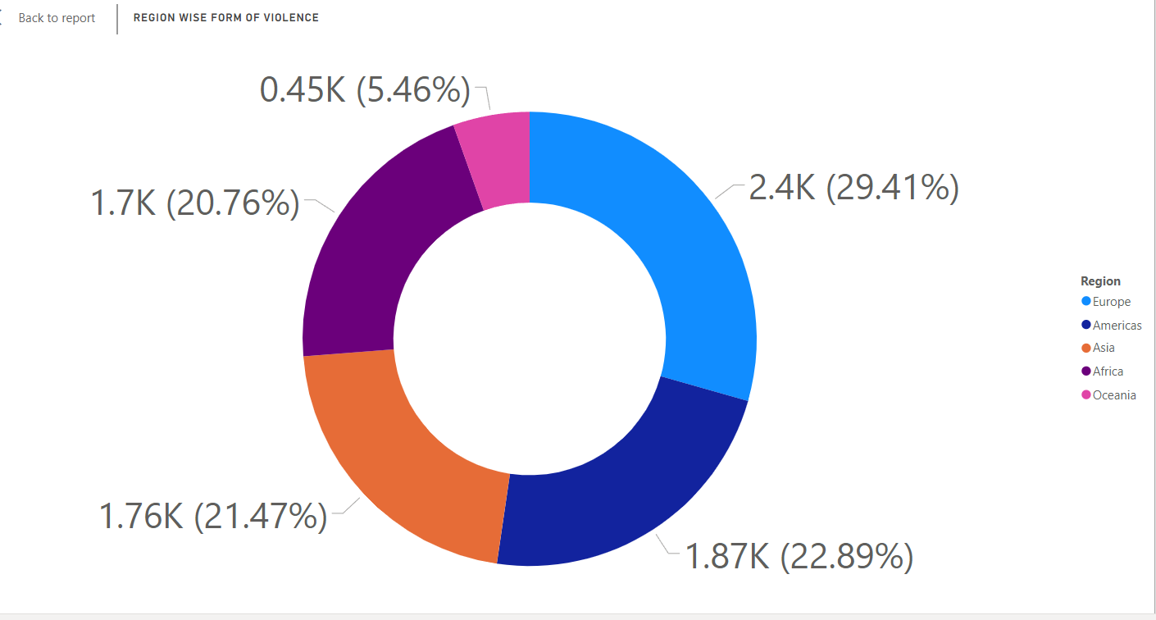
Fig 1:Doughnut chart of Region wise Form of Violence
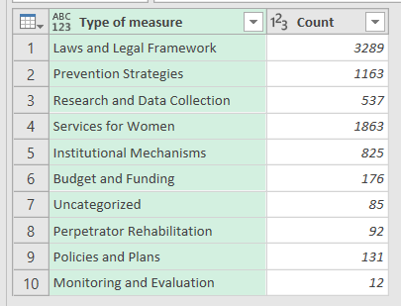
Table 1:Count of Type of Measure
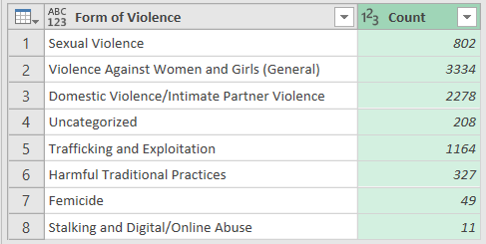
Table 2: Count of Form of Violence
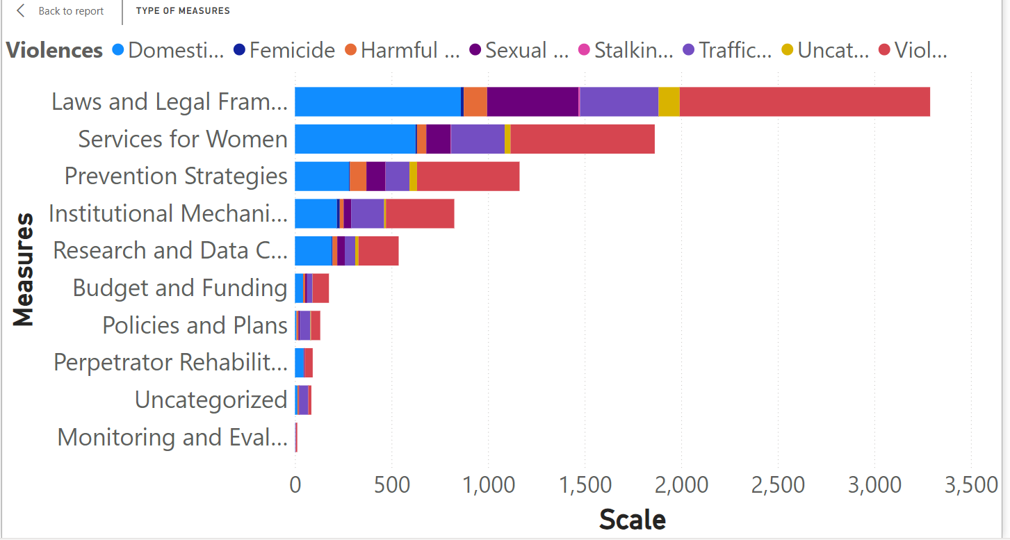
Fig 2: Bar graph of Types of Measure Taken Region wise

Research Methodology
The creation and deployment of the Women Safety Application (WSA) were informed by a systematic and stringent research approach to make it practicable, user-friendly, and effective. A detailed description of the methodology used is presented below:
1. Problem Identification: The main aim was to identify safety issues for women, particularly in emergency or high-stress situations. Surveys, interviews, and focus group discussions were done with women from different age groups and occupations to identify their difficulties and preferences when using safety apps. The findings gave a thorough insight into the actual problems encountered by women in maintaining personal safety.
2. Requirement Analysis: From the feedback, the most important features were determined, including emergency activation through intense shaking, location tracking, and instant messaging using WhatsApp. The emphasis was on creating a solution that is simple to use, trustworthy, and effective in real-life situations. The analysis involved studying current applications, their shortcomings, and how the WSA could complement them effectively.
3.\tConceptualization of Design: A user-focused design approach was followed for the application. Storyboarding and prototyping methods were employed to conceptualize the user interface and experience. Major elements like the shake detection feature, GPS, and WhatsApp API were planned in this phase. Iterative reviews were also performed by the team to validate that the design was in line with user expectations and resolved usability issues.
4. Technology Stack Choice: The app was built with a strong and scalable technology stack:
2. Frontend: React Native for cross-platform compatibility, so the app functions flawlessly on both Android and iOS devices.
o Backend: Node.js for optimized server-side operations, providing scalability and high performance.
o Database: Firebase for real-time data storage and retrieval, which provides instant updates and secure data management.
o APIs: WhatsApp Business API for real-time communication, providing instant messaging functionality.
3. Implementation: The app was developed in iterative rounds with the use of the Agile methodology. There was a specific sprint for every feature to be implemented and tested for functionality and compatibility. Every iteration incorporated feedback from users in order to streamline the app. The Agile development enabled the developers to respond to changes and incrementally improve the performance of the app.
4. Testing and Validation: A thorough test was conducted to prove the performance and reliability of the application:
o Functional Testing: Checking that all functions operate as required, including emergency activation and messaging features.
o Usability Testing: Checking for ease of use and intuitiveness of the application through user trials and questionnaires.
o Stress Testing: Confirming the app's responsiveness across different scenarios, including high user load, poor internet connectivity, and concurrent emergency triggers.
5. Deployment and Feedback: The application was released on Android and iOS platforms for beta testing. Feedback from early users was gathered to detect and resolve any bugs prior to the launch. Ongoing observation of user experiences and interactions enabled the app to be continuously perfected and made reliable.

Proposed Methodology
The development and implementation of the Women Safety Application (WSA) were guided by a rigorous and structured research methodology to ensure its practicality, usability, and effectiveness. Below is a detailed description of the approach taken:
- Problem Identification: Crimes against women in public spaces remain a significant concern, with many safety applications relying on manual activation methods that are impractical during emergencies. To address this, surveys, interviews, and focus group discussions were conducted with women across diverse demographics. These interactions uncovered the real-world difficulties of accessing safety apps during high-stress situations and the preference for a more intuitive, gesture-based activation mechanism. This stage ensured that the research was grounded in the lived experiences of women, emphasizing the need for a practical and reliable solution.
- Requirement Analysis: Existing apps like bSafe and Circle of 6 often fail due to their reliance on manual interaction. 85% of women reported difficulty using such apps during emergencies. The requirement analysis phase prioritized the integration of features such as high-intensity shaking for emergency activation, real-time location tracking, and WhatsApp messaging. This analysis involved evaluating the limitations of existing applications and ensuring that the WSA addressed these gaps effectively by offering features that required minimal manual interaction and provided immediate assistance.
- Design Conceptualization: Current safety solutions lack accessibility and usability in emergencies, and crimes against women have been increasing (NCRB 2024). A user-centric design approach was adopted to ensure the WSA was intuitive and accessible. Storyboarding and prototyping focused on creating an interface that could be easily used even under stressful conditions. Iterative reviews ensured the design met user expectations while addressing challenges like activating the app discreetly and sharing location details instantly.
- Technology Stack Selection: Technological innovations are needed to create an effective and scalable solution for women’s safety. The chosen technology stack supported real-time performance and scalability.
- Frontend: React Native ensured compatibility across Android and iOS platforms.
- Backend: Node.js provided high performance and reliability for server-side operations.
- Database: Firebase facilitated instant data updates and secure handling of sensitive information like location data.
- APIs: The WhatsApp Business API enabled seamless communication with emergency contacts, a critical feature in ensuring rapid responses.
- Implementation: A practical, reliable, and intuitive solution is needed to overcome the limitations of current safety apps. The Agile methodology allowed iterative development and testing, ensuring that every feature—such as the gesture-based activation mechanism—was refined through user feedback. This iterative approach addressed practical usability concerns and ensured that the application could adapt to real-world scenarios.
- Testing and Validation: Safety apps must function reliably under various conditions to ensure user trust and effectiveness. Comprehensive testing validated the WSA's functionality, usability, and reliability:
- Functional Testing: Verified that emergency activation and messaging features worked flawlessly.
- Usability Testing: Assessed the app's intuitiveness and accessibility through real-world trials.
- Stress Testing: Ensured the app's responsiveness under challenging conditions, such as weak internet connectivity and high user loads
- Deployment and Feedback : Continuous refinement and user-centric improvements are essential for ensuring the effectiveness of technological innovations. The beta testing phase gathered feedback from users to identify and resolve any remaining issues before the official launch. Continuous monitoring of user interactions allowed for iterative improvements, ensuring the app met the needs of its users while maintaining reliability

System Design
The Women Safety Application (WSA) is designed to provide a seamless and efficient emergency response mechanism. The system design is divided into three layers: Frontend Layer, Backend Layer, and Communication Layer.
- Frontend Layer:
  - User Interface (UI): Designed using React Native for a uniform experience across Android and iOS platforms. The UI includes simple buttons for manual activation, visual feedback for successful emergency activation, and a minimalistic design for ease of use. The focus on simplicity ensures that users can quickly understand and navigate the app in stressful situations.
  - Shake Detection Mechanism: Integrated with the device’s accelerometer, the app detects high-intensity shakes and triggers emergency actions. The sensitivity of the shake detection mechanism was carefully calibrated to prevent false triggers while ensuring reliability in emergencies.
- Backend Layer:
  - Server Operations: A Node.js server handles all backend processes, including location tracking, data storage, and integration with the WhatsApp API. The server architecture is designed to support real-time communication and data processing with minimal latency.
  - Database: Firebase is used for storing user details, emergency contact information, and real-time location data. Firebase’s scalability ensures the app can handle a large number of users simultaneously, making it suitable for wide-scale deployment.
- Communication Layer:
  - Location Tracking: The app leverages GPS technology to capture and transmit the user’s real-time location to pre-configured emergency contacts. The location data is updated continuously to provide accurate tracking during an emergency.
  - WhatsApp Integration: Using the WhatsApp Business API, the app sends automated messages with the user’s location and a predefined emergency alert. This ensures that emergency contacts are notified instantly.
  - Phone Call Trigger: The app automatically initiates a phone call to emergency services (e.g., 112) upon activation, providing an additional layer of response in critical situations.
- System Workflow:
  - Step 1: User triggers emergency mode via a high-intensity shake or manual button press.
  - Step 2: The app captures the user’s real-time location and processes the data.
  - Step 3: Emergency messages and location details are sent to predefined contacts via WhatsApp.
  - Step 4: A phone call is initiated to emergency services, ensuring a multi-channel alert system.
  - Step 5: Continuous location updates are provided until the emergency mode is deactivated, ensuring that responders have up-to-date information.
Fig : Block Diagram of Our Women’s Safety
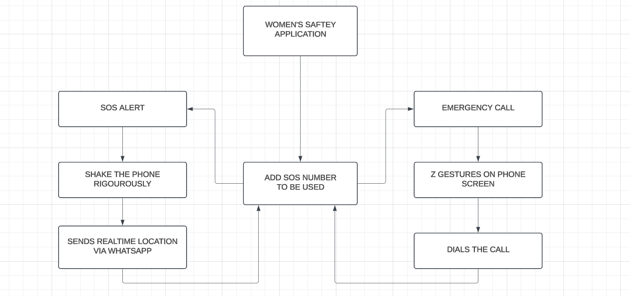
Fig 3: Block Diagram of working of the WSA app

Future Scope

The Women Safety Application (WSA) has immense potential for growth and innovation. Below are some of the future enhancements and applications envisioned for the app:
- Integration of AI and ML:
  - Incorporate machine learning algorithms to detect potential threats based on user behavior and environmental factors. AI can analyze patterns and send proactive alerts to users.
  - Develop predictive analytics to anticipate unsafe situations and alert the user proactively, enhancing the app's preventive capabilities.
- Advanced Sensor Integration:
  - Use additional sensors such as gyroscopes, heart rate monitors, and wearable devices to enhance the accuracy of emergency detection. This can provide more reliable triggers in diverse scenarios.
  - Explore the integration of smartwatches and fitness bands to expand the app’s usability and accessibility.
- Global Accessibility:
  - Expand the app’s compatibility with international emergency numbers and services to make it usable worldwide. This involves integrating a dynamic database of global emergency contacts.
  - Support multiple languages for broader reach and inclusivity, catering to a diverse user base.
- Enhanced Privacy Features:
  - Implement end-to-end encryption for all communication to ensure user data remains secure. This is crucial to build trust among users.
  - Introduce features that allow users to customize the level of information shared with emergency contacts, ensuring a balance between safety and privacy.
- Community and Crowdsourcing Features:
  - Develop a community safety feature where nearby users can be alerted during emergencies, enabling a collective response to crises.
  - Create a crowdsourcing model for real-time safety updates in specific areas, allowing users to stay informed about potential risks.
- Integration with Smart City Infrastructure:
  - Collaborate with local governments to integrate the app with city-wide surveillance and monitoring systems, such as CCTV networks.
  - Use smart traffic signals and public transportation systems to assist in emergencies, enabling quicker responses.
- Offline Functionality:
  - Enable the app to function in offline mode by leveraging SMS-based alerts and pre-saved location data. This ensures usability in areas with limited internet connectivity.
  - Introduce Bluetooth-based peer-to-peer communication for emergencies in remote or internet-deprived regions, offering an additional layer of reliability.

Conclusion

The Women Safety Application (WSA) provides a reliable, fast, and user-friendly way for women to seek immediate help during emergency situations. The use of mobile sensors ensures that the app can be triggered intuitively through a simple gesture, eliminating the need to unlock the phone or navigate through multiple screens. This feature is particularly beneficial in high-stress situations where every second matters. The integration with WhatsApp’s messaging platform further enhances the app’s effectiveness by enabling seamless communication with emergency contacts. The use of WhatsApp ensures that messages containing real-time location data are promptly delivered, even in areas with poor internet connectivity, as it can function over cellular networks. The combination of automatic alerts and GPS tracking allows responders to locate the user quickly and provide timely assistance. Despite its strengths, the current version of the WSA faces a few challenges, such as battery consumption due to continuous sensor monitoring and the possibility of false triggers from accidental movements. These issues highlight areas for improvement, which will be addressed in future updates to provide a smoother user experience. Looking ahead, future developments will focus on enhancing the app’s accuracy by refining the shake-detection algorithm, thereby minimizing accidental activations. Efforts will also be made to optimize battery consumption by incorporating more efficient sensor management techniques. Additional features like physical panic button integration and voice-activated commands will offer greater accessibility, ensuring that users can activate the app in various scenarios, even without physical interaction with their phones. Moreover, collaborations with local authorities will be explored to enable direct communication with emergency services, ensuring that help arrives as quickly as possible. By continuously evolving and adapting to user feedback, the Women Safety Application aims to become a comprehensive personal safety tool that empowers women to feel safe and secure, no matter where they are. In conclusion, the WSA addresses an important need by combining modern technology, real-time communication, and intuitive design to offer a powerful safety solution. With further enhancements and expanded functionalities, the app is poised to become a vital tool in promoting women’s safety and well-being in diverse environments.

Acknowledgment
We extend our heartfelt gratitude to Dr. Ashutosh Lanjewar, our project guide, for his invaluable guidance throughout the process of this research. His expertise and insights have been instrumental in shaping the direction of this paper. From the initial stages of formulating our research questions to the final stages of analysis and interpretation, Dr. Ashutosh Lanjewar’s mentorship provided us with the confidence to explore complex concepts and methodologies. His ability to challenge our thinking while offering constructive feedback encouraged us to delve deeper into our subject matter, ultimately enhancing the quality of our work.
Moreover, Dr. Ashutosh Lanjewar’s unwavering support and encouragement motivated us during challenging moments in our research journey. His commitment to academic excellence and passion for education inspired us to push the boundaries of our knowledge and strive for the best possible outcomes. We are profoundly grateful for the time and effort he dedicated to guiding us and for fostering an environment conducive to learning and growth. Without his mentorship, this paper would not have reached its current level of quality and insight. Thank you, Dr. Ashutosh Lanjewar, for being an exceptional mentor and for your invaluable contributions to our academic pursuits.
We also wish to express our deepest appreciation to our Team for their relentless efforts, collaboration, and dedication throughout this research. The synergy and commitment of the team have been a driving force behind the successful completion of this work. Each member’s contribution, whether in brainstorming ideas, conducting research, or drafting this paper, has been vital to achieving our goals.
Additionally, we would like to extend our gratitude to the Data analysts who supported us by performing critical data processing and analysis. Their technical expertise and attention to detail provided us with the foundation necessary for deriving meaningful insights and conclusions. Without their invaluable assistance, this research would not have been as robust and comprehensive.
Finally, we thank everyone who directly or indirectly contributed to the completion of this paper. Your support and encouragement have been instrumental in making this research a success.

x. References
[1] United Nations, Violence against Women and Girls, United Nations. Available at: https://www.un.org/womenwatch/daw/cedaw/text/econvention.htm
[2] World Health Organization (WHO), Violence Against Women Prevalence Estimates, 2018, Geneva: World Health Organization. Available at: https://www.who.int/publications/i/item/9789240061350
[3] Reuters, "Trial starts over rape, murder of junior doctor in India's Kolkata," Reuters, November 11, 2024. Available at:https://www.reuters.com/world/india/trial-starts-over-rape-murder-junior-doctor-indias-kolkata-2024-11-11/
[4] National Crime Records Bureau (NCRB), Crime in India 2019, Ministry of Home Affairs, Government of India. Available at: https://ncrb.gov.in/en/crime-india
[5] P. Dastan & S. B. Rathi, “Women’s Safety through Technology,” International Journal of Technology and Security, 2023.
[6] A. Patel, Mobile Technology for Women’s Safety: A Step Forward, Indian Journal of Technology, 2024.
[7] S. Mehra & A. Thakur, “Digital Solutions to Women’s Safety,” Tech and Women, 2023.
[8] A. Sharma & V. Kaur, “Usability of Mobile Apps for Women Safety in Urban Areas,” Journal of Safety Research, 2024.
[9] P. Kumar & R. Kapoor, Improving Women’s Safety: Innovations in Mobile Technology, 2024.
[10] bSafe: A mobile app offering real-time tracking and emergency alerts for women's safety. Available at: https://www.bsafeapp.com
[11] Circle of 6: A safety app that enables users to send emergency messages to pre-selected contacts. Available at: https://www.circleof6app.com
[12] Raksha: A mobile app that allows users to send their location and emergency alerts to preset contacts. Available at: https://www.rakshaapp.com
[13] Android Operating System: Google’s mobile platform, offering a robust and open-source environment for app development. Available at: https://www.android.com
[14] N. Westmarland et al., "Exploring the Use of Smartphones in Relation to Domestic and Sexual Violence," Journal of Technology and Social Change, 2015.
[15] GPS Tracking in Safety Apps: Enhancing real-time emergency alerts with precise location sharing, Technology and Public Safety Review.
[16] Mobile Apps for Reporting Violence: Using mobile technology to help women document and report incidents of violence, Journal of Mobile Applications for Social Change.
[17] UN Women. (n.d.). Global Database on Violence Against Women: Data Form. Retrieved January 8, 2025, from https://data.unwomen.org/global-database-on-violence-against-women/data-form

