

**Department of Artificial Intelligence**

**College of Computer Science and Information Technology**

**Due Date: Friday September 17, 2024 @ 11:59 PM \***

**Late Submissions:**

Q: Can I skip the lab and submit the solution?

You will receive a mark of **zero** if you do not attend the lab, even if you complete the exercise. Attending the labs is compulsory for evaluation. If you have a justified excuse, you may receive a partial mark depending on the circumstances. See the next question for information on late submissions.

**Q:** If I submit it at 12:00am, you’ll still mark it, right?

**A:** 11:59pm and earlier is on time. Anything after 11:59pm is late. Anything late will **NOT** be probably marked. If I find you have a legitimate cause, you will be graded according to the following rules (24 hours after deadline à assignment is marked out of 75% only, 48 hours after deadline à assignment is marked out of 50% only, 72 hours after deadline à assignment is marked out of 25% only).

Task 1

In this image processing lab session, you will be tasked with the challenge of removing salt-and-pepper noise from an X-ray image of a circuit board. Salt-and-pepper noise appears as random white and black pixels scattered throughout the image, degrading its quality and making it difficult to analyze. To enhance the image and prepare it for further analysis, you will employ image filtering techniques.

Task: Using image filtering methods, particularly median and/or mean filters, your objective is to remove the salt-and-pepper noise from the provided X-ray image of the circuit board. Your end goal is to obtain a cleaner, noise-free version of the image that retains as much detail as possible.

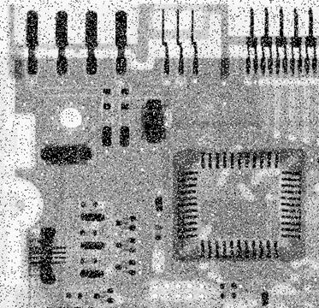

**Output**

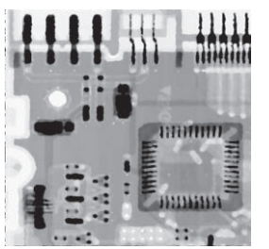

Provide an explanation of your code in your own words. This is to ensure that you have a deep understanding of the code you've written and its underlying concepts. You are expected to comments on the main parts and functions of the code.

Guidelines:

* Your explanation should be original and in your own words. Do not copy explanations from textbooks, online resources, or peers.
* Go beyond just describing what the code does. Explain why you chose certain methods or approaches and how they benefit the solution.

**Assessment**

1. Each student will show all the above parts running as demo to the Lab Instructor **before leaving the lab.** Total marks for the lab is as follows

|  |  |
| --- | --- |
| Task 1 | Marks (demo + report) |
| 1 | 10 |
| Total | 10 |

1. Students will prepare a report in which they will submit the snapshots taken while they worked on each part. They will explain the figures to make sure that they understood what they did.