

**Department of Artificial Intelligence**

**College of Computer Science and Information Technology**

**Due Date: Tuesday September 24, 2024 @ 11:59 PM**

**Late Submissions:**

* Q: Can I skip the lab and submit the solution?
  + You will receive a mark of **zero** if you do not attend the lab, even if you complete the exercise. Attending the labs is compulsory for evaluation. If you have a justified excuse, you may receive a partial mark depending on the circumstances. See the next question for information on late submissions.
* **Q:** If I submit it at 12:00am, you’ll still mark it, right?
  + **A:** 11:59pm and earlier is on time. Anything after 11:59pm is late. Anything late will **NOT** be probably marked. If I find you have a legitimate cause, you will be graded according to the following rules (24 hours after deadline 🡪 assignment is marked out of 75% only, 48 hours after deadline 🡪 assignment is marked out of 50% only, 74 hours after deadline 🡪 assignment is marked out of 25% only).

Task 1

In the world of digital image processing, the task of uncovering hidden patterns and textures within images is akin to unraveling the secrets of creation. Imagine standing within the sacred precincts of the Prophet's Mosque in Medina, surrounded by the harmonious blend of architectural grandeur and spiritual tranquility. In this digital realm, we embark on a journey to reveal the intricate textures that adorn the walls of this divine sanctuary.

Our voyage begins with a prophet's mosque image to understand and classify these textures, we must wield the power of Python and the skimage library. Our quest is to create multiple custom structuring elements, each with its unique shape and size, just as the textures within this sacred space are diverse and distinctive.

In this endeavor, our custom structuring elements become the chisels and brushes of a digital artist. Each element is meticulously crafted to accentuate the particular texture it seeks to reveal. As we choose different shapes and sizes for our structuring elements, we are akin to artisans, selecting the perfect tool for each unique masterpiece hidden in the image.

The process of applying morphological operations is our invocation, a sacred ritual to reveal the textures' true essence. Through erosion, we gently peel away the layers, bringing forth the delicate nuances of each pattern. With dilation, we breathe life into the textures, allowing them to flourish and bloom. As we manipulate opening and closing operations, we sculpt the image, emphasizing or subduing various textures as if shaping the contours of a sacred relic.

Through this process, we aspire to attain a deeper understanding of the textures within the Prophet's Mosque.

Create multiple custom structuring elements of varying shapes and sizes to analyze and classify different textures within the image. Apply morphological operations to segment and identify these textures in prophet Masjid image using python and skimage

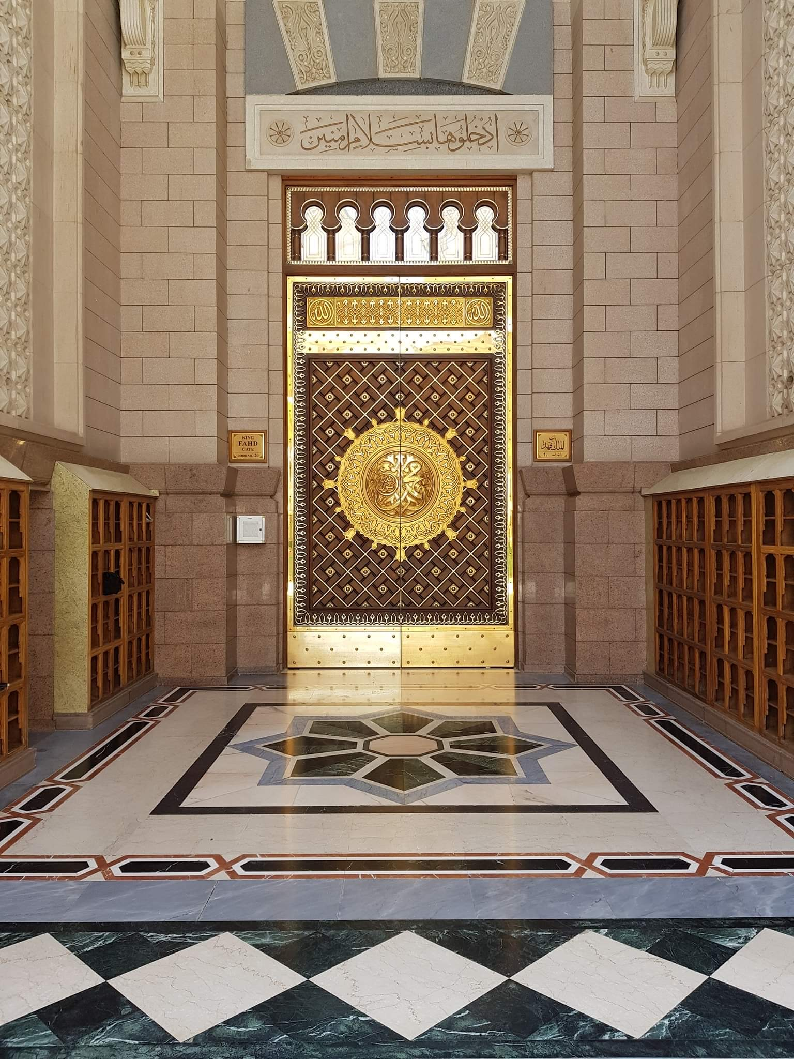 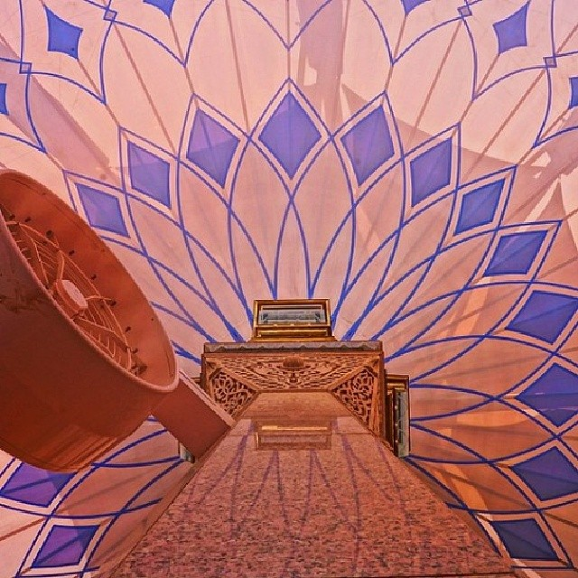

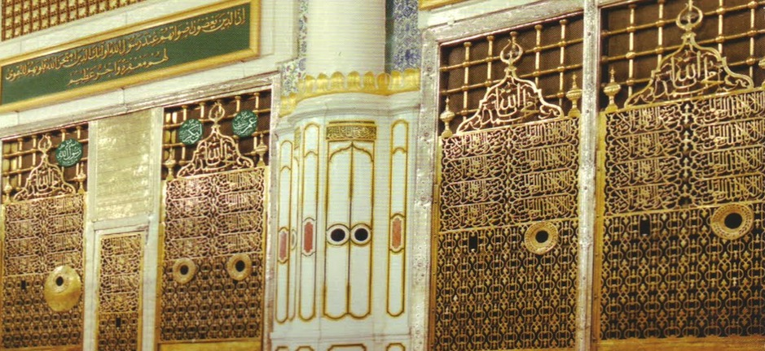

Provide an explanation of your code in your own words. This is to ensure that you have a deep understanding of the code you've written and its underlying concepts. You are expected to comments on the main parts and functions of the code.

Guidelines:

* Your explanation should be original and in your own words. Do not copy explanations from textbooks, online resources, or peers.
* Go beyond just describing what the code does. Explain why you chose certain methods or approaches and how they benefit the solution.
* Remember the roles for using generative AI. You need to provide explanation and share details on the prompts used and reasons to call it.

**Assessment**

1. Each student will show all the above parts running as demo to the Lab Instructor **before leaving the lab.** Total marks for the lab is as follows

|  |  |
| --- | --- |
| Task 1 | Marks (demo + report) |
| 1 | 100 |
| Total | 100 |

1. Students will prepare a report in which they will submit the snapshots taken while they worked on each part. They will explain the figures to make sure that they understood what they did.