

**Department of Artificial Intelligence**

**College of Computer Science and Information Technology**

**Due Date: Tuesday October 15, 2024 @ 11:59 PM**

**Late Submissions:**

* Q: Can I skip the lab and submit the solution?
  + You will receive a mark of **zero** if you do not attend the lab, even if you complete the exercise. Attending the labs is compulsory for evaluation. If you have a justified excuse, you may receive a partial mark depending on the circumstances. See the next question for information on late submissions.
* **Q:** If I submit it at 12:00am, you’ll still mark it, right?
  + **A:** 11:59pm and earlier is on time. Anything after 11:59pm is late. Anything late will **NOT** be probably marked. If I find you have a legitimate cause, you will be graded according to the following rules (24 hours after deadline 🡪 assignment is marked out of 75% only, 48 hours after deadline 🡪 assignment is marked out of 50% only, 72 hours after deadline 🡪 assignment is marked out of 25% only).

You are provided with an input image, and you are required to perform the following operations:

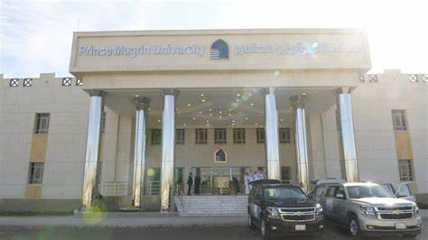

**Image Enhancement:**

Apply histogram equalization to enhance the contrast of the input image.

Implement gamma correction to adjust the brightness and improve image visibility.

**Frequency Domain Filtering:**

Convert the input image to the frequency domain using the 2D Fast Fourier Transform (FFT).

Implement low-pass and high-pass filtering in the frequency domain. You can design your own filter kernel or use predefined filters.

Apply the inverse FFT to bring the image back to the spatial domain.

**Display and Save Results:**

Display the original image, the contrast-enhanced image, and the filtered images.

Save the enhanced and filtered images as separate files.

**Bonus Tasks (Optional):**

Implement additional image enhancement techniques like adaptive histogram equalization.

Experiment with different filter kernels and cutoff frequencies for frequency domain filtering

Provide an explanation of your code in your own words. This is to ensure that you have a deep understanding of the code you've written and its underlying concepts. You are expected to comments on the main parts and functions of the code.

Guidelines:

* Your explanation should be original and in your own words. Do not copy explanations from textbooks, online resources, or peers.
* Go beyond just describing what the code does. Explain why you chose certain methods or approaches and how they benefit the solution.
* Avoid Using ChatGPT: It has come to our attention that some students might be using ChatGPT or similar AI tools to assist in explaining code. Using ChatGPT or similar tools for this purpose is strictly prohibited. Students found using these tools for explaining their code will be penalized heavily

**Assessment**

1. Each student will show all the above parts running as demo to the Lab Instructor **before leaving the lab.** Total marks for the lab is as follows

|  |  |
| --- | --- |
| Task 1 | Marks (demo + report) |
| 1 | 10 |
| Total | 10 |

1. Students will prepare a report in which they will submit the snapshots taken while they worked on each part. They will explain the figures to make sure that they understood what they did.