

***Lab 5***

**Camera calibration with OpenCV**

**Learning Objectives:**

* *To use OpenCV for camera calibration*
* *Detect chessboard corners for calibration.*
* *Compute intrinsic parameters and distortion coefficients.*
* *Apply image undistortion to remove lens distortion.*
* *Use calibration for real-world applications like AR and robotics.*

**Introduction:**

Camera calibration is an essential process in computer vision that allows us to correct distortions caused by a camera lens and accurately map real-world points onto an image. Calibration estimates the intrinsic and extrinsic parameters that define how a camera perceives the environment. This process is crucial for applications such as augmented reality (AR), 3D reconstruction, autonomous navigation, and object tracking.

Generally when we have a scene and we want to project it into an image 3D to 2D we need to find the projection matrix which include the intrinsic and extrinsic parameters , finding this matrix is camera calibration

**Why Do We Need Camera Calibration:**

When an image is captured using a camera, distortions cause straight lines to appear curved, affecting depth estimation and object localization. Calibration corrects these distortions, ensuring **accurate mapping of 3D world coordinates onto a 2D image plane**.

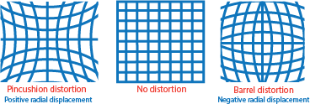

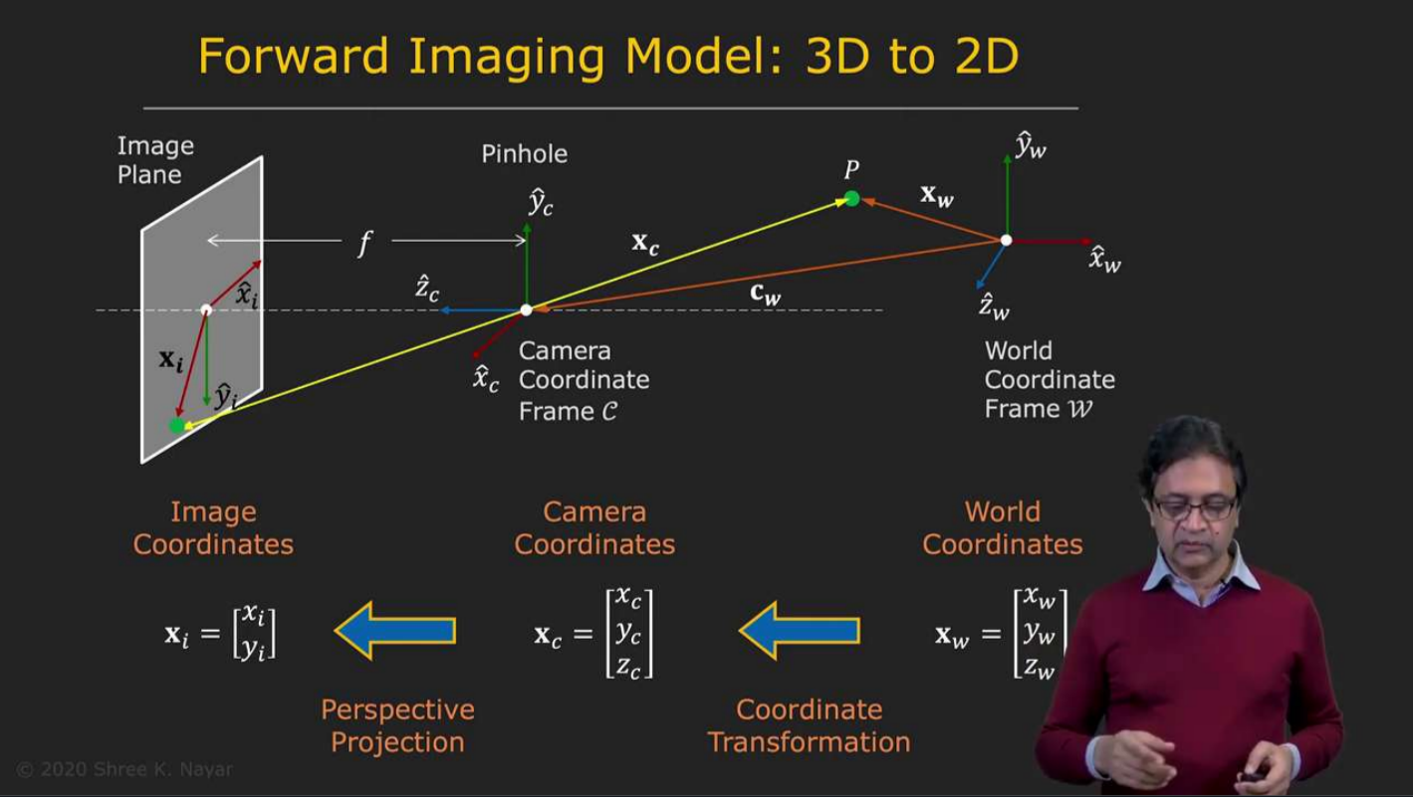How 3D scene become a 2D image

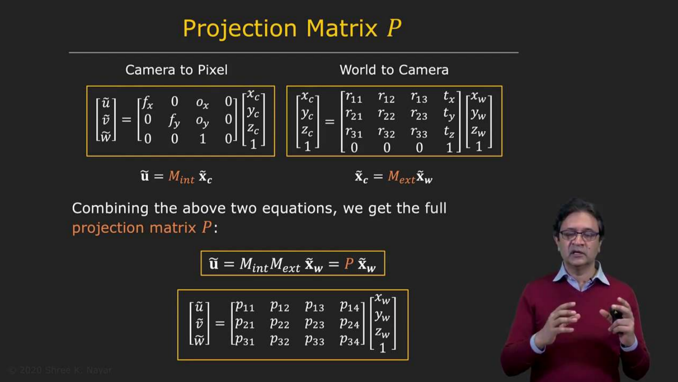

The final form of the projection Matrix

**Camera Model: Intrinsic and Extrinsic Parameters:**

A camera model consists of:

1. **Intrinsic Parameters** (Internal camera properties):
   * **Focal length (fx, fy)**: Defines how much the camera magnifies the scene.
   * **Principal point (cx, cy)**: The image center where the optical axis meets the image plane.
   * **Distortion coefficients (k1, k2, p1, p2, k3)**: Corrects radial and tangential distortions.
2. **Extrinsic Parameters** (Defines camera position and orientation):
   * **Rotation matrix (R)**: Describes how the camera is rotated.
   * **Translation vector (T)**: Defines the camera’s position in space.

Mathematical Model: The relationship between 3D world coordinates and 2D image points is:

where K is the intrinsic matrix, and [R | T] represents the extrinsic parameters.

**Steps of Camera Calibration:**

**📌 Step 1: Capture Chessboard Images**

* **Why?** A checkerboard pattern provides well-defined corners, which help estimate distortion parameters.
* The images used for calibration must be taken from different angles to ensure accurate parameter estimation.

**📌 Step 2: Detect Chessboard Corners**

* **Why?** Detecting corner points provides a mapping between the real-world 3D structure and the 2D image.
* This function detects the corners required for calibration.

ret, corners = cv2.findChessboardCorners(gray, checkerboard_size, None)

**📌 Step 3: Store Object Points and Image Points**

* **Why?** Object points represent real-world 3D coordinates, and image points represent their corresponding 2D projections**.**

objpoints.append(objp)

imgpoints.append(corners)

* **These lists store real-world and detected points for calibration.**

**📌 Step 4: Compute Camera Calibration Parameters**

* **Why?** Computes intrinsic parameters (camera matrix) and distortion coefficients.

ret, mtx, dist, rvecs, tvecs = cv2.calibrateCamera(objpoints, imgpoints, gray.shape[::-1], None, None)

* mtx: Intrinsic matrix (focal length, principal point).
* dist: Distortion coefficients (radial and tangential distortion).
* rvecs:
* tvecs:

**📌 Step 5: Apply Calibration to Remove Distortion**

* **Why?** Corrects lens distortion and produces an undistorted image.

undistorted_img = cv2.undistort(img, mtx, dist, None, new_camera_mtx)

* cv2.undistort() removes distortions using the calibration parameters.

Lets do step 1 and 2

**Task: Find Chessboard Corners for Calibration**

import cv2

import numpy as np

# Load a checkerboard image

img = cv2.imread('checkerboard.jpg')

gray = cv2.cvtColor(img, cv2.COLOR_BGR2GRAY)

# Define chessboard size (columns, rows)

checkerboard_size = (6, 9)

# Find chessboard corners

ret, corners = cv2.findChessboardCorners(gray, checkerboard_size, None)

# Draw detected corners

if ret:

    img = cv2.drawChessboardCorners(img, checkerboard_size, corners, ret)

    cv2.imshow('Detected Corners', img)

    cv2.waitKey(0)

    cv2.destroyAllWindows()

Lets do step 3 and 4

### **Task: Compute Camera Parameters**

* **Step 1:** Different viewpoints of check-board image is captured.

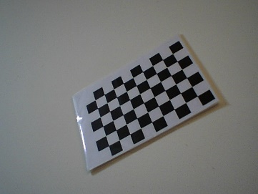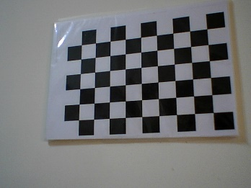

* **Step 2:** *Find Chessboard Corners for each image*

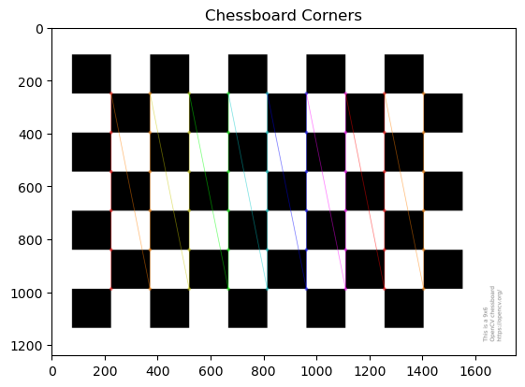

* **Step 3:** Store Object Points and Image Points
* **Step 4:** given all previous information we can calculate the camera parameters using *calibrateCamera() function*
* **Step 5:** print the extrinsic and intrinsic parameters

Code Example:

import cv2

import numpy as np

import glob

import os

# Define the chessboard size (columns, rows)

checkerboard_size = (6, 9)

# Prepare object points

objp = np.zeros((checkerboard_size[0] * checkerboard_size[1], 3), np.float32)

objp[:, :2] = np.mgrid[0:checkerboard_size[0], 0:checkerboard_size[1]].T.reshape(-1, 2)

# Store object points and image points

objpoints = []  # Real world 3D points

imgpoints = []  # 2D points in image plane

# Define the path to the folder containing calibration images

image_folder = r'C:\Users\m.nasif\Desktop\CV\Lab 5\Images'

# Get all image file paths in the folder

image_files = glob.glob(os.path.join(image_folder, '*.jpg'))  # Change '*.jpg' to '*.png' if needed

# Process each image

for fname in image_files:

    img = cv2.imread(fname)

    if img is None:

        print(f"Warning: Could not read {fname}")

        continue

    gray = cv2.cvtColor(img, cv2.COLOR_BGR2GRAY)

    ret, corners = cv2.findChessboardCorners(gray, checkerboard_size, None)

    if ret:

        objpoints.append(objp)

        imgpoints.append(corners)

# Perform camera calibration

ret, mtx, dist, rvecs, tvecs = cv2.calibrateCamera(objpoints, imgpoints, gray.shape[::-1], None, None)

# Print the camera matrix and distortion coefficients

print("Camera Matrix:\n", mtx)

print("Distortion Coefficients:\n", dist)

**Exercise 1:** Read image pattern from camera or folder and detect the pattern corners.

**Exercise 2:** Perform camera calibration using webcam and print the calibration parameters.

**Bonus Task: Augmented Reality (AR) with Calibration**

**🔹 Objective:**

Use camera calibration data to overlay a **virtual object** in a real-world scene.

**🛠️ Task:**

1. **Detect a chessboard pattern in real-time video.**
2. **Correct distortions** using the camera matrix.
3. **Overlay a 3D virtual object (cube or marker).**

Reference:

* [Open CV camera calibration](https://docs.opencv.org/4.x/dc/dbb/tutorial_py_calibration.html)
* [Video Tutorials for the theoretical part](https://www.youtube.com/playlist?list=PL2zRqk16wsdoCCLpou-dGo7QQNks1Ppzo)