

***Lab 6***

**SIFT Detector and Features Matching with OpenCV**

**Learning Objectives:**

* Understand how SIFT works and why it is useful.
* Detect keypoints and compute descriptors using SIFT.
* Perform feature matching between two images..
* Use SIFT for applications like object recognition and image stitching

**Introduction**

Feature detection and matching are fundamental techniques in computer vision used to identify corresponding points in different images. These techniques enable tasks such as **object recognition, image stitching, 3D reconstruction, augmented reality, and autonomous navigation**.

Among the most powerful feature detection methods is the **Scale-Invariant Feature Transform (SIFT)** algorithm, which extracts unique keypoints and descriptors that remain consistent across different scales, rotations, and lighting conditions.

**1️⃣ Understanding SIFT (Scale-Invariant Feature Transform)**

**📌 Why Is SIFT Important?**

SIFT is a widely used method for detecting and describing local features in images. Unlike traditional edge detection methods, SIFT keypoints are:

* **Scale-invariant:** They remain consistent regardless of the image size.
* **Rotation-invariant:** They can be detected in different orientations.
* **Illumination-robust:** They work well under varying lighting conditions.

📌 How Does SIFT Work?

* **Scale-space extrema detection:** Identifies keypoints at different scales.
* **Keypoint localization:** Filters out low-contrast keypoints.
* **Orientation assignment:** Ensures keypoints are rotation-invariant.
* **Descriptor computation:** Creates a feature vector for each keypoint.

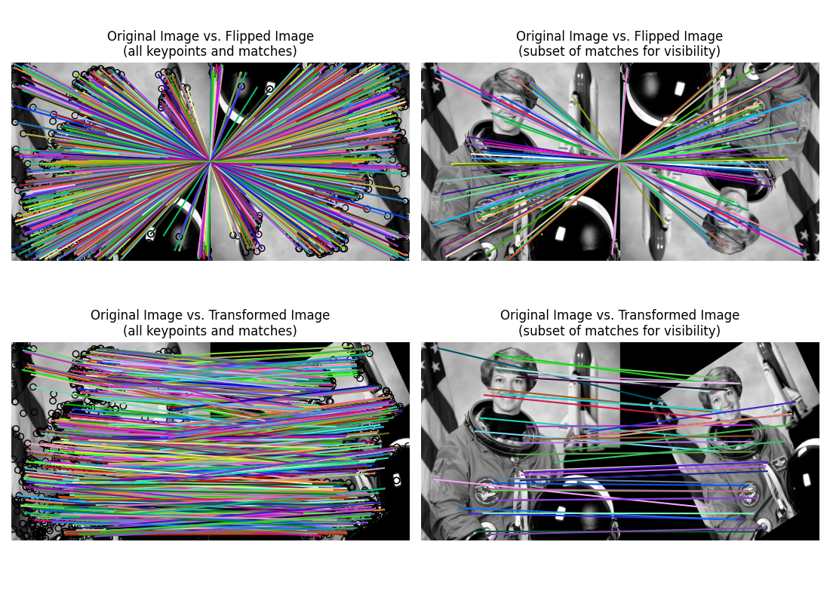

**2️⃣ Detecting SIFT Features**

**🛠️ Task: Extract SIFT Keypoints from an Image**

import cv2

import numpy as np

# Load an image

gray = cv2.imread('image.jpg', cv2.IMREAD_GRAYSCALE)

# Initialize SIFT detector

sift = cv2.SIFT_create()

# Detect keypoints and compute descriptors

keypoints, descriptors = sift.detectAndCompute(gray, None)

# Draw keypoints on the image

img_keypoints = cv2.drawKeypoints(gray, keypoints, None, flags=cv2.DRAW_MATCHES_FLAGS_DRAW_RICH_KEYPOINTS)

cv2.imshow('SIFT Keypoints', img_keypoints)

cv2.waitKey(0)

cv2.destroyAllWindows()

**3️⃣ Understanding Feature Matching**

**📌 Why Is Feature Matching Important?**

Feature matching allows us to compare images and recognize patterns despite changes in **scale, rotation, illumination, and perspective**. It enables:

* **Object recognition:** Identifying objects in different images.
* **Image stitching:** Combining multiple images to create panoramas.
* **3D reconstruction:** Estimating depth and structure from multiple images.
* **Augmented reality (AR):** Detecting real-world surfaces to overlay virtual content.
* **Autonomous navigation:** Enabling robots and self-driving cars to recognize landmarks and objects.

**📌 How Does Feature Matching Work?**

1. **Feature Detection:** Identify keypoints in an image (e.g., edges, corners, textures).
2. **Descriptor Computation:** Generate unique numerical representations of each keypoint.
3. **Feature Matching:** Compare descriptors between two images to find corresponding features.
4. **Filtering Matches:** Apply techniques like Lowe’s ratio test to remove weak matches.

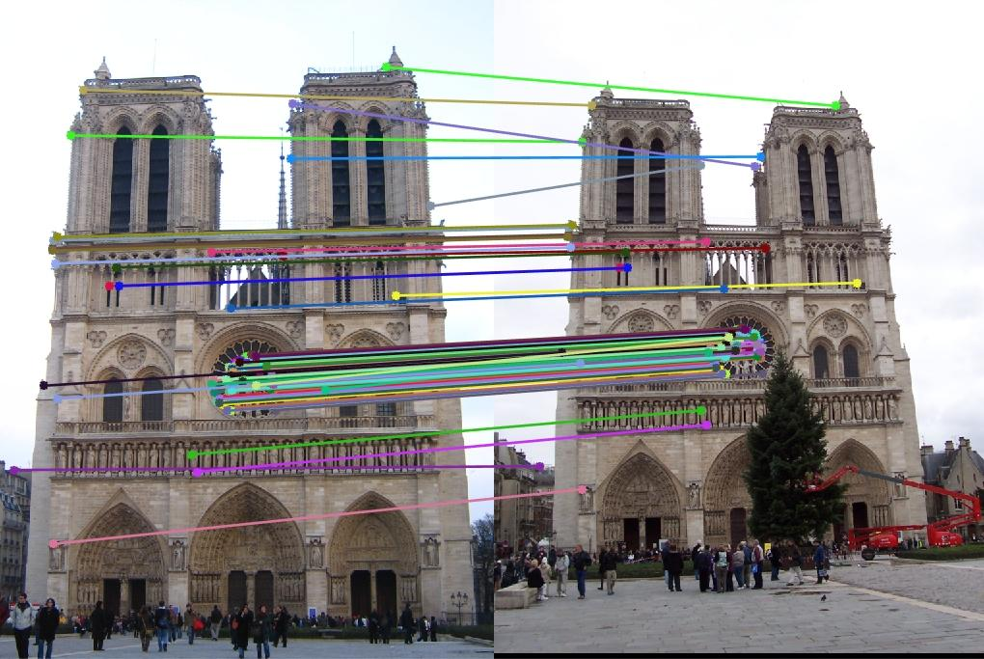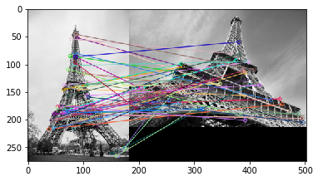

**4️⃣ Feature Matching with SIFT**

**🛠️ Task: Match Features Between Two Images**

# Load two images

gray1 = cv2.imread('image1.jpg', cv2.IMREAD_GRAYSCALE)

gray2 = cv2.imread('image2.jpg', cv2.IMREAD_GRAYSCALE)

# Detect and compute features

sift = cv2.SIFT_create()

kp1, des1 = sift.detectAndCompute(gray1, None)

kp2, des2 = sift.detectAndCompute(gray2, None)

# Use BFMatcher for feature matching

bf = cv2.BFMatcher()

matches = bf.knnMatch(des1, des2, k=2)

# Apply ratio test (Lowe's ratio test)

good_matches = []

for m, n in matches:

if m.distance < 0.75 * n.distance:

good_matches.append(m)

# Draw matches

img_matches = cv2.drawMatches(gray1, kp1, gray2, kp2, good_matches, None, flags=cv2.DrawMatchesFlags_NOT_DRAW_SINGLE_POINTS)

cv2.imshow('SIFT Feature Matching', img_matches)

cv2.waitKey(0)

cv2.destroyAllWindows()

**🛠️ Exercise 1: Extract SIFT Keypoints from an Image**

**Objective:**

Extract and visualize SIFT keypoints from an image to understand how local features are detected.

Instructions:

1. *Load an image and convert it to grayscale.*
2. *Use SIFT to detect keypoints and compute descriptors.*
3. *Draw the detected keypoints on the image and display it.*

**🛠️ Exercise 2: Match Features Between Two Images**

**Objective:**

Match features between two images using SIFT and Brute Force Matcher to find correspondences.

Instructions:

1. *Load two images and convert them to grayscale.*
2. *Detect and compute SIFT features in both images.*
3. *Use Brute Force Matcher (BFMatcher) to find feature correspondences.*
4. *Filter matches using Lowe's ratio test.*
5. *Draw the matching keypoints between the two images and display them.*

**References:**

* [**OpenCV**](https://docs.opencv.org/4.x/da/df5/tutorial_py_sift_intro.html)
* [**Good Article**](https://medium.com/@deepanshut041/introduction-to-sift-scale-invariant-feature-transform-65d7f3a72d40)
* [**Youtube**](https://www.youtube.com/watch?v=KgsHoJYJ4S8)