

*AI 407 – Introduction to Robotics*

**Lab 2 Manual**

**Introduction to ROS and Installation**

* **Lab objectives**
* **Introduction to ROS 1 & ROS 2**
* **Installing ROS 2**
* **Running Basic ROS 2 Commands**:

o   Running a simple demo like a "talker" and "listener" node to demonstrate communication between ROS 2 nodes.

* **Lab Requirements**
* **Software:** Ubuntu 22.04 LTS, ROS 2 Humble
* **Hardware:** Students should work on Lab Devices
* **Before You Start**

Kindly read the manual, review the references if any, before beginning implementation.

* **Introduction to ROS 1 & ROS 2**

Kindly review the following power point file, which covers the introduction to ROS 1 and ROS 2, including their key features, components, and differences.

[AI407-Spring25-Lab2-ROS.pptx](https://pmqu-my.sharepoint.com/:p:/g/personal/r_jomaa_upm_edu_sa/EUsiLLkhYf5DrhMy3HmsfVwB8BlSRts3IvP5R5Su9XZvAQ?e=sZh9Mg)

* **Installing ROS 2**

Kindly follow the commands in the documentation below to install ROS 2

[Ubuntu (deb packages) — ROS 2 Documentation: Humble documentation](https://docs.ros.org/en/humble/Installation/Ubuntu-Install-Debs.html)

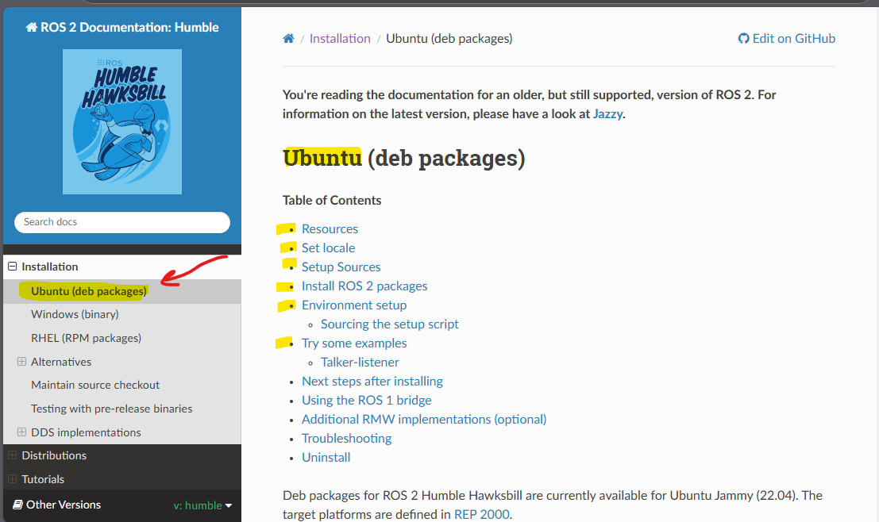

* **Running Basic ROS 2 Commands:**

**1. Verify that you installed ROS2**

**Open a new terminal, run the command** *ros2* **and show the output:**

**Put screenshot of your work here:**

**It is already installed in the PC**

**_________________________________________________________________________________**

**2. Talker-listener example**

If you installed ros-humble-desktop above, you could try some examples.

1.      In one terminal, source the setup file and then run a Python talker:

*source /opt/ros/humble/setup.bash*

*ros2 run demo_nodes_py talker*

2.      In another terminal source the setup file and then run a Python listener:

*source /opt/ros/humble/setup.bash*

*ros2 run demo_nodes_py listener*

You should see the talker saying that it’s Publishing messages and the listener saying I heard those messages.

**Put screenshot of your work here:**

*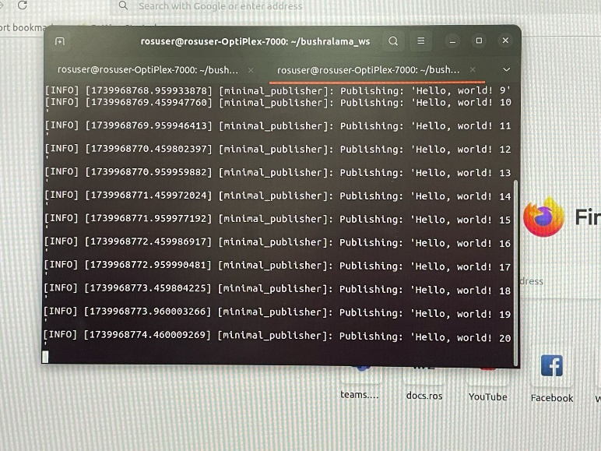صورة تحتوي على نص, لقطة شاشة, الإلكترونيات, عرض

قد يكون المحتوى المعد بواسطة الذكاء الاصطناعي غير صحيح.*

**_________________________________________________________________________________**

**3. Source ROS 2 Setup File**

Before using ROS 2, you need to source the setup file in every terminal session. But you can make this automatic, by adding it to your ~/.bashrc:

*echo "source /opt/ros/humble/setup.bash" >> ~/.bashrc*

*source ~/.bashrc*

**Put screenshot of your work here:**

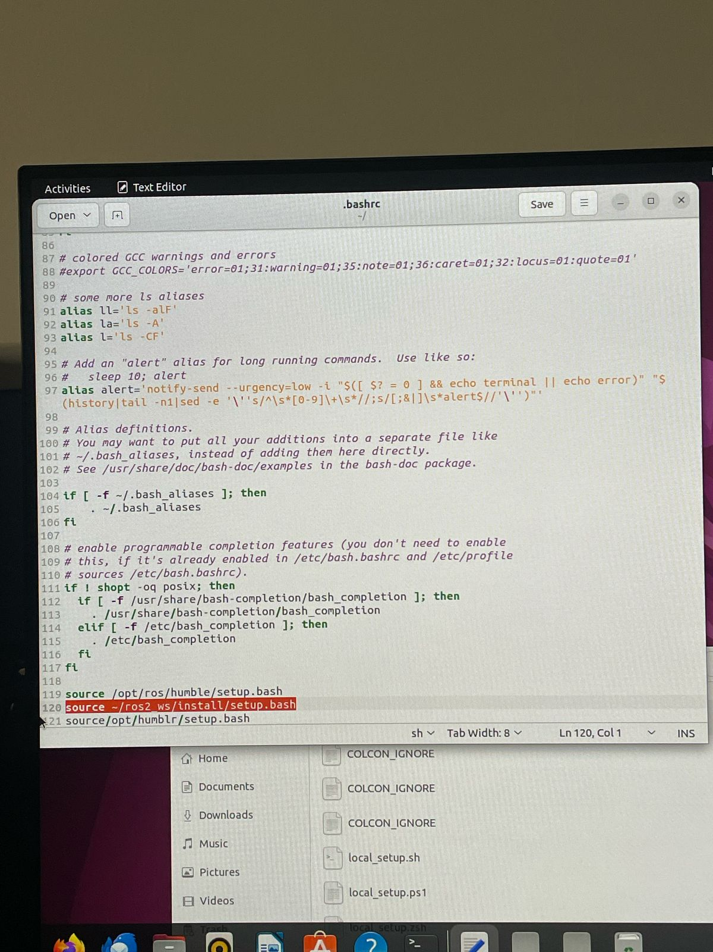

**_________________________________________________________________________________**

**4. Check ROS 2 Environment**

Run: *printenv | grep ROS* You should see output like this:

ROS_VERSION=2

ROS_PYTHON_VERSION=3

ROS_DOMAIN_ID=0

ROS_LOCALHOST_ONLY=1

ROS_DISTRO=humble

**Put screenshot of your work here:**

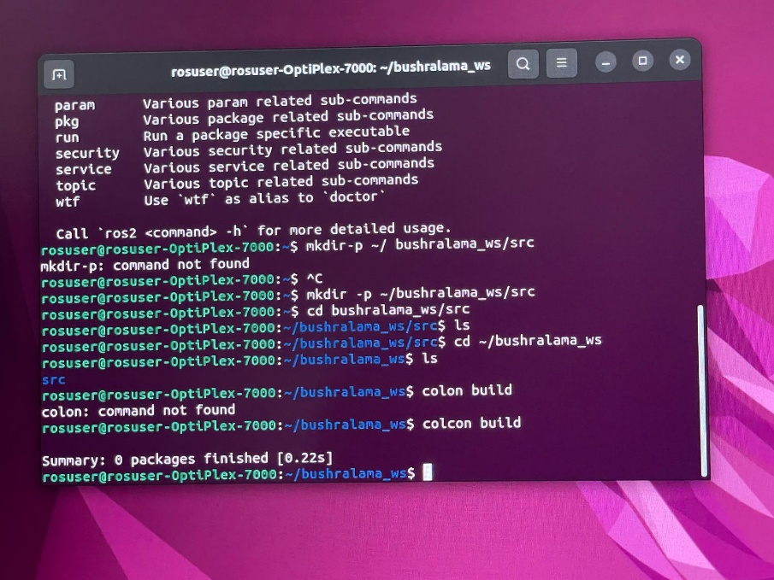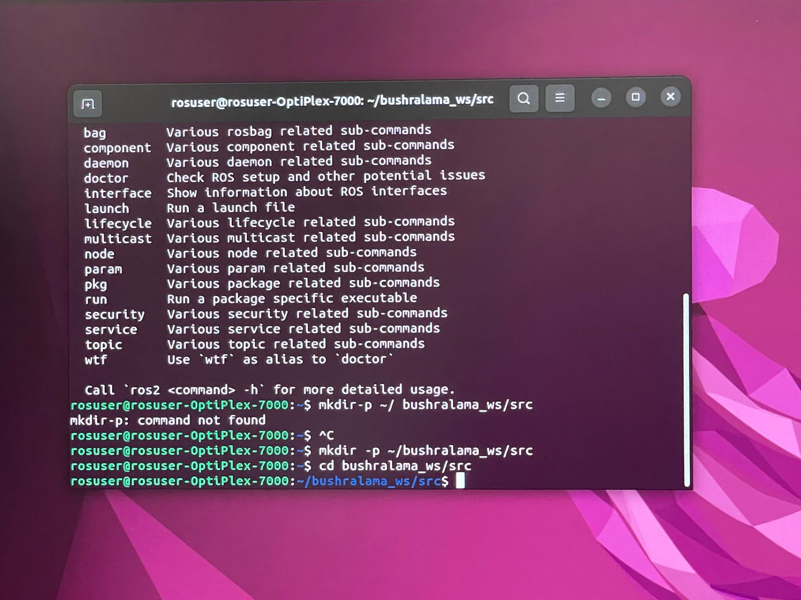

**References**

[**Ubuntu (deb packages) — ROS 2 Documentation: Humble documentation**](https://docs.ros.org/en/humble/Installation/Ubuntu-Install-Debs.html)

[**Documentation - ROS Wiki**](https://wiki.ros.org/)