Name: Abubakar Waziri

ID: 4220056

Lab02, OS

Q1:

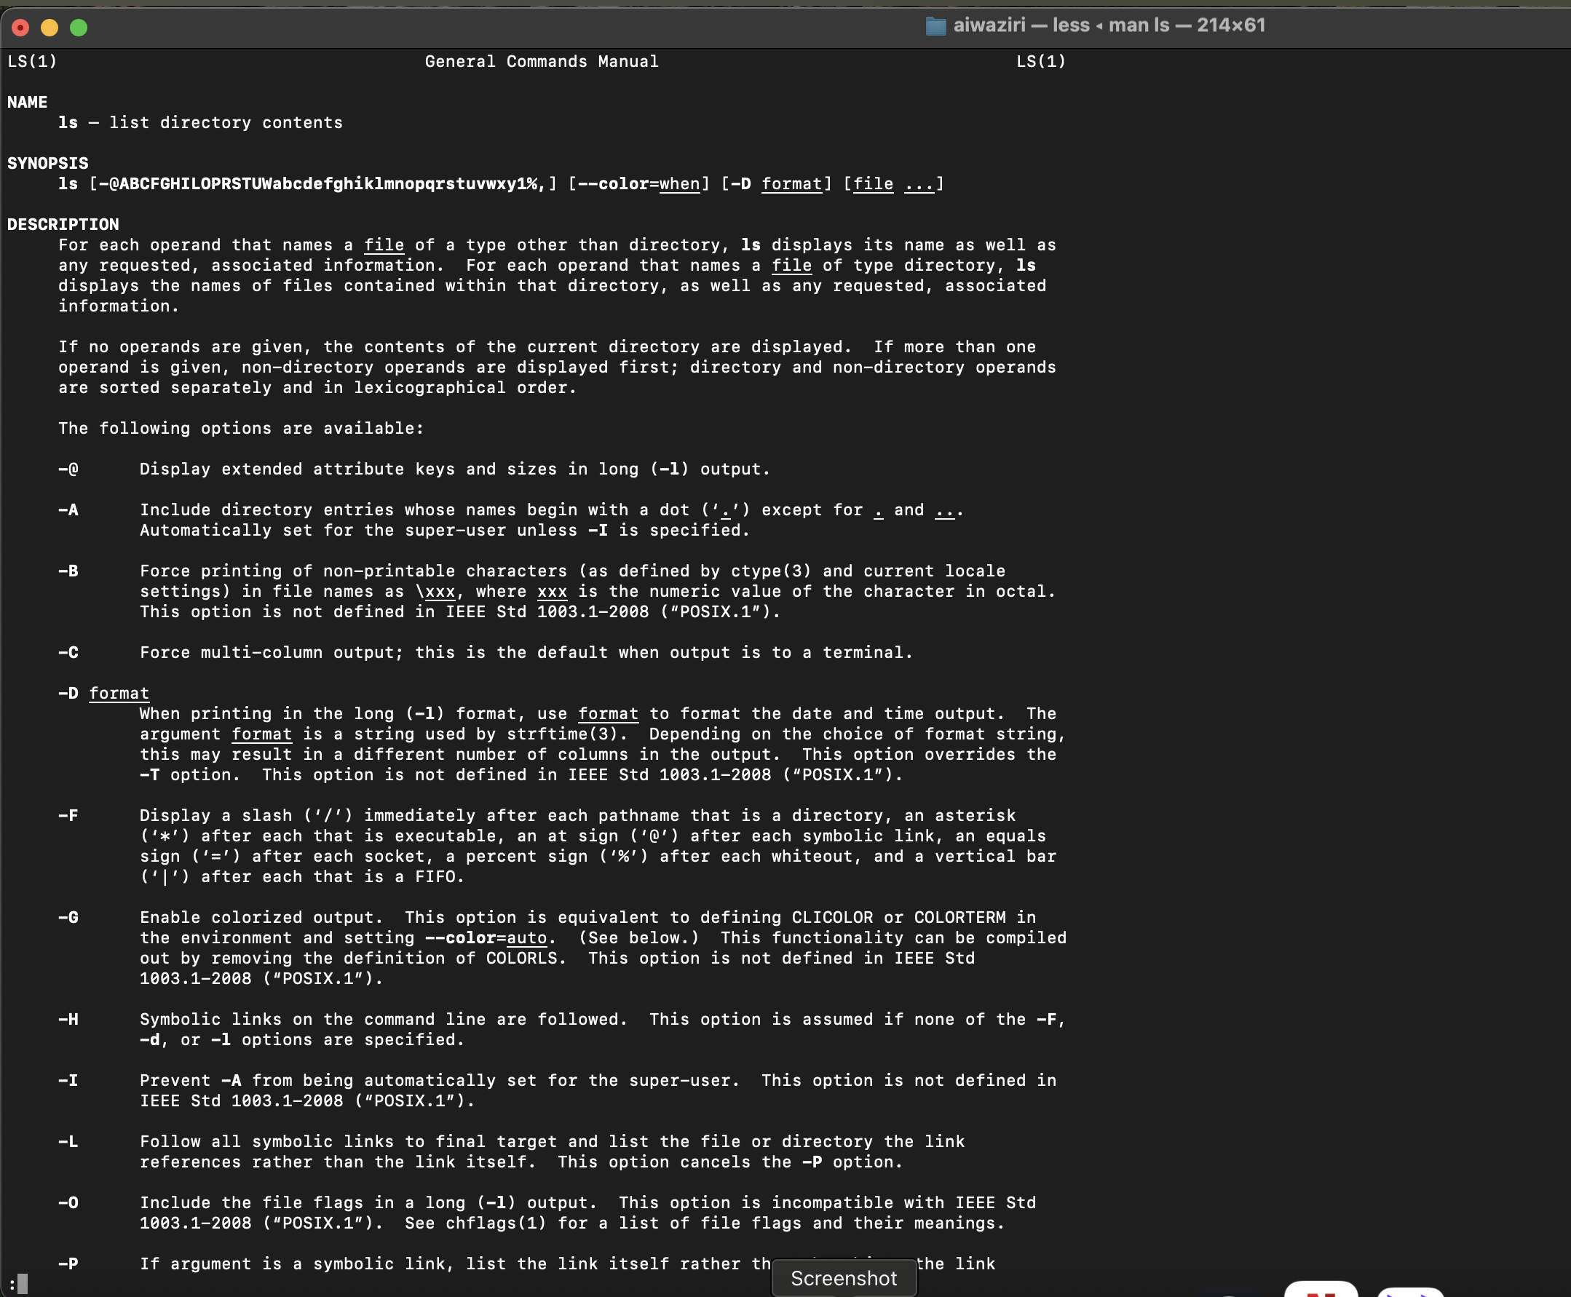

2a.

2b.

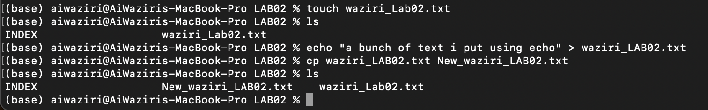

2c.



2d.

2e.



3a.



3b.



3c.

3d.



3e.

