Name: Abubakar Waziri

ID: 4220056

Q1a:

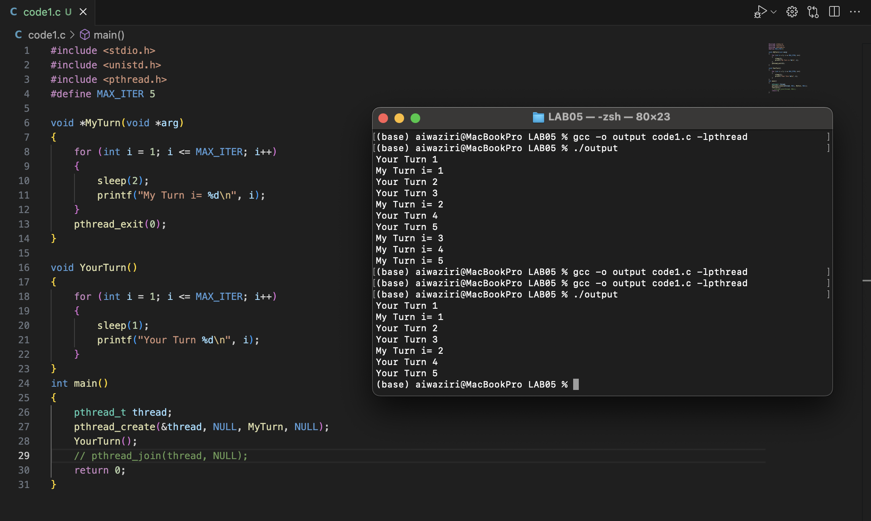

Explanation: YES

Removing ***pthread_join()***will lead to incomplete execution of the ***MyTurn***thread, resulting in missing output from that thread.

Q1b:

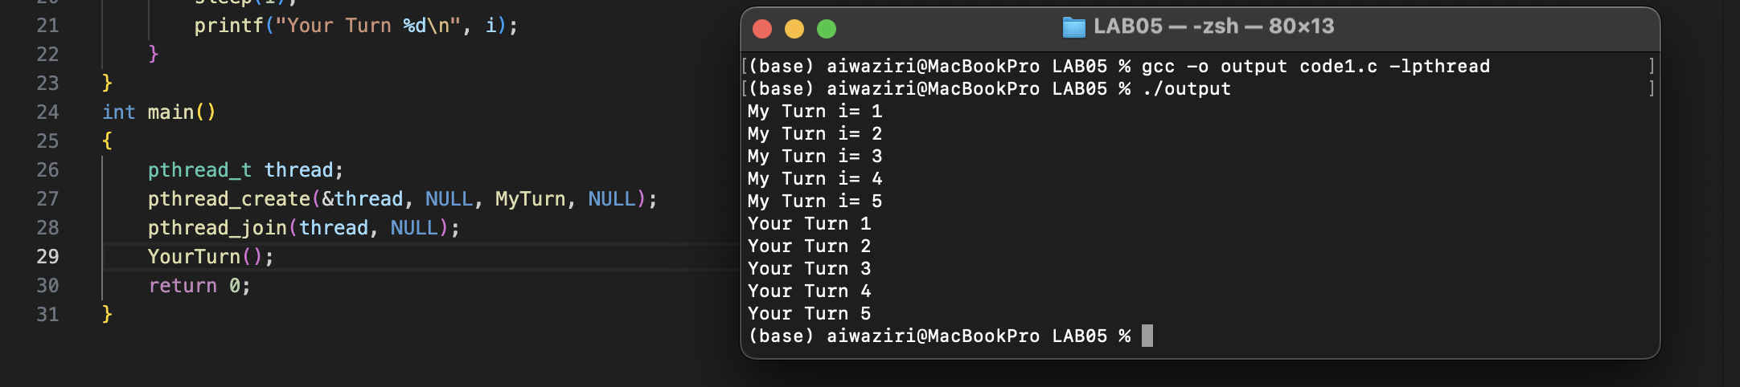

**Explanation of Output:**

1. The ***MyTurn*** thread starts and prints "*My Turn i= 1" to "My Turn i= 5*", with a 2-second sleep between each print.
2. The *pthread_join(thread, NULL);* ensures that the main thread waits for the ***MyTurn*** thread to complete before proceeding.
3. After the ***MyTurn*** thread completes, the ***YourTurn*** function is called, which prints "Your Turn 1" to "Your Turn 5", with a 1-second sleep between each print.

Q1c:

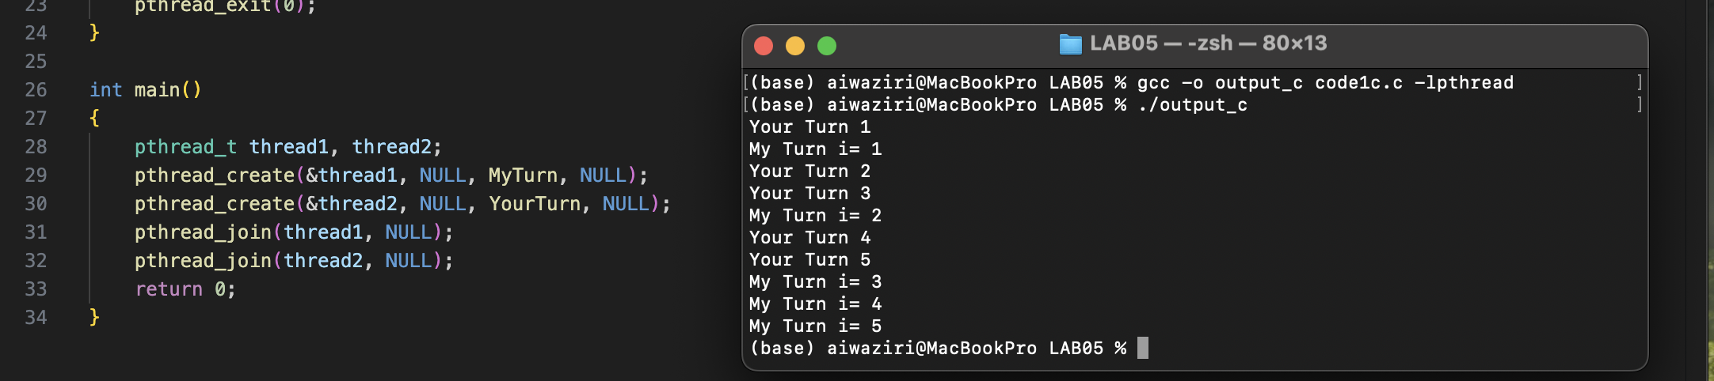

Q2a:

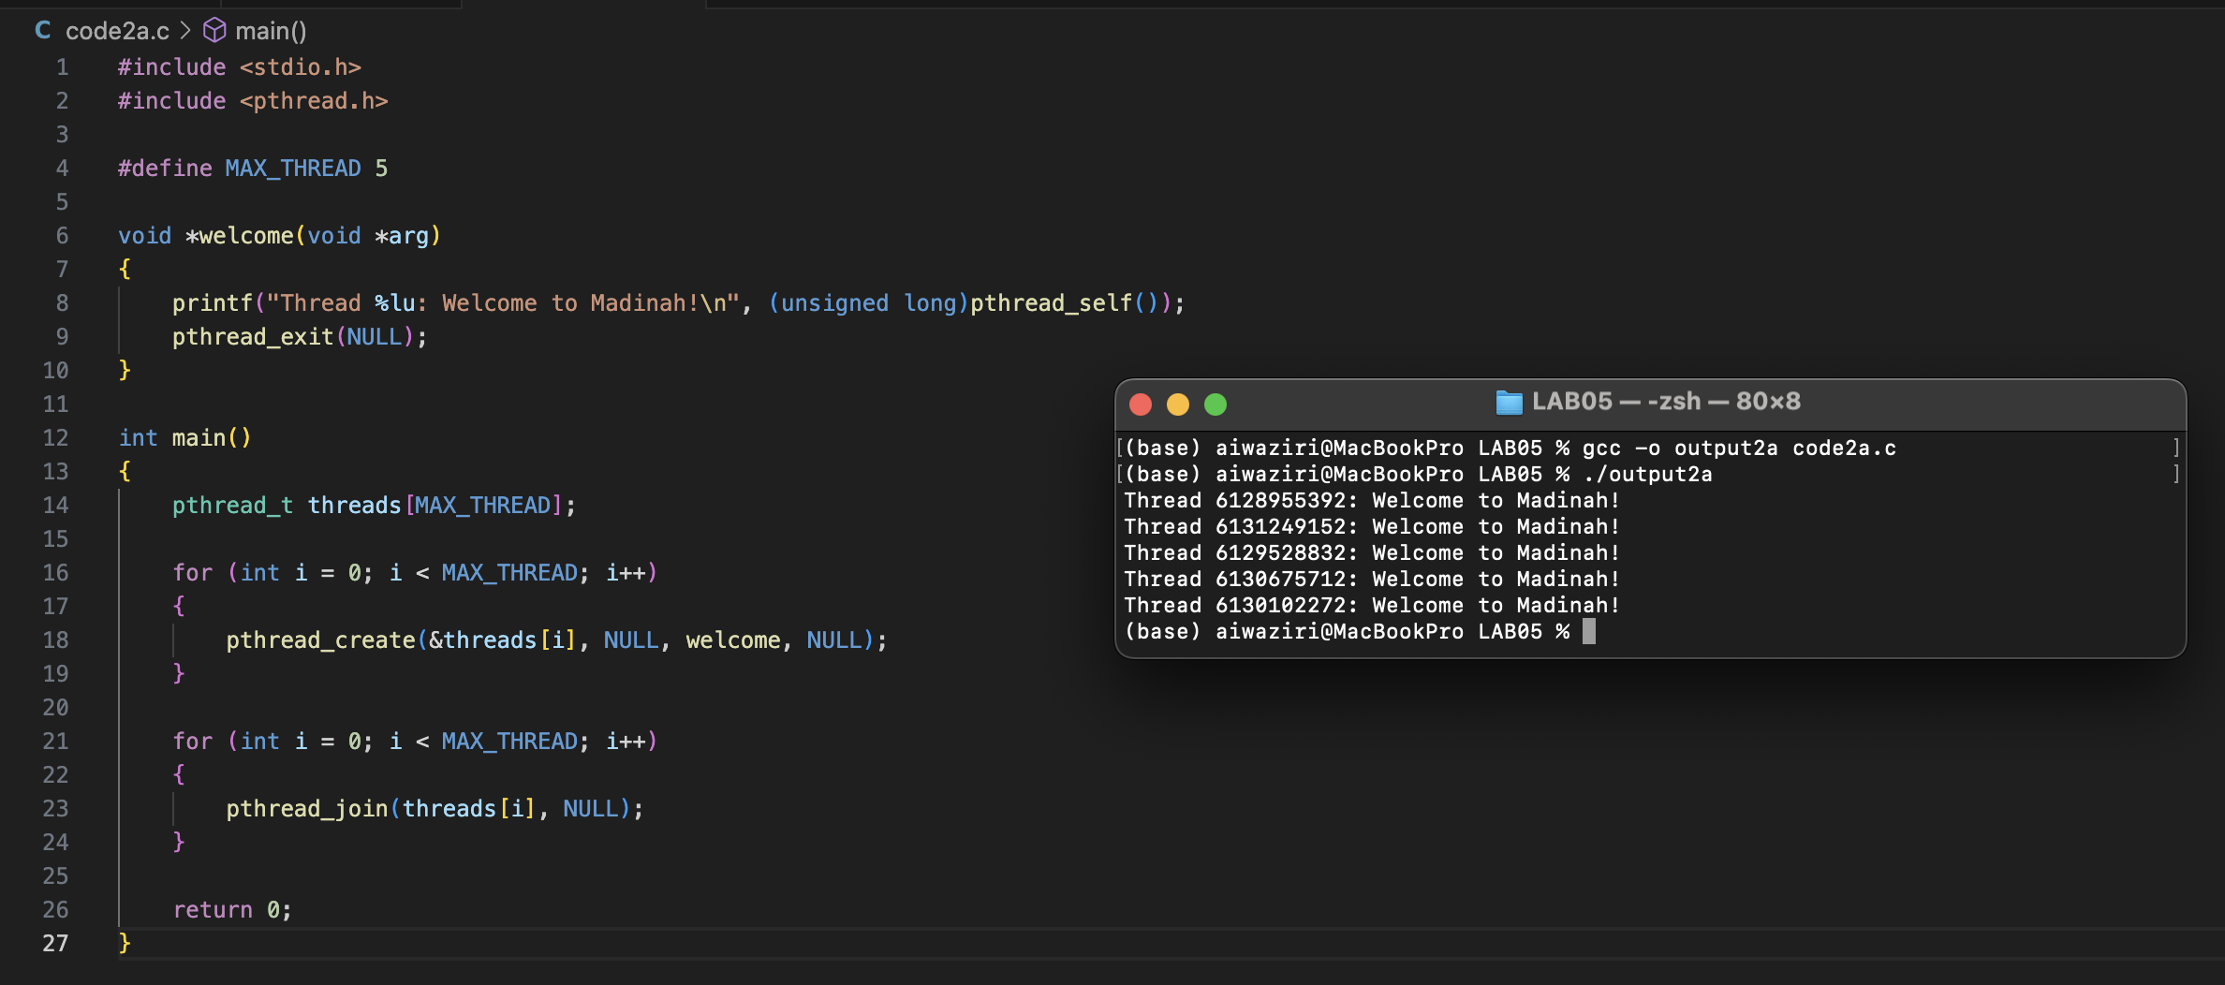

Q2b:

