# Bayes' Theorem for Medical Diagnosis

**Problem Statement**

Calculate the probability of having a disease given a positive test result using Bayes' Theorem.

**Given:**

* Prior probability of having the disease, P(A)=0.01P(A) = 0.01P(A)=0.01
* Test sensitivity (probability of testing positive given disease), P(B∣A)=0.95P(B \mid A) = 0.95P(B∣A)=0.95
* Test specificity (probability of testing negative given no disease), P(not B∣not A)=0.90P(\text{not } B \mid \text{not } A) = 0.90P(not B∣not A)=0.90

### **Calculations**

**Code:**

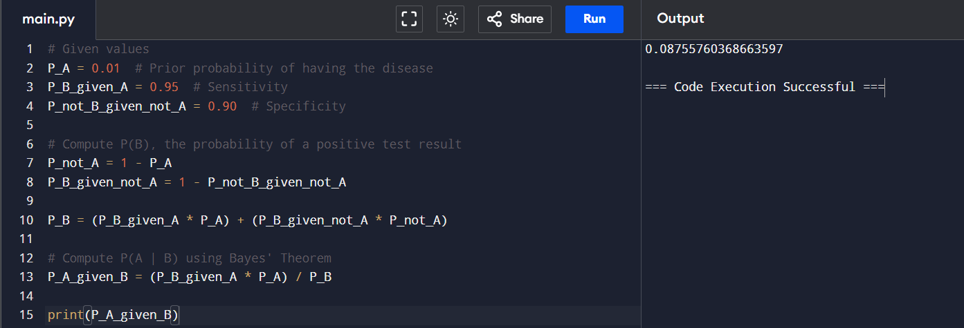

**2. Eigenvalues and Eigenvectors of a Matrix**

**Problem Statement**

Find the eigenvalues and eigenvectors of the matrix A=(4123)A = \begin{pmatrix} 4 & 1 \\ 2 & 3 \end{pmatrix}A=(42​13​).

**Calculations**

**Code:**

**3. Determinant and Inverse of a 3x3 Matrix**

**Problem Statement**

Calculate the determinant and inverse of the matrix A=(123014560)A = \begin{pmatrix} 1 & 2 & 3 \\ 0 & 1 & 4 \\ 5 & 6 & 0 \end{pmatrix}A=​105​216​340​​.

**Calculations**

**Code:**

**4. Properties and Applications of the Normal Distribution**

**Problem Statement**

Describe the properties of the Normal distribution and calculate the probability for a normally distributed variable.

**Given:**

* Mean (μ\muμ) = 100
* Standard deviation (σ\sigmaσ) = 15
* Find the probability that XXX is less than 120.

**Calculations**

**Code:**

