COMP SCI BYTES
Biannual Technical Magazine

DEPARTMENTAL ACTIVITIES:
- A 5-day workshop on AI Applications was conducted for 4th-semester students.
- Department hosted TechFusion 2024, showcasing 30 innovative student prototypes.
- Organized an expert session on Cyber-Physical Systems for final-year students.

GUEST LECTURES – DELIVERED BY THE FACULTY:
• Dr. Asha Rao delivered a lecture on Federated Learning in Healthcare at NITK.
• Prof. Sunder presented Secure Data Encoding at JSS Science & Technology University.

GUEST LECTURE/S – INVITED:
• Mr. Vivek Rao (Adobe) presented “Modern Frontend Architectures for Scalable Web Platforms.”
• Dr. Kavita Gopal (IISc) delivered a talk on “Deep Learning Approaches for Biomedical Imaging.”

FACULTY PUBLICATIONS IN (NATIONAL / INTERNATIONAL) JOURNALS:
Sl. No | Title of Publication | Journal Details | Faculty Name
1 | Optimized CNN Model for Medical Scan Analysis | Elsevier, 2024 | Dr. Meera
2 | Low-Latency IoT Algorithms for Smart Mobility | IJCA, 2024 | Prof. Gautham
3 | Secure P2P Blockchain Auditing | Springer, 2024 | Prof. Rakesh

FACULTY PUBLICATIONS IN (NATIONAL / INTERNATIONAL) CONFERENCES:
Sl. No | Title | Conference | Faculty Name
1 | Lightweight Encryption Models | IEEE ICMLA 2024 | Prof. Divya
2 | Drone-Assisted GIS Modelling | ACM SIGSPATIAL 2024 | Dr. Shankar

FACULTY ACHIEVEMENTS:
• Dr. Preethi awarded Young Researcher Award 2024.
• Prof. Alok selected as Mentor for Smart India Hackathon 2024.

FUNDED PROJECTS:
Project Title | Funding Agency | Amount | Faculty PI
AI-Driven Soil Nutrient Analysis | DST | ₹6,50,000 | Dr. Latha
Vision-Based Autonomous Wheelchair | MSME | ₹7,20,000 | Prof. Kumar

PATENTS:
Patent Title | Status | Application Number
Wearable Health Index Monitor | Filed | 2024/001234
Real-Time Vehicle Motion Predictor | Published | 2024/004321

STUDENT PUBLICATIONS:
Sl. No | USN | Name | Publication Details
1 | 1RT21CS001 | Anagha R | “Smart Irrigation Using IoT”, IJERT 2024
2 | 1RT21CS078 | Manoj S | “Sign Language Recognition using DL”, Springer LNCS
3 | 1RT20CS114 | Riya P | “AI-Assisted Study Planner”, IEEE Xplore

STUDENT ACHIEVEMENTS:
Co-curricular Activities
Sl. No | Name of Student | USN | Sem | Activity | Award/Honor | Level
1 | Pooja R | 1RT21CS012 | 6 | Code-a-thon 2024 | Winner | State
2 | Sharan M | 1RT20CS045 | 7 | Data Science Challenge | Runner-Up | National
Extra-curricular Activities
Sl. No | Name of Student | USN | Sem | Activity | Award/Honor | Level
1 | Rithika R | 1RT21CS031 | 6 | Classical Dance | Gold Medal | State
2 | Madhav K | 1RT20CS063 | 7 | Volleyball | Bronze Medal | VTU

PLACEMENT AND HIGHER STUDIES RECORD:
Placement Details
Program | Total Students | Registered | Placed | Percentage | Min/Max Package
UG | 165 | 150 | 138 | 92% | ₹3.6 LPA / ₹18 LPA
PG | 24 | 22 | 17 | 77% | ₹4.2 LPA / ₹12 LPA

Higher Studies
Sl. No | Name | USN | PG/PhD | University | Place
1 | Aisha Q | 1RT20CS077 | MS | University of Toronto | Canada
2 | Rohan S | 1RT21CS022 | M.Tech | IISc Bangalore | India

TECHNICAL ARTICLES:

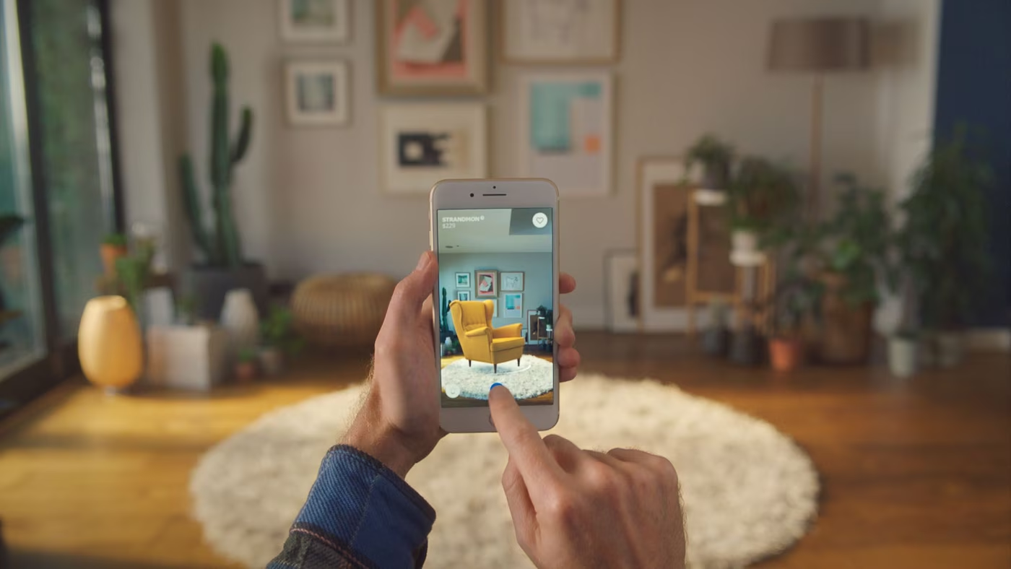

Augmented Reality vs Virtual Reality - Exploring The Battle of Immersive Technologies
Augmented Reality (AR) overlays virtual elements onto real environments, enhancing user perception.
Virtual Reality (VR) immerses users into digitally created worlds using specialized headsets.
Both technologies have applications in simulation, healthcare, training, education, gaming, and design.

