COMP SCI BYTES
Biannual Technical Magazine

DEPARTMENTAL ACTIVITIES:
- Organized an International Webinar on Quantum Computing Fundamentals.
- Conducted a hands-on workshop on Full-Stack Development with React and Node.js.
- Hosted the annual event CodeNova 2024, where 45 teams presented mini-projects.

GUEST LECTURES – DELIVERED BY THE FACULTY:
• Dr. Harini delivered a masterclass on AI-Based Image Segmentation at BITS Pilani.
• Prof. Deepak conducted an expert session on Blockchain Smart Contracts.

GUEST LECTURE/S – INVITED:
• Mr. Arjun Raman (Google) presented a talk on LLM Deployment in Production Environments.
• Dr. Nivedita (IIT Madras) delivered a lecture on Efficient Reinforcement Learning Models.

FACULTY PUBLICATIONS IN (NATIONAL / INTERNATIONAL) JOURNALS:
Sl. No | Title of Publication | Journal Details | Faculty Name
1 | Adaptive Spiking Neural Models | Nature Applied Sciences | Dr. Harini
2 | Real-Time Big Data Analytics Pipeline | IEEE Access, 2024 | Prof. Naveen
3 | Distributed Computing for Smart Sensors | Elsevier IoT Journal | Dr. Varun

FACULTY PUBLICATIONS IN (NATIONAL / INTERNATIONAL) CONFERENCES:
Sl. No | Title | Conference | Faculty Name
1 | Efficient Model Pruning Techniques | ACM CoNEXT 2024 | Prof. Priya
2 | AI-Driven Route Optimization | IEEE ICRA 2024 | Dr. Manoj

FACULTY ACHIEVEMENTS:
• Prof. Leena received the Innovative Teacher Award 2024.
• Dr. Naveen appointed as Reviewer for IEEE Transactions on AI.

FUNDED PROJECTS:
Project Title | Funding Agency | Amount | Faculty PI
AI-Powered Skin Cancer Detection | ICMR | ₹8,50,000 | Dr. Harini
Indoor Navigation for Visually Impaired | DST | ₹5,80,000 | Prof. Raman

PATENTS:
Patent Title | Status | Application Number
Smart Garbage Segregation System | Filed | 2024/008921
Real-Time Gesture Authentication | Published | 2024/006743

STUDENT PUBLICATIONS:
Sl. No | USN | Name | Publication Details
1 | 1RT21CS020 | Meghana S | “AI Tutor for Personalized Learning,” IJCTET 2024
2 | 1RT21CS089 | Arvind M | “Low-Cost Robotics Arm Control,” IEEE ICMA 2024
3 | 1RT20CS033 | Kavya H | “Face Mask Detection System,” Springer CCIS

STUDENT ACHIEVEMENTS:
Co-curricular Activities
Sl. No | Name of Student | USN | Sem | Activity | Award/Honor | Level
1 | Charan R | 1RT21CS057 | 6 | AI Art Competition | Winner | VTU
2 | Nisha K | 1RT20CS111 | 7 | Ethical Hacking Contest | Runner-Up | National
Extra-curricular Activities
Sl. No | Name of Student | USN | Sem | Activity | Award/Honor | Level
1 | Aditya P | 1RT21CS099 | 6 | Table Tennis | Gold Medal | State
2 | Swetha V | 1RT20CS090 | 7 | Short Film Making | Best Creative Award | VTU

PLACEMENT AND HIGHER STUDIES RECORD:
Placement Details
Program | Total Students | Registered | Placed | Percentage | Min/Max Package
UG | 170 | 160 | 144 | 90% | ₹4 LPA / ₹21 LPA
PG | 18 | 16 | 12 | 75% | ₹5 LPA / ₹14 LPA

Higher Studies
Sl. No | Name | USN | PG/PhD | University | Place
1 | Shruti M | 1RT21CS007 | MS | University of Melbourne | Australia
2 | Pranav S | 1RT20CS058 | M.Tech | NIT Trichy | India

TECHNICAL ARTICLES:

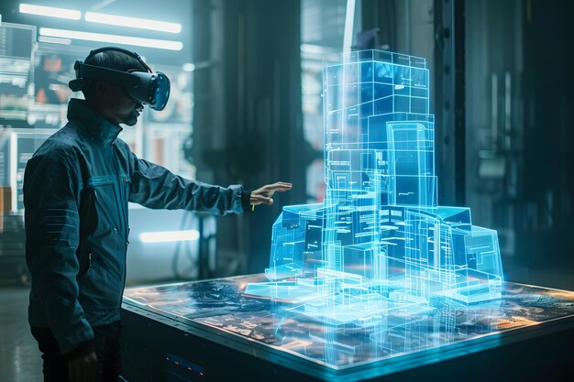

Quantum Computing: Breaking the Barriers of Classical Computation
Quantum computing leverages qubits to perform large-scale computation at unprecedented speeds.
This technology is expected to revolutionize cryptography, drug discovery, optimization, and scientific simulations.
Although still in early stages, its potential impact makes it one of the most promising computing paradigms of the decade.

