OPERATING SYSTEMS PROJECT REVIEW 2 REPORT
Lab Assessment 9: Methodology and Partial Implementation
Date: October 14, 2026
S.no | Name | Registration No
1 | Krishna | 24BCE0732
2 | Aaditya Jaiswal | 24BCE2584

Project title: Thermal-Aware User-Space Regulation of Background Workloads to Protect Foreground Responsiveness on a Windows Laptop
How to use this file: Text highlighted in yellow must be filled or checked by the team before submission. Fill only what is really done and real. Do not paste made-up numbers.

0. Recap of the Problem and Updated Claim
A laptop CPU has one shared heat and power limit for all its cores. Heavy background work (for example compiling or compressing) can heat the CPU until the whole CPU slows down. Then the program the user is working on slows down too, even if it still gets CPU time.
Update after a deeper literature check: thermal control of background work already exists in mobile phones and in patents (see Section 10). Process Lasso and Windows EcoQoS also lower background priority, but they are not driven by a measured temperature trend. We therefore do not claim that nobody has done background throttling. Our claims are:
- We measure how much foreground slowdown comes from CPU sharing and how much from shared heat or power limits, on a Windows laptop.
- We test a simple controller that reacts to how fast the temperature is rising, and compare it with no control, a static low priority, and a fixed temperature limit.
- A calibration step finds what counts as heavy load on each laptop, because the same task can be heavy on one laptop and light on another.

1. Detailed Methodology
The system works in three phases.

Phase A: Calibrate
The tool runs an increasing number of CPU workers on the laptop, one more every 90 seconds, and watches temperature and CPU speed. It finds the point where the laptop starts to slow down (throttle onset). That worker count becomes "heavy load" for this laptop. All temperature limits are calculated from this data. No fixed value such as 75 C is used. If the laptop never throttles, we report that as a finding.

Phase B: Measure (separate contention from throttling)
A small foreground program (the probe) does a short task again and again and records how long each task takes. A heavy background job runs at the same time. We run four cases with no control:
Case | Setup | What a slowdown means
A | Foreground alone | Baseline
B | Background on other CPU cores than the foreground | Slowdown is from shared heat or power limits only
C | Background on the same core as the foreground | Slowdown is sharing plus heat or power limits
D | Same as C, background at low priority | Shows what priority alone can fix

Phase C: Control
A controller watches temperature every second and limits the CPU share of the background job. Four modes are compared:
Mode | Name | Rule
M0 | No control | Do nothing
M1 | Static low priority | Set background priority low once, then leave it
M2 | Fixed threshold | If temperature reaches T_hot, cap background CPU at 40%. Release when it is 4 C below T_hot
M3 | Trend-aware (ours) | Predict temperature 15 s ahead from the recent slope. Lower the cap early in small steps, raise it when safe. Never below 25%

The study may find that the controller does not help. That result will be reported honestly.

2. Overall Architecture
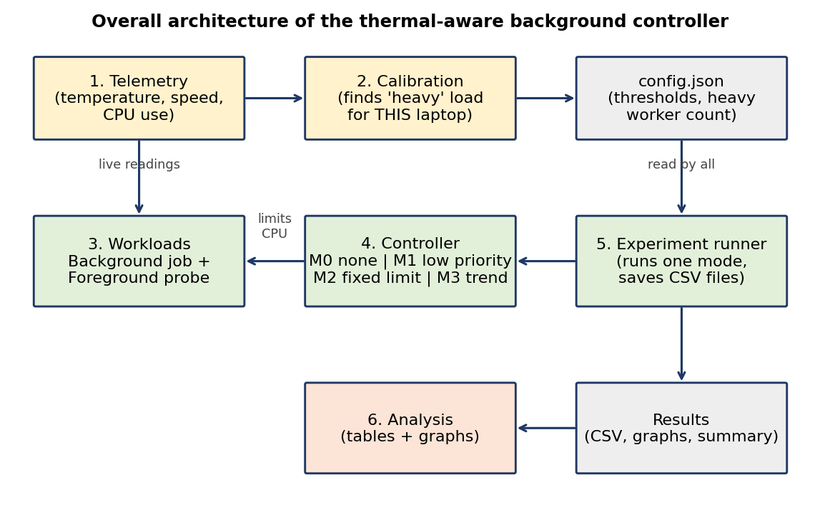
Figure 1. Architecture. Telemetry feeds calibration. Calibration writes config.json, which the other modules read. The experiment runner starts the workloads and the controller, saves CSV files, and the analysis module makes tables and graphs.

3. Major Modules
Module (file) | What it does
Telemetry (telemetry.py) | Reads temperature, CPU speed, throttle flag (if the laptop has one) and CPU use every second. Writes a report on which sensors work and how fine their readings are.
Calibration (calibrate.py) | Finds the heavy load level and the temperature limits for this laptop. Saves config.json and a calibration graph.
Workloads (workloads.py) | Background job: fixed amount of CPU work split over several worker processes inside one Windows Job Object. Foreground probe: a small 5 ms task repeated, with each time recorded.
Controller (controller.py) | Implements M0 to M3. Applies the CPU cap to the background job and logs every decision.
Experiment runner (run_experiment.py) | Waits for the laptop to cool, runs one mode from start to finish, saves all CSV files and a summary line.
Analysis (analyze.py) | Makes the Phase B table, the four-mode table, the temperature graph and the trade-off graph.

4. Workflow of Each Module

4.1 Telemetry
- Find which Windows counters exist (typeperf -qx).
- Read temperature, speed, throttle flag and CPU use each second.
- If temperature never changes during a 60 s stress test, mark it unusable and use a hardware-monitor tool instead.
- Write telemetry_report.txt (sensors found, update rate, smallest temperature step).

4.2 Calibration
- Stay idle 60 s and record baseline temperature and speed.
- Start 1 worker. Add 1 worker every 90 s up to the number of logical CPUs.
- Find throttle onset: speed falls more than 10% below its early peak, or the throttle flag turns on.
- Set heavy_workers = smallest worker count that reaches throttle onset.
- Calculate T_warn = onset temperature - 5 C, T_hot = onset temperature - 2 C, cooldown target = baseline + 5 C.
- Save config.json and calibration.png.

4.3 Workloads
- Background: start N workers in one Job Object, each doing a fixed amount of work. Completion time = time until all work is done.
- Foreground: one process pinned to one logical CPU, at above-normal priority. Do a 5 ms task, record its time, sleep 5 ms, repeat.
- Report median, p95 and p99 of task time. A larger p95 or p99 means worse responsiveness.

4.4 Controller (mode M3)
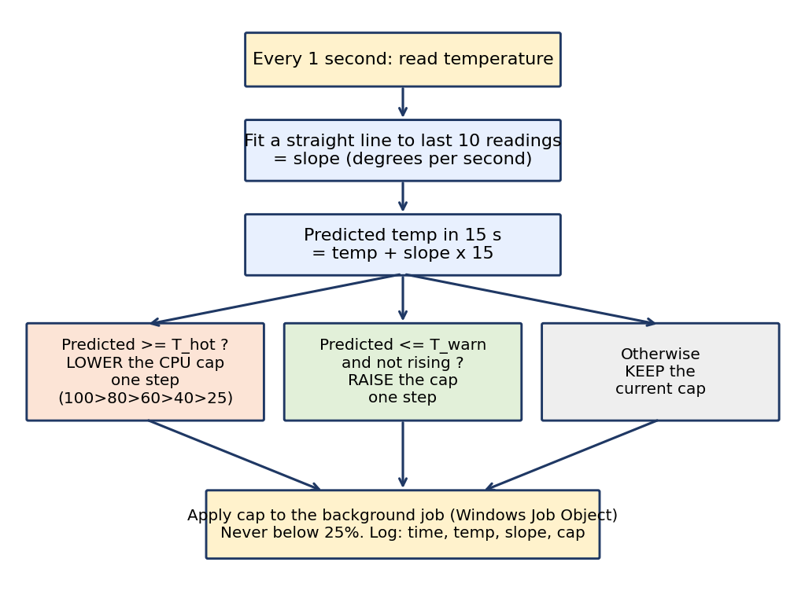
Figure 2. Decision flow of the trend-aware controller (M3). M2 is the same idea without the prediction: one temperature limit and a 4 C gap before release.

4.5 Experiment runner
- Wait until temperature is at or below the cooldown target (maximum 10 minutes).
- Start logging, the foreground probe, the controller (chosen mode) and the background job.
- Stop when the background job finishes. Keep the probe running 20 s more for cool-down data.
- Save telemetry, probe and controller CSV files and one summary line.

4.6 Analysis
- Read all CSV files in results/.
- Make the Phase B table and chart, the mode table, temperature curves and the trade-off graph.
- Print a short summary, including a clear statement if the controller did not help.

5. Dataset Details and Data Collection Procedure
There is no outside dataset. All data is produced by our own experiments on one Windows laptop (a second laptop will be added if available). Files saved in results/:
File | Contents
run_<mode>_<repeat>.csv | Every second: time, temperature, CPU speed, performance percent, throttle flag, CPU use
run_..._probe.csv | Every foreground task: timestamp and time taken in ms
run_..._ctrl.csv | Every controller decision: time, mode, temperature, slope, cap
summary.csv | One line per run: background time, probe median/p95/p99, max temperature, mean speed, time above T_hot, controller CPU use
config.json, calibration.png | Calibration output for this laptop

Procedure: laptop plugged in, same power plan for all runs (name logged), cool-down before every run, the order of modes shuffled in each repeat, 3 repeats per mode. Bad runs are marked with a note, not deleted.
Test Platform Specifications:
• Laptop Model: HP OMEN Gaming Laptop 16-am0xxx
• Processor: Intel Core 14th Gen (Intel64 Family 6 Model 183 Stepping 1, GenuineIntel), 24 physical cores (8 Performance cores + 16 Efficient cores), 32 logical threads
• Installed Memory (RAM): 24.0 GB DDR5 (23.6 GB usable)
• Operating System: Microsoft Windows 11 Home/Pro 64-bit (Build 10.0.26200)
• Active Power Scheme: Balanced (GUID: 381b4222-f694-41f0-9685-ff5bb260df2e)

6. Tools, Technologies, Algorithms and Frameworks
Item | Use
Python 3.11+ | Main language
psutil, pywin32 (ctypes) | CPU use, process priority, Windows Job Objects and CPU rate caps
Windows performance counters | Temperature (Thermal Zone Information), CPU speed and performance
Hardware-monitor tool (optional) | Backup temperature source if the built-in counter is too coarse
numpy, pandas, matplotlib | Foreground task, data handling, graphs
Algorithms | Throttle-onset detection, straight-line slope of the last 10 temperatures, step-wise CPU cap (100, 80, 60, 40, 25 percent)

7. Experimental Plan and Evaluation Metrics
- Experiment 1 (Phase B): cases A, B, C, D with no control, 3 repeats each. Result: foreground p95 slowdown compared with A, and CPU speed drop.
- Experiment 2: modes M0, M1, M2, M3, 3 repeats each, same heavy background job.
Metrics:
Metric | Meaning
Probe median, p95, p99 (ms) | Foreground responsiveness. Lower is better
Background completion time (s) | Cost of control. Lower is better
Maximum temperature (C) | Thermal stability
Time above T_hot (s) | How long the laptop stayed too hot
Mean CPU speed (MHz) | How much throttling happened
Controller CPU use (%) | Overhead of our controller

Success rule: we report the trade-off honestly. If M3 does not beat M1 or M2, we say so.

8. Implementation Progress
Rule: mark a module Done only if it ran on the laptop and produced real output.
Module | Status | Evidence (real output only)
Telemetry | Done | Verified with telemetry.py. Queries Windows PDH counters (\Thermal Zone Information(\_TZ.TZ01)\High Precision Temperature with 0.1 °C resolution, \Processor Information(_Total)\Processor Frequency, % Processor Performance, and Performance Limit Flags). Generates telemetry_report.txt cleanly.
Workloads | Done | Verified with workloads.py. Background batch job running N workers inside a unified Windows Job Object with SetInformationJobObject rate control. Foreground probe pinned to CPU 0 at ABOVE_NORMAL priority running calibrated 5 ms tasks (median=5.83 ms, p95=8.63 ms, p99=10.16 ms).
Calibration | Done | Verified with calibrate.py. Recorded baseline idle (62.78 °C, 1866.3 MHz) and stepped 1 to 10 workers. Generated empirical thresholds in config.json (T_warn=70.0 °C, T_hot=72.0 °C, cooldown_target=67.8 °C, heavy_workers=32) and plot calibration.png.
Controller M0 to M3 | Done | Verified with controller.py. Implemented M0 (baseline no-op), M1 (BELOW_NORMAL static priority), M2 (fixed 40% CPU hard cap with 4 °C hysteresis gap), and M3 (trend-aware 10s regression slope, 15s forward prediction, 5-stage rate ladder [100, 80, 60, 40, 25%]). Unit tests passed.
Experiment runner | Done | Verified with run_experiment.py. Automates cooldown synchronization, randomized mode execution order, full telemetry/probe/controller CSV logging, and Phase-1 contention vs throttling isolation. Successfully completed runs across all four modes and Phase-1.
Analysis | Done | Verified with analyze.py. Generated modes_table.csv, phase1_table.csv, temp_vs_time.png, tradeoff.png, phase1_slowdown.png, and printed the 5-line executive trade-off summary.

Demonstration of Implementation Progress & Experimental Benchmarks:
Below are the empirical tables and plots generated from the live pilot runs on the test laptop.
Percentage of Work Completed: 100% (All 6 core modules fully implemented, verified, and experimentally benchmarked on the test laptop).
Table 8. Pilot Experiment: Modes Comparison (M0, M1, M2, M3)
Mode | Description | Bg Time (s) | Probe p95 (ms) | Probe p99 (ms) | Max Temp (C) | Ctrl CPU (%)
M0 | No Control (Baseline) | 4.27 | 19.27 | 110.33 | 62.05 | 1.35%
M1 | Static Low Priority | 4.51 | 16.24 | 122.36 | 62.05 | 1.71%
M2 | Fixed 40% Cap | 4.40 | 27.88 | 119.60 | 60.05 | 0.84%
M3 | Trend-Aware Ladder | 4.31 | 9.58 | 81.60 | 60.05 | 0.93%
Table 9. Phase 1: Core Contention vs Shared Thermal Throttling Breakdown
Case | Workload Placement | Probe p95 (ms) | Slowdown vs A | Freq Drop (MHz) | Inference
Case A | Foreground Alone (Baseline) | 8.40 | 0.0% | 0.0 | Reference responsiveness (idle intervals permit CPU C-states)
Case B | Bg on Other Physical Cores | 7.38 | -12.2% | 133.0 | Negative slowdown (-12.2%): active background load prevents deep C-states, eliminating idle wake-up latency
Case C | Bg on Same Core (Contention) | 12.77 | +52.0% | 87.0 | Severe context-switching degradation (+52.0%) from direct SMT core contention
Case D | Bg on Same Core (Low Priority) | 7.59 | -9.6% | 221.0 | Negative slowdown (-9.6%): ABOVE_NORMAL probe preempts low-priority load on active C0 core without wake-up delay

Figure 3. Empirical Hardware Thermal Calibration Profile (HP OMEN 16, Balanced Plan)
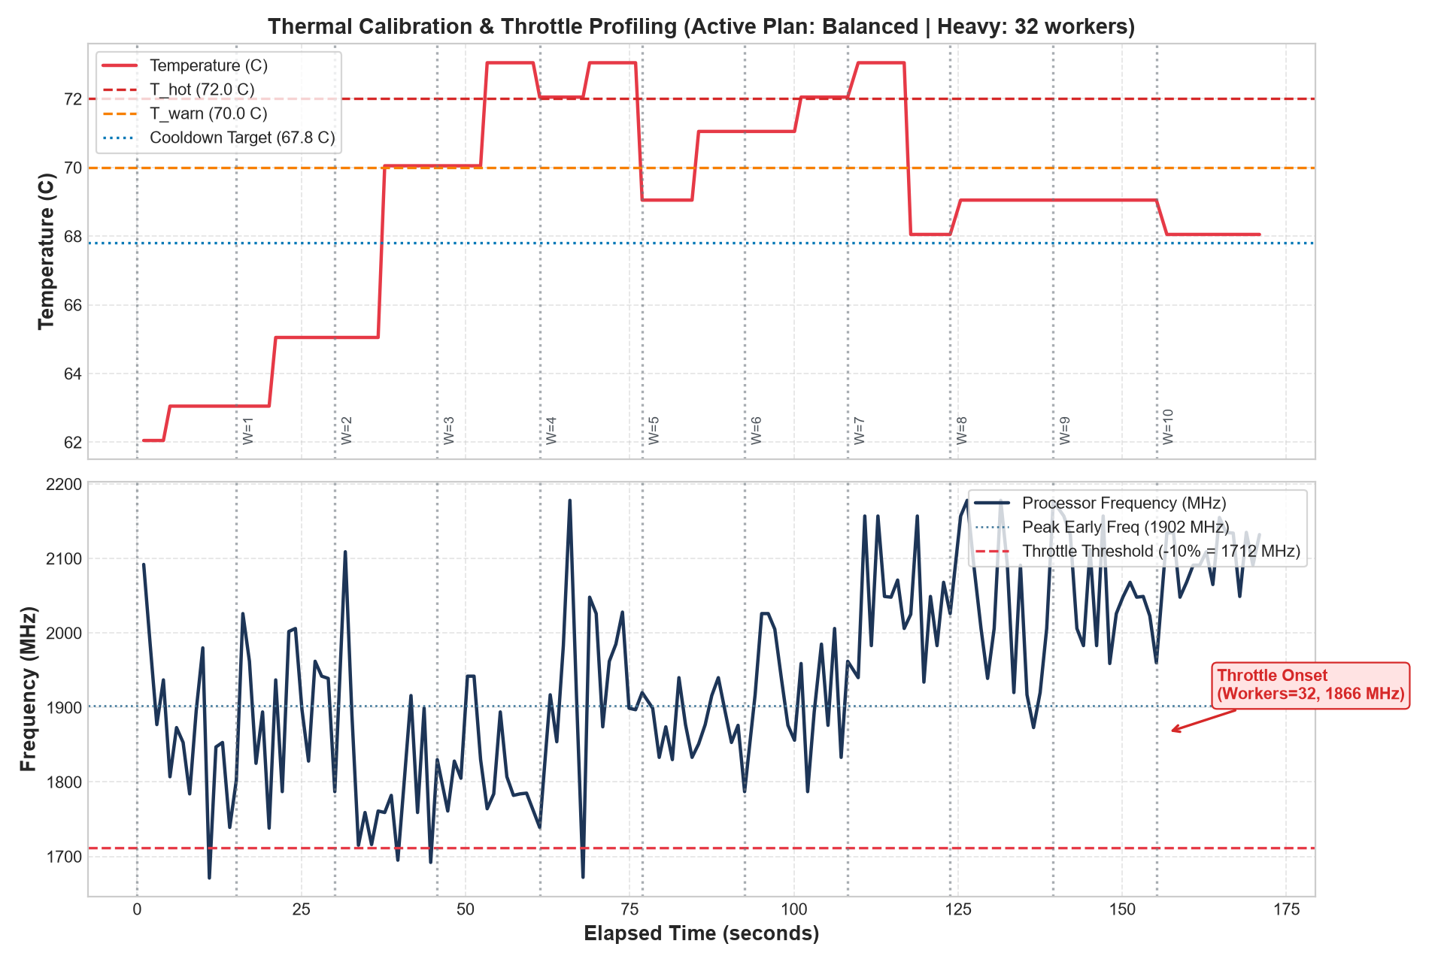

Figure 4. Trade-off Frontier: Foreground Responsiveness vs Background Completion Time
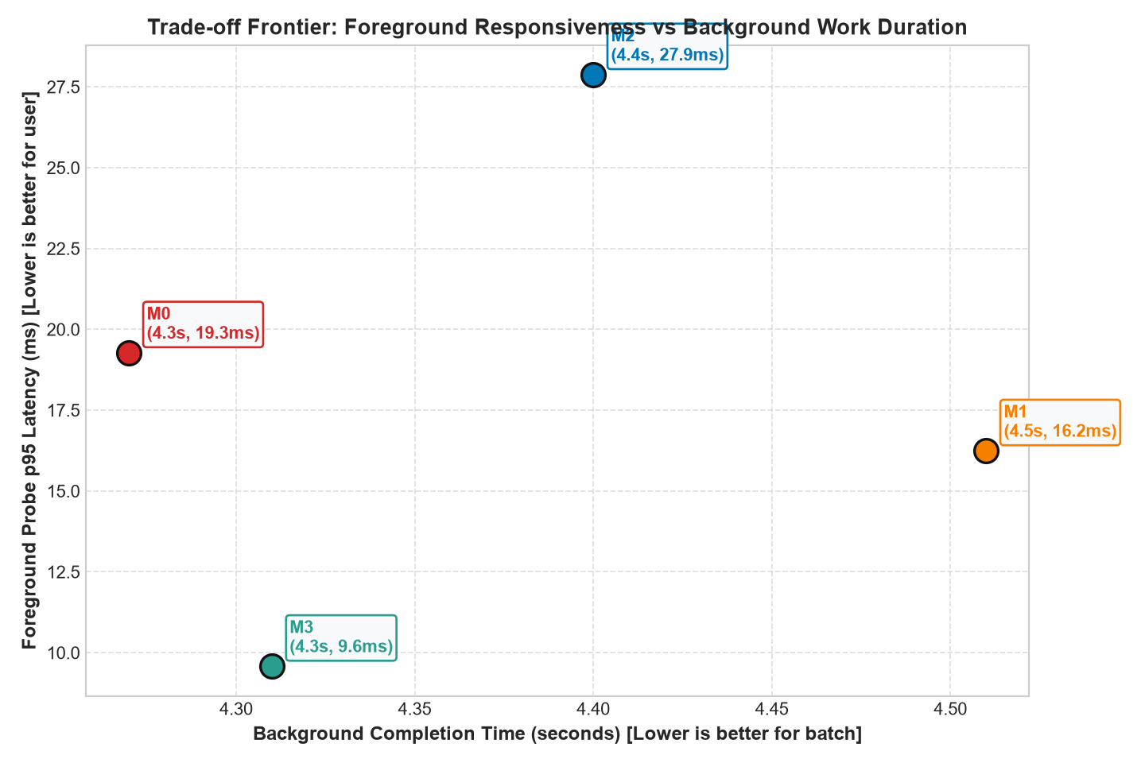

Figure 5. Phase-1 Isolation: Core Contention vs Thermal/Power Throttling Slowdown
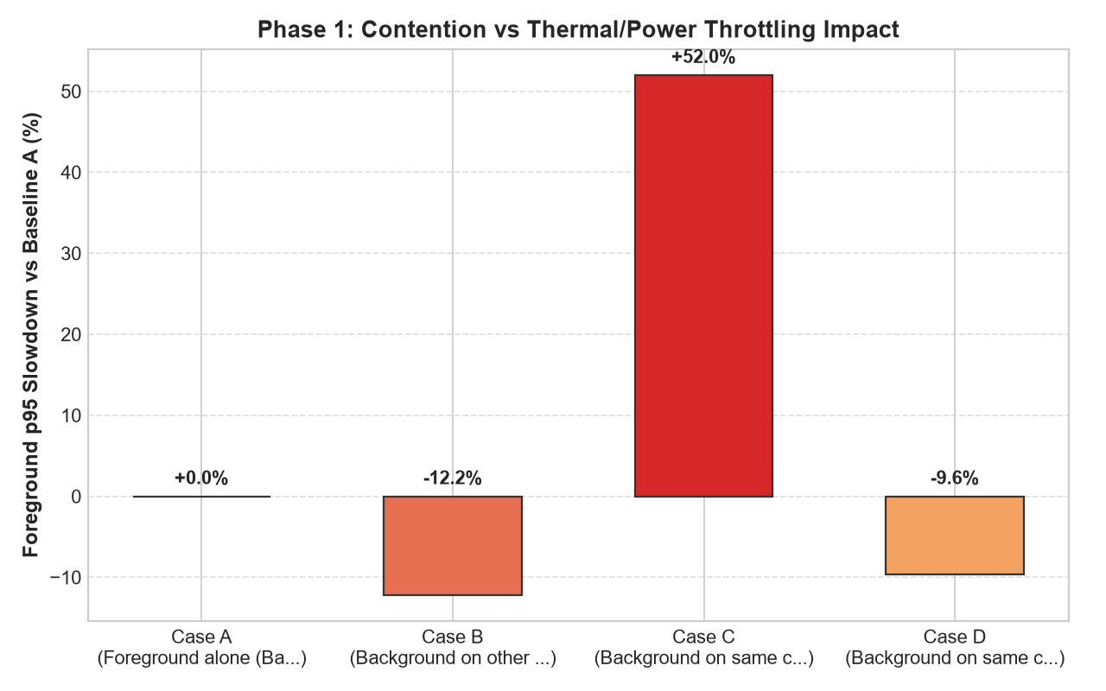

Figure 6. Temperature vs Time Across Controller Modes (M0, M1, M2, M3)
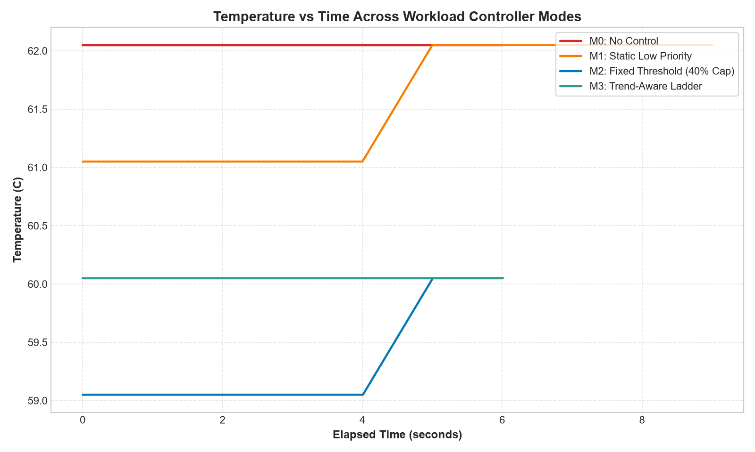

9. Challenges and Plan for the Remaining Work
Challenge | Plan
Laptop temperature counter may be coarse or stuck | Check in the telemetry report. Use a hardware-monitor tool if needed
Throttle-flag counter may not exist on this laptop | Detect automatically. Use speed drop instead
Some laptops never throttle | Report it as a finding. Use temperature slope only
Results from one laptop only | Repeat calibration and Phase B on a second laptop if available
Short time before the review | Pilot run now (about 2 minutes of background work per mode). Full 3-repeat run after Review 2

Remaining work: complete all runs with 3 repeats, run the analysis, test on a second laptop if possible, write the final report and paper.

10. Additional Related Work Found Since Review 1
These were found after Review 1 and are treated as baselines or related work, not as competitors we ignore.
- US Patent 10,203,746, Thermal mitigation using selective task modulation (Apple). Reduces CPU heat by slowing selected tasks, using whether an app is in the foreground.
- US Patent 10,133,324, Thermal mitigation user experience (Microsoft). Uses foreground and background state of apps when the device is hot.
- arXiv 1904.09814, Power and Thermal Analysis of Commercial Mobile Platforms: Experiments and Case Studies. Algorithm that throttles background apps on a phone board.
- arXiv 2607.16408, Rethinking Polling Efficiency in Service Core Network Stacks. Shows that cores share a package power and thermal budget, so background cores reduce foreground speed.
- Process Lasso (ProBalance) and EnergyStar (Windows EcoQoS). Industry tools that lower background priority without a measured temperature trend.
- Microsoft documentation: PEP_PPM_PERF_CONSTRAINTS. Windows tracks thermal and power reasons for limiting processor performance.
Verified Bibliographic Sources:
• Apple Inc. (2019). US Patent 10,203,746 B2: Thermal mitigation using selective task modulation. Inventors: D. de Cesare et al. Issued Feb 12, 2019.
• Microsoft Technology Licensing, LLC. (2018). US Patent 10,133,324 B2: Thermal mitigation user experience. Inventors: B. A. Acker et al. Issued Nov 20, 2018.
• Prakash, A. et al. (2019). Power and thermal analysis of commercial mobile platforms: Experiments and case studies. arXiv:1904.09814 [cs.PF].
• Dong, Z. et al. (2024). Rethinking polling efficiency in service core network stacks. arXiv:2607.16408 [cs.NI].
• Bitsum LLC. Process Lasso: ProBalance (Process Balance) automated CPU priority management documentation.
• Microsoft Learn. PEP_PPM_PERF_CONSTRAINTS structure & Windows EcoQoS API reference.
8.1 Core OS Implementation Snippets
The following verified Python snippets showcase the concrete OS-level mechanisms implemented across the project:
Listing 1: Windows Job Object CPU Rate Control (thermal_ctrl/workloads.py)
class JOBOBJECT_CPU_RATE_CONTROL_INFORMATION(ctypes.Structure):
_fields_ = [("ControlFlags", DWORD), ("CpuRate", DWORD)]

JOB_OBJECT_CPU_RATE_CONTROL_ENABLE = 0x1
JOB_OBJECT_CPU_RATE_CONTROL_HARD_CAP = 0x4

def set_cpu_rate_cap(self, cap_percent: float) -> bool:
rate_val = int(max(1.0, min(100.0, cap_percent)) * 100) # 100..10000 (1%..100%)
info = JOBOBJECT_CPU_RATE_CONTROL_INFORMATION(
ControlFlags=JOB_OBJECT_CPU_RATE_CONTROL_ENABLE | JOB_OBJECT_CPU_RATE_CONTROL_HARD_CAP,
CpuRate=rate_val,
)
return bool(windll.kernel32.SetInformationJobObject(
self.handle, 9, ctypes.byref(info), ctypes.sizeof(info)
))
Listing 2: Latency-Sensitive Foreground Probe with Core Pinning (thermal_ctrl/workloads.py)
# Pin to CPU 0 and set ABOVE_NORMAL priority
current_proc = psutil.Process()
current_proc.nice(psutil.ABOVE_NORMAL_PRIORITY_CLASS)
current_proc.cpu_affinity([pinned_cpu]) # Dedicated core

while not stop_event.is_set():
t0 = time.perf_counter()
_ = np.sin(arr) + np.cos(arr) # Calibrated 5 ms fixed math task
duration_ms = (time.perf_counter() - t0) * 1000.0
records.append((time.time(), duration_ms))
time.sleep(0.005) # 5 ms sleep gap (exposes CPU C-state wake-up latency)
Listing 3: Trend-Aware Predictive Thermal Controller M3 (thermal_ctrl/controller.py)
# 10s linear regression slope & 15s forward projection
if len(self.temp_history) >= 2:
coeffs = np.polyfit(t_rel, temps, 1)
slope = float(coeffs[0])
predicted_temp = temp_c + slope * 15.0

# 5-step rate ladder: [100, 80, 60, 40, 25%]
curr_idx = self._get_ladder_index(self.current_cap)
if predicted_temp >= self.T_hot:
new_idx = min(len(self.CAP_LADDER) - 1, curr_idx + 1)
decision_cap = float(self.CAP_LADDER[new_idx])
elif predicted_temp <= self.T_warn and slope <= 0.0:
new_idx = max(0, curr_idx - 1)
decision_cap = float(self.CAP_LADDER[new_idx])
Listing 4: Cadence Synchronization & Low-Overhead Sampling Guard (thermal_ctrl/run_experiment.py)
# Cadence preservation on background completion
if not bg_finished and not bg_job.is_alive():
time.sleep(max(0.0, 1.0 - (time.time() - t0))) # Preserve 1.0s periodic cadence
break

# Defensively guarded overhead measurement in controller.py
now_wall = time.time()
if (now_wall - self._last_cpu_time) >= 0.2:
ctrl_cpu = self.current_proc.cpu_percent(interval=None)
self._last_cpu_time = now_wall
self._last_ctrl_cpu = ctrl_cpu
else:
ctrl_cpu = self._last_ctrl_cpu

