CEDRIC MASTERS AUTOS
Workshop & Dealership Management System

User Manual

Version 1.0 • July 2026

Table of Contents
1. Introduction
2. Getting Started — Login & Navigation
3. Administrator — Full System Access
4. Customer Service Representative — Front Desk
5. Technician — Workshop Jobs
6. Inventory Manager — Parts & Stock
7. Finance Personnel — Invoices & Payments
8. Manager — Oversight & Approvals
9. Sales Rep — Leads, Orders & Deliveries

1. Introduction
The solution is a web-based workshop and dealership management system. It helps automotive businesses manage their entire after sales and vehicle sales services.
The system is organized into three core modules:
- After-Sales Service — Customer check-in, technician workflow, spare parts, invoicing
- Vehicle Sales — Inventory tracking, customer leads, sales orders, delivery handover

Who this manual is for:
- Customer Service Representatives (CSR) — Front desk, check-in, customer registration
- Technicians — Diagnose issues, work on jobs, request parts
- Inventory Managers — Manage parts catalogue and stock levels
- Finance Personnel — Generate invoices, record payments
- Managers — Approve invoices, oversee operations
- Sales Reps — Manage leads, create orders, handle deliveries
- Administrators — Full access, manage users, configure settings

2. Getting Started — Login & Navigation

2.1 Accessing the System
Open your web browser and navigate to the application URL: https://aas-two-iota.vercel.app/. You will see the login screen.
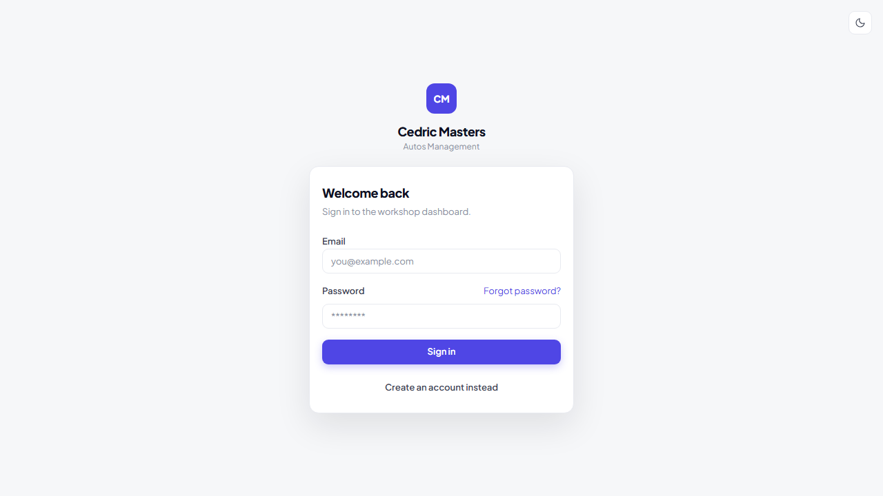
Login Screen — Enter your email and password to sign in.

2.2 Signing In
Enter your registered email address and password, then click "Sign in".
If you do not have an account, click "Create an account instead" to register. An administrator must assign your role before you can access the system.

2.3 Dashboard Overview
After signing in, the Dashboard displays key performance indicators, active jobs, and recent check-ins
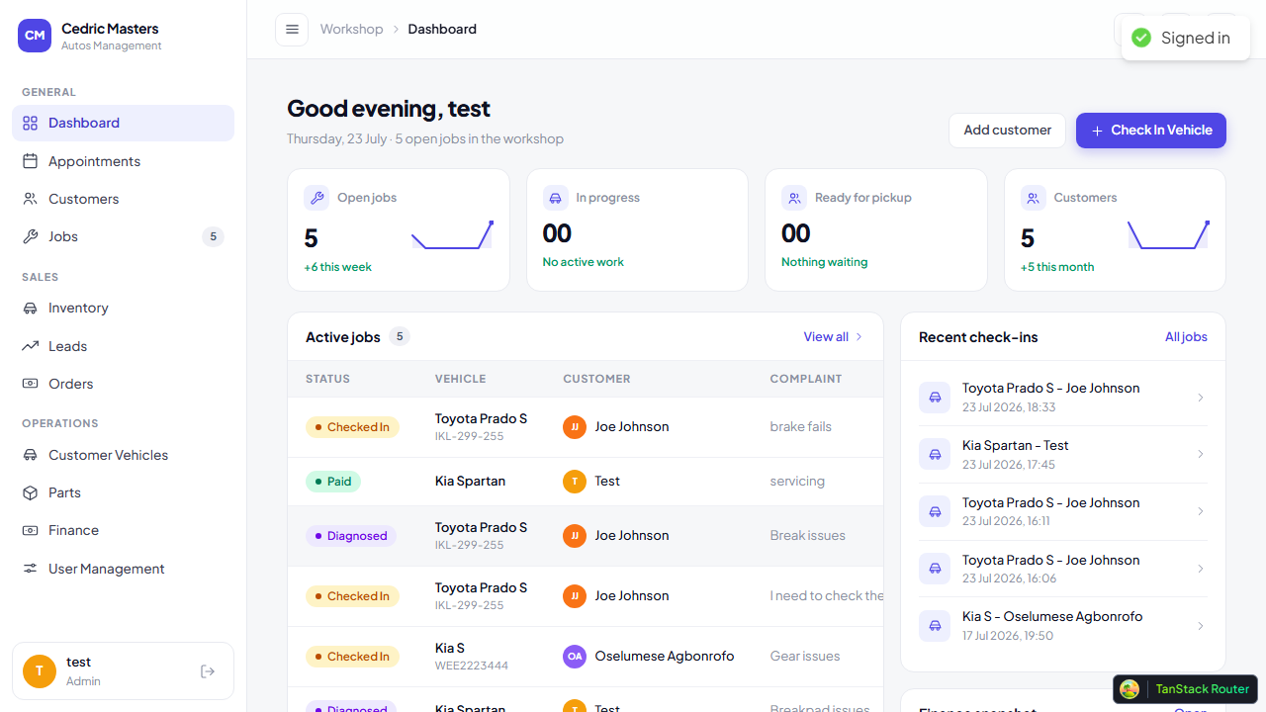
Dashboard — KPI cards, and active jobs table.

2.4 Navigation
The sidebar on the left provides access to all sections. Sections are grouped:
- General — Dashboard, Appointments, Customers, Jobs
- Sales — Inventory, Leads, Orders
- Operations — Customer Vehicles, Parts, Finance, User Management
Your role determines which menu items you can see. The top bar shows your current location and provides dark mode toggle, notifications, and profile access.

3. Administrator — Full System Access
Administrators have unrestricted access to every feature. Your primary responsibilities include managing users, configuring system settings, and overseeing all operations.

3.1 User Management
Navigate to Operations > User Management to view, and manage staff accounts. Each user can be assigned one of seven roles that control their access level.
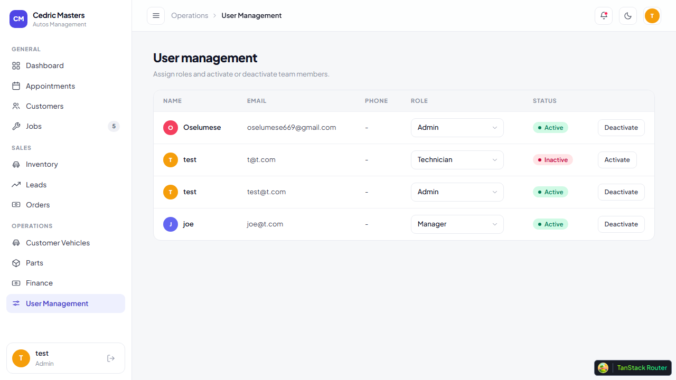
User Management — View all staff, assign roles, manage access.

3.2 Role Assignments
The seven roles available are:
- Admin — Full system access
- CSR — Front desk, appointments, check-in
- Technician — Jobs, diagnosis, parts requests
- Inventory Manager — Parts catalogue, stock
- Finance Personnel — Invoices, payments
- Manager — Oversight, approvals
- Sales Rep — Leads, sales orders, deliveries

3.3 Finance Configuration
Configure VAT rate and labour types under Operations > Finance. These settings affect invoice calculations across the system.
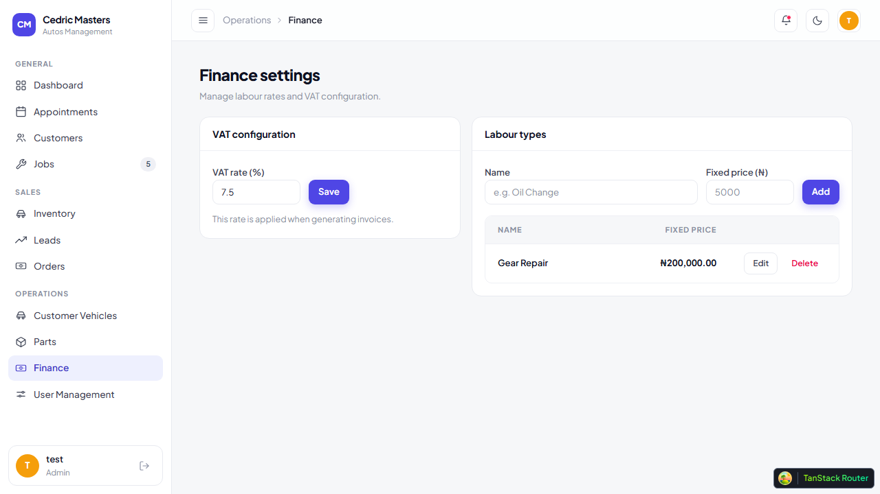
Finance Settings — Configure VAT rate (default 7.5%) and labour type flat fees.

3.4 Parts Catalogue Management
The Parts Catalogue under Operations > Parts allow addition, item information update and restocking of spare parts, including CSV import for bulk data loading, stock adjustments, and low-stock alerts.
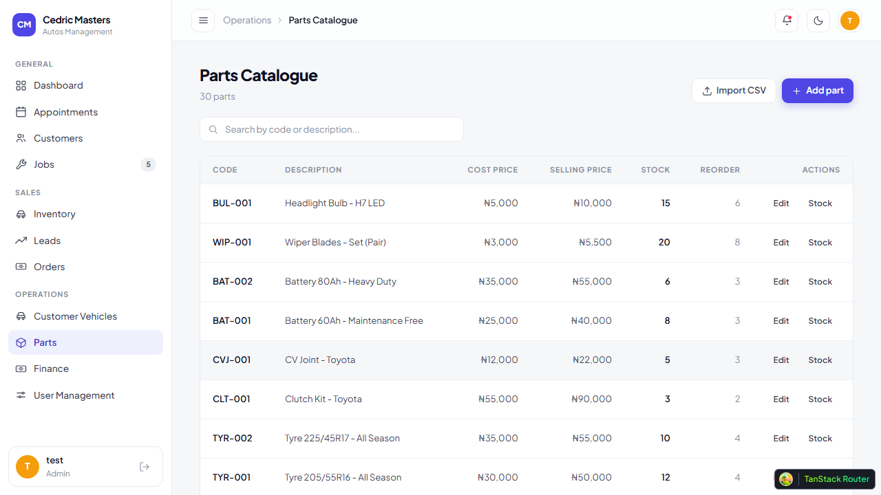
Parts Catalogue — Manage parts, stock levels, and import from CSVs.

3.5 Appointments
View and manage all customer appointments under General > Appointments. Appointments can be viewed by day, week, or month ranges.
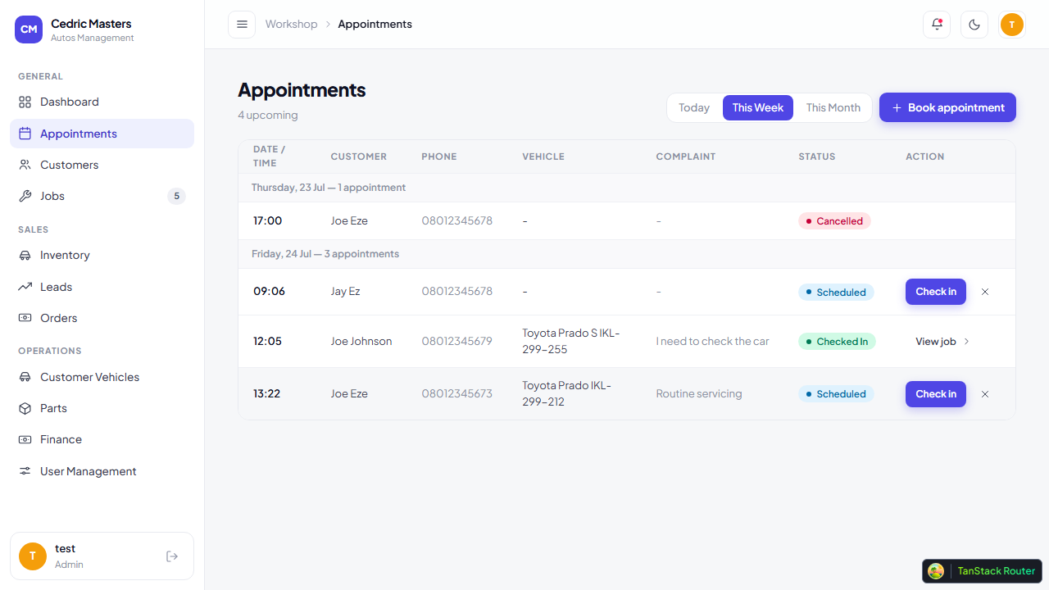
Appointments — Range view with day/week/month presets.

4. Customer Service Representative — Front Desk
As a Customer Service Representative, you are the first point of contact for customers. Your workflow covers customer registration, vehicle check-in, appointment booking, and managing the customer database.

4.1 Customer Management
Navigate to General > Customers to view the customer directory. You can search by name or phone number, view repair history, and add new customers.
The one-stop creation flow lets you add a customer, their vehicle, and a new job in a single process.
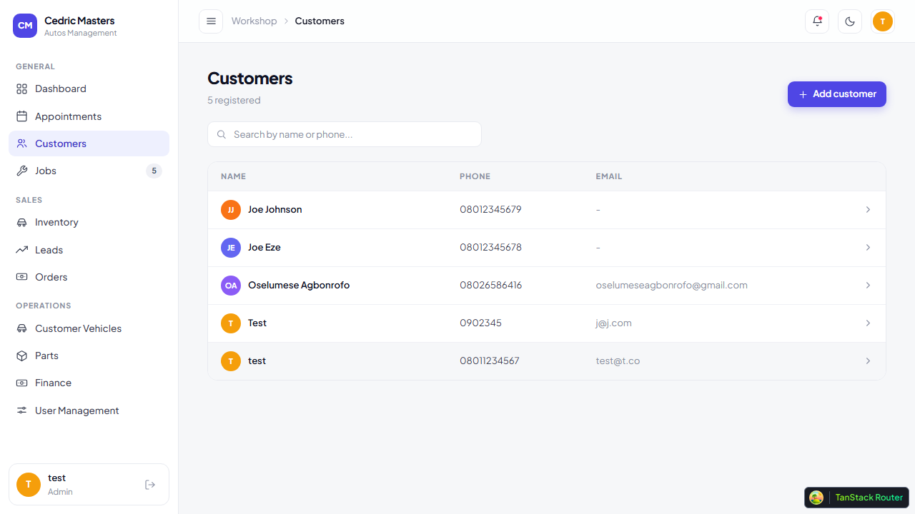
Customers — Searchable directory with repair history per customer.

4.2 Vehicle Check-In
Click "Check In Vehicle" from the Dashboard or navigate to General > Jobs > Check In. The 3-step flow captures vehicle details, customer information, and the reported issue.
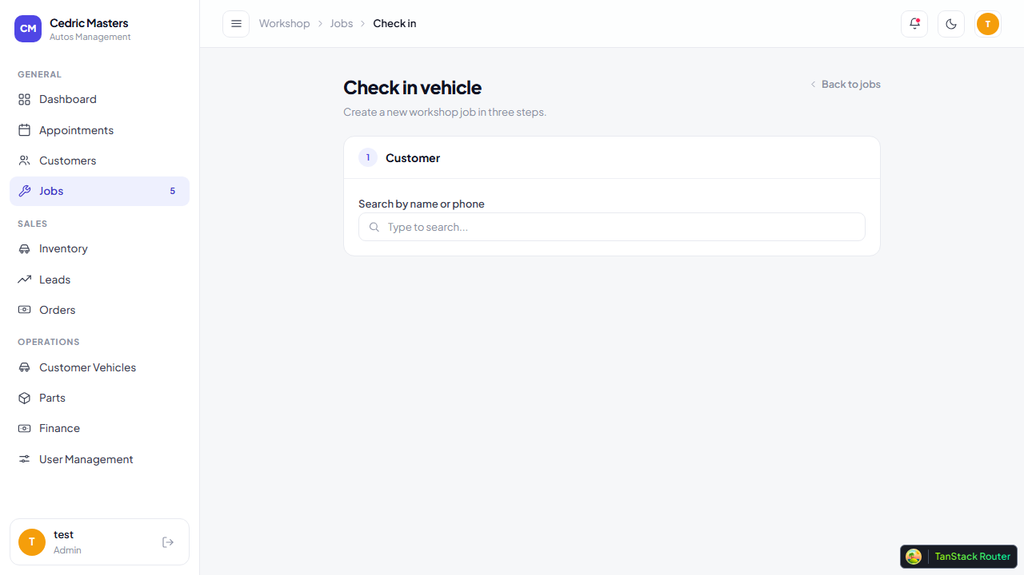
Check-In Flow — 3-step process to register a new service job.

4.3 Appointment Booking
Under General > Appointments, you can book appointments for customers. Vehicle details (make, model, plate) and complaint are mandatory fields.

Appointments — Book and manage customer appointments with day navigation.

4.4 Customer Vehicles
View all vehicles registered in the system under Operations > Customer Vehicles. Each vehicle is linked to its owner and service history.
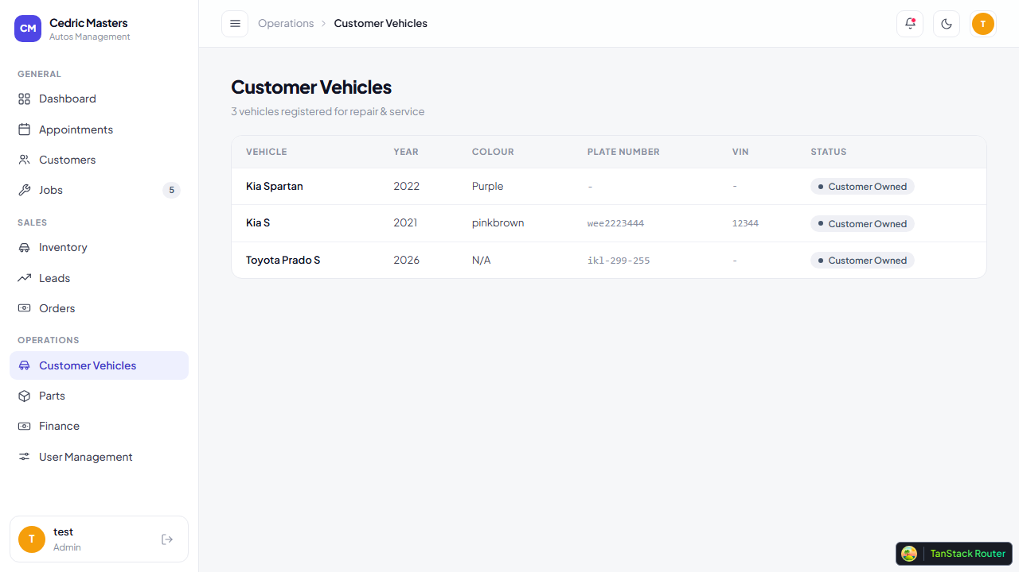
Customer Vehicles — Directory of all vehicles with owner details.

5. Technician — Workshop Jobs
Technicians are responsible for diagnosing issues, performing repairs, and requesting parts. Your workflow is centered around the Jobs section.

5.1 Viewing Assigned Jobs
Navigate to General > Jobs to see the list of all jobs in the workshop. Filter by status to focus on your assigned work.
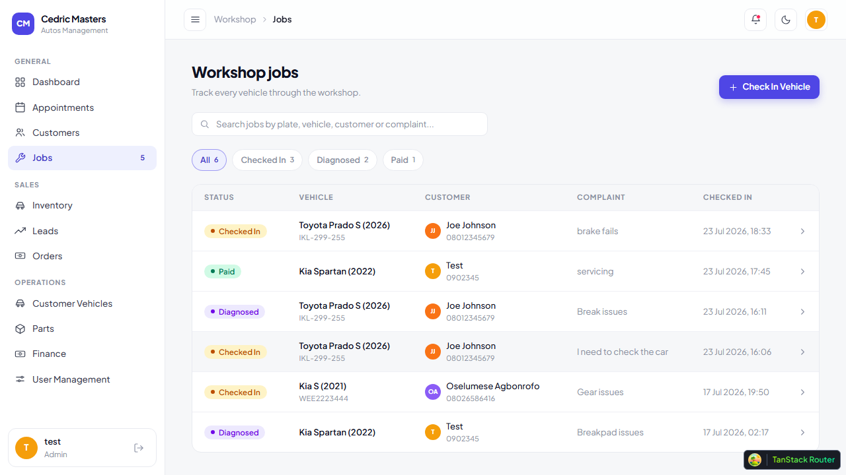
Jobs List — All workshop jobs with status, vehicle, and customer details.

5.2 Job Detail & Diagnosis
Click on any job to open its detail page. The status tracker shows the current stage of the job. You can record your diagnosis, request for parts, and transition the job through statuses.

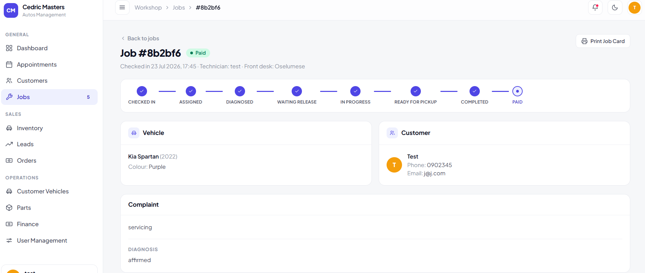
Job Detail — Status tracker, diagnosis, and parts requests

5.3 Parts Requests
When parts are needed, create a parts request from the job detail page. The Inventory Manager will approve and dispatch the parts. Dispatched parts are automatically added to the job items and invoice.
Note: Technicians cannot view or modify invoice information. Parts requests are restricted to Finance personnel and Administrators.

5.4 Printable Job Card
Each job has a printable job card accessible via the Print button. This card shows vehicle details, diagnosis, and job details that can be printed for use in the workshop by technicians.

6. Inventory Manager — Parts & Stock
Inventory Managers are responsible for the spare parts catalogue, stock levels, and fulfilling technician parts requests.

6.1 Parts Catalogue
Under Operations > Parts, view the complete parts catalogue. Each part has a unique code, cost price, selling price, and stock quantity.

Parts Catalogue — Search, filter, edit parts, and view low-stock alerts.

6.2 Stock Management
Use the stock adjustment feature to record stock movements (in/out/adjust). Low-stock alerts appear when quantity falls below the reorder level. All stock movements are tracked in an audit trail.

6.3 Excel Import
Bulk-import parts using the CSV import feature. The system validates the data and adds parts to the catalogue in one operation.

6.4 Parts Request Fulfillment
When a Technician requests parts, you will receive the request in the job detail. Review stock availability, approve or reject, and dispatch the parts. Dispatched parts are automatically deducted from inventory and added to the job.
Note: A confirmation modal shows stock status before finalizing dispatch. You can also reverse a dispatch to return items to inventory.

7. Finance Personnel — Invoices & Payments
Finance Personnel handle invoice generation, approval workflow, and payment recording.

7.1 Finance Settings
Under Operations > Finance, view and manage the VAT rate and labour type configurations. These settings are used when calculating invoices.

Finance Dashboard — Configure VAT, manage labour types with fixed prices.

7.2 Invoice Generation
From any job detail page, generate an invoice. The invoice auto-calculates totals from parts and labour line items, applies VAT at the configured rate, and locks line items at the time of generation.

7.3 Manager Approval
Generated invoices require Manager approval before they are finalized. The invoice status shows its current stage in the approval workflow.

7.4 Payment Recording
Record payments against invoices using the payment panel on the job detail page. Supported methods:
- Cash
- Bank Transfer
- Card / POS
Partial payments are supported with automatic balance tracking. When fully paid, the job auto-transitions to "Paid" status.

7.5 Invoice Regeneration
If job items change after invoice generation, use the "Regenerate" button to re-sync the invoice with the latest items.

7.6 Printable Invoice
Each invoice can be printed in a clean, print-friendly format via the Print button.

8. Manager — Oversight & Approvals
Managers have broad access across all modules for oversight. Your key actions include approving invoices, monitoring workshop progress, and managing customer relationships.

8.1 Dashboard & Monitoring
The Dashboard gives you a real-time view of open jobs, in-progress work, vehicles ready for pickup, and customer metrics for the month.

Dashboard — KPI cards, active jobs, recent check-ins for full oversight.

8.2 Invoice Approval
Review and approve invoices generated by Finance Personnel. Navigate to the job detail to see pending invoices and approve them with a single click.

8.3 Job Completion
Managers (and Admins) can mark jobs as "Completed" after work is finished. This is a restricted action as Technicians and CSRs cannot complete jobs.

8.4 Customer & Vehicle Viewing
Access the full customer database and vehicle directory to review service history and customer details.

8.5 Sales Overview
View sales inventory, leads pipeline, and sales orders. Monitor lead stages and review sales team performance.
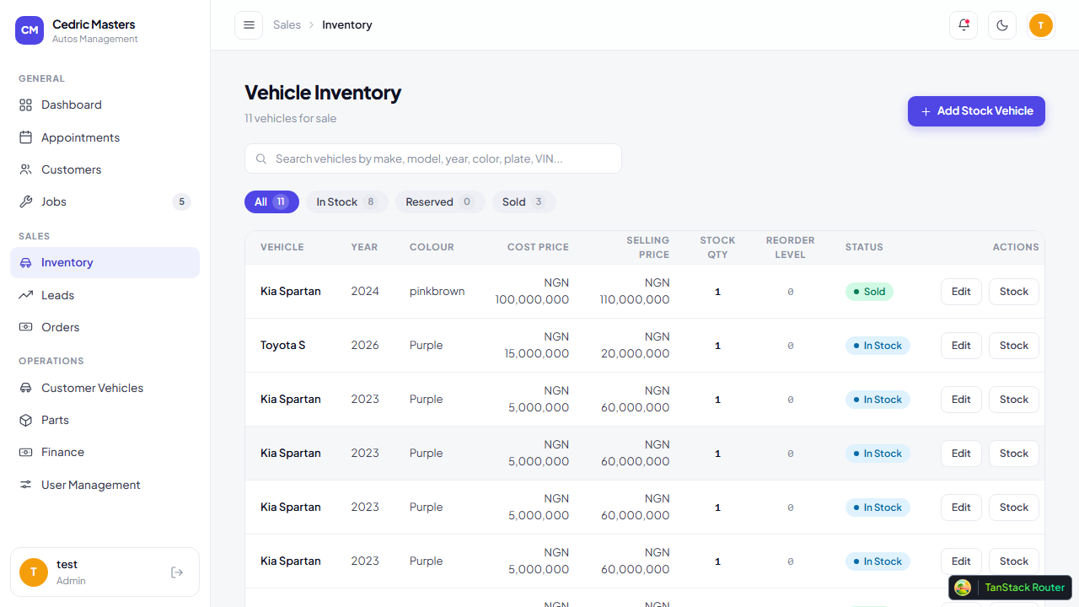
Sales Inventory — Vehicle stock tracking with sales status.
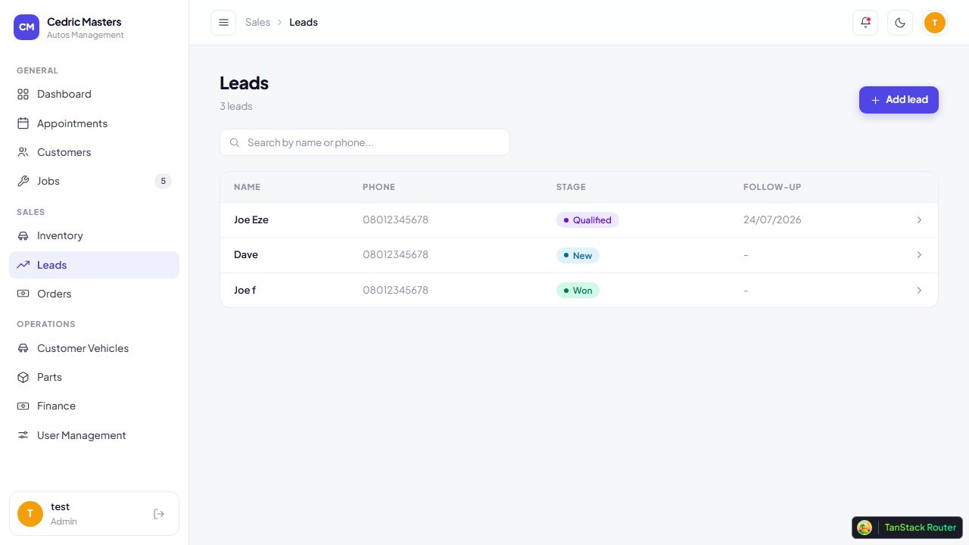
Sales Leads — Pipeline view with lead stages and follow-up tracking.
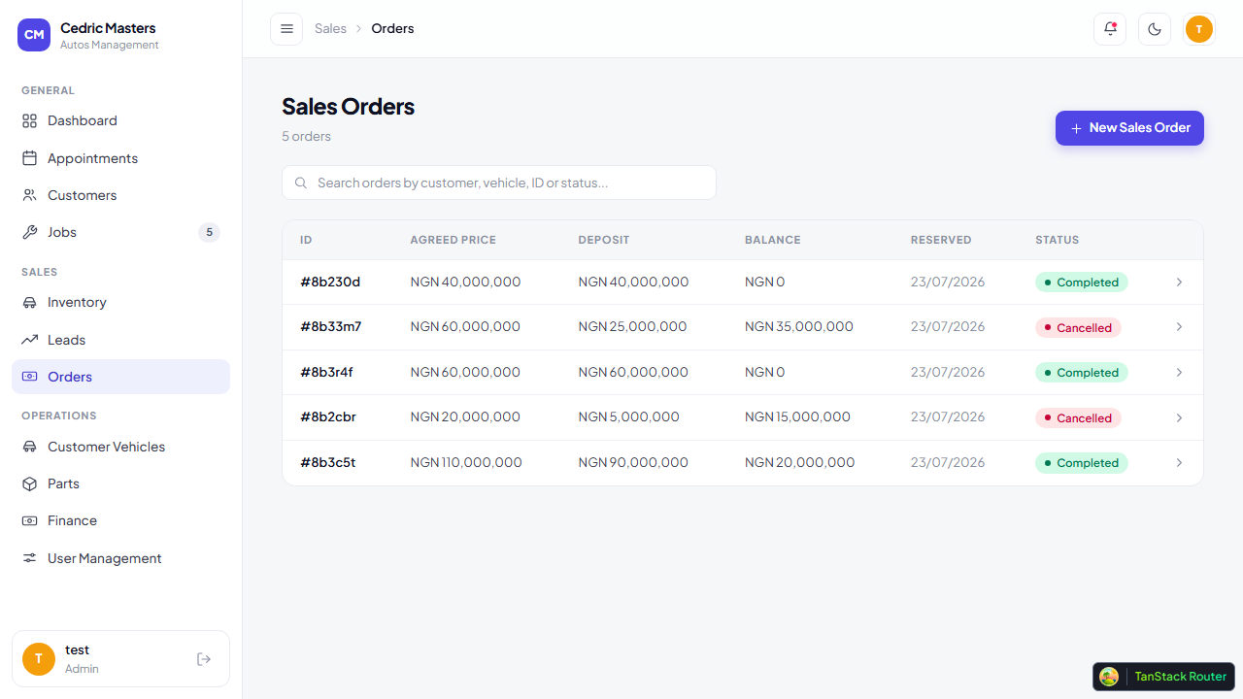
Sales Orders — Order management with deposit and balance tracking.

9. Sales Rep — Leads, Orders & Deliveries
Sales Representatives manage the full sales cycle from lead generation to vehicle delivery.

9.1 Vehicle Inventory
Under Sales > Inventory, view all vehicles available for sale. Track stock quantities, reorder levels, and adjust stock as needed. Vehicles have status: In Stock / Reserved / Sold.

Sales Inventory — Vehicle list with make, model, year, status, and stock levels.

9.2 Lead Management
Navigate to Sales > Leads to manage customer enquiries. Track leads through stages:
- New
- Contacted
- Qualified
- Won / Lost
Log follow-up notes and set reminders directly on the lead detail page.

Leads — Searchable list with stage filters and create lead action.

9.3 Creating Sales Orders
From the lead detail page or Sales > Orders, create a new sales order. Select the vehicle, set the agreed price and deposit amount. The vehicle is automatically reserved.

Sales Orders — Order list with deposit and balance tracking.

9.4 Recording Payments
On the order detail page, record customer payments. Track deposits and remaining balances. Partial payments are supported.

9.5 Delivery Handover
When a sale is complete, use the Delivery Handover checklist. The checklist covers:
- Keys handover
- Owner's manual
- Toolkit
- Vehicle inspection
The handover is recorded against the sales rep.

Quick Tips
- Use the sidebar to navigate between sections. Your role determines visible menu items.
- The search bar at the top adapts its placeholder based on your current page.
- Toggle dark mode using the sun/moon icon in the top bar.
- Your profile (top-right corner) shows your name, email, and role. Sign out from there.
- All actions on the system are logged for accountability.

