Yingjie Sun  - Industrial & Product Designer | Physical Products  13515249897 2950884508@qq.com | 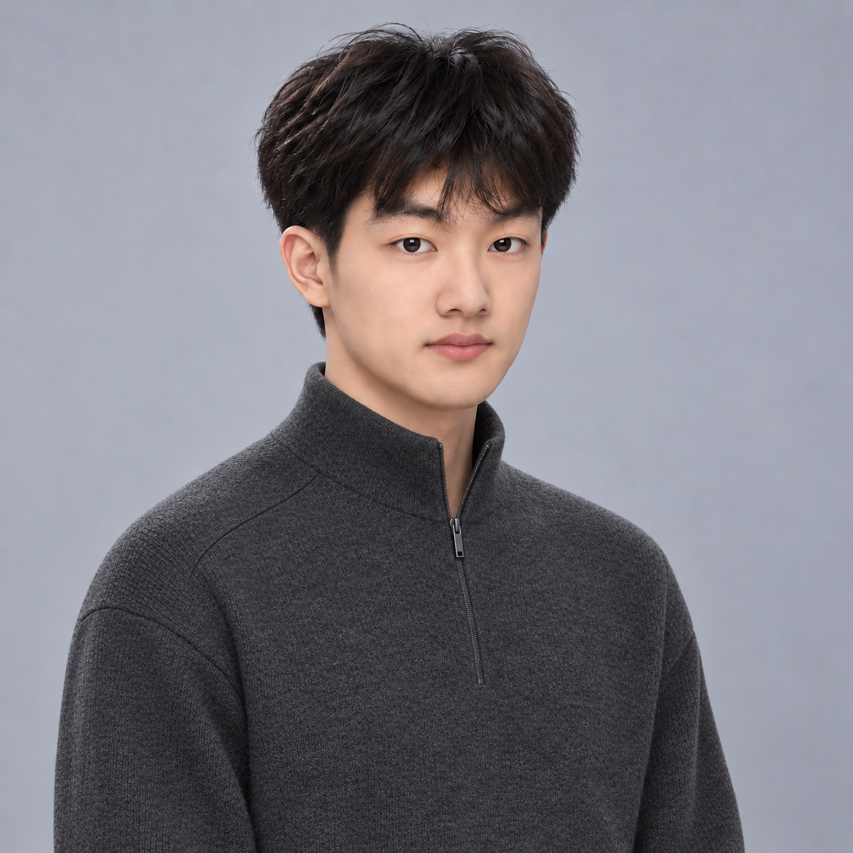
I explore product form, CMF and component relationships around use, making proposals tangible through 3D.

Design focus
Product form: Compare proportion and use in lighting, HUHU CARE and GO GLOW.
CMF and 3D: Study materials, edges and scale through models and rendering.
Engineering context: Bring awareness of standards, quality and constraints from manufacturing.

Experience
Hangzhou Liling Enterprise Services | Brand design & project coordination 2026.02 - Present
Design and iterate Biyuan AI’s visual identity and UI.
Collaborate on Periastra identity and information systems, and YELISI brand, product concepts and CMF studies.
HannStar Board | Design systems engineering designer 2025.08 - 2026.01
Worked on design-systems engineering in PCB manufacturing, within standardisation, engineering and quality constraints.
BENWU | 3D designer 2025.03 - 2025.12
Contributed 3D design and visual presentation to Hermès and Arc'teryx window projects.
Developed lighting visualisations and material comparisons; organised the Karimoku × BENWU design study.
Hunan Ouyin Culture & Media | Design assistant 2023.12 - 2025.02
Organised market research and user feedback; built Figma prototypes to support design comparisons and iteration.

Tools and independent practice
Product and 3D: Rhino, SolidWorks, KeyShot, Cinema 4D, Blender
Visual and digital: Photoshop, Illustrator, Figma; React / TypeScript
AI and research: Codex, ChatGPT, ComfyUI, Midjourney; market and cultural context
Independent AI practice: character sheets, lighting studies and ink film connect visual constraints, prompts and human review with 3D and brand expression.

Education
Changzhou Institute of Technology | BA Product Design 2021.09 - 2025.06
 | Portfolio / complete cases and design process  https://aj-nb.github.io/sun-yingjie-portfolio/en/

