SIX-WEEK HEALTHCARE DATA ANALYTICS INTERNSHIP · WEEK 2 SUBMISSION
Data Collection and Quality Assurance Plan
Sourcing, acquiring, validating and cleaning healthcare data

Project: 30-day readmission and resource use among diabetic inpatients in 130 US hospitals (UCI Diabetes 130-US Hospitals dataset, 1999–2008)

Prepared by: Juluru Akshay
Internship organisation: [Organisation name]
Supervisor: [Supervisor name]
Date: 24 October 2026
Project repository: https://github.com/AJ1206/healthcare-readmission-analytics

Contents
1. Executive Summary 3
2. Characteristics of Healthcare Data 4
3. Public Data Sources Researched 5
4. Selection Criteria and Process 6
5. Data Acquisition Procedure 7
6. Quality Assurance Framework 8
6.1 Validation rules 8
7. Cleaning Procedures and Justification 9
8. Tools 10
9. Quality Results from Executing the Plan 11
10. Risk Assessment: Data Issues and Mitigation 13
11. Governance and Privacy during Collection 14
12. Replicability Checklist 14
References 15

This document describes how healthcare data are sourced, selected, acquired and quality-assured. The procedures were executed on the selected dataset; Section 9 reports the actual quality results as evidence that the plan is feasible and replicable.

1. Executive Summary
Seven public healthcare data sources were researched and scored on nine weighted criteria. The UCI Diabetes 130-US Hospitals dataset was selected because it is openly licensed (CC BY 4.0), immediately downloadable, documented and contains a patient-level 30-day readmission outcome. A quality-assurance framework based on recognised data-quality dimensions (Kahn et al., 2016; Weiskopf & Weng, 2013) defines 44 automated validation rules, documented cleaning procedures and an issue log. Applying the plan raised cell completeness from 95.8% to 97.6% and all rules passed. A risk assessment identifies 12 data issues with mitigations.

2. Characteristics of Healthcare Data
Table 1. Types of healthcare data
Data type | Strengths | Typical issues
Electronic health records (EHR) | Clinical detail (diagnoses, labs, medications) | Missingness, free text, local coding, access restrictions
Administrative / claims data | Large, standardised codes, costs | Coded for billing; limited clinical detail
Registries | Condition-specific, curated | Narrow scope; access agreements
Surveys (e.g. BRFSS, NFHS) | Population representativeness | Self-reported; no hospital outcomes
Hospital quality reporting (e.g. CMS) | Comparable hospital-level measures | Aggregated; no patient-level analysis

Healthcare data are reused for analysis after being collected for care or payment, so their fitness for a new purpose must be demonstrated rather than assumed (Weiskopf & Weng, 2013). Data quality is also multidimensional: accuracy alone is not enough if data are incomplete, inconsistent or out of date (Wang & Strong, 1996).

3. Public Data Sources Researched
Table 2. Public healthcare data sources considered
Source | Publisher | Unit | Access | Notes
UCI Diabetes 130-US Hospitals (1999–2008) | UCI ML Repository | Patient encounter | Open download, CC BY 4.0 | 101,766 encounters; 30-day readmission label
Hospital Readmissions Reduction Program | CMS (US) | Hospital × condition | Open API/CSV | FY 2026 file: 18,330 rows, 3,055 hospitals × 6 conditions
CDC Diabetes Health Indicators (BRFSS) | CDC via UCI | Survey respondent | Open download | 253,680 respondents; no hospital outcomes
MIMIC-IV | PhysioNet / MIT | ICU and hospital stays | Credentialing + training + data use agreement | Rich clinical detail; weeks to obtain access
Nationwide Readmissions Database | AHRQ HCUP (US) | Discharge record | Purchase + data use agreement | Designed for readmission research; cost and approval
Global Health Observatory | WHO | Country indicator | Open API | National statistics; no patient data
National Family Health Survey (NFHS) | MoHFW India / DHS Program | Household survey | Registration request | Indian population health; no readmission outcome

4. Selection Criteria and Process
Table 3. Weighted selection criteria
Criterion | Weight | What is assessed
Relevance to the research questions | 20% | Contains the outcome and predictors needed
Patient-level outcome available | 15% | Readmission flag at patient/encounter level
Accessibility | 15% | Can be obtained within the project timeline
Licensing | 10% | Reuse and redistribution permitted
Documentation | 10% | Variable definitions and provenance available
Sample size | 10% | Enough events for stable estimates and modelling
Completeness | 10% | Low missingness in key fields
Recency | 5% | Reflects current practice
Ethical / privacy risk | 5% | De-identified; low re-identification risk

Table 4. Scoring of shortlisted sources (1–5; weighted total out of 5)
Source | Rel. | Outcome | Access | Licence | Docs | Size | Compl. | Recency | Ethics | Weighted
UCI Diabetes 130-US | 5 | 5 | 5 | 5 | 4 | 5 | 3 | 1 | 5 | 4.50
CMS HRRP | 4 | 2 | 5 | 5 | 4 | 3 | 4 | 5 | 5 | 3.95
CDC BRFSS indicators | 2 | 1 | 5 | 3 | 3 | 5 | 5 | 2 | 5 | 3.25
MIMIC-IV | 5 | 4 | 1 | 2 | 5 | 5 | 4 | 4 | 3 | 3.70
HCUP NRD | 5 | 5 | 1 | 2 | 5 | 5 | 4 | 4 | 4 | 3.90
Weighted total = Σ(score × weight). Example for UCI: 5×0.20+5×0.15+5×0.15+5×0.10+4×0.10+5×0.10+3×0.10+1×0.05+5×0.05 = 4.50.
1. Long-list sources from official portals (CDC, CMS, WHO, AHRQ), repositories (UCI, PhysioNet) and national surveys.
2. Screen out sources without a usable outcome for the research questions.
3. Verify access in practice (download or API call) and record the date.
4. Score shortlisted sources on the weighted criteria; document the reasoning.
5. Select the top source; keep the next two as contingencies.
6. Do not merge sources unless populations, periods, definitions and join keys are compatible (CMS HRRP is hospital-level, 2021–2024, so it was not merged with the patient-level 1999–2008 UCI data).

5. Data Acquisition Procedure
Table 5. Provenance record
Item | Recorded value
Source | https://archive.ics.uci.edu/static/public/296/diabetes+130-us+hospitals+for+years+1999-2008.zip
DOI | https://doi.org/10.24432/C5230J
Licence | Creative Commons Attribution 4.0 International (CC BY 4.0)
Access date | 2026-10-24
Files | diabetic_data.csv (encounters); IDS_mapping.csv (code labels)
Checksum (SHA-256) | 0689e7ec031237dc63031b938805c48377748761a3b26acab621567afa24df97
Storage | Untouched ZIP kept in data/raw; processed outputs written to data/processed only

- Download with a script (no manual steps) so the process is repeatable.
- Extract only expected files (protects against unexpected archive contents).
- Record checksum, size, licence and timestamp in a metadata file.
- Never edit raw data; every change happens in code and is logged.

6. Quality Assurance Framework
Table 6. Quality dimensions and checks (after Kahn et al., 2016)
Dimension | Question | Method | Acceptance threshold
Completeness | Are required values present? | Missing % per column and per row; missing-pattern plot | ≤ 40% missing or documented exception
Conformance / validity | Do values match allowed formats and ranges? | Range and domain rules | 0 failures
Plausibility / consistency | Do related fields agree? | Cross-field rules (e.g. death vs readmission) | < 0.5% of rows
Uniqueness | Are records duplicated? | Duplicate IDs and rows; one row per patient in cohort | 0 duplicates
Accuracy | Are values correct? | Comparison with published figures; clinician review | Matches documentation
Timeliness / relevance | Is the data current enough? | Data period vs intended use | Fit for stated purpose

6.1 Validation rules
Table 7. Validation rules (first 16 of 44; all passed after cleaning)
Rule | Type | Failures | Threshold | Status
time_in_hospital within [1, 14] | Range | 0 | 0 failures | PASS
num_lab_procedures within [0, 200] | Range | 0 | 0 failures | PASS
num_procedures within [0, 6] | Range | 0 | 0 failures | PASS
num_medications within [1, 100] | Range | 0 | 0 failures | PASS
number_outpatient within [0, 100] | Range | 0 | 0 failures | PASS
number_emergency within [0, 100] | Range | 0 | 0 failures | PASS
number_inpatient within [0, 100] | Range | 0 | 0 failures | PASS
number_diagnoses within [1, 16] | Range | 0 | 0 failures | PASS
gender in [Female, Male] | Domain | 0 | 0 failures | PASS
readmitted in [<30, >30, NO] | Domain | 0 | 0 failures | PASS
max_glu_serum in [>200, >300, None, Norm] | Domain | 0 | 0 failures | PASS
A1Cresult in [>7, >8, None, Norm] | Domain | 0 | 0 failures | PASS
change in [Ch, No] | Domain | 0 | 0 failures | PASS
diabetesMed in [No, Yes] | Domain | 0 | 0 failures | PASS
metformin in [Down, No, Steady, Up] | Domain | 0 | 0 failures | PASS
repaglinide in [Down, No, Steady, Up] | Domain | 0 | 0 failures | PASS
Equivalent SQL check: SELECT COUNT(*) FROM encounters WHERE time_in_hospital NOT BETWEEN 1 AND 14; -- expected 0

7. Cleaning Procedures and Justification
Table 8. Cleaning decisions
Issue type | Procedure | Justification
Placeholder codes ('?') | Convert to true missing values | Makes missingness countable
Field almost entirely missing (weight, 97%) | Drop the field | Imputing 97% of values would fabricate data
Missing categorical values (race, payer, specialty) | Keep as explicit 'Unknown' level | Avoids guessing sensitive attributes; missingness may be informative (Rubin, 1976)
Missing numeric values | None present; plan: multiple imputation if needed | Preserves uncertainty (White et al., 2011)
Invalid values (gender 'Unknown/Invalid') | Remove the 3 rows | Too few to form a category
Constant columns | Drop | No information
Coded IDs (admission/discharge/source) | Map to labels with the official mapping file; group 'NULL/Not mapped' as Unknown | Readability; consistent categories
High-cardinality codes (700+ ICD-9) | Group into 9 clinical categories | Sparse levels give unstable estimates
Repeated encounters per patient | Keep first encounter per patient in the analysis cohort | Independence; prevents train/test overlap
Deaths and hospice discharges | Exclude from the readmission cohort | Readmission not applicable

Table 9. Transformation log (as executed)
# | Stage | Action | Affected
1 | Missing values | Replaced '?' placeholder with a true missing value (NaN) | 192849
2 | Validity | Removed rows with gender 'Unknown/Invalid' | 3
3 | Completeness | Dropped 'weight' | 1 column
4 | Relevance | Dropped constant columns ['examide', 'citoglipton'] | 2 columns
5 | Missing values | Filled missing 'payer_code' with explicit 'Unknown' category | 40255
6 | Missing values | Filled missing 'medical_specialty' with explicit 'Unknown' category | 49947
7 | Missing values | Filled missing 'race' with explicit 'Unknown' category | 2271
8 | Normalisation | Grouped medical_specialty into 10 most frequent + 'Other' + 'Unknown' | 7469
9 | Normalisation | Mapped admission_type_id codes to descriptive labels via IDS_mapping.csv; codes for NULL/Not Available/Not Mapped/Unknown set to 'Unknown' | 10396
10 | Normalisation | Mapped discharge_disposition_id codes to descriptive labels via IDS_mapping.csv; codes for NULL/Not Available/Not Mapped/Unknown set to 'Unknown' | 4680
11 | Normalisation | Mapped admission_source_id codes to descriptive labels via IDS_mapping.csv; codes for NULL/Not Available/Not Mapped/Unknown set to 'Unknown' | 7067
12 | Feature engineering | Created discharge_group, admission_type_grp, admission_source_grp | 101763
13 | Data types | Converted 8 count columns from text to integer | 8 columns
14 | Normalisation | Derived age_band label, numeric age_mid (band midpoint) and 4-level age_group | 101763
15 | Feature engineering | Grouped diag_1–diag_3 ICD-9 codes into 9 clinical categories (Strack et al., 2014 scheme) | 305289
16 | Normalisation | Relabelled lab value 'None' as 'Not measured'; added A1C_measured flag | 101763
17 | Feature engineering | Created prior_visits_total, n_diabetes_meds, n_med_dose_changes, any_prior_inpatient | 101763
18 | Cohort definition | Added readmit_30 (<30 days) target, expired_or_hospice flag and encounter sequence per patient (ordered by encounter_id) | 101763
19 | Cohort definition | Analysis cohort = index encounter per patient, excluding expired/hospice | 69970

8. Tools
Table 10. Tools for validation, cleaning and QA
Tool | Role in the QA process
Python + pandas | Profiling, validation and cleaning in reproducible scripts
SQL | Same rules expressed as queries against a hospital data warehouse
Excel | Quick visual inspection of samples by non-programmers (never for transformations)
Validation libraries (e.g. Great Expectations, pandera) | Optional: declarative rule suites for production pipelines
Git | Versioning of scripts and data dictionary
Checksums (SHA-256) | Proof that raw data have not changed

9. Quality Results from Executing the Plan
Table 11. Quality metrics before and after cleaning
Metric | Raw (as downloaded) | Cleaned (all encounters) | Analysis cohort (index, alive, non-hospice)
rows | 101,766 | 101,763 | 69,970
unique_patients | 71,518 | 71,515 | 69,970
completeness_pct_cells | 95.77 | 97.57 | 97.45
rows_fully_complete_pct | 1.02 | 25.4 | 24.23
columns_over_40pct_missing | 2 | 1 | 2
validity_pct_rows | 100 | 100 | 100
duplicate_encounter_ids | 0 | 0 | 0
constant_columns | 2 | 0 | 1
consistency_violations_total | 0 | 0 | 0
'Unknown' fills are counted as missing, so completeness gains reflect real information.
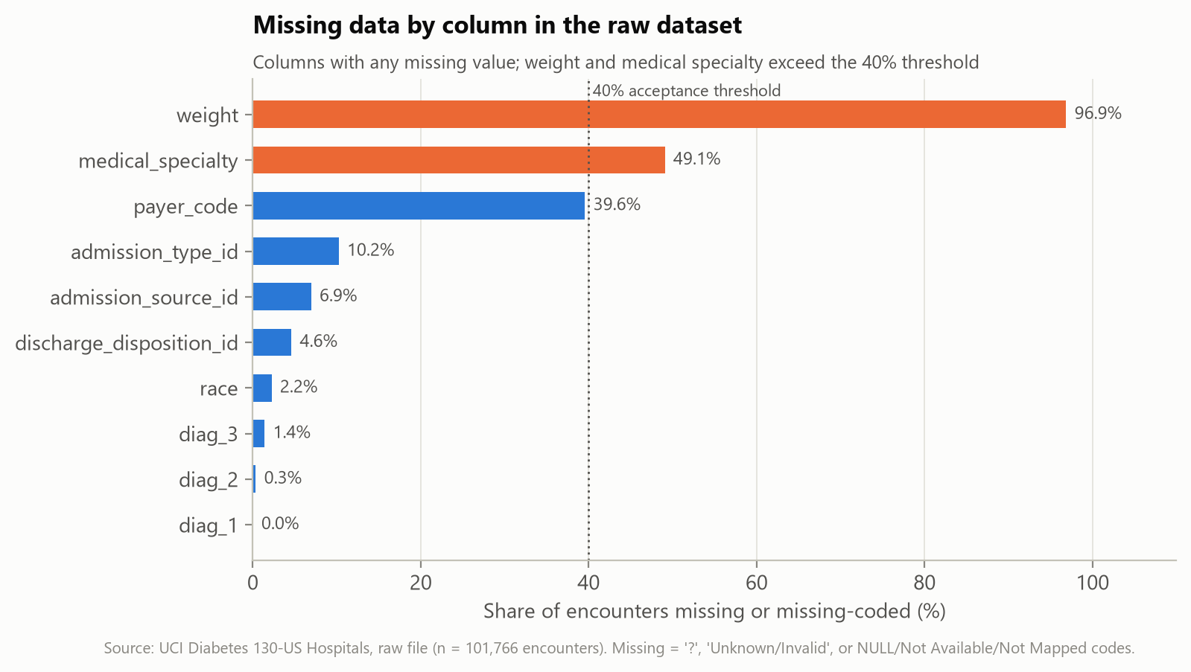
Figure 1. Missing data by column (raw data)
Interpretation. Weight and medical specialty exceed the 40% threshold; weight was dropped and specialty kept with an explicit 'Unknown' level.
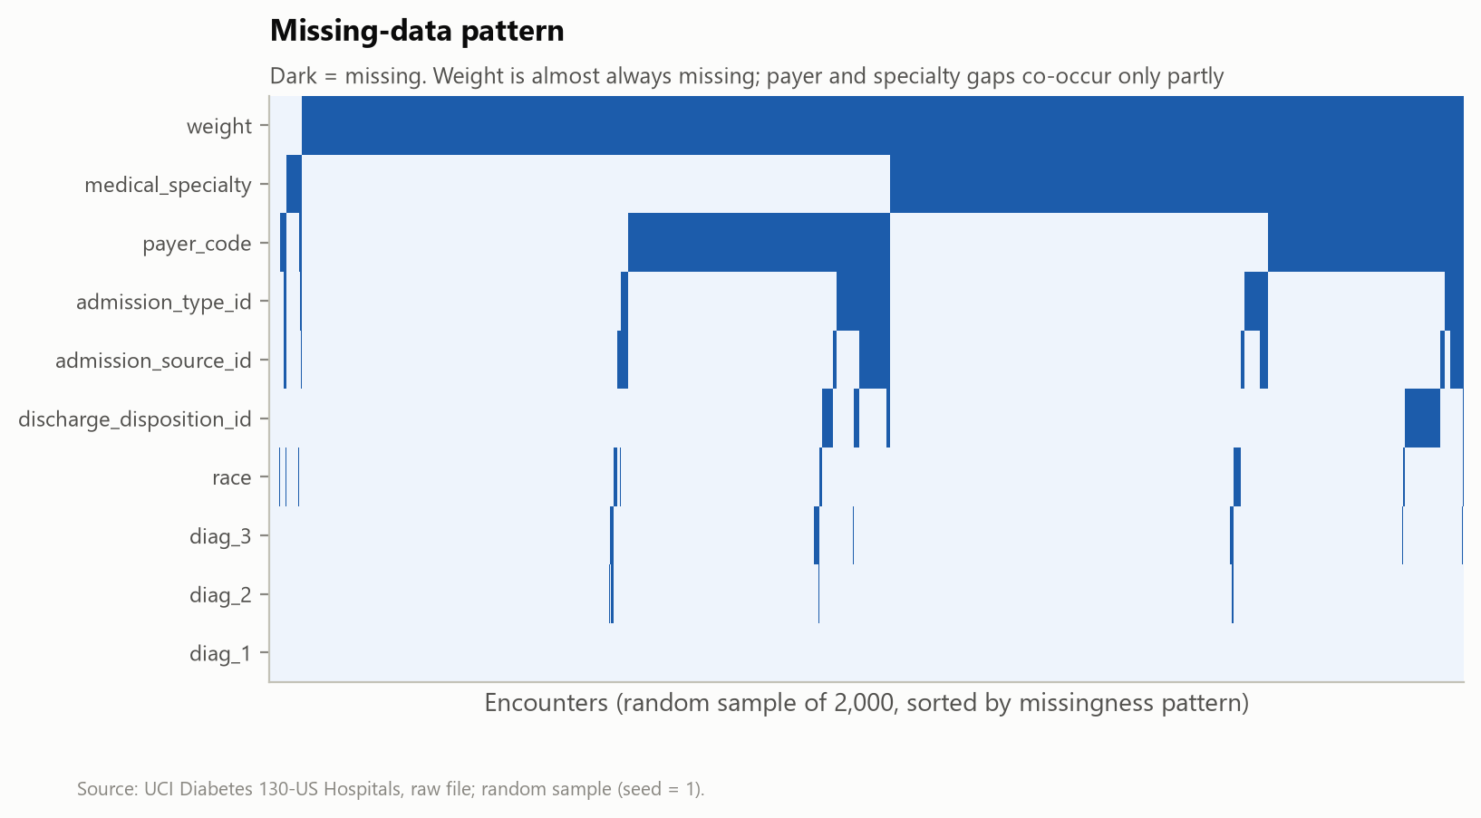
Figure 2. Missing-data pattern (random sample)
Interpretation. Gaps are not concentrated in one block of records, so they are unlikely to come from a single data-entry failure.

10. Risk Assessment: Data Issues and Mitigation
Table 12. Data issue risk assessment (as found)
ID | Dimension | Issue | Magnitude | Mitigation | Residual risk
DQ-01 | Validity | Gender recorded as 'Unknown/Invalid' | 3 rows | Rows removed | Negligible
DQ-02 | Completeness | Weight almost entirely missing | 96.9% of rows | Column dropped | Body weight/BMI cannot be analysed as a risk factor
DQ-03 | Relevance | Constant medication columns ['examide', 'citoglipton'] | 2 columns | Columns dropped
DQ-04 | Completeness | Missing payer_code | 39.6% of rows | Explicit 'Unknown' category | Analyses by this field are limited to recorded values; bias if missingness is non-random
DQ-05 | Completeness | Missing medical_specialty | 49.1% of rows | Explicit 'Unknown' category | Analyses by this field are limited to recorded values; bias if missingness is non-random
DQ-06 | Completeness | Missing race | 2.2% of rows | Explicit 'Unknown' category | Analyses by this field are limited to recorded values; bias if missingness is non-random
DQ-07 | Completeness | Uninformative admission_type_id codes | 10.2% of rows | Recoded as 'Unknown' | Some loss of detail
DQ-08 | Completeness | Uninformative discharge_disposition_id codes | 4.6% of rows | Recoded as 'Unknown' | Some loss of detail
DQ-09 | Completeness | Uninformative admission_source_id codes | 6.9% of rows | Recoded as 'Unknown' | Some loss of detail
DQ-10 | Completeness | Missing secondary/tertiary diagnoses | diag_1 21, diag_2 358, diag_3 1423 rows | Kept as 'Missing' group | Fewer recorded comorbidities may reflect coding depth rather than health
DQ-11 | Uniqueness | Repeated encounters for the same patient | 30,248 non-index encounters | Analysis cohort keeps first encounter per patient | Later-encounter risk not modelled; encounter_id ordering assumed chronological (not documented)
DQ-12 | Timeliness | Data cover 1999–2008 and contain no admission dates | Entire dataset | Documented; no time-trend analysis attempted | Practice patterns and coding (ICD-9 to ICD-10) have changed since; findings may not transfer
DQ-13 | Accuracy | Values cannot be checked against source medical records | Entire dataset | Range, domain and consistency checks only | Passing automated checks does not prove clinical accuracy
DQ-14 | Validity | Readmission label scope (same hospital system vs any hospital) not documented | Target variable | Documented as a limitation | Readmissions may be under-counted

Table 13. Prospective data risks for future refreshes
Prospective risk | Likelihood | Mitigation
Coding changes over time (ICD-9 → ICD-10) | Medium | Map codes with official crosswalks; analyse eras separately
Outcome ascertainment gaps (readmission elsewhere) | Medium | State as limitation; link to regional data where lawful
Silent schema change in a refreshed extract | Medium | Automated schema and rule checks fail the pipeline
Re-identification through rare combinations | Low | Aggregate outputs; suppress cells n < 30; no linkage

11. Governance and Privacy during Collection
- Use the minimum data needed; exclude identifiers from analysis.
- Public de-identified data: follow licence attribution (CC BY 4.0).
- Local data: data-protection impact assessment and approval before access; obligations under India's DPDP Act 2023 and DPDP Rules 2025 (core duties apply from 14 May 2027) and the ABDM Health Data Management Policy (MeitY, 2025; National Health Authority, 2020).
- US-origin data: HIPAA de-identification standards (HHS, 2012).

12. Replicability Checklist
Table 14. Replicability checklist
Item | Status
Raw data checksummed and unchanged | ✓
Every transformation scripted and logged | ✓
Validation rules automated | ✓
Data dictionary published | ✓
Issue log with residual risks | ✓
Before/after metrics computed | ✓

References
Centers for Medicare & Medicaid Services. (2026). Hospital Readmissions Reduction Program [Data set]. Provider Data Catalog. https://data.cms.gov/provider-data/dataset/9n3s-kdb3
Clore, J., Cios, K., DeShazo, J., & Strack, B. (2014). Diabetes 130-US hospitals for years 1999–2008 [Data set]. UCI Machine Learning Repository. https://doi.org/10.24432/C5230J
Kahn, M. G., Callahan, T. J., Barnard, J., Bauck, A. E., Brown, J., Davidson, B. N., Estiri, H., Goerg, C., Holve, E., Johnson, S. G., Liaw, S.-T., Hamilton-Lopez, M., Meeker, D., Ong, T. C., Ryan, P., Shang, N., Weiskopf, N. G., Weng, C., Zozus, M. N., & Schilling, L. (2016). A harmonized data quality assessment terminology and framework for the secondary use of electronic health record data. eGEMs, 4(1), 1244. https://doi.org/10.13063/2327-9214.1244
McKinney, W. (2010). Data structures for statistical computing in Python. In S. van der Walt & J. Millman (Eds.), Proceedings of the 9th Python in Science Conference (pp. 56–61). https://doi.org/10.25080/Majora-92bf1922-00a
Ministry of Electronics and Information Technology. (2025). Digital Personal Data Protection Rules, 2025 (notified 14 November 2025). Government of India. https://www.meity.gov.in/
National Health Authority. (2020). Health data management policy: Ayushman Bharat Digital Mission. Government of India. https://abdm.gov.in/
Rubin, D. B. (1976). Inference and missing data. Biometrika, 63(3), 581–592. https://doi.org/10.1093/biomet/63.3.581
Strack, B., DeShazo, J. P., Gennings, C., Olmo, J. L., Ventura, S., Cios, K. J., & Clore, J. N. (2014). Impact of HbA1c measurement on hospital readmission rates: Analysis of 70,000 clinical database patient records. BioMed Research International, 2014, 781670. https://doi.org/10.1155/2014/781670
U.S. Department of Health and Human Services. (2012). Guidance regarding methods for de-identification of protected health information in accordance with the Health Insurance Portability and Accountability Act (HIPAA) Privacy Rule. https://www.hhs.gov/hipaa/for-professionals/special-topics/de-identification/index.html
Wang, R. Y., & Strong, D. M. (1996). Beyond accuracy: What data quality means to data consumers. Journal of Management Information Systems, 12(4), 5–33. https://doi.org/10.1080/07421222.1996.11518099
Weiskopf, N. G., & Weng, C. (2013). Methods and dimensions of electronic health record data quality assessment: Enabling reuse for clinical research. Journal of the American Medical Informatics Association, 20(1), 144–151. https://doi.org/10.1136/amiajnl-2011-000681
White, I. R., Royston, P., & Wood, A. M. (2011). Multiple imputation using chained equations: Issues and guidance for practice. Statistics in Medicine, 30(4), 377–399. https://doi.org/10.1002/sim.4067

