SIX-WEEK HEALTHCARE DATA ANALYTICS INTERNSHIP · WEEK 4 SUBMISSION
Statistical Analysis and Predictive Modelling Framework
Methods, validation and ethics for healthcare predictive analytics

Project: 30-day readmission and resource use among diabetic inpatients in 130 US hospitals (UCI Diabetes 130-US Hospitals dataset, 1999–2008)

Prepared by: Juluru Akshay
Internship organisation: [Organisation name]
Supervisor: [Supervisor name]
Date: 24 October 2026
Project repository: https://github.com/AJ1206/healthcare-readmission-analytics

Contents
1. Executive Summary 3
2. Statistical Techniques for Healthcare Data 4
3. Mapping Questions to Methods 5
4. Data Segmentation 6
5. Variable Selection 7
6. Pre-processing and Model Selection 8
7. Evaluation and Validation 9
8. Pitfalls, Biases and Mitigation 10
9. Ethical Considerations 11
10. Illustrative Application of the Framework 12
11. Replication Checklist 14
References 15

This framework is written so that it can be replicated on another hospital's data. Section 10 shows the results obtained when the framework was applied to the selected dataset, demonstrating that it is practical.

1. Executive Summary
The framework moves from descriptive statistics to inferential tests, adjusted regression and finally predictive modelling, with each method chosen for the data type and question. Data are segmented by patient into training, validation and test sets; variables are selected on clinical grounds and screened for leakage; models are compared against simple baselines and validated by cross-validation and a single untouched test evaluation, including calibration and subgroup analysis. Ethical safeguards cover privacy, fairness, transparency, accountability and human oversight, consistent with TRIPOD+AI reporting (Collins et al., 2024), WHO (2021) and ICMR (2023) guidance.

2. Statistical Techniques for Healthcare Data
Table 1. Common statistical techniques
Technique | Use in healthcare | Key assumption / note
Descriptive statistics | Summarise distributions (mean, median, IQR, rates) | Use medians for skewed counts
Confidence intervals (Wilson) | Precision of rates | Binomial sampling
Chi-square test | Categorical factor vs binary outcome | Independent observations; expected counts ≥ 5
Mann–Whitney U / Kruskal–Wallis | Compare skewed numeric variables between groups | Independent groups
t-test / ANOVA | Compare means of roughly normal variables | Normality, equal variances (or Welch)
Correlation (Spearman) | Monotonic association | No causal meaning
Logistic regression | Adjusted associations with a binary outcome | Linear logit; low collinearity
Poisson / negative binomial regression | Counts such as length of stay or visits | Over-dispersion check
Survival analysis (Kaplan–Meier, Cox) | Time to readmission with censoring | Proportional hazards
Time-series (ETS, ARIMA) | Trends and forecasts of monthly rates | Requires dated data
Multiple-comparison control (Holm) | Many tests at once | Controls family-wise error (Holm, 1979)

3. Mapping Questions to Methods
Table 2. Question-to-method mapping
Question | Method | Main output
How common is readmission? | Proportion + Wilson CI | Rate with 95% CI
Which factors are associated? | χ², Mann–Whitney (+ effect sizes, Holm) | Cramér's V, rank-biserial r
Which associations survive adjustment? | Multivariable logistic regression | Adjusted odds ratios
Does an association vary by subgroup? | Interaction terms + likelihood-ratio test | Effect modification
How are resources used? | Kruskal–Wallis; bed-day shares | ε², distributions
Can risk be predicted? | Supervised machine learning | ROC-AUC, PR-AUC, calibration
How will rates change? (when dates exist) | Exponential smoothing / ARIMA | Forecast with prediction intervals

4. Data Segmentation
- Cohort definition: one index encounter per patient; exclude deaths and hospice discharges (outcome not applicable).
- Unit of analysis: the patient — prevents the same person appearing in training and test data.
- Split: 60% training, 20% validation, 20% test, stratified on the outcome so each set has the same readmission rate.
- Grouped or temporal splits: if repeated encounters are used, split by patient (GroupKFold); if dates exist, train on earlier periods and test on later ones.
- Analytic segments: pre-specified subgroups (age, sex, race, diagnosis) for descriptive comparison and fairness audit.
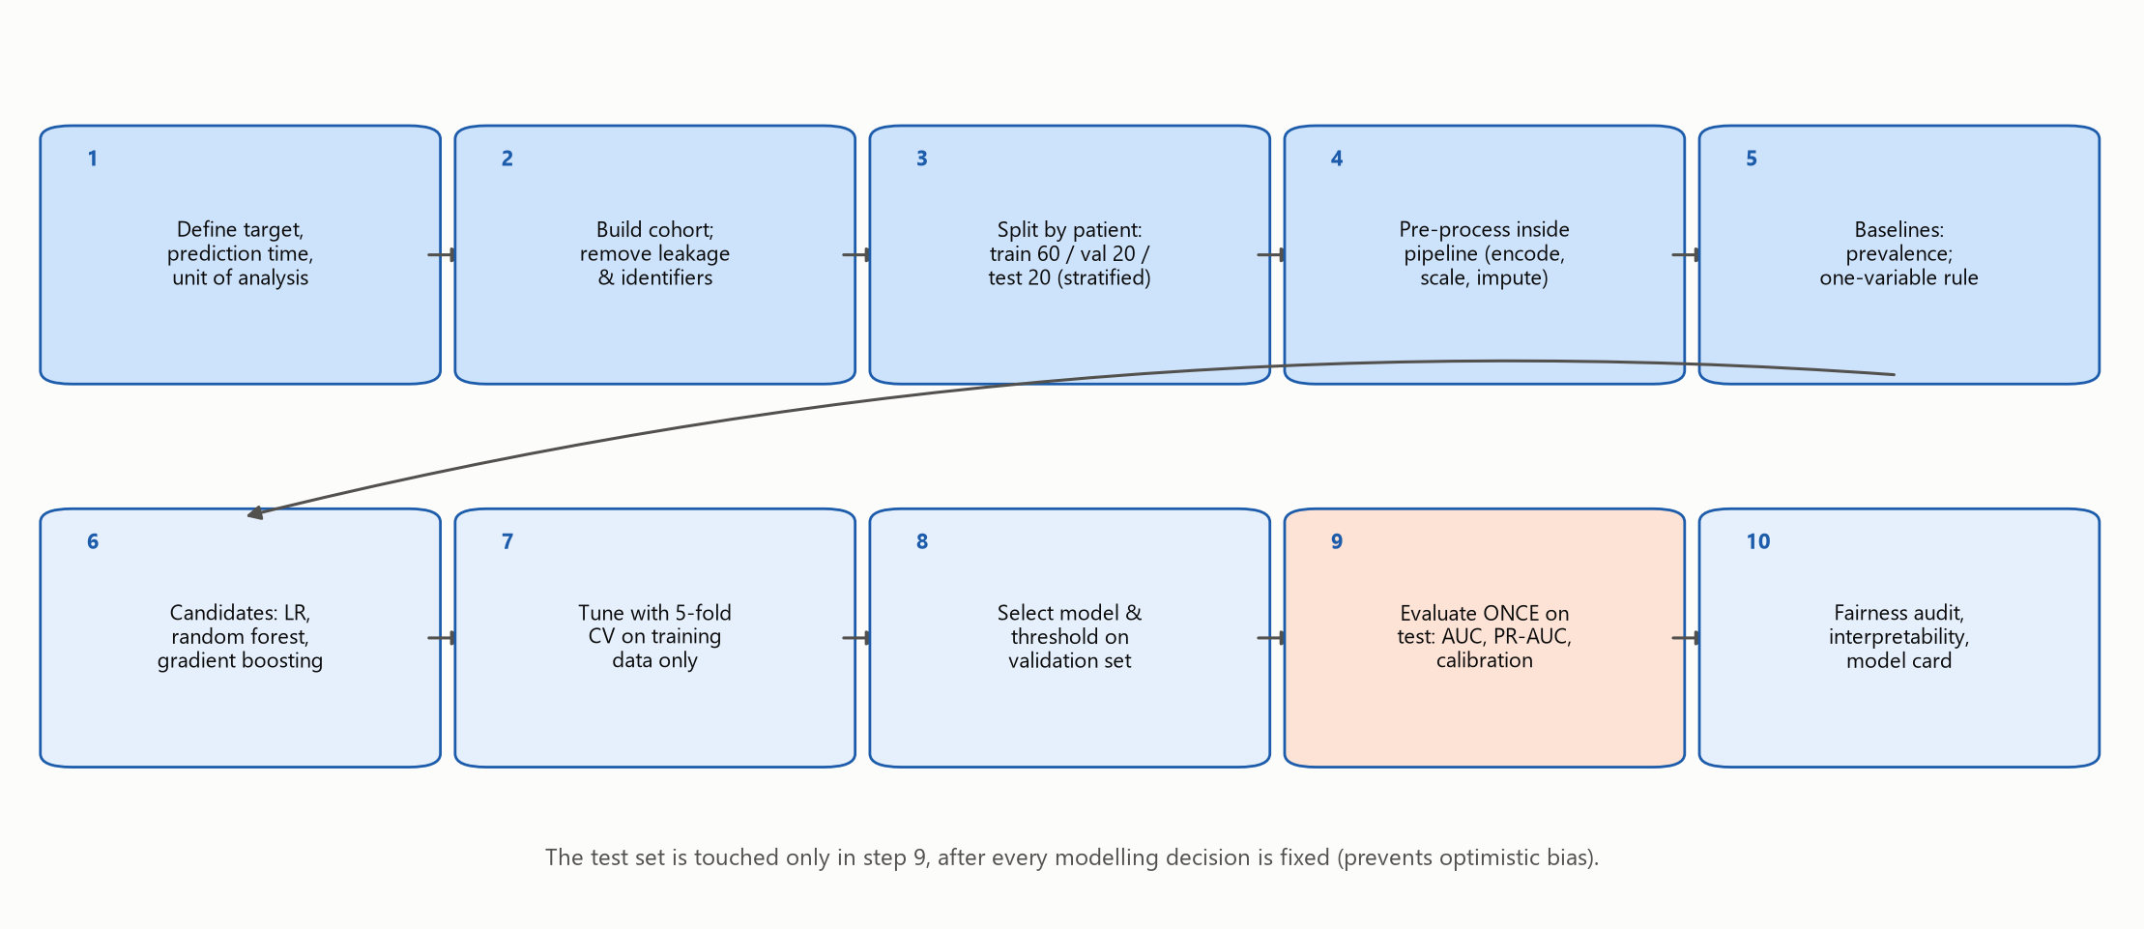
Figure 1. Step-by-step predictive modelling process

5. Variable Selection
1. Fix the prediction time (at discharge) and keep only variables known by then.
2. Start from clinical knowledge and literature (prior use, comorbidity, discharge destination, age).
3. Remove identifiers and anything derived from the outcome (target leakage; Kaufman et al., 2012).
4. Group sparse categories; check collinearity (variance inflation factor < 5).
5. Decide on sensitive attributes deliberately: race and payer are excluded as predictors but used to audit fairness.
6. Let regularisation (L2) and tree models handle remaining redundancy; confirm with permutation importance.
Table 3. Variables excluded and why
Excluded variable(s) | Reason
encounter_id, patient_nbr | Identifiers - no predictive meaning; risk of memorisation
readmitted, readmit_any | Outcome information (target leakage)
encounter_seq, is_index_encounter, expired_or_hospice | Constant within the analysis cohort
race | Excluded as a predictor to avoid encoding structural inequities; used only for fairness audit
payer_code | Socio-economic proxy with 40% missing; excluded for fairness and data-quality reasons
diag_1/2/3 raw ICD-9 codes | 700+ sparse levels; replaced by clinical groups
raw ID columns (admission/discharge/source) | Replaced by grouped labels

6. Pre-processing and Model Selection
Table 4. Pre-processing
Step | Approach
Missing values | Explicit 'Unknown' level for categories; multiple imputation for numeric values if needed (White et al., 2011)
Encoding | One-hot encoding; rare levels grouped
Scaling | Standardisation for linear models only
Class imbalance | Keep natural prevalence (preserves calibration); handle through threshold choice
Leakage prevention | All steps fitted inside a pipeline on training folds only

Table 5. Candidate models
Model | Why | Trade-off
Baseline: prevalence | Reference for no information | AUC = 0.5 by definition
Baseline: one-variable rule | What a hospital could do today | Prior-admission flag
Logistic regression | Interpretable, well calibrated | Linear effects only
Random forest | Non-linearities and interactions | Less transparent; can be poorly calibrated
Gradient boosting | Strong tabular performance | Needs careful tuning

Hyperparameters are tuned by randomised search with 5-fold stratified cross-validation on the training set. The final model is chosen on the validation set, with a parsimony rule favouring logistic regression when performance is within 0.005 AUC (Steyerberg, 2019; Hastie et al., 2009).

7. Evaluation and Validation
Table 6. Validation design
Technique | Purpose | Rule
k-fold cross-validation | Tuning and internal performance estimate | Training set only
Hold-out validation set | Model and threshold selection | Never used for training
Untouched test set | Final, unbiased performance | Used exactly once
Bootstrap | Confidence intervals for AUC and PR-AUC | 1,000 resamples
Temporal / external validation | Transportability to new periods or hospitals | Required before deployment

Table 7. Evaluation metrics
Aspect | Metrics
Discrimination | ROC-AUC; PR-AUC (better for rare outcomes; Saito & Rehmsmeier, 2015)
Calibration | Calibration curve, slope and intercept (Van Calster et al., 2019)
Classification at a threshold | Sensitivity, specificity, PPV, NPV, F1 — threshold chosen from workload
Clinical utility | Decision-curve analysis (net benefit; Vickers & Elkin, 2006)
Fairness | Metrics by subgroup with confidence intervals

Accuracy is misleading for rare outcomes: in this data a rule that flags nobody is 91.0% accurate but finds no readmissions.

8. Pitfalls, Biases and Mitigation
Table 8. Pitfalls and mitigation
Pitfall | Consequence | Mitigation
Target leakage | Inflated performance | Prediction-time rule; exclude outcome-derived fields; pipelines
Non-independent records | Over-optimistic validation | Patient-level split
Overfitting | Poor generalisation | Cross-validation; regularisation; simple baselines
Confounding | Spurious causal claims | Adjusted models; causal language avoided
Selection bias | Unrepresentative cohort | Document inclusion rules; compare with population
Measurement / label bias | Model learns documentation patterns | Audit missingness by group; clinician review
Historical bias | Model reproduces inequities (Obermeyer et al., 2019) | Exclude proxies; fairness audit
Dataset shift | Performance decays over time | Temporal validation; drift monitoring
Multiple testing | False positives | Holm correction; pre-specified hypotheses

9. Ethical Considerations
Table 9. Ethical framework
Principle | How it is applied
Privacy | De-identified data; minimum necessary; secure storage; DPDP Act/Rules obligations for local data (MeitY, 2025)
Fairness and equity | Exclude race and payer as inputs; report performance by subgroup; agree fairness criteria with stakeholders (Rajkomar et al., 2018)
Transparency | Model card; plain-language reasons; published code
Accountability | Named clinical owner; governance committee sign-off
Autonomy and human oversight | Scores support, never replace, clinical judgement
Beneficence / non-maleficence | Weigh harms of false negatives (missed patients) and false positives (unnecessary follow-up)
Validity before use | External validation and recalibration before deployment (ICMR, 2023; WHO, 2021)
Monitoring | Quarterly drift, calibration and subgroup checks; decommissioning plan

10. Illustrative Application of the Framework
Applied to 69,970 patients, the framework produced the following results.
- Facility discharge: 15.2% vs 7.5% readmitted (risk ratio 2.03); adjusted OR 2.95 (rehab) and 1.81 (skilled nursing) vs home.
- Each prior inpatient admission: adjusted OR 1.42.
- HbA1c measured: adjusted OR 0.92; association varies by diagnosis (p = 0.009).
- Best model (Random forest): test ROC-AUC 0.649 (95% CI 0.634–0.664) vs 0.548 for the one-variable rule; calibration slope 1.26.
Table 10. Test-set results
Model | ROC-AUC | PR-AUC | Brier | Sensitivity | Precision
Logistic regression (L2) | 0.641 | 0.158 | 0.080 | 0.351 | 0.162
Random forest | 0.649 | 0.174 | 0.079 | 0.368 | 0.170
Gradient boosting (HistGB) | 0.646 | 0.164 | 0.079 | 0.385 | 0.176
Baseline: prevalence only | 0.500 | 0.090 | 0.082 | 0.000 | 0.000
Baseline: prior inpatient count (1-variable LR) | 0.548 | 0.115 | 0.081 | 0.201 | 0.153

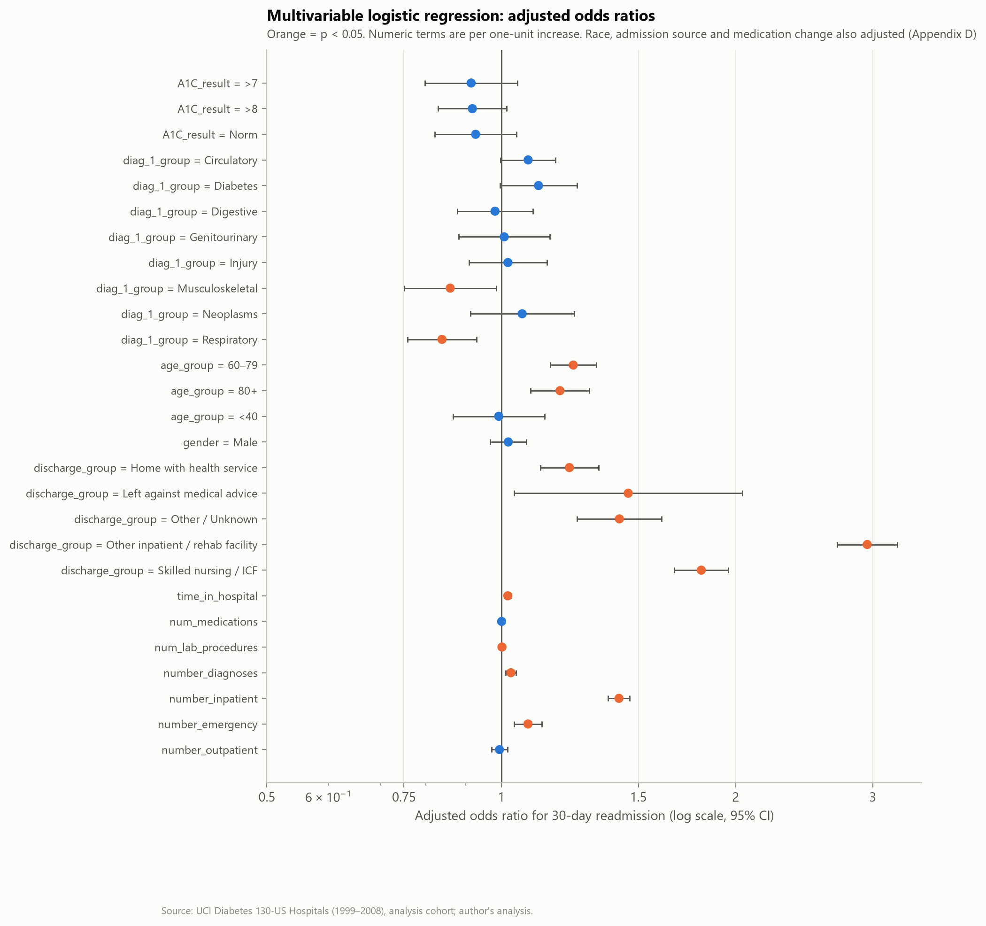
Figure 2. Adjusted odds ratios (logistic regression)
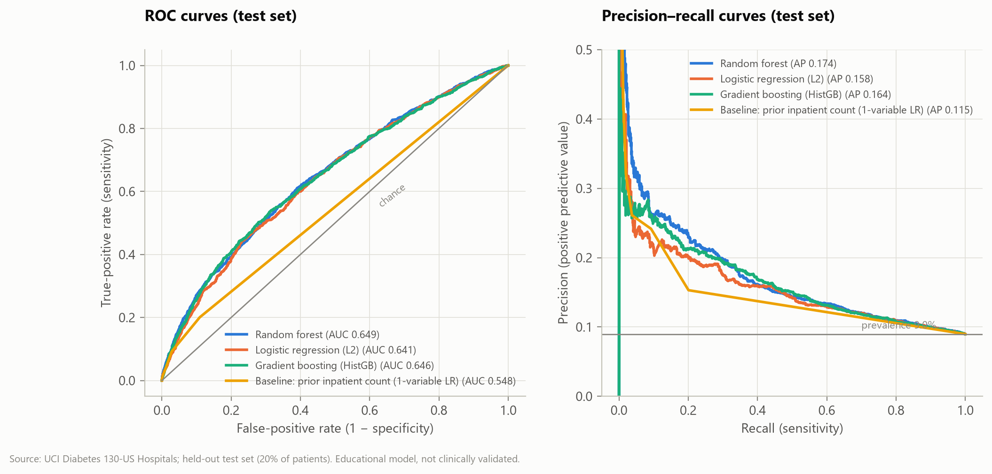
Figure 3. ROC and precision–recall curves
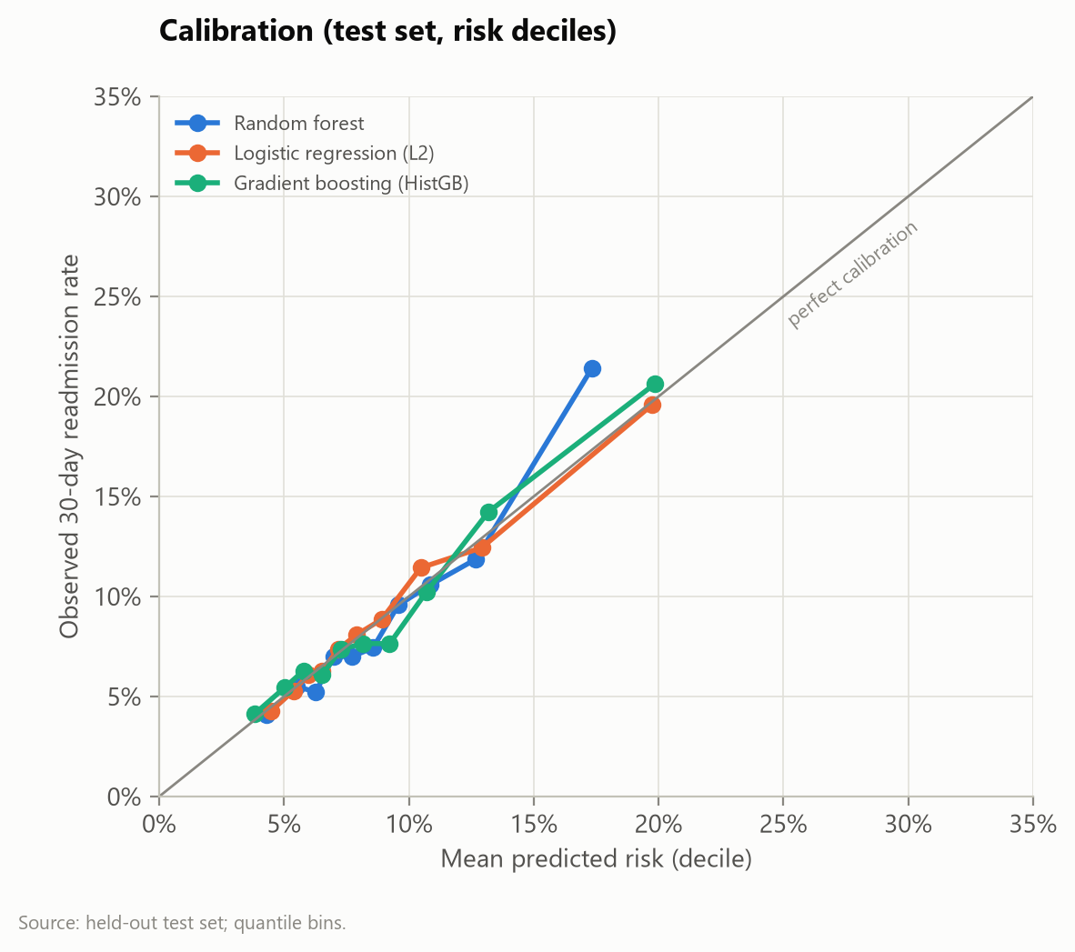
Figure 4. Calibration curves
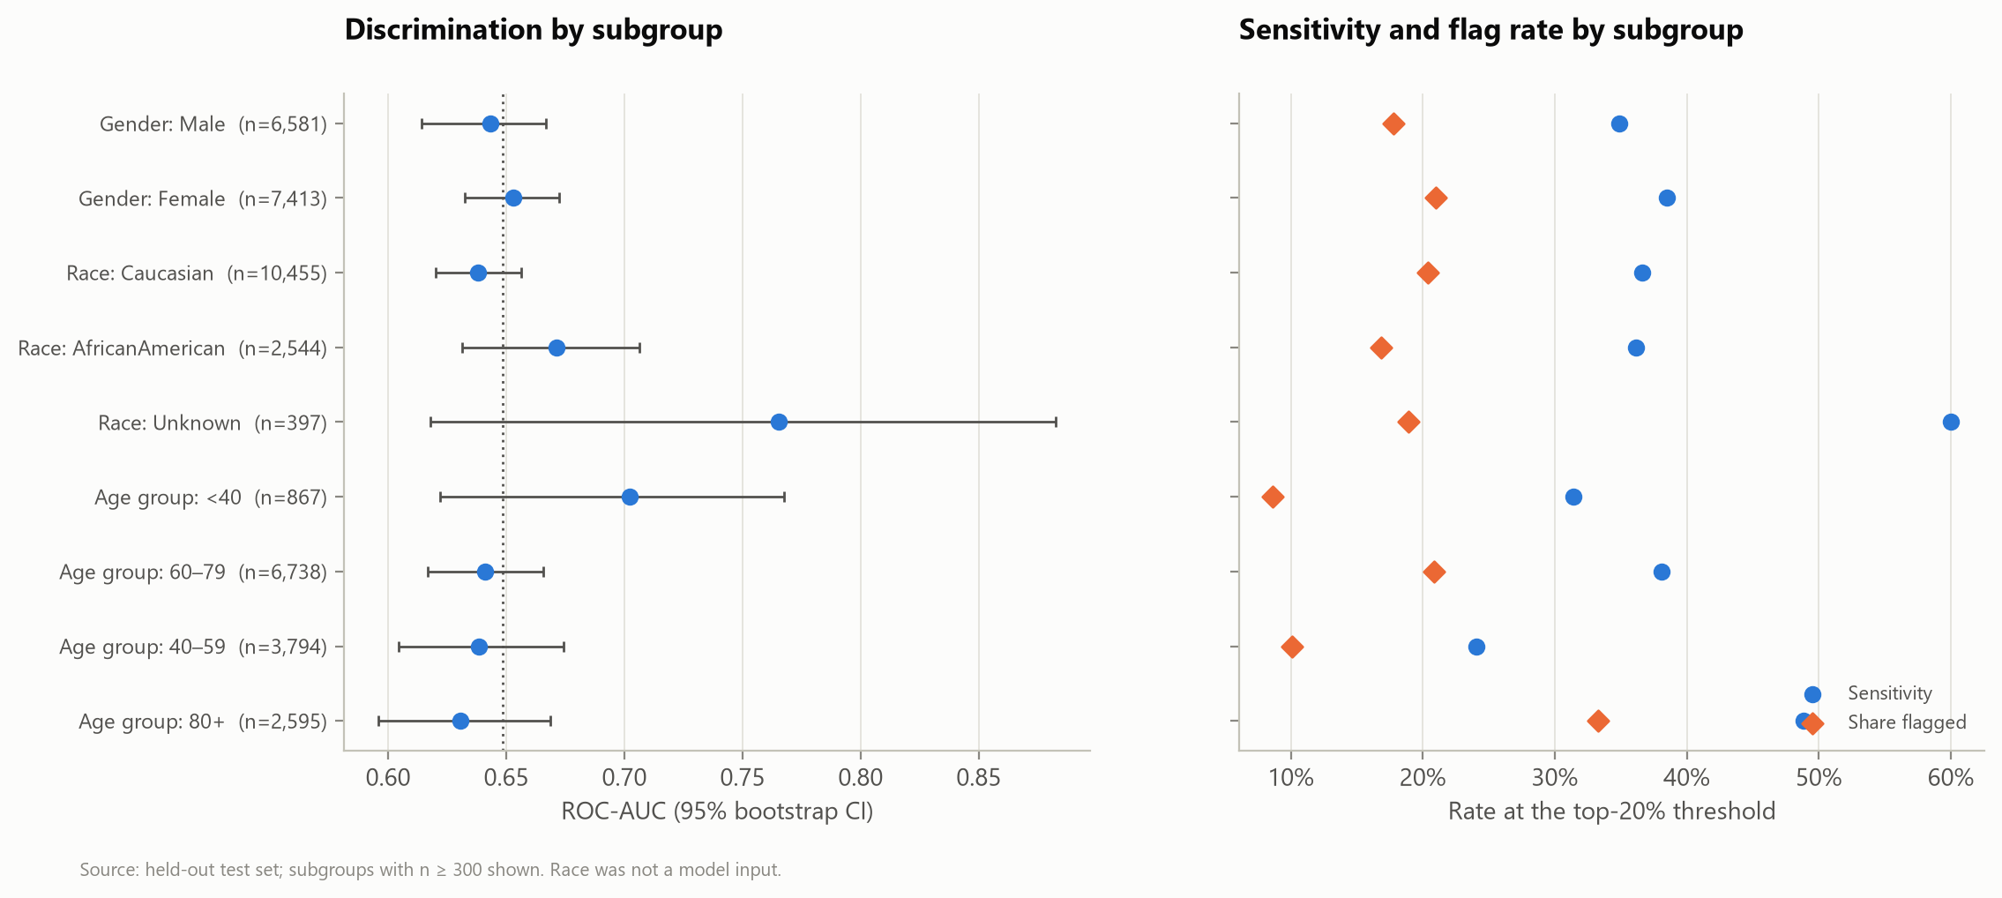
Figure 5. Subgroup performance (fairness audit)

11. Replication Checklist
Table 11. Replication checklist
Item | Status
Prediction time and unit defined | ✓
Leakage screen documented | ✓
Patient-level split, fixed seed | ✓
Pre-processing inside pipelines | ✓
Baselines reported | ✓
Test set used once | ✓
Calibration and fairness reported | ✓
External / temporal validation | Required before use

References
Collins, G. S., Moons, K. G. M., Dhiman, P., Riley, R. D., Beam, A. L., Van Calster, B., Ghassemi, M., Liu, X., Reitsma, J. B., van Smeden, M., Boulesteix, A.-L., Camaradou, J. C., Celi, L. A., Denaxas, S., Denniston, A. K., Glocker, B., Golub, R. M., Harvey, H., Heinze, G., … Logullo, P. (2024). TRIPOD+AI statement: Updated guidance for reporting clinical prediction models that use regression or machine learning methods. BMJ, 385, e078378. https://doi.org/10.1136/bmj-2023-078378
Hastie, T., Tibshirani, R., & Friedman, J. (2009). The elements of statistical learning: Data mining, inference, and prediction (2nd ed.). Springer. https://doi.org/10.1007/978-0-387-84858-7
Holm, S. (1979). A simple sequentially rejective multiple test procedure. Scandinavian Journal of Statistics, 6(2), 65–70.
Indian Council of Medical Research. (2023). Ethical guidelines for application of artificial intelligence in biomedical research and healthcare. https://www.icmr.gov.in/ethical-guidelines-for-application-of-artificial-intelligence-in-biomedical-research-and-healthcare
Kansagara, D., Englander, H., Salanitro, A., Kagen, D., Theobald, C., Freeman, M., & Kripalani, S. (2011). Risk prediction models for hospital readmission: A systematic review. JAMA, 306(15), 1688–1698. https://doi.org/10.1001/jama.2011.1515
Kaufman, S., Rosset, S., Perlich, C., & Stitelman, O. (2012). Leakage in data mining: Formulation, detection, and avoidance. ACM Transactions on Knowledge Discovery from Data, 6(4), 1–21. https://doi.org/10.1145/2382577.2382579
Ministry of Electronics and Information Technology. (2025). Digital Personal Data Protection Rules, 2025 (notified 14 November 2025). Government of India. https://www.meity.gov.in/
Obermeyer, Z., Powers, B., Vogeli, C., & Mullainathan, S. (2019). Dissecting racial bias in an algorithm used to manage the health of populations. Science, 366(6464), 447–453. https://doi.org/10.1126/science.aax2342
Rajkomar, A., Hardt, M., Howell, M. D., Corrado, G., & Chin, M. H. (2018). Ensuring fairness in machine learning to advance health equity. Annals of Internal Medicine, 169(12), 866–872. https://doi.org/10.7326/M18-1990
Saito, T., & Rehmsmeier, M. (2015). The precision-recall plot is more informative than the ROC plot when evaluating binary classifiers on imbalanced datasets. PLOS ONE, 10(3), e0118432. https://doi.org/10.1371/journal.pone.0118432
Steyerberg, E. W. (2019). Clinical prediction models: A practical approach to development, validation, and updating (2nd ed.). Springer. https://doi.org/10.1007/978-3-030-16399-0
Van Calster, B., McLernon, D. J., van Smeden, M., Wynants, L., & Steyerberg, E. W. (2019). Calibration: The Achilles heel of predictive analytics. BMC Medicine, 17, 230. https://doi.org/10.1186/s12916-019-1466-7
Vickers, A. J., & Elkin, E. B. (2006). Decision curve analysis: A novel method for evaluating prediction models. Medical Decision Making, 26(6), 565–574. https://doi.org/10.1177/0272989X06295361
White, I. R., Royston, P., & Wood, A. M. (2011). Multiple imputation using chained equations: Issues and guidance for practice. Statistics in Medicine, 30(4), 377–399. https://doi.org/10.1002/sim.4067
Wilson, E. B. (1927). Probable inference, the law of succession, and statistical inference. Journal of the American Statistical Association, 22(158), 209–212. https://doi.org/10.1080/01621459.1927.10502953
World Health Organization. (2021). Ethics and governance of artificial intelligence for health: WHO guidance. https://www.who.int/publications/i/item/9789240029200

