SIX-WEEK DATA ANALYTICS INTERNSHIP · INTEGRATED FINAL REPORT
End-to-End Healthcare Data Analytics
Data Acquisition, Quality Assurance, Statistical Analysis, Predictive Modelling, Visualisation and Evidence-Based Decision-Making

Case study: 30-day readmission and resource use among diabetic inpatients in 130 US hospitals (UCI Diabetes 130-US Hospitals dataset, 1999–2008)

Prepared by: Juluru Akshay
Internship organisation: [Organisation name]
Supervisor / mentor: [Supervisor name]
Submission date: 24 October 2026
Data accessed: 2026-10-24 (UCI Machine Learning Repository, CC BY 4.0)

Educational and analytical use only. The predictive model in this report has not been clinically or institutionally validated and must not be used to make decisions about individual patients.

Table of Contents
1. Executive Summary 7
2. Introduction and Healthcare Problem Statement 8
2.1 Background 8
2.2 Problem statement 8
2.3 Business justification 8
2.4 Decisions the analysis supports 8
3. Project Vision, Objectives, Scope and Research Questions 9
3.1 Vision 9
3.2 Measurable objectives 9
3.3 Scope 9
3.4 Research questions and hypotheses 9
4. Strategic Planning and Project Governance 11
4.1 Stakeholder analysis 11
4.2 Analytical framework and workflow 11
4.3 Technology and resource requirements 11
4.4 Governance and review procedures 12
5. Dataset Selection and Data Acquisition 13
5.1 Candidate datasets compared 13
5.2 Selected dataset 13
5.3 Structure and suitability 14
5.4 Acquisition procedure 14
6. Data Cleaning and Quality Assurance 15
6.1 Initial profiling 15
6.2 Cleaning and transformation procedures 16
6.3 Cohort definition 16
6.4 Quality before and after cleaning 17
6.5 Quality dimensions assessed 17
6.6 Issue log and unresolved issues 17
7. Data Privacy, Ethics and Governance 19
7.1 Privacy, confidentiality and de-identification 19
7.2 Licensing and permitted use 19
7.3 Indian legal and policy context (verified October 2026) 19
7.4 International standards 19
7.5 Data minimisation, secure storage, access control and retention 20
7.6 Bias, fairness, transparency and accountability 20
8. Healthcare KPIs and Definitions 21
9. Exploratory Data Analysis 22
9.1 Executive overview and cohort profile 22
9.2 Outcome distribution 23
9.3 Demographics 23
9.4 Clinical and care-process comparisons 24
9.5 Resource utilisation 26
9.6 Relationships between variables 27
9.7 Operational and quality issues identified 28
10. Statistical Analysis and Results 29
10.1 Methods and assumptions 29
10.2 Overall rate 29
10.3 Categorical factors 29
10.4 Numeric factors 30
10.5 Pre-specified two-group comparisons 30
10.6 Resource use across diagnoses 30
10.7 Multivariable logistic regression 30
10.8 HbA1c and readmission (H3) 31
10.9 Hypothesis summary 31
11. Visualisation and Dashboard Design 33
11.1 Design principles 33
11.2 Interactive dashboard (delivered) 33
11.3 Power BI build pack 33
12. Predictive Modelling Methodology 34
12.1 Problem framing 34
12.2 Predictors and leakage control 34
12.3 Pre-processing 34
12.4 Baselines and candidate models 34
13. Model Evaluation and Responsible AI 36
13.1 Test-set performance 36
13.2 Why accuracy is misleading 36
13.3 Calibration 37
13.4 Interpretability 38
13.5 Subgroup performance and fairness 39
13.6 Responsible-AI statement and deployment conditions 39
13.7 Model evaluation checklist 40
14. Analytical Results and Interpretation 41
14.1 Answers to the research questions 41
14.2 Discussion 41
14.3 Alternative explanations 41
15. Evidence-Based Recommendations 42
16. Project Timeline and Resource Allocation 43
17. Risk Register and Contingency Planning 44
18. Integrated Project Workflow 45
18.1 How the components interlink 45
19. Limitations, Lessons Learned and Future Research 46
19.1 Limitations 46
19.2 Lessons learned 46
19.3 Best practices for future healthcare analytics projects 46
19.4 Methodological improvements and future research 46
20. Conclusion 47
Appendix A: Data Dictionary 48
Appendix B: Data Quality Checklist 50
Appendix C: KPI Formulas 51
Appendix D: Statistical Test Results 52
Appendix E: Model Evaluation Tables 54
Appendix F: Dashboard Screenshots 55
Appendix G: Reflective Self-Assessment 57
G.A Assessment of approach and methodology 57
G.B Personal learning reflection (to be completed by the intern) 57
Appendix H: Career Development Plan 59
References 60

List of Figures
Figure 1. Missing data by column in the raw dataset 15
Figure 2. Missing-data pattern in a random sample of 2,000 encounters 15
Figure 3. Executive KPI overview 22
Figure 4. Distribution of the readmission outcome 23
Figure 5. Age distribution and 30-day readmission by age band 23
Figure 6. 30-day readmission by recorded race and gender 24
Figure 7. 30-day readmission by primary diagnosis group 24
Figure 8. 30-day readmission by discharge destination 25
Figure 9. 30-day readmission by prior-year inpatient admissions 25
Figure 10. HbA1c testing by primary diagnosis and readmission by HbA1c result 26
Figure 11. Length-of-stay distribution and readmission by length of stay 26
Figure 12. Bed-day consumption and length of stay by primary diagnosis 27
Figure 13. Spearman correlation matrix 27
Figure 14. Adjusted odds ratios for 30-day readmission 31
Figure 15. ROC and precision–recall curves on the test set 36
Figure 16. Confusion matrix at the top-20% threshold 37
Figure 17. Calibration curves on the test set (risk deciles) 38
Figure 18. Permutation feature importance (Random forest) 38
Figure 19. Discrimination, sensitivity and flag rate by subgroup 39
Figure 20. Interactive dashboard — desktop layout (1,360 px wide) 55
Figure 21. Interactive dashboard — mobile layout (390 px wide, first screen) 56

List of Tables
Table 1. Project objectives and measures of success 9
Table 2. Research questions and hypotheses 9
Table 3. Stakeholder analysis 11
Table 4. Technology stack 11
Table 5. Dataset selection matrix 13
Table 6. Selected dataset metadata 13
Table 7. Transformation log 16
Table 8. Data-quality metrics before and after cleaning 17
Table 9. Quality dimensions, thresholds and results 17
Table 10. Data-quality issue log 17
Table 11. Data governance controls 20
Table 12. KPI catalogue with calculated values 21
Table 13. Descriptive statistics of numeric variables (n = 69,970) 22
Table 14. Statistical methods 29
Table 15. Chi-square tests of association with 30-day readmission 29
Table 16. Mann–Whitney U tests: numeric variables by 30-day readmission 30
Table 17. Pre-specified comparisons of 30-day readmission 30
Table 18. Hypothesis outcomes 31
Table 19. Prediction problem specification 34
Table 20. Variables excluded from the model 34
Table 21. Baselines and candidate models 34
Table 22. Cross-validation and validation results 35
Table 23. Held-out test-set performance (n = 13,994; prevalence 9.0%) 36
Table 24. Effect of the decision threshold (Random forest, test set) 36
Table 25. Readmission by predicted-risk decile (test set) 39
Table 26. Subgroup performance at the top-20% threshold (test set) 39
Table 27. Model evaluation checklist 40
Table 28. Recommendation matrix 42
Table 29. Six-week roadmap: planned effort and executed work 43
Table 30. Risk register 44
Table 31. Pipeline scripts, inputs and outputs 45
Table 32. Integration of project components 45
Table 33. Data dictionary of the cleaned dataset 48
Table 34. Data-quality assurance checklist 50
Table 35. Automated validation rules and results (cleaned data) 50
Table 36. KPI and metric formulas 51
Table 37. Full multivariable logistic regression (adjusted odds ratios) 52
Table 38. Spearman correlations for key variable pairs 52
Table 39. Chi-square assumption check (expected cell counts) 52
Table 40. Permutation importance (validation set, top 15) 54
Table 41. Largest coefficients of the regularised logistic regression (reference model) 54
Table 42. Model card summary 54
Table 43. Self-assessment of the approach 57
Table 44. Career development plan 59

1. Executive Summary
This report documents a complete, reproducible healthcare analytics project carried out across a six-week internship plan. It analyses 101,766 real, de-identified inpatient encounters of patients with diabetes from 130 US hospitals (1999–2008), published by the UCI Machine Learning Repository under a CC BY 4.0 licence. The project asks which patients are readmitted within 30 days of discharge, how hospital resources are used, and whether a model can usefully rank readmission risk at discharge.
Key results (all calculated from the data in this project):
- Readmission burden. Among 69,970 patients (first eligible encounter each; deaths and hospice discharges excluded), 6,277 were readmitted within 30 days: 9.0% (95% CI 8.8%–9.2%). Across all encounters the rate was 11.2%, and 16.7% for repeat encounters.
- Discharge destination is the strongest signal. Patients discharged to a skilled-nursing or other inpatient/rehabilitation facility were readmitted at 15.2% versus 7.5% for other destinations (risk ratio 2.03, 95% CI 1.93–2.13); the association persisted after adjustment (adjusted OR 2.95 for rehabilitation/other inpatient facilities versus home).
- Prior utilisation matters. Patients with at least one inpatient admission in the previous year had a 30-day rate of 15.4% versus 8.1% (RR 1.90); each additional prior admission carried an adjusted OR of 1.42.
- HbA1c was rarely measured. Only 18.4% of patients had HbA1c tested during the stay. Testing was associated with modestly lower readmission (adjusted OR 0.92, 95% CI 0.85–0.99), and the association differed by primary diagnosis (interaction p = 0.009), consistent with Strack et al. (2014). This is an association, not evidence that testing prevents readmission.
- Resource use. Mean length of stay was 4.27 days (median 3); circulatory conditions consumed 29.8% of 299,000 bed-days. Stays of 7 days or more were associated with a higher 30-day rate (11.7% vs 8.3%).
- Predictive model. A tuned random forest achieved a test ROC-AUC of 0.649 (95% CI 0.634–0.664) and PR-AUC 0.174 against a prevalence of 9.0%. Flagging the highest-risk 20% of patients would identify 36.8% of readmissions with a positive predictive value of 17.0%. Discrimination is modest; the model is suitable for learning and population-level exploration, not for clinical decisions.
- Data quality. Raw cell completeness was 95.8%; weight was 96.9% missing and was dropped. All 44 automated validation rules passed after cleaning, but clinical accuracy could not be verified against source records.
Priority recommendations (Section 15) are: strengthen transitions of care for facility discharges; trigger early discharge planning and prompt follow-up for patients with prior-year admissions; audit and pilot more consistent HbA1c assessment; improve documentation of weight, specialty and payer; and keep any risk model in a supervised, locally validated pilot with subgroup monitoring.
What was not done: no Power BI .pbix file could be produced (Power BI Desktop cannot be automated here), so an interactive HTML dashboard plus a complete Power BI build pack (data model, DAX, step-by-step guide) is provided instead. No time-trend or hospital-level comparison was possible because the public dataset contains no admission dates or hospital identifiers. The personal learning reflection in Appendix G (Part B) is left for the intern to write in their own words.

2. Introduction and Healthcare Problem Statement

2.1 Background
Unplanned hospital readmissions are costly for health systems and distressing for patients. In the US Medicare fee-for-service population, about one in five discharged patients was rehospitalised within 30 days (Jencks et al., 2009), and the Centers for Medicare & Medicaid Services (CMS) penalises hospitals with excess readmissions through the Hospital Readmissions Reduction Program (HRRP; CMS, 2026). Diabetes is a common comorbidity in hospitalised adults, and inconsistent inpatient diabetes management has been linked to readmission risk (Strack et al., 2014). These figures are external context; the findings in later sections come from this project's own analysis.

2.2 Problem statement
A hospital quality team wants to know (a) how often diabetic inpatients return within 30 days, (b) which patient, clinical and care-process factors are associated with early readmission, (c) where inpatient resources are concentrated, and (d) whether readily available discharge data can rank patients by readmission risk well enough to prioritise follow-up. Without this evidence, transition-of-care resources are spread uniformly rather than targeted.

2.3 Business justification
- Readmissions consume beds and staff time that could serve new admissions.
- Readmission performance is a publicly reported, payment-linked quality measure in several systems (e.g., HRRP).
- Targeted discharge interventions have reduced readmissions in randomised trials (Jack et al., 2009; Naylor et al., 1999; Leppin et al., 2014), but they need a way to decide whom to target.
- A reproducible analytics pipeline can be re-run on local data, turning a one-off study into a monitoring capability.

2.4 Decisions the analysis supports
- Which discharge groups should receive enhanced transition-of-care support.
- Whether to standardise HbA1c assessment for admitted patients with diabetes.
- Where bed-day consumption is concentrated (for length-of-stay review).
- Whether a risk score is accurate and fair enough to justify a supervised pilot.
- Which data-capture gaps to close before more advanced analytics.

3. Project Vision, Objectives, Scope and Research Questions

3.1 Vision
To give clinical and operational leaders a transparent, reproducible and ethically governed evidence base on diabetic inpatient readmissions and resource use that can be refreshed with local data.

3.2 Measurable objectives
Table 1. Project objectives and measures of success
ID | Objective | Success measure | Status
O1 | Acquire and document a real, licensed healthcare dataset | Source, licence, checksum and schema recorded | Achieved
O2 | Deliver an analysis-ready dataset | 100% of validation rules pass; issue log complete | Achieved
O3 | Quantify 30-day readmission and resource-use KPIs | ≥10 KPIs with formulas and 95% CIs where applicable | Achieved (14 KPIs)
O4 | Test five pre-specified hypotheses | Tests with effect sizes and multiplicity control | Achieved
O5 | Build and evaluate a readmission risk model | Beats baseline on untouched test set; calibration and subgroups reported | Achieved (modest AUC)
O6 | Provide an interactive dashboard | Filters, KPI cards, CIs, small-sample suppression | Achieved (HTML); Power BI pack
O7 | Produce traceable recommendations | Each linked to a result or cited source | Achieved

3.3 Scope
- In scope: patient-level analysis of the UCI Diabetes 130-US Hospitals data; descriptive, inferential and predictive analysis of 30-day readmission; resource-use indicators (length of stay, bed-days, medications, laboratory procedures); dashboard; governance and ethics review.
- Out of scope: causal effect estimation; cost analysis (no cost fields); hospital benchmarking (no hospital identifier); time trends (no dates); deployment into clinical systems.
- Assumptions: readmission labels are correct as coded; encounter_id order approximates chronological order within a patient; the 1999–2008 data are adequate for learning methods, not for current operational targets.
- Constraints: public data only (no credentialed access); open-source tools; Power BI Desktop not automatable in the project environment; six-week timeframe.

3.4 Research questions and hypotheses
Table 2. Research questions and hypotheses
ID | Research question | Testable hypothesis
RQ1 | What is the 30-day readmission rate and how is it distributed across patient groups? | Descriptive (no hypothesis)
RQ2 | Is prior inpatient use associated with 30-day readmission? | H1: patients with ≥1 prior-year admission have a higher 30-day rate
RQ3 | Does discharge destination matter? | H2: discharge to a care facility is associated with higher 30-day readmission
RQ4 | Is in-hospital HbA1c measurement associated with readmission? | H3: HbA1c measurement is associated with lower readmission after adjustment, and the association differs by primary diagnosis
RQ5 | Are length of stay and age associated with readmission? | H4: longer stays and older age are associated with higher 30-day readmission
RQ6 | Does resource use differ by primary diagnosis? | H5: length of stay differs across primary-diagnosis groups
RQ7 | Can discharge data rank readmission risk better than simple rules? | H6: a multivariable model outperforms a prior-admission baseline on held-out data (ROC-AUC)

4. Strategic Planning and Project Governance

4.1 Stakeholder analysis
Table 3. Stakeholder analysis
Stakeholder | Main interest | Influence | Impact on / of project | Information needs | Engagement
Hospital executive leadership | Cost, penalties, capacity | High | High | One-page KPI summary; recommendation matrix | Monthly briefing
Chief Medical Officer / quality committee | Patient safety, quality measures | High | High | Validated findings, limitations | Review at each milestone
Diabetes / endocrinology team | Glycaemic management, HbA1c practice | Medium | High | HbA1c findings by diagnosis | Clinical review workshop
Hospitalists and attending physicians | Discharge readiness | Medium | High | Risk factors; model limitations | Ward meetings
Nursing, case managers, discharge planners | Transition-of-care workload | Medium | High | Who to prioritise; dashboard | Co-design of pilot
Health information management (HIM) | Documentation quality | Medium | Medium | Data-quality issue log | Data-quality forum
IT / data engineering | Pipelines, security | Medium | Medium | Code, data model, access needs | Technical hand-over
Data protection officer / privacy | Lawful, minimal processing | High | Medium | Data inventory, DPIA inputs | Sign-off before any local data use
Patients and caregivers | Safe discharge, fewer returns | Low | High | Plain-language summary | Patient advisory group
Internship supervisor / mentor | Learning outcomes, rigour | High | Medium | Weekly deliverables | Weekly review

4.2 Analytical framework and workflow
The project follows a CRISP-DM-style lifecycle adapted for healthcare: problem definition → data acquisition → profiling and quality assurance → cleaning and cohort definition → exploratory analysis → inferential statistics → predictive modelling → evaluation (discrimination, calibration, fairness) → visualisation and dashboard → recommendations → governance review. Each stage is a numbered Python script with defined inputs and outputs (Section 18), so any stage can be re-run and audited. Model development and reporting follow the TRIPOD+AI reporting principles (Collins et al., 2024) where applicable.

4.3 Technology and resource requirements
Table 4. Technology stack
Tool / resource | Purpose in this project
Python 3.14 | Core language for all processing, analysis and report generation
pandas, NumPy | Loading, profiling, cleaning and reshaping tabular data (McKinney, 2010)
SciPy, statsmodels | Hypothesis tests, confidence intervals, logistic regression (Virtanen et al., 2020; Seabold & Perktold, 2010)
scikit-learn | Pre-processing pipelines, model training, cross-validation, metrics (Pedregosa et al., 2011)
Matplotlib, seaborn | Publication-quality static figures (Hunter, 2007)
HTML/JavaScript (no external libraries) | Self-contained interactive dashboard with filters and tooltips
Power BI Desktop (optional) | Rebuild of the dashboard from the provided star schema and DAX measures
python-docx; Microsoft Word | Generation of this report; field (TOC) refresh
SQL (conceptual) | Validation rules in Appendix B are written so they translate directly to SQL CHECK/WHERE clauses
Hardware | Standard laptop (8–16 GB RAM); full pipeline runs in under 15 minutes

4.4 Governance and review procedures
- Weekly milestone review: deliverables checked against the acceptance criteria in Section 16 by the supervisor; decisions and changes logged.
- Analytical peer review: a second analyst re-runs the pipeline from raw data and compares key numbers (cohort size, 30-day rate, test AUC) before results are shared.
- Clinical review: clinicians review variable definitions (diagnosis grouping, discharge grouping) and the plausibility of findings.
- Privacy and ethics checkpoint: before any local (non-public) data is used, a data-protection impact assessment and ethics-committee review are required (Section 7).
- Change control: scripts are version-controlled; any change to cohort or outcome definitions requires re-running all downstream steps.
- Model governance: no model output is used for patient care without clinical validation, a named accountable owner and a monitoring plan (Section 13.6).

5. Dataset Selection and Data Acquisition

5.1 Candidate datasets compared
Four credible public or controlled-access sources were evaluated. Accessibility was confirmed programmatically on 2026-10-24 (HTTP 200 for every landing page or API). Scores run from 1 (poor) to 5 (excellent).
Table 5. Dataset selection matrix
Criterion | UCI Diabetes 130-US Hospitals (selected) | CMS Hospital Readmissions Reduction Program | CDC Diabetes Health Indicators (BRFSS) | MIMIC-IV (PhysioNet)
Relevance to readmission | 5 | 4 | 2 | 5
Accessibility | 5 – direct download | 5 – open API/CSV | 5 – direct download | 1 – credentialing, training and DUA
Documentation | 4 – UCI page + paper | 4 – CMS data dictionary | 3 | 5
Completeness | 3 – some sparse fields | 4 | 5 | 4
Recency | 1 – 1999–2008 | 5 – Jul 2021–Jun 2024 | 2 – BRFSS survey year | 4
Sample size | 5 – 101,766 encounters | 3 – 18,330 hospital-measure rows | 5 – 253,680 respondents | 5
Patient-level readmission target | 5 – yes | 2 – hospital-level ratios only | 1 – none | 4 – derivable
Licensing | 5 – CC BY 4.0 | 5 – US government open data | 3 – not stated on UCI page | 2 – restricted DUA
Feasibility in six weeks | 5 | 4 | 4 | 1
Total (max 45) | 38 | 36 | 30 | 31
CMS file verified: FY 2026 HRRP hospital file, 18,330 rows covering 3,055 hospitals × 6 conditions. CDC figures as listed on the UCI page. MIMIC-IV requires PhysioNet credentialing and a data use agreement.
Decision. The UCI Diabetes 130-US Hospitals dataset is the only option that is immediately accessible, openly licensed and has a patient-level readmission outcome. Its main weakness is age (1999–2008), which limits the transferability of absolute rates to current practice; this is treated as a key limitation rather than hidden. The CMS HRRP data were not combined with it because the populations (diabetic inpatients vs Medicare condition cohorts), periods (1999–2008 vs 2021–2024) and units (patients vs hospitals) are incompatible and there is no join key.

5.2 Selected dataset
Table 6. Selected dataset metadata
Attribute | Value
Title | Diabetes 130-US Hospitals for Years 1999-2008
Creators | Clore, J., Cios, K., DeShazo, J., & Strack, B. (2014)
Publisher | UCI Machine Learning Repository
DOI | https://doi.org/10.24432/C5230J
Landing page | https://archive.ics.uci.edu/dataset/296/diabetes+130-us+hospitals+for+years+1999-2008
Direct download | https://archive.ics.uci.edu/static/public/296/diabetes+130-us+hospitals+for+years+1999-2008.zip
Licence | Creative Commons Attribution 4.0 International (CC BY 4.0)
Access date | 2026-10-24
Files | diabetic_data.csv (encounters); IDS_mapping.csv (code labels); ZIP archive kept unchanged
SHA-256 (diabetic_data.csv) | 0689e7ec031237dc63031b938805c48377748761a3b26acab621567afa24df97
Size | 101,766 rows × 50 columns; 19.2 MB
Unit | Inpatient encounter (stay of 1–14 days) of a patient with diabetes; 71,518 unique patients
Outcome | readmitted: '<30' (within 30 days), '>30', 'NO'
Introductory paper | Strack et al. (2014), BioMed Research International, 781670

5.3 Structure and suitability
The 50 columns comprise two identifiers (encounter_id, patient_nbr); demographics (race, gender, 10-year age band, weight band); administrative codes (admission type, discharge disposition, admission source, payer, admitting specialty); utilisation counts (length of stay, laboratory procedures, procedures, medications, prior outpatient/emergency/inpatient visits); up to three ICD-9 diagnoses and the number of diagnoses; two laboratory results (maximum glucose serum, HbA1c); 23 diabetes-medication status columns (No/Steady/Up/Down); medication change and diabetes-medication flags; and the readmission outcome. The data contain no dates, hospital identifiers, costs or free text. They are suitable for patient-level readmission analysis and resource-use description, but not for time trends or hospital comparisons.

5.4 Acquisition procedure
1. 01_data_acquisition.py downloads the ZIP from the UCI static URL using HTTPS.
2. The untouched archive is saved to data/raw/ and only the two expected CSV files are extracted (defensive against unexpected archive members).
3. SHA-256 checksums, byte sizes, licence, DOI and access timestamp are written to SOURCE_METADATA.json.
4. Accessibility of the alternative datasets is probed and logged (docs/dataset_access_probes.json).
5. Raw files are never modified; all later steps write to data/processed/.

6. Data Cleaning and Quality Assurance

6.1 Initial profiling
Profiling found no duplicate encounter IDs and no exact duplicate rows. Missing values are encoded as '?' and, for the ID columns, as 'NULL', 'Not Available' or 'Not Mapped' codes. Weight was missing for 96.9% of encounters, medical specialty for 49.1% and payer code for 39.6%. Two medication columns (examide, citoglipton) were constant. Three records had gender 'Unknown/Invalid'. Of 71,518 patients, many had several encounters (up to 40), so encounters are not independent observations.
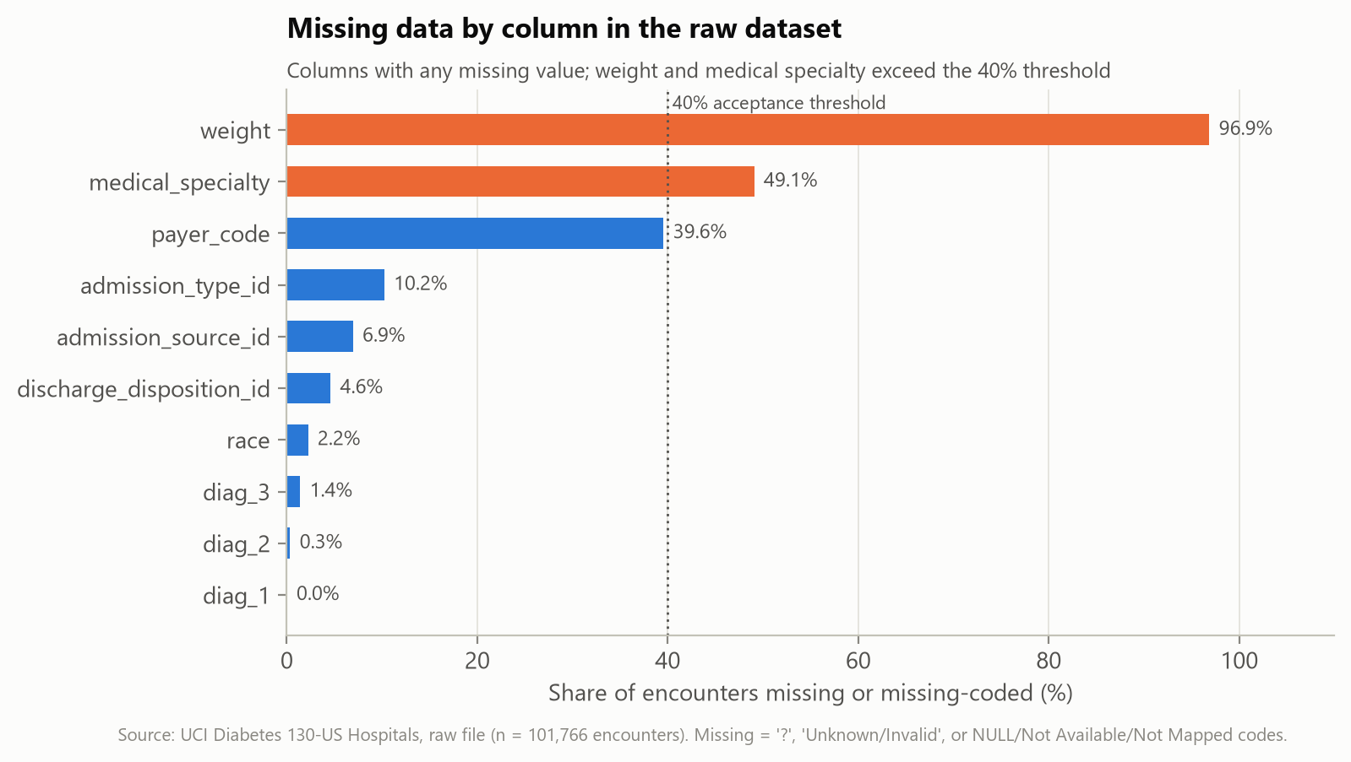
Figure 1. Missing data by column in the raw dataset
Interpretation. Two fields breach the 40% acceptance threshold. Weight is unusable; medical specialty is retained with an explicit 'Unknown' level because half the rows would otherwise be lost and missingness itself may carry information about documentation practice.
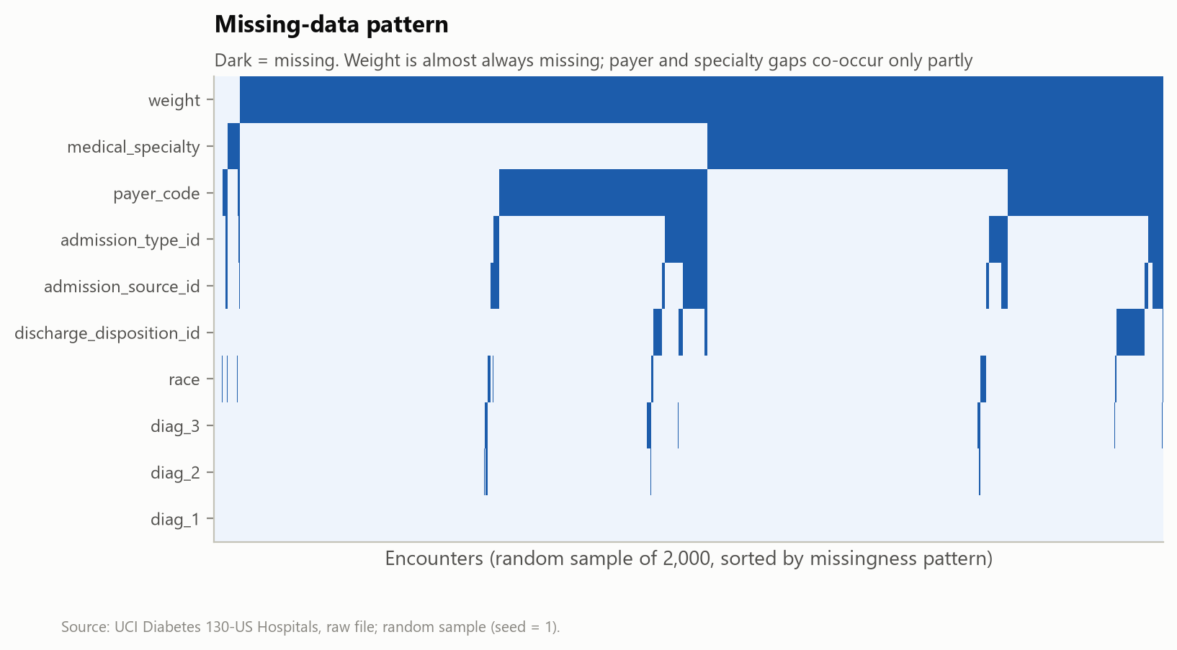
Figure 2. Missing-data pattern in a random sample of 2,000 encounters
Interpretation. Payer and specialty gaps overlap only partly, so missingness is not driven by a single data-entry failure. Because missingness is unlikely to be completely random, analyses by these fields are interpreted cautiously.

6.2 Cleaning and transformation procedures
Each transformation, its rationale and the number of rows or cells affected were logged by the cleaning script (Table 6). Missing categorical values were kept as an explicit 'Unknown' level rather than imputed, because imputing race, payer or specialty would fabricate sensitive attributes. Numeric fields had no missing values.
Table 7. Transformation log
# | Stage | Action | Rationale | Affected
1 | Missing values | Replaced '?' placeholder with a true missing value (NaN) | '?' is the dataset's documented missing marker; NaN lets tools count and handle it | 192,849
2 | Validity | Removed rows with gender 'Unknown/Invalid' | Invalid domain value; too few rows (n=3) to justify an extra category | 3
3 | Completeness | Dropped 'weight' | 96.9% missing; imputation would fabricate most values | 1 column
4 | Relevance | Dropped constant columns ['examide', 'citoglipton'] | Zero variance: carry no information | 2 columns
5 | Missing values | Filled missing 'payer_code' with explicit 'Unknown' category | Missingness may itself be informative (e.g., documentation practice); keeps rows and avoids guessing values | 40,255
6 | Missing values | Filled missing 'medical_specialty' with explicit 'Unknown' category | Missingness may itself be informative (e.g., documentation practice); keeps rows and avoids guessing values | 49,947
7 | Missing values | Filled missing 'race' with explicit 'Unknown' category | Missingness may itself be informative (e.g., documentation practice); keeps rows and avoids guessing values | 2,271
8 | Normalisation | Grouped medical_specialty into 10 most frequent + 'Other' + 'Unknown' | 73 sparse levels; rare levels give unstable estimates | 7,469
9 | Normalisation | Mapped admission_type_id codes to descriptive labels via IDS_mapping.csv; codes for NULL/Not Available/Not Mapped/Unknown set to 'Unknown' | Human-readable categories; merges several codes that all mean 'unknown' | 10,396
10 | Normalisation | Mapped discharge_disposition_id codes to descriptive labels via IDS_mapping.csv; codes for NULL/Not Available/Not Mapped/Unknown set to 'Unknown' | Human-readable categories; merges several codes that all mean 'unknown' | 4,680
11 | Normalisation | Mapped admission_source_id codes to descriptive labels via IDS_mapping.csv; codes for NULL/Not Available/Not Mapped/Unknown set to 'Unknown' | Human-readable categories; merges several codes that all mean 'unknown' | 7,067
12 | Feature engineering | Created discharge_group, admission_type_grp, admission_source_grp | Clinically meaningful groupings with adequate counts per level | 101,763
13 | Data types | Converted 8 count columns from text to integer | Enables numeric validation and analysis | 8 columns
14 | Normalisation | Derived age_band label, numeric age_mid (band midpoint) and 4-level age_group | Ordered numeric use in models; broader groups for stable subgroup estimates | 101,763
15 | Feature engineering | Grouped diag_1–diag_3 ICD-9 codes into 9 clinical categories (Strack et al., 2014 scheme) | 700+ raw codes are too sparse for analysis | 305,289
16 | Normalisation | Relabelled lab value 'None' as 'Not measured'; added A1C_measured flag | 'None' means the test was not done, not a missing value | 101,763
17 | Feature engineering | Created prior_visits_total, n_diabetes_meds, n_med_dose_changes, any_prior_inpatient | Summarise utilisation history and treatment intensity | 101,763
18 | Cohort definition | Added readmit_30 (<30 days) target, expired_or_hospice flag and encounter sequence per patient (ordered by encounter_id) | Readmission is impossible after death and not a quality failure after hospice discharge; repeated encounters of one patient are not independent | 101,763
19 | Cohort definition | Analysis cohort = index encounter per patient, excluding expired/hospice | Independent observations with an observable readmission outcome | 69,970

6.3 Cohort definition
The cleaned file keeps all 101,763 valid encounters with flags. The analysis cohort keeps the first encounter of each patient (ordered by encounter_id) and excludes encounters ending in death (1,652 encounters overall) or hospice discharge (771), for which a readmission outcome is not meaningful. This yields 69,970 patients, one row each, which makes observations independent and prevents the same patient appearing in both model training and test data. The approach mirrors Strack et al. (2014).

6.4 Quality before and after cleaning
Table 8. Data-quality metrics before and after cleaning
Quality metric | Raw (as downloaded) | Cleaned (all encounters) | Analysis cohort (index, alive, non-hospice)
Rows | 101,766 | 101,763 | 69,970
Columns (original fields) | 50 | 47 | 47
Unique patients | 71,518 | 71,515 | 69,970
Cell completeness (%) | 95.77 | 97.57 | 97.45
Rows with no missing field (%) | 1.02 | 25.4 | 24.23
Columns > 40% missing | 2 | 1 | 2
Rows passing all validity rules (%) | 100 | 100 | 100
Duplicate encounter IDs | 0 | 0 | 0
Exact duplicate rows | 0 | 0 | 0
Constant columns | 2 | 0 | 1
Cross-field consistency violations | 0 | 0 | 0
Completeness counts 'Unknown' (the explicit fill value) as missing, so the improvement reflects information actually gained (mainly by dropping weight), not relabelling. The cohort retains one constant column (a rarely used drug never prescribed at index encounters).
Cell completeness rose from 95.77% to 97.57% and the share of rows with no missing field from 1.02% to 25.40%. Medical specialty remains above the 40% threshold (accepted with an 'Unknown' level). All four cross-field consistency checks (for example, 'diabetesMed = No' while a diabetes drug is recorded; a death recorded with a readmission) returned zero violations.

6.5 Quality dimensions assessed
Table 9. Quality dimensions, thresholds and results
Dimension | How it was assessed | Acceptance threshold | Result
Completeness | Share of non-missing cells and rows; per-column missingness | Columns ≤ 40% missing or justified; no silent imputation | Met with documented exceptions (specialty, payer)
Validity | Range rules (e.g., LOS 1–14) and domain rules for every coded field | 0 failures | 44 of 44 rules pass
Consistency | Cross-field logic (medication flags, deaths vs readmission) | < 0.5% of rows | 0 violations
Uniqueness | Duplicate encounter IDs and rows; one row per patient in cohort | 0 duplicates | Met
Accuracy | Plausibility of values and distributions; comparison with published counts | Matches source documentation | Partly verifiable only (see note)
Timeliness and relevance | Data period vs intended use | Fit for learning purposes | Data are 17–26 years old; not fit for current targets
Accuracy note: the record count (101,766) and HbA1c testing share (18.4% of the cohort; Strack et al. report 18.4%) agree with published figures, but passing automated checks does not prove that individual values are clinically correct. Source records were not available for verification.

6.6 Issue log and unresolved issues
Table 10. Data-quality issue log
ID | Dimension | Issue | Magnitude | Resolution | Residual risk / effect on findings
DQ-01 | Validity | Gender recorded as 'Unknown/Invalid' | 3 rows | Rows removed | Negligible
DQ-02 | Completeness | Weight almost entirely missing | 96.9% of rows | Column dropped | Body weight/BMI cannot be analysed as a risk factor
DQ-03 | Relevance | Constant medication columns ['examide', 'citoglipton'] | 2 columns | Columns dropped
DQ-04 | Completeness | Missing payer_code | 39.6% of rows | Explicit 'Unknown' category | Analyses by this field are limited to recorded values; bias if missingness is non-random
DQ-05 | Completeness | Missing medical_specialty | 49.1% of rows | Explicit 'Unknown' category | Analyses by this field are limited to recorded values; bias if missingness is non-random
DQ-06 | Completeness | Missing race | 2.2% of rows | Explicit 'Unknown' category | Analyses by this field are limited to recorded values; bias if missingness is non-random
DQ-07 | Completeness | Uninformative admission_type_id codes | 10.2% of rows | Recoded as 'Unknown' | Some loss of detail
DQ-08 | Completeness | Uninformative discharge_disposition_id codes | 4.6% of rows | Recoded as 'Unknown' | Some loss of detail
DQ-09 | Completeness | Uninformative admission_source_id codes | 6.9% of rows | Recoded as 'Unknown' | Some loss of detail
DQ-10 | Completeness | Missing secondary/tertiary diagnoses | diag_1 21, diag_2 358, diag_3 1423 rows | Kept as 'Missing' group | Fewer recorded comorbidities may reflect coding depth rather than health
DQ-11 | Uniqueness | Repeated encounters for the same patient | 30,248 non-index encounters | Analysis cohort keeps first encounter per patient | Later-encounter risk not modelled; encounter_id ordering assumed chronological (not documented)
DQ-12 | Timeliness | Data cover 1999–2008 and contain no admission dates | Entire dataset | Documented; no time-trend analysis attempted | Practice patterns and coding (ICD-9 to ICD-10) have changed since; findings may not transfer
DQ-13 | Accuracy | Values cannot be checked against source medical records | Entire dataset | Range, domain and consistency checks only | Passing automated checks does not prove clinical accuracy
DQ-14 | Validity | Readmission label scope (same hospital system vs any hospital) not documented | Target variable | Documented as a limitation | Readmissions may be under-counted

7. Data Privacy, Ethics and Governance

7.1 Privacy, confidentiality and de-identification
The dataset was de-identified by its publishers: patient and encounter numbers are surrogate keys, age is banded in 10-year intervals and no names, addresses, dates or hospital identifiers are released. In US terms this resembles HIPAA de-identification, which allows either removal of 18 identifier types (Safe Harbor) or an expert determination that re-identification risk is very small (US Department of Health and Human Services [HHS], 2012). De-identification lowers but does not remove risk: rare combinations (for example, a patient with 40 encounters, an uncommon diagnosis and a recorded race) could in principle be linked to other data. This project therefore (a) does not attempt any linkage, (b) publishes only aggregated results and model outputs, and (c) suppresses dashboard rates for groups with fewer than 30 patients.

7.2 Licensing and permitted use
The data are licensed CC BY 4.0, which permits sharing and adaptation with attribution. The raw and processed files are therefore included in the project package with attribution to Clore et al. (2014) and the UCI repository. The CC BY licence does not remove ethical obligations: the data concern real patients and should not be used to profile individuals or communities.

7.3 Indian legal and policy context (verified October 2026)
- Digital Personal Data Protection Act, 2023 (DPDP Act). India's general data-protection law. Its implementing Digital Personal Data Protection Rules, 2025 were notified on 14 November 2025 with phased commencement: provisions on the Data Protection Board took effect on notification, while most obligations on data fiduciaries (notice, consent, security safeguards, breach notification, retention and erasure) apply from 14 May 2027 (Ministry of Electronics and Information Technology [MeitY], 2025). Any project using identifiable patient data in India should design for these obligations now.
- Ayushman Bharat Digital Mission (ABDM) Health Data Management Policy. Sets minimum privacy standards for entities in the national digital health ecosystem, including consent-based sharing, purpose limitation and data minimisation (National Health Authority, 2020; a revised draft was released for consultation in 2022).
- ICMR Ethical Guidelines for Application of AI in Biomedical Research and Healthcare (2023). Require ethics-committee review, attention to data quality, non-discrimination, accountability and clinical validation before AI tools are deployed (Indian Council of Medical Research [ICMR], 2023).
Because this project uses openly licensed, de-identified US data, the DPDP Act's consent obligations are not triggered by the analysis itself. They would apply in full if the pipeline were re-run on identifiable data from an Indian hospital.

7.4 International standards
- WHO guidance on ethics and governance of AI for health sets six principles: protect autonomy; promote well-being, safety and the public interest; ensure transparency, explainability and intelligibility; foster responsibility and accountability; ensure inclusiveness and equity; and promote responsive, sustainable AI (World Health Organization [WHO], 2021).
- TRIPOD+AI provides a 27-item checklist for reporting prediction models built with regression or machine learning (Collins et al., 2024); Section 13 follows its main elements (data source, outcome, predictors, sample size, missing data, model building, performance, fairness, limitations).
- HIPAA de-identification guidance (HHS, 2012) informs the de-identification assessment above.

7.5 Data minimisation, secure storage, access control and retention
Table 11. Data governance controls
Control | Implementation
Data minimisation | Only fields needed for the research questions are used in models; race and payer excluded as predictors; identifiers excluded.
Secure storage | For local (non-public) data: encrypted disk, organisation-managed storage, no copies on personal devices or public repositories.
Access control | Role-based access: raw data restricted to named analysts; dashboard shows aggregates only.
Auditability | Scripted pipeline, checksums of raw files, transformation log, fixed random seeds, versioned code.
Retention | Public data: retained with the project. Local data: retained only as long as the approved purpose requires, then securely erased (DPDP Rules timelines).
Re-identification controls | No linkage to other datasets; small-cell suppression (n < 30) in published views.

7.6 Bias, fairness, transparency and accountability
Recorded race is missing for 2.2% of encounters, and categories are coarse. Using race or payer (an insurance and socio-economic proxy) as predictors could encode structural inequities into risk scores (Obermeyer et al., 2019; Rajkomar et al., 2018). The model therefore excludes both, and subgroup performance is audited instead (Section 13.5). Explainability is supported by permutation importance and a parallel logistic regression. Accountability for any future clinical use must rest with a named clinical owner and a governance committee, not with the analyst or the model.

8. Healthcare KPIs and Definitions
KPIs are computed on the analysis cohort unless stated. Formulas are repeated in Appendix C and implemented as DAX measures in the Power BI pack.
Table 12. KPI catalogue with calculated values
ID | KPI | Formula | Value | Type
K1 | 30-day readmission rate | Readmissions < 30 days ÷ eligible index discharges | 9.0% (95% CI 8.8%–9.2%) | Quality / outcome
K2 | Any-time readmission rate | Readmissions (< 30 or > 30 days) ÷ eligible discharges | 40.7% | Outcome
K3 | Encounter-level 30-day readmission rate | Readmissions < 30 days ÷ all valid encounters | 11.2% | Outcome
K4 | In-hospital mortality (encounters) | Encounters with expired disposition ÷ all valid encounters | 1.62% | Outcome
K5 | Average length of stay (ALOS) | Σ days in hospital ÷ patients | 4.27 days | Utilisation
K6 | Total bed-days | Σ days in hospital | 299,000 | Utilisation
K7 | Mean medications per stay | Σ distinct medications ÷ patients | 15.7 | Utilisation
K8 | Mean laboratory procedures per stay | Σ lab procedures ÷ patients | 42.9 | Utilisation
K9 | HbA1c testing rate | Patients with HbA1c measured ÷ patients | 18.4% | Process
K10 | Diabetes medication change rate | Patients with any diabetes drug change ÷ patients | 45.0% | Process
K11 | Discharge-to-home rate | Discharged home (± home health) ÷ patients | 75.2% | Flow
K12 | Prior-year inpatient share | Patients with ≥ 1 prior inpatient stay ÷ patients | 11.7% | Risk mix
K13 | Facility-discharge 30-day readmission rate | Readmissions < 30 days among SNF/ICF/rehab discharges ÷ those discharges | 15.2% | Quality
K14 | Data completeness | Non-missing cells ÷ all cells (cleaned) | 97.6% | Data quality
K15 | Model ROC-AUC (test) | Area under ROC curve on held-out patients | 0.649 | Model
K16 | Readmissions captured in top-20% risk | True positives ÷ all readmissions at top-20% threshold | 36.8% | Model

9. Exploratory Data Analysis

9.1 Executive overview and cohort profile
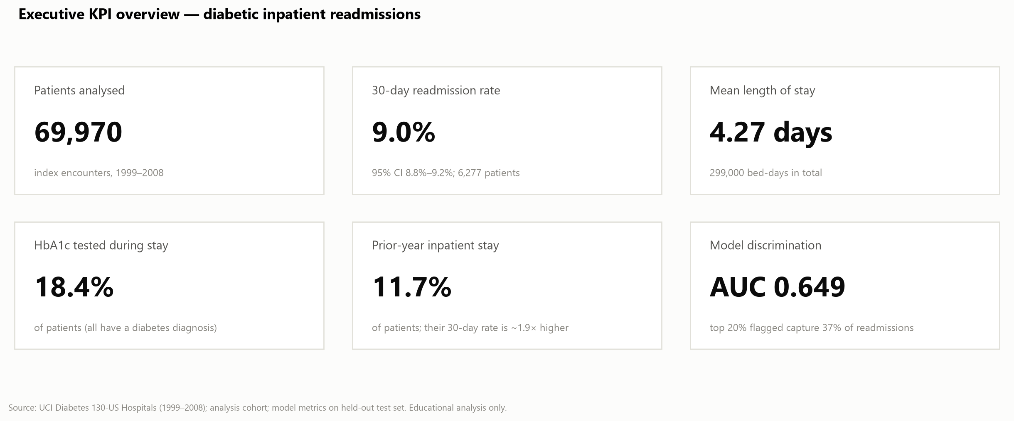
Figure 3. Executive KPI overview
Interpretation. The overview gives leaders the headline: roughly one patient in eleven returns within 30 days, stays are short on average, and HbA1c testing is uncommon.
The cohort is 53.2% female; 66.2% are aged 60 or over; 50.7% were emergency admissions; 76.2% received a diabetes medication and 51.0% insulin. Counts of prior visits are heavily right-skewed (skewness of prior inpatient visits 5.6), so medians and rank-based tests are used alongside means.
Table 13. Descriptive statistics of numeric variables (n = 69,970)
Variable | Mean | SD | Min | Q1 | Median | Q3 | Max | Skew
time_in_hospital | 4.27 | 2.93 | 1.0 | 2.0 | 3.0 | 6.0 | 14.0 | 1.18
num_lab_procedures | 42.88 | 19.89 | 1.0 | 31.0 | 44.0 | 57.0 | 132.0 | -0.22
num_procedures | 1.42 | 1.76 | 0.0 | 0.0 | 1.0 | 2.0 | 6.0 | 1.23
num_medications | 15.66 | 8.29 | 1.0 | 10.0 | 14.0 | 20.0 | 81.0 | 1.44
number_outpatient | 0.28 | 1.06 | 0.0 | 0.0 | 0.0 | 0.0 | 42.0 | 9.7
number_emergency | 0.1 | 0.51 | 0.0 | 0.0 | 0.0 | 0.0 | 42.0 | 21.23
number_inpatient | 0.18 | 0.6 | 0.0 | 0.0 | 0.0 | 0.0 | 12.0 | 5.59
number_diagnoses | 7.22 | 2.0 | 1.0 | 6.0 | 8.0 | 9.0 | 16.0 | -0.72
age_mid | 65.44 | 15.97 | 5.0 | 55.0 | 65.0 | 75.0 | 95.0 | -0.63

9.2 Outcome distribution
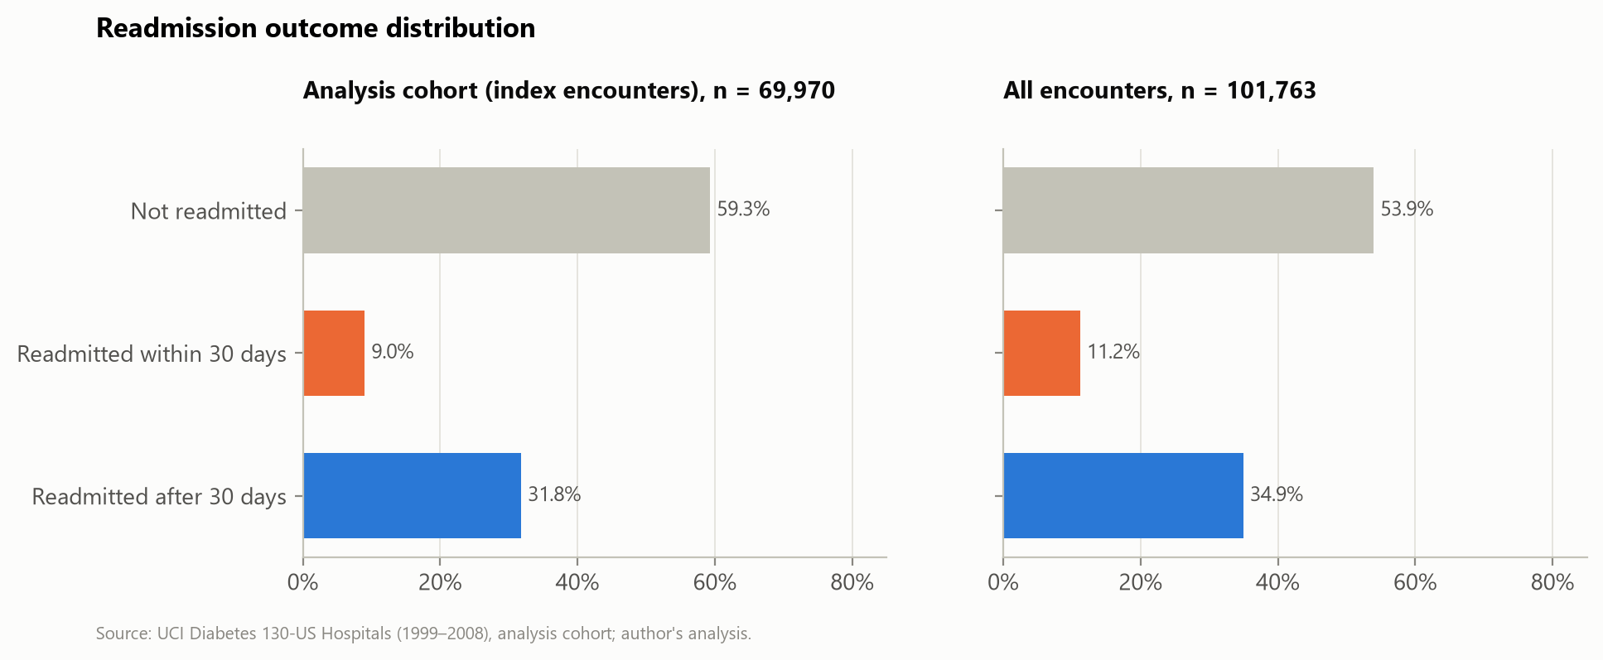
Figure 4. Distribution of the readmission outcome
Interpretation. The 30-day outcome is imbalanced (9.0% positive in the cohort). The encounter-level rate is higher (11.2%) because frequent users contribute many encounters; analysing encounters as independent would overstate precision and mix in repeat-visit risk.

9.3 Demographics
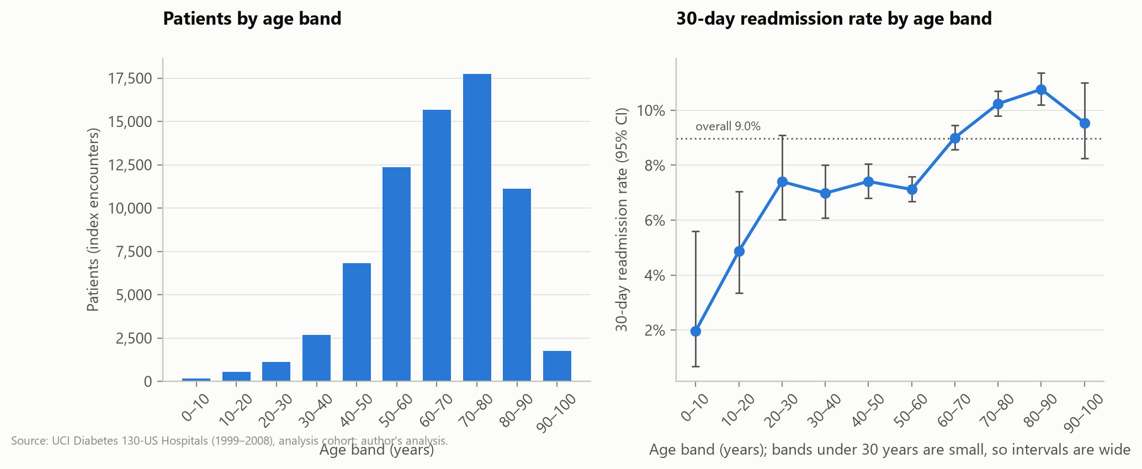
Figure 5. Age distribution and 30-day readmission by age band
Interpretation. Most patients are 50–90 years old. Readmission rises from about 7% below age 60 to over 10% at 70–90, with wide intervals in small young bands.
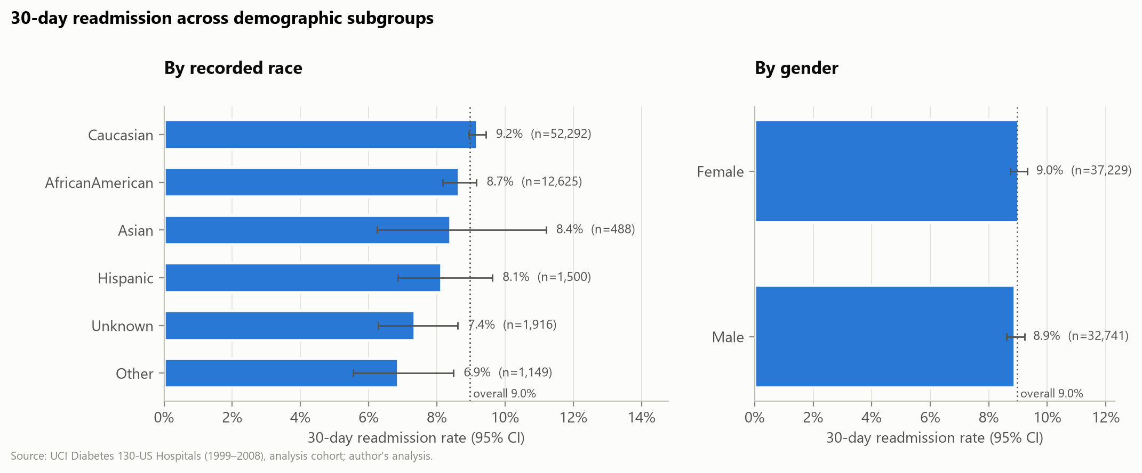
Figure 6. 30-day readmission by recorded race and gender
Interpretation. Differences by gender are negligible. Rates by race differ slightly (Caucasian 9.2% vs African American 8.7%), with overlapping intervals for smaller groups; the 'Unknown' and 'Other' groups are lower, possibly reflecting documentation differences rather than risk.

9.4 Clinical and care-process comparisons
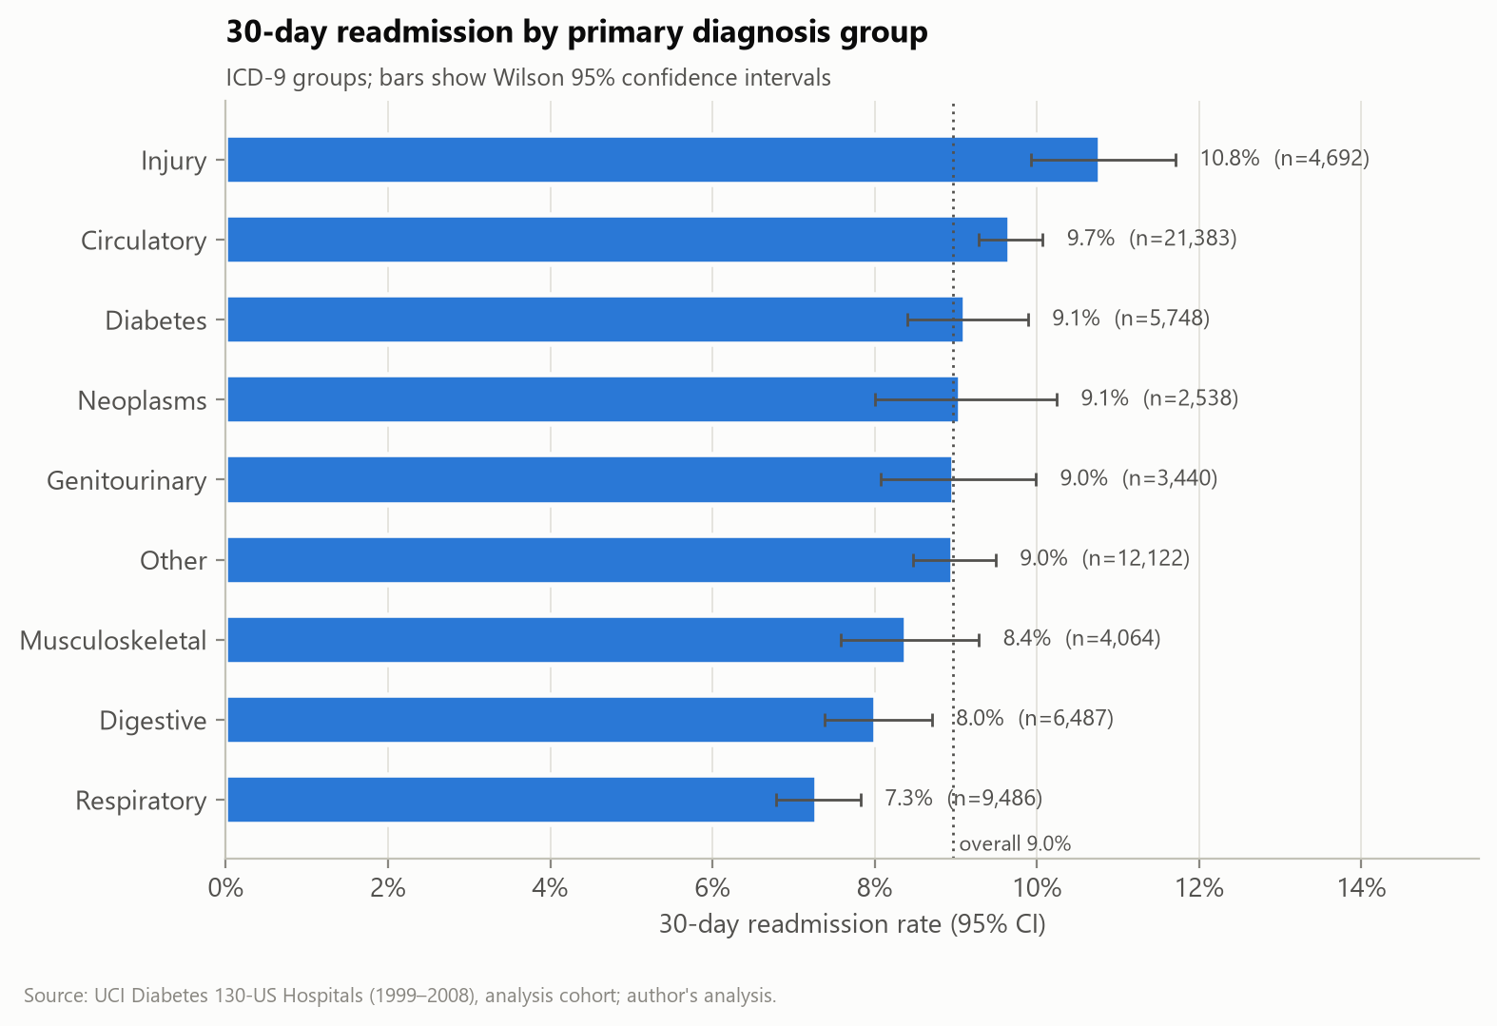
Figure 7. 30-day readmission by primary diagnosis group
Interpretation. Injury (10.8%) and circulatory conditions (9.7%) have the highest rates; respiratory conditions the lowest (7.3%). Differences between groups are real but small in absolute terms.
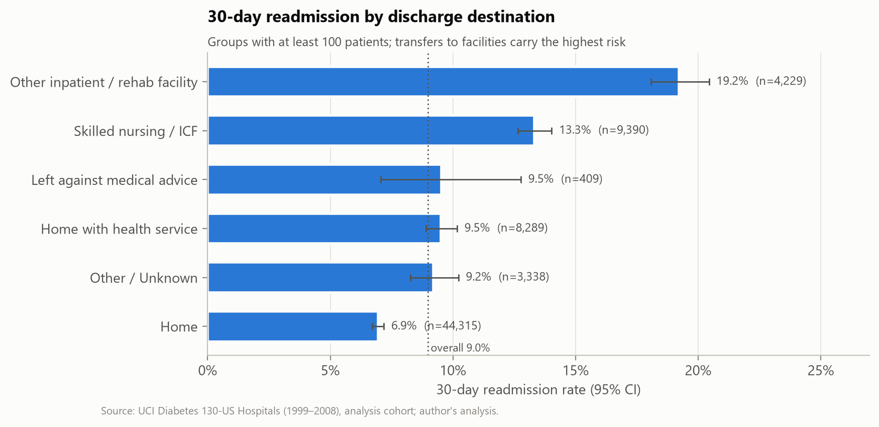
Figure 8. 30-day readmission by discharge destination
Interpretation. Transfers to rehabilitation/other inpatient facilities (19.2%) and skilled nursing (13.3%) have about two to three times the rate of patients discharged home (7.0%). Facility discharge is a marker of frailty and complexity, so this is not evidence that the destination itself causes readmission.
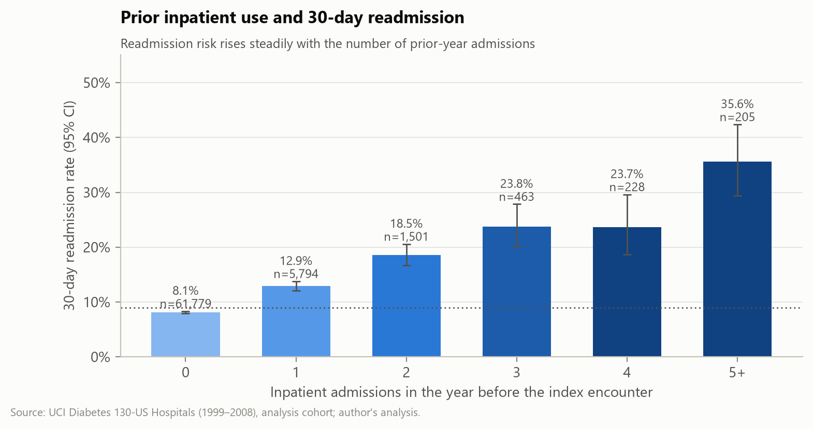
Figure 9. 30-day readmission by prior-year inpatient admissions
Interpretation. A clear dose–response gradient: from 8.1% with no prior admission to 35.6% with five or more.
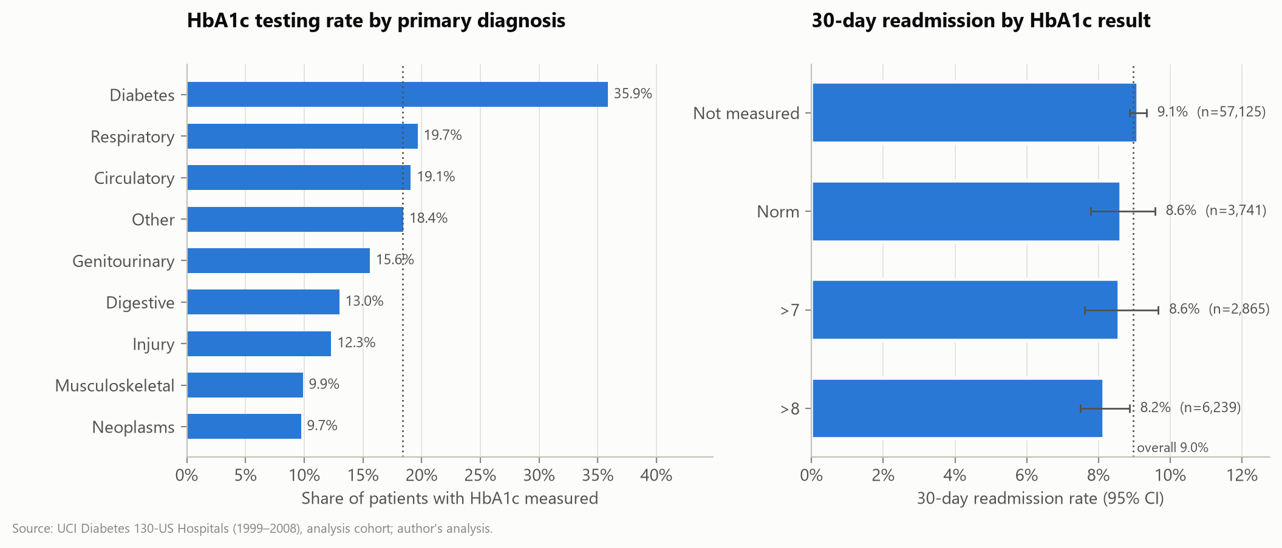
Figure 10. HbA1c testing by primary diagnosis and readmission by HbA1c result
Interpretation. HbA1c is tested in about a third of patients admitted primarily for diabetes but in only 10–20% of others. Unadjusted readmission is slightly lower when HbA1c was measured, regardless of the result.

9.5 Resource utilisation
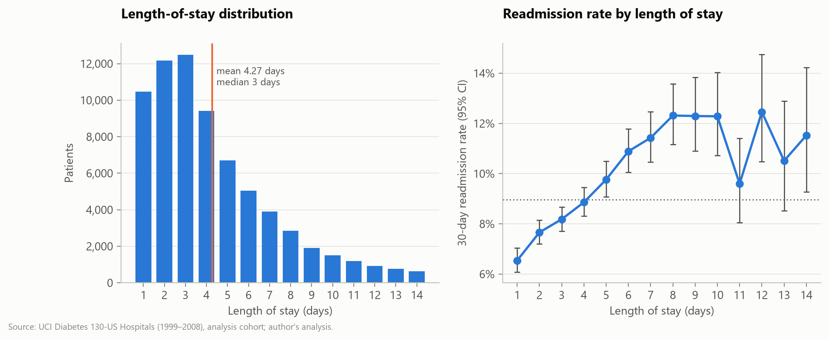
Figure 11. Length-of-stay distribution and readmission by length of stay
Interpretation. Stays are right-skewed (median 3 days, mean 4.27). Readmission rises gradually with length of stay, reflecting illness severity.
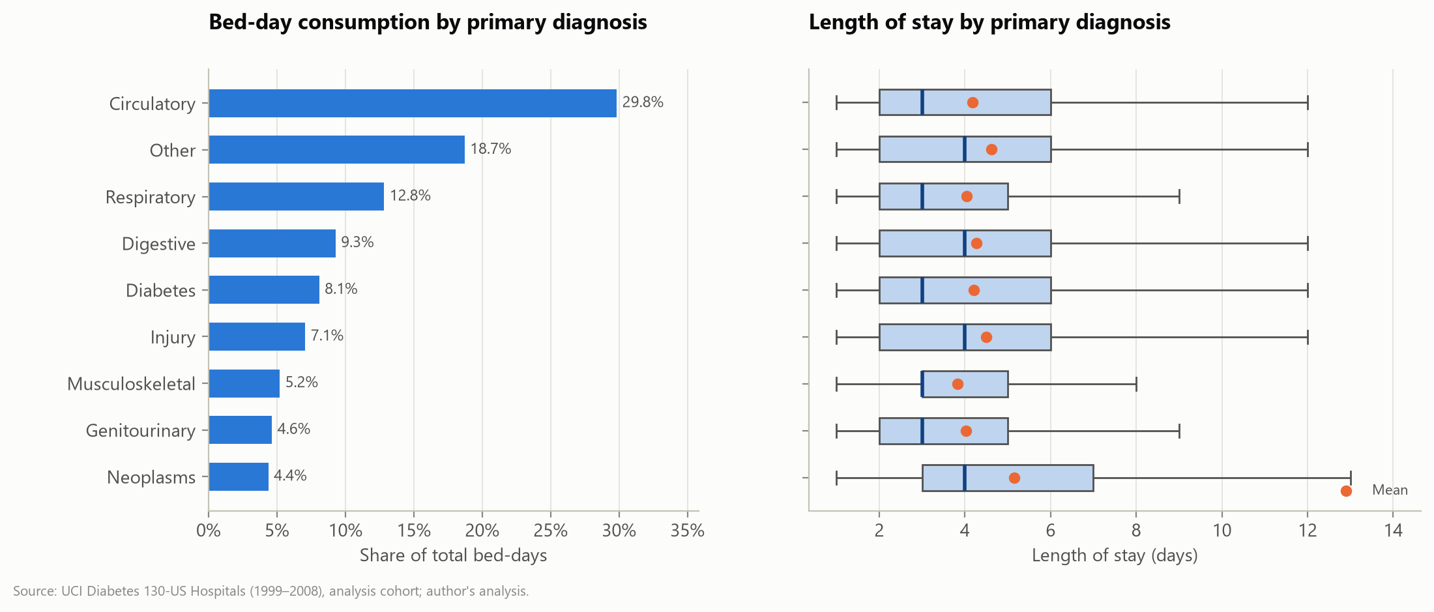
Figure 12. Bed-day consumption and length of stay by primary diagnosis
Interpretation. Circulatory conditions account for 29.8% of bed-days because they are common, not because stays are long; neoplasms have the longest mean stay (5.2 days).

9.6 Relationships between variables
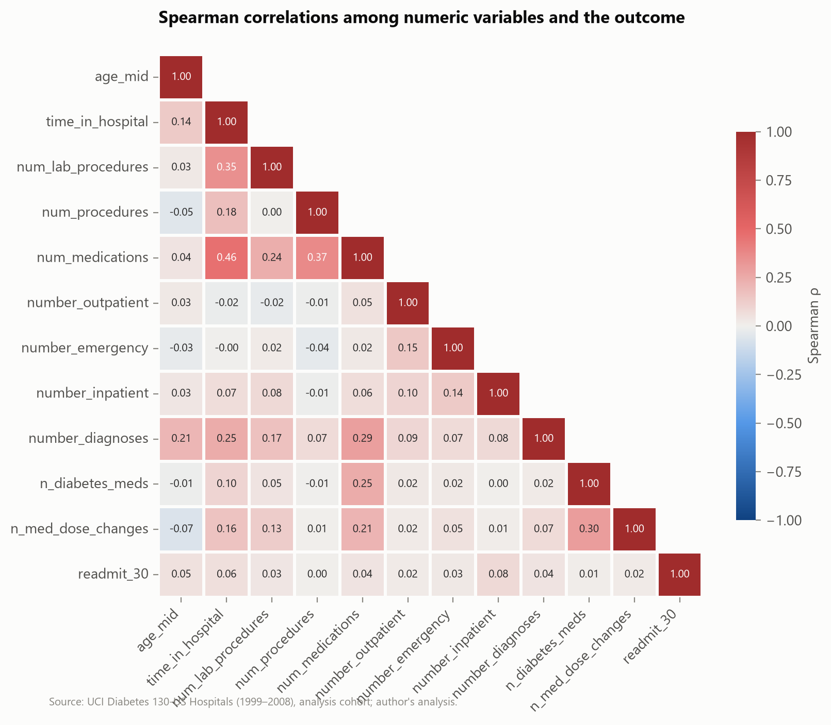
Figure 13. Spearman correlation matrix
Interpretation. Utilisation measures move together (length of stay with medications ρ = 0.46, with lab procedures ρ = 0.35), but no single numeric variable is strongly correlated with readmission (largest: prior inpatient visits, ρ = 0.08). Readmission is therefore driven by many weak signals, which foreshadows modest model performance.

9.7 Operational and quality issues identified
- Concentrated risk in facility discharges and frequent users — a small share of patients carries a large share of readmissions.
- Low and uneven HbA1c testing — a process gap independent of whether testing changes outcomes.
- Documentation gaps (weight, specialty, payer) that limit risk adjustment and equity analysis.
- No admission dates or hospital identifiers — trends and benchmarking cannot be produced from this extract.

10. Statistical Analysis and Results

10.1 Methods and assumptions
Table 14. Statistical methods
Method | Used for | Effect size reported | Key assumptions
Proportion with CI | Rates | Wilson score interval (Wilson, 1927) | Binomial sampling; accurate for small or extreme proportions
Pearson χ² test of independence | Categorical factor × readmission | Cramér's V | Independent observations (one row per patient); expected counts ≥ 5 (checked)
Mann–Whitney U | Numeric / count variable × readmission | Rank-biserial r; Cohen's d; Welch 95% CI for mean difference | Independent groups; no normality assumption (counts are skewed)
Two-proportion z-test | Pre-specified binary comparisons | Risk difference, risk ratio, odds ratio with 95% CI | Large samples
Kruskal–Wallis H | Length of stay across diagnosis groups | Epsilon-squared (ε²) | Independent groups; similar distribution shapes
Spearman ρ | Monotonic association between numeric variables | ρ | Monotonic relationship
Multivariable logistic regression | Adjusted associations with readmission | Adjusted odds ratio (95% CI) | Linearity of logit for numeric terms; low collinearity (all VIF < 1.4); independent observations
Likelihood-ratio test | HbA1c × diagnosis interaction | χ² on 8 df | Nested models

Multiple comparisons were controlled with Holm's step-down method within each family of tests (Holm, 1979). With about 70,000 patients, very small differences reach statistical significance, so interpretation focuses on effect sizes and confidence intervals rather than p-values alone. All results are associations in observational data; unmeasured confounding (for example, frailty, social support, discharge quality) may explain part or all of any association.

10.2 Overall rate
The 30-day readmission rate was 8.97% (95% Wilson CI 8.76%–9.18%; 6,277 of 69,970 patients).

10.3 Categorical factors
Table 15. Chi-square tests of association with 30-day readmission
Variable | Levels | χ² | df | Cramér's V | p (Holm) | Lowest-rate level | Highest-rate level
discharge_group | 6 | 988.2 | 5 | 0.119 | < 0.001 | Home (6.9%) | Other inpatient / rehab facility (19.2%)
age_group | 4 | 162.1 | 3 | 0.048 | < 0.001 | <40 (6.7%) | 80+ (10.6%)
payer_code | 18 | 133.0 | 17 | 0.044 | < 0.001 | FR (0.0%) | Unknown (9.9%)
diag_1_group | 10 | 75.2 | 9 | 0.033 | < 0.001 | Respiratory (7.3%) | Missing (20.0%)
medical_specialty_grp | 12 | 63.5 | 11 | 0.030 | < 0.001 | Orthopedics-Reconstructive (6.6%) | Nephrology (11.0%)
diabetesMed | 2 | 54.3 | 1 | 0.028 | < 0.001 | No (7.5%) | Yes (9.4%)
insulin | 4 | 50.6 | 3 | 0.027 | < 0.001 | No (8.3%) | Down (10.5%)
race | 6 | 18.1 | 5 | 0.016 | 0.017 | Other (6.9%) | Caucasian (9.2%)
change | 2 | 15.1 | 1 | 0.015 | < 0.001 | No (8.6%) | Ch (9.4%)
admission_type_grp | 5 | 11.9 | 4 | 0.013 | 0.092 | Other (3.7%) | Unknown (9.3%)
admission_source_grp | 4 | 8.2 | 3 | 0.011 | 0.168 | Transfer (8.4%) | Emergency room (9.2%)
A1C_result | 4 | 7.3 | 3 | 0.010 | 0.191 | >8 (8.2%) | Not measured (9.1%)
glucose_serum | 4 | 7.0 | 3 | 0.010 | 0.191 | Not measured (8.9%) | >200 (10.9%)
gender | 2 | 0.3 | 1 | 0.002 | 0.574 | Male (8.9%) | Female (9.0%)

Discharge destination has by far the largest effect (Cramér's V = 0.119); all other factors have V < 0.05, which is conventionally a negligible effect even when highly significant. Gender, HbA1c result category, glucose test result, admission type and admission source were not significant after Holm correction.

10.4 Numeric factors
Table 16. Mann–Whitney U tests: numeric variables by 30-day readmission
Variable | Mean (readmitted) | Mean (not) | Difference (95% CI) | Rank-biserial r | p (Holm)
time_in_hospital | 4.8 | 4.22 | 0.58 (0.50 to 0.65) | 0.12 | < 0.001
age_mid | 67.83 | 65.2 | 2.62 (2.23 to 3.02) | 0.096 | < 0.001
number_inpatient | 0.37 | 0.16 | 0.21 (0.19 to 0.24) | 0.096 | < 0.001
num_medications | 16.63 | 15.57 | 1.06 (0.84 to 1.27) | 0.086 | < 0.001
number_diagnoses | 7.51 | 7.2 | 0.32 (0.27 to 0.37) | 0.083 | < 0.001
num_lab_procedures | 44.92 | 42.68 | 2.24 (1.74 to 2.74) | 0.066 | < 0.001
n_med_dose_changes | 0.3 | 0.26 | 0.04 (0.02 to 0.05) | 0.035 | < 0.001
number_emergency | 0.15 | 0.1 | 0.05 (0.04 to 0.07) | 0.028 | < 0.001
number_outpatient | 0.31 | 0.28 | 0.03 (0.00 to 0.06) | 0.019 | < 0.001
num_procedures | 1.42 | 1.43 | -0.00 (-0.05 to 0.04) | 0.007 | 0.351

Readmitted patients stayed longer (mean difference 0.58 days), were older, had more prior inpatient visits and more diagnoses. All effect sizes are small (|r| ≤ 0.12). The number of non-laboratory procedures was not associated with readmission.

10.5 Pre-specified two-group comparisons
Table 17. Pre-specified comparisons of 30-day readmission
Comparison | Rates | Risk difference (95% CI) | Risk ratio (95% CI) | p (Holm)
≥1 prior inpatient admission vs none | 15.4% vs 8.1% | +7.3 pp (+6.5 to +8.1) | 1.90 (1.79–2.01) | < 0.001
HbA1c measured vs not measured | 8.4% vs 9.1% | -0.7 pp (-1.2 to -0.2) | 0.92 (0.87–0.98) | 0.011
Discharged to a care facility vs all other destinations | 15.2% vs 7.5% | +7.7 pp (+7.0 to +8.3) | 2.03 (1.93–2.13) | < 0.001
LOS ≥ 7 days vs LOS < 7 days | 11.7% vs 8.3% | +3.4 pp (+2.8 to +4.0) | 1.41 (1.33–1.48) | < 0.001
Age ≥ 60 vs Age < 60 | 9.9% vs 7.1% | +2.8 pp (+2.4 to +3.2) | 1.39 (1.32–1.47) | < 0.001

10.6 Resource use across diagnoses
Length of stay differed across the nine primary-diagnosis groups (Kruskal–Wallis H = 591.5, df = 8, p < 0.001), but the effect size was very small (ε² = 0.008): diagnosis group explains under 1% of the variation in length of stay.

10.7 Multivariable logistic regression
A logistic regression of 30-day readmission on HbA1c result, primary diagnosis, age group, gender, race group, discharge destination, admission source, medication change and seven utilisation counts was fitted to 69,960 patients (6,275 events; about 179 events per parameter). The model converged; McFadden pseudo-R² was 0.037 and the maximum variance inflation factor among numeric predictors was 1.39. The low pseudo-R² again shows that the available variables explain only a small part of readmission risk.
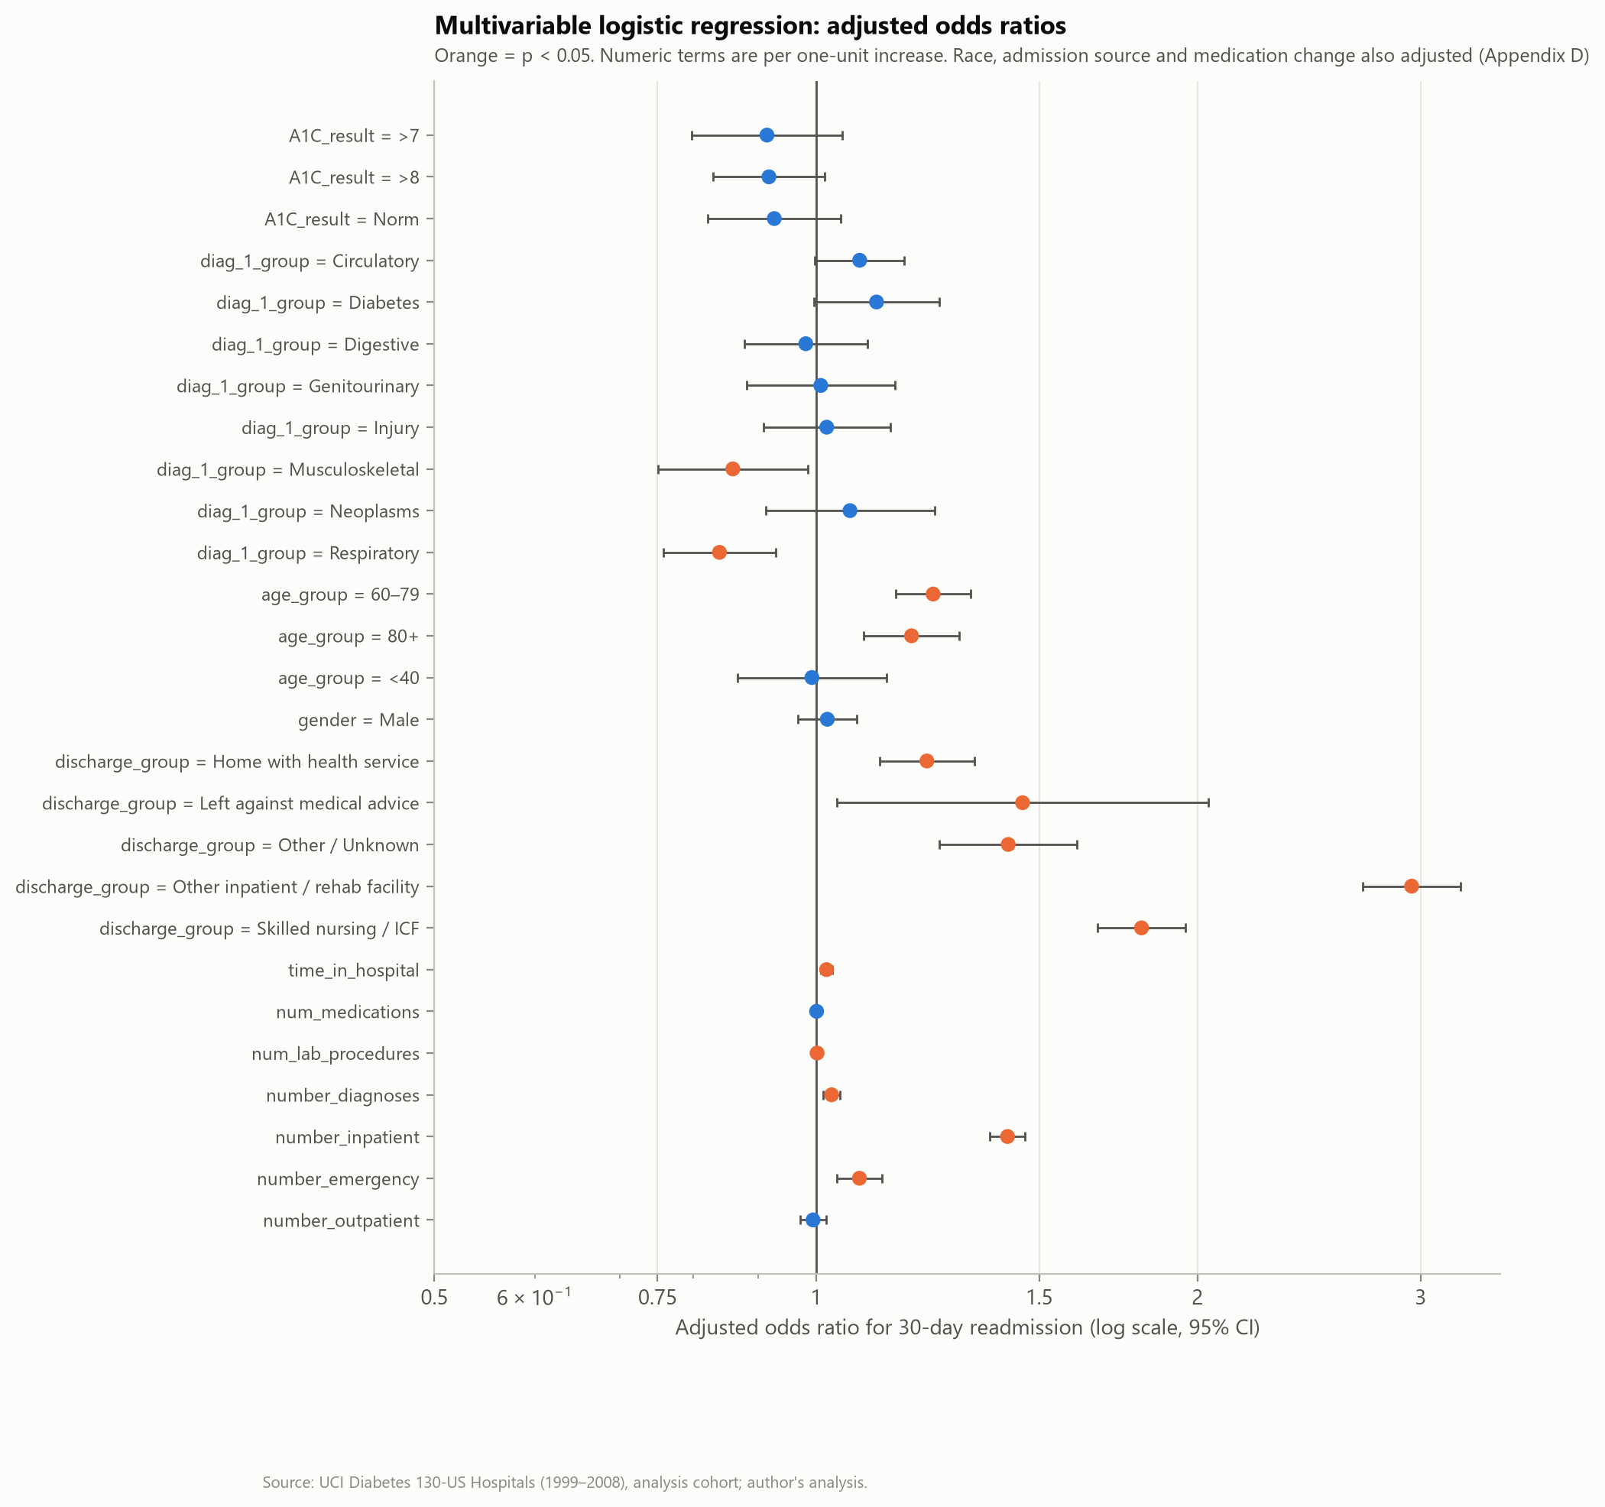
Figure 14. Adjusted odds ratios for 30-day readmission
Interpretation. After adjustment, discharge to a rehabilitation/other inpatient facility (OR 2.95) or skilled nursing (OR 1.81), each prior inpatient admission (OR 1.42) and age 60–79 (OR 1.24) remain the strongest associations. Respiratory and musculoskeletal primary diagnoses carry lower odds than the reference ('Other').

10.8 HbA1c and readmission (H3)
In a model with a binary HbA1c-measured indicator and the same covariates, measurement was associated with lower odds of readmission (adjusted OR 0.92, 95% CI 0.85–0.99, p = 0.026). Adding HbA1c × diagnosis interaction terms improved fit (likelihood-ratio χ² = 20.4, df = 8, p = 0.009), so the association depends on the primary diagnosis. This replicates the central finding of Strack et al. (2014) on an independently constructed cohort. However, testing may simply mark more attentive care or different patient mixes; a trial or quasi-experimental evaluation would be needed to show that testing itself reduces readmissions.

10.9 Hypothesis summary
Table 18. Hypothesis outcomes
ID | Hypothesis | Evidence | Conclusion
H1 | Prior inpatient use → higher readmission | RR 1.90 (1.79–2.01); adj. OR 1.42 per admission | Supported
H2 | Facility discharge → higher readmission | RR 2.03 (1.93–2.13); Cramér's V 0.119 | Supported
H3 | HbA1c measured → lower readmission; differs by diagnosis | adj. OR 0.92; interaction p = 0.009 | Supported (small association)
H4 | Longer stay and older age → higher readmission | LOS ≥ 7 d RR 1.41; age ≥ 60 RR 1.39 | Supported (small effects)
H5 | LOS differs across diagnoses | H = 592, ε² = 0.008 | Statistically supported; negligible effect
H6 | Model beats prior-admission baseline | Test AUC 0.649 vs 0.548 | Supported (modest absolute performance)

11. Visualisation and Dashboard Design

11.1 Design principles
- Every chart answers one question, states it in the title and shows units and sample sizes.
- Rates are always shown with 95% confidence intervals, and a reference line marks the overall rate.
- One colour for a single series (no rank-based colouring); a second colour only for emphasis.
- Colour palettes are colour-vision-deficiency-validated; text never relies on colour alone.
- Small groups (n < 30) are suppressed rather than shown with misleading precision.
- No dual axes; related measures on different scales are placed in side-by-side panels.

11.2 Interactive dashboard (delivered)
Because Power BI Desktop could not be automated in this environment, the working dashboard was built as a single, self-contained HTML file (dashboard/healthcare_readmission_dashboard.html, about 1.9 MB, no internet connection or software installation required). It contains:
- Five filters (age group, gender, recorded race, primary diagnosis, admission type) with a reset button.
- Six KPI cards that recalculate for the current selection, including the readmission rate with its 95% confidence interval.
- Six interactive charts (discharge destination, primary diagnosis, prior admissions, age band, length-of-stay distribution, HbA1c result) with hover tooltips and an expandable data table each.
- A model panel showing observed readmission by predicted-risk decile on the held-out test set.
- Automatic suppression of rates for groups under 30 patients, light/dark themes and method notes.
Screenshots of the dashboard (desktop and mobile widths) are reproduced in Appendix F.

11.3 Power BI build pack
The dashboard/powerbi folder contains a star-schema data model (one fact table with one row per patient and six dimension tables), 14 DAX measures (including Wilson confidence limits, small-sample suppression and comparison with the overall rate) and a step-by-step build guide with validation totals. No .pbix file is claimed or supplied.

12. Predictive Modelling Methodology

12.1 Problem framing
Table 19. Prediction problem specification
Element | Specification
Prediction target | readmit_30 = 1 if readmitted within 30 days of discharge
Prediction time | At discharge from the index encounter; all predictors are known by then
Unit of analysis | Patient (first eligible encounter); one row per patient
Intended use (hypothetical) | Rank patients for transition-of-care follow-up; not diagnosis or treatment
Target distribution | 9.0% positive in training; identical (stratified) in validation and test
Data split | Train 41,982 (60%), validation 13,994 (20%), test 13,994 (20%), stratified on outcome, seed 42

12.2 Predictors and leakage control
Eleven numeric predictors (age_mid, time_in_hospital, num_lab_procedures, num_procedures, num_medications, number_outpatient, number_emergency, number_inpatient, number_diagnoses, n_diabetes_meds, n_med_dose_changes) and fourteen categorical predictors (gender, admission_type_grp, admission_source_grp, discharge_group, diag_1_group, diag_2_group, diag_3_group, A1C_result, glucose_serum, insulin, metformin, change, diabetesMed, medical_specialty_grp) were selected on clinical and operational grounds. the table below lists the variables deliberately excluded.
Table 20. Variables excluded from the model
Excluded variable(s) | Reason
encounter_id, patient_nbr | Identifiers - no predictive meaning; risk of memorisation
readmitted, readmit_any | Outcome information (target leakage)
encounter_seq, is_index_encounter, expired_or_hospice | Constant within the analysis cohort
race | Excluded as a predictor to avoid encoding structural inequities; used only for fairness audit
payer_code | Socio-economic proxy with 40% missing; excluded for fairness and data-quality reasons
diag_1/2/3 raw ICD-9 codes | 700+ sparse levels; replaced by clinical groups
raw ID columns (admission/discharge/source) | Replaced by grouped labels

12.3 Pre-processing
- Missing categorical values were already explicit 'Unknown' levels; no numeric values were missing, so no imputation was needed.
- Categorical variables: one-hot encoding with levels seen fewer than 50 times in training grouped as 'infrequent'; unseen levels handled safely at prediction time.
- Numeric variables: standardised for logistic regression; left unscaled for tree models.
- All pre-processing is fitted inside scikit-learn pipelines on training folds only, preventing leakage from validation or test data.

12.4 Baselines and candidate models
Table 21. Baselines and candidate models
Model | Description | Why included
Baseline 1: prevalence only | Predicts the training prevalence for everyone | Reference for 'no information' (AUC = 0.5)
Baseline 2: prior inpatient count | One-variable logistic regression; equivalent to flagging anyone with a prior-year admission | A simple rule a hospital could apply today
Logistic regression (L2) | Linear, interpretable, well calibrated by construction | Transparent reference model
Random forest | Captures non-linearities and interactions; robust to irrelevant features | Flexible non-parametric model
Histogram gradient boosting | Strong on tabular data; early stopping limits overfitting | State-of-the-art tabular baseline

Hyperparameters were tuned by randomised search with 5-fold stratified cross-validation on the training set only, optimising ROC-AUC. Class weights were not used, so predicted probabilities remain interpretable as risks; class imbalance is handled at the decision-threshold stage instead. The final model was chosen on the validation set (highest ROC-AUC, with a rule to prefer logistic regression if within 0.005). The decision threshold was fixed on validation predictions as the cut-off that flags the 20% highest-risk patients, an operationally realistic workload for a care-transition team. The test set was used once, after all choices were made.
Table 22. Cross-validation and validation results
Model | CV ROC-AUC (mean) | CV SD | Selected hyperparameters | Validation ROC-AUC | Validation PR-AUC
Logistic regression (L2) | 0.644 | 0.012 | {'C': 0.03149} | 0.642 | 0.155
Random forest | 0.652 | 0.012 | {'max_depth': 14, 'max_features': 'sqrt', 'min_samples_leaf': 19} | 0.649 | 0.160
Gradient boosting (HistGB) | 0.647 | 0.011 | {'l2_regularization': 0.51756, 'learning_rate': 0.09195, 'max_leaf_nodes': 9, 'min_samples_leaf': 153} | 0.639 | 0.152
Baseline: prevalence only | — | — | — | 0.500 | 0.090
Baseline: prior inpatient count (1-variable LR) | — | — | — | 0.546 | 0.110
Random forest had the highest validation ROC-AUC.

13. Model Evaluation and Responsible AI

13.1 Test-set performance
Table 23. Held-out test-set performance (n = 13,994; prevalence 9.0%)
Model | ROC-AUC | PR-AUC | Brier | Accuracy | Precision | Recall | Specificity | F1
Logistic regression (L2) | 0.641 | 0.158 | 0.080 | 0.779 | 0.162 | 0.351 | 0.821 | 0.221
Random forest | 0.649 | 0.174 | 0.079 | 0.782 | 0.170 | 0.368 | 0.822 | 0.232
Gradient boosting (HistGB) | 0.646 | 0.164 | 0.079 | 0.783 | 0.176 | 0.385 | 0.822 | 0.241
Baseline: prevalence only | 0.500 | 0.090 | 0.082 | 0.910 | 0.000 | 0.000 | 1.000 | 0.000
Baseline: prior inpatient count (1-variable LR) | 0.548 | 0.115 | 0.081 | 0.829 | 0.153 | 0.201 | 0.890 | 0.174
Threshold metrics use each model's own validation-derived top-20% cut-off; the prevalence-only baseline uses 0.5 and therefore never flags anyone. Baseline 2 flags patients with any prior admission.
The selected random forest reached ROC-AUC 0.649 (bootstrap 95% CI 0.634–0.664) and PR-AUC 0.174 (0.159–0.194), about twice the prevalence. The three multivariable models perform similarly; all clearly beat the prior-admission rule (AUC 0.548). Performance in this range is typical of readmission models built from administrative data (Kansagara et al., 2011), and it means the model can separate groups of patients by risk but cannot reliably identify individual patients who will be readmitted.
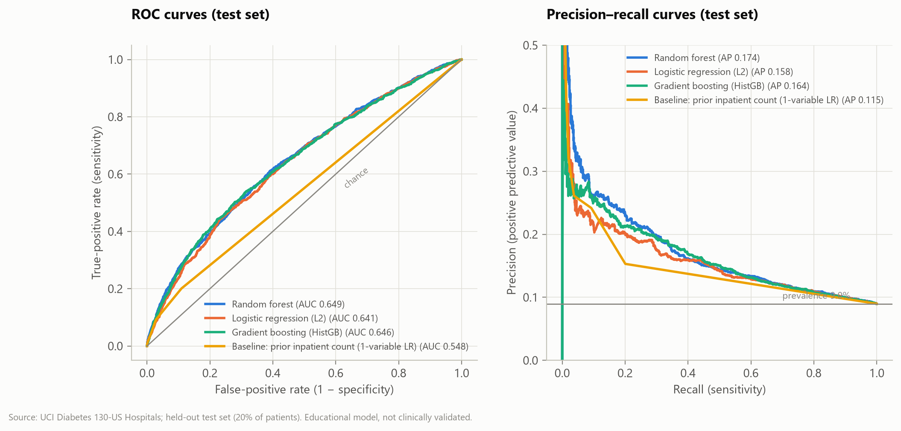
Figure 15. ROC and precision–recall curves on the test set
Interpretation. The ROC curves sit well above chance but far from the top-left corner. The precision–recall curve is the more informative view for an imbalanced outcome (Saito & Rehmsmeier, 2015): precision falls quickly as recall increases.

13.2 Why accuracy is misleading
Table 24. Effect of the decision threshold (Random forest, test set)
Decision rule | Accuracy | Precision (PPV) | Sensitivity | Specificity | F1 | Share flagged
Default 0.5 cut-off | 91.0% | 0.0% | 0.0% | 100.0% | 0.0% | 0.0%
Top 20% highest risk (validation-derived) | 78.2% | 17.0% | 36.8% | 82.2% | 23.2% | 19.5%
Max-F1 on validation | 71.0% | 14.9% | 47.3% | 73.4% | 22.7% | 28.5%
Flag nobody (always predict 'no readmission') | 91.0% | 0.0% | 0.0% | 100.0% | 0.0% | 0.0%

A rule that never flags anyone achieves 91.0% accuracy — higher than any useful model — while finding no readmissions. The default 0.5 cut-off behaves the same way because almost no predicted risks exceed 50%. For imbalanced outcomes, sensitivity, precision, PR-AUC and the workload implied by a threshold are the relevant measures.
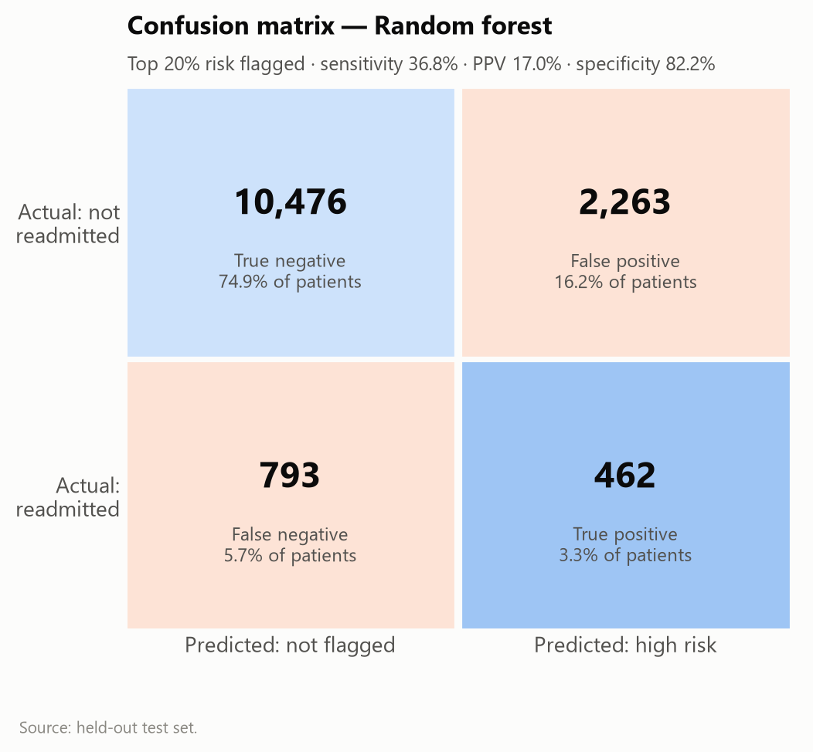
Figure 16. Confusion matrix at the top-20% threshold
Interpretation. Of 1,255 readmitted test patients, 462 were flagged; 2,263 flagged patients were not readmitted. Roughly five patients would be reviewed per readmission found.

13.3 Calibration
Mean predicted risk (8.98%) matches the observed rate (8.97%), so calibration-in-the-large is good (intercept -0.002). The calibration slope of 1.26 (> 1) shows that the random forest's predictions are too compressed toward the average: true risk in the highest decile (21.4%) exceeds the mean prediction. Recalibration (e.g., Platt or isotonic scaling on validation data) would be required before any risk value is shown to users (Van Calster et al., 2019). Brier score was 0.0793.
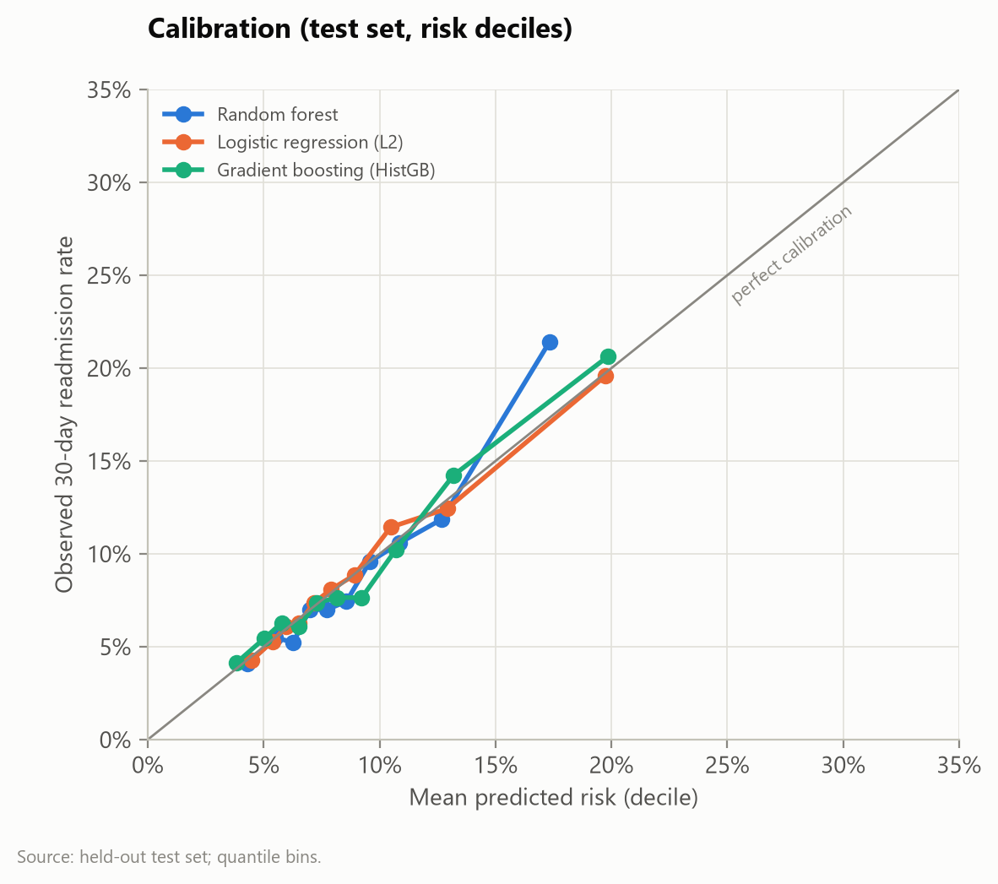
Figure 17. Calibration curves on the test set (risk deciles)

13.4 Interpretability
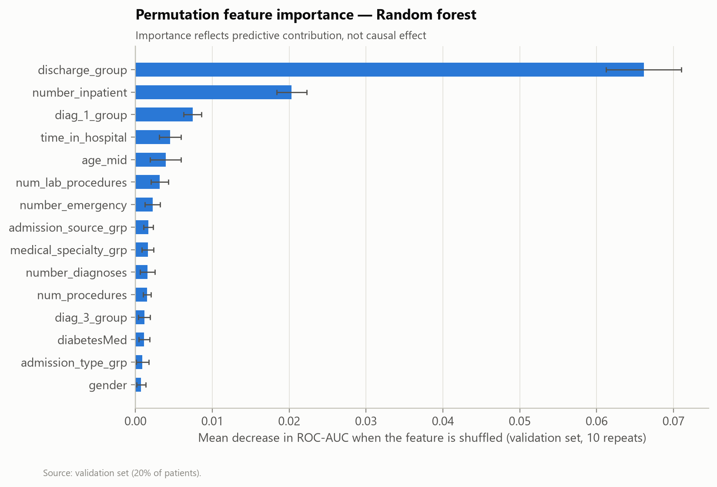
Figure 18. Permutation feature importance (Random forest)
Interpretation. Discharge destination and prior inpatient admissions dominate, consistent with the statistical analysis. Importance measures how much the model relies on a feature, not whether changing it would change outcomes.
Table 25. Readmission by predicted-risk decile (test set)
Risk decile (1 = highest) | Patients | Readmissions | Mean predicted | Observed rate | Cumulative capture | Lift
1 | 1400 | 300 | 17.3% | 21.4% | 23.9% | 2.39
2 | 1399 | 166 | 12.7% | 11.9% | 37.1% | 1.32
3 | 1399 | 148 | 10.9% | 10.6% | 48.9% | 1.18
4 | 1400 | 134 | 9.6% | 9.6% | 59.6% | 1.07
5 | 1399 | 104 | 8.6% | 7.4% | 67.9% | 0.83
6 | 1399 | 98 | 7.7% | 7.0% | 75.7% | 0.78
7 | 1400 | 98 | 7.0% | 7.0% | 83.5% | 0.78
8 | 1399 | 73 | 6.3% | 5.2% | 89.3% | 0.58
9 | 1399 | 77 | 5.5% | 5.5% | 95.5% | 0.61
10 | 1400 | 57 | 4.3% | 4.1% | 100.0% | 0.45

13.5 Subgroup performance and fairness
Table 26. Subgroup performance at the top-20% threshold (test set)
Attribute | Group | n | Events | Observed | Mean predicted | AUC (95% CI) | Sensitivity | PPV | Flagged
Gender | Male | 6581 | 582 | 8.8% | 8.9% | 0.643 (0.61–0.67) | 34.9% | 17.4% | 17.8%
Gender | Female | 7413 | 673 | 9.1% | 9.1% | 0.653 (0.63–0.67) | 38.5% | 16.6% | 21.0%
Race | Caucasian | 10455 | 964 | 9.2% | 9.1% | 0.638 (0.62–0.66) | 36.6% | 16.5% | 20.4%
Race | AfricanAmerican | 2544 | 224 | 8.8% | 8.6% | 0.671 (0.63–0.71) | 36.2% | 18.9% | 16.8%
Race | Asian | 90 | 6 | 6.7% | 8.1% | 0.720 (0.53–0.90) | 16.7% | 10.0% | 11.1%
Race | Unknown | 397 | 20 | 5.0% | 8.7% | 0.765 (0.62–0.88) | 60.0% | 16.0% | 18.9%
Race | Other | 217 | 13 | 6.0% | 8.3% | 0.659 (0.48–0.81) | 30.8% | 13.8% | 13.4%
Race | Hispanic | 291 | 28 | 9.6% | 8.6% | 0.691 (0.57–0.79) | 39.3% | 22.4% | 16.8%
Age group | <40 | 867 | 51 | 5.9% | 6.9% | 0.702 (0.62–0.77) | 31.4% | 21.3% | 8.7%
Age group | 60–79 | 6738 | 659 | 9.8% | 9.3% | 0.641 (0.62–0.67) | 38.1% | 17.9% | 20.8%
Age group | 40–59 | 3794 | 287 | 7.6% | 7.7% | 0.638 (0.60–0.67) | 24.0% | 18.0% | 10.1%
Age group | 80+ | 2595 | 258 | 9.9% | 10.7% | 0.630 (0.60–0.67) | 48.8% | 14.6% | 33.3%

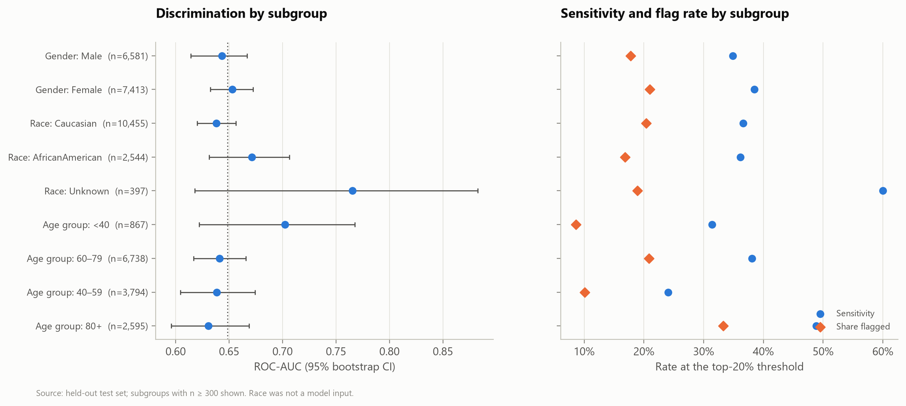
Figure 19. Discrimination, sensitivity and flag rate by subgroup
Interpretation. Discrimination is similar across gender and the two largest race groups. Sensitivity is lowest for patients aged 40–59, who are flagged less often because their baseline risk is lower, and highest for those aged 80+. Estimates for small groups (Asian, Hispanic, Other) are imprecise. A deployed model would need explicit fairness criteria agreed with clinicians and community representatives.

13.6 Responsible-AI statement and deployment conditions
Status. The model is an educational artefact. It must not be used to make or influence decisions about individual patients. Before any operational use, the following would be required:
1. External and temporal validation on current local data (performance and calibration).
2. Recalibration and an agreed operating threshold based on intervention capacity and the harms of false negatives (missed high-risk patients) and false positives (unnecessary follow-up, alarm fatigue).
3. Ethics-committee and data-protection review; clinical safety case; named accountable owner.
4. Human-in-the-loop use: scores support, never replace, clinical discharge judgement.
5. Monitoring of data drift (input distributions), performance drift (AUC, calibration) and subgroup metrics at least quarterly, with a retraining and decommissioning policy.

13.7 Model evaluation checklist
Table 27. Model evaluation checklist
Check | Done | Evidence
Target, prediction time and unit defined | Yes | Section 12.1
Identifiers and leakage variables removed | Yes | Section 12.2
Patients not shared across train/validation/test | Yes | One row per patient
Pre-processing fitted on training data only | Yes | scikit-learn pipelines
Simple baseline(s) reported | Yes | Two baselines
Hyperparameters tuned without test data | Yes | 5-fold CV on training set
Model and threshold selected on validation data | Yes | Section 12.4
Single evaluation on untouched test set | Yes | Section 13.1
Discrimination with uncertainty | Yes | Bootstrap 95% CI
Imbalance-appropriate metrics | Yes | PR-AUC, sensitivity, PPV
Calibration assessed | Yes | Slope, intercept, curve
Subgroup / fairness analysis | Yes | Gender, race, age
Interpretability output | Yes | Permutation importance; LR coefficients
External / temporal validation | No | Not possible with one historical dataset
Clinical utility (e.g., decision-curve) analysis | No | Recommended future work

14. Analytical Results and Interpretation

14.1 Answers to the research questions
- RQ1 — How common is early readmission? 9.0% of patients at their first eligible encounter; higher in older patients, after facility discharge and among frequent users.
- RQ2 — Prior use. The strongest patient-level gradient in the data: from 8.1% (no prior admission) to 35.6% (five or more).
- RQ3 — Discharge destination. Facility discharges carry two to three times the risk of home discharges, and the association survives adjustment.
- RQ4 — HbA1c. Testing is uncommon and associated with slightly lower readmission; the association varies by diagnosis. Causality cannot be inferred.
- RQ5 — Length of stay and age. Both are associated with higher readmission, with small effects.
- RQ6 — Resource use. Bed-days are concentrated in circulatory conditions because of volume; stay lengths differ little between diagnoses.
- RQ7 — Prediction. A multivariable model ranks risk better than a simple rule (AUC 0.649 vs 0.548); the top two risk deciles contain 37.1% of readmissions.

14.2 Discussion
The results point to a consistent picture: readmission risk is concentrated in patients who are sicker, frailer and more dependent at discharge, as reflected by facility discharge, prior admissions and age. These are largely markers of underlying vulnerability rather than levers that a hospital can change directly. The actionable implication is to use them for targeting — directing transition-of-care resources to the groups where risk is concentrated — while the HbA1c finding identifies a care-process gap that is worth testing through a quality-improvement pilot.

14.3 Alternative explanations
- Confounding by severity and frailty: facility discharge and prior admissions may proxy unmeasured illness burden, functional status or social support.
- Selection into HbA1c testing: clinicians may test patients who are more stable, better documented or under endocrinology care, which would produce a favourable association without a causal effect.
- Outcome ascertainment: readmissions to hospitals outside the contributing network may be missing, which would bias rates downwards, possibly unevenly across groups.
- Competing risk of death after discharge: patients who die soon after discharge cannot be readmitted; post-discharge deaths are not recorded.
- Era effects: practice patterns in 1999–2008 differ from current care (e.g., ICD-10 coding, readmission penalties introduced from 2012).

15. Evidence-Based Recommendations
Each recommendation is traced to a result calculated in this project (D = dataset finding) and, where relevant, to external evidence (E) or labelled as an operational hypothesis to be tested (H). Priorities reflect the size of the effect, the number of patients affected and feasibility.
Table 28. Recommendation matrix
ID | Finding / issue | Supporting evidence | Recommended action | Expected benefit | Responsible stakeholder | Priority | Effort | Success metric | Monitoring
R1 | High readmission after facility discharge | D: 15.2% vs 7.5%; RR 2.03; adj. OR up to 2.95. E: structured discharge programmes reduce readmissions (Jack et al., 2009; Leppin et al., 2014) | Standardise facility hand-offs: reconciled medication list and discharge summary sent before transfer; follow-up call to the facility within 72 h | Fewer avoidable returns from facilities | Case management; nursing; receiving facilities | High | Medium | 30-day readmission rate for facility discharges (K13) | Monthly
R2 | Steep risk gradient with prior admissions | D: 15.4% vs 8.1%; adj. OR 1.42 per admission. E: Naylor et al. (1999) | Flag patients with ≥ 1 prior-year admission at admission; start discharge planning early; arrange follow-up within 7 days | Earlier support for highest-risk group; simple rule, no model needed | Hospitalists; discharge planners | High | Low | % flagged patients with 7-day follow-up; their 30-day rate | Monthly
R3 | HbA1c rarely measured; association with lower readmission | D: tested 18.4%; adj. OR 0.92; varies by diagnosis (p = 0.009). E: Strack et al. (2014) | Audit HbA1c practice; pilot a prompt to check or order HbA1c for admitted patients with diabetes (if none in previous 3 months) with a controlled evaluation | More consistent diabetes management; evidence on whether testing matters (H) | Diabetes team; laboratory; quality improvement | Medium | Low | HbA1c testing rate (K9); readmission in pilot vs comparison wards | Quarterly
R4 | Older patients at higher risk | D: age ≥ 60 RR 1.39; adj. OR 1.24 (60–79) | Add functional and caregiver assessment to discharge planning for patients ≥ 70 (operational hypothesis) | Better-prepared discharges for frail older adults (H) | Geriatrics; nursing | Medium | Medium | 30-day rate in patients ≥ 70 | Quarterly
R5 | Risk concentrated in top deciles but model AUC modest | D: AUC 0.649; top 2 deciles capture 37.1%; calibration slope 1.26 | Do not deploy for individual decisions. If pursued, run a supervised pilot only after local re-validation, recalibration and governance approval | Avoids harm from over-trusting a weak model | Analytics; clinical governance committee | Medium | High | Local AUC ≥ 0.70 and calibration slope 0.8–1.2 before pilot | Quarterly
R6 | Documentation gaps | D: weight 97%, specialty 49%, payer 40% missing | Make weight/BMI and admitting specialty mandatory structured fields; publish a monthly data-quality dashboard | Better risk adjustment and equity analysis | Health information management; IT | Medium | Medium | Completeness ≥ 90% for each field (K14) | Monthly
R7 | Subgroup differences in model sensitivity | D: sensitivity 24% (40–59) vs 49% (80+); small-group estimates imprecise | Define fairness criteria before any model use; monitor subgroup metrics; review with patient representatives | Equitable allocation of follow-up resources | Ethics committee; analytics | Medium | Low | Subgroup AUC and sensitivity within agreed tolerance | Quarterly
R8 | Long stays linked to readmission; circulatory bed-day share | D: LOS ≥ 7 d RR 1.41; circulatory 29.8% of bed-days | Review complex discharge needs for stays ≥ 7 days; focus length-of-stay reviews on circulatory pathways | Smoother discharge for complex patients without shortening safe stays (H) | Bed management; cardiology | Low | Medium | ALOS (K5) and 30-day rate for stays ≥ 7 days | Monthly

16. Project Timeline and Resource Allocation
The roadmap below is the planned six-week internship schedule (30–35 hours per week, 195 hours in total). Planned hours are estimates for an intern working through each stage; they are not a log of time actually spent. The 'Executed in this project' column records what was actually produced.
Table 29. Six-week roadmap: planned effort and executed work
Week | Theme | Activities | Planned h | Tools | Dependencies | Milestone | Deliverables | Acceptance criteria | Executed in this project
1 | Strategic planning | Problem, objectives, scope, stakeholders, KPIs, risks, roadmap | 32 | Word, Excel, literature databases | Supervisor availability | Project charter approved | Charter; KPI catalogue; risk register | Objectives measurable; RQs answerable with data | Sections 2–4, 8, 17
2 | Data acquisition and QA | Dataset comparison, download, profiling, cleaning, validation | 34 | Python, pandas, SQL, Excel | Dataset access | Clean dataset + QA report | Raw/clean data; dictionary; issue log | All validation rules pass; issues logged | Scripts 01–02; Section 6; Appendices A–B
3 | EDA and visualisation | Descriptives, distributions, comparisons, figures, dashboard | 34 | Matplotlib, seaborn, HTML/JS, Power BI | Clean data | Figure set + dashboard | 12 figures; dashboard; Power BI pack | Every chart titled, labelled, interpreted | Scripts 03, 06; Sections 9, 11
4 | Statistics and modelling | Hypothesis tests, regression, model training and evaluation | 35 | SciPy, statsmodels, scikit-learn | EDA findings | Validated model + test report | Test tables; model artefact; 6 figures | No leakage; test set used once; baseline beaten | Scripts 04–05; Sections 10, 12–13
5 | Interpretation and recommendations | Synthesis, alternative explanations, recommendation matrix | 30 | Word | Weeks 2–4 results | Draft analytical report | Results chapter; recommendation matrix | Each recommendation traceable | Sections 14–15
6 | Integration and reflection | Integrated report, README, packaging, self-assessment | 30 | Word, Python, ZIP | All prior outputs | Final submission | Final report; ZIP package; README | All files open; numbers consistent | Script 07; full package

Dependencies form a chain: Week 2 cannot start without an accessible dataset; modelling depends on the cleaned cohort; recommendations depend on statistical and model results. The critical path therefore runs through data acquisition and cleaning, which is why the dataset choice prioritised accessibility.

17. Risk Register and Contingency Planning
Table 30. Risk register
ID | Risk | Likelihood | Impact | Mitigation | Contingency | Owner | Status
RK1 | Chosen dataset becomes inaccessible | Low | High | Download early; keep checksummed raw copy | Switch to verified alternative (CMS HRRP, hospital-level redesign) | Analyst | Closed – data secured
RK2 | Data quality too poor for objectives | Medium | High | Profile in Week 2 before committing | Narrow scope; drop unusable fields; document | Analyst | Mitigated – weight dropped
RK3 | Target leakage inflates model performance | Medium | High | Exclude outcome-derived fields; pipelines; patient-level split | Re-run with stricter feature set | Analyst / reviewer | Mitigated
RK4 | Non-independent repeat encounters | High | Medium | Index-encounter cohort | Grouped cross-validation by patient | Analyst | Mitigated
RK5 | Over-interpretation of associations as causes | Medium | High | Explicit causal caveats; alternative explanations | Clinical review before dissemination | Analyst / supervisor | Mitigated
RK6 | Model misused for individual decisions | Low | High | Educational labels; deployment conditions | Withdraw artefact; governance escalation | Supervisor | Open – monitor
RK7 | Bias against patient subgroups | Medium | High | Exclude race/payer as predictors; subgroup audit | Re-weighting or group-specific thresholds after review | Ethics committee | Open – monitor
RK8 | Privacy breach / re-identification | Low | High | Aggregates only; small-cell suppression; no linkage | Incident response; notify DPO | Data protection officer | Mitigated
RK9 | Tool unavailability (e.g., Power BI) | Medium | Medium | Open-source alternatives | HTML dashboard + Power BI build pack | Analyst | Occurred – contingency used
RK10 | Schedule overrun | Medium | Medium | Weekly milestones; scripted pipeline | Reduce optional analyses (e.g., extra models) | Intern / supervisor | Closed
RK11 | Results not reproducible | Low | High | Fixed seeds; requirements file; scripted steps | Re-run from raw; compare checksums | Reviewer | Mitigated

18. Integrated Project Workflow
The six weekly assignments were implemented as one reproducible pipeline. Each script reads only the outputs of earlier steps, so the whole analysis can be regenerated from the raw download with one command per step.
Table 31. Pipeline scripts, inputs and outputs
Script | Input | Output | Week
01_data_acquisition.py | UCI URL | Raw ZIP + CSVs; SOURCE_METADATA.json; access probes | 2
02_data_quality_and_cleaning.py | Raw CSVs | Clean encounters; analysis cohort; QA tables; data dictionary; transformation log | 2
03_exploratory_data_analysis.py | Clean data | Descriptive tables; figures 1–12 | 3
04_statistical_analysis.py | Cohort | Test results; logistic regression; figure 13 | 4
05_predictive_modeling.py | Cohort | Model artefact; metrics; figures 14–18 | 4
06_visualization_dashboard.py | Cohort; model metrics | KPI overview; HTML dashboard; Power BI pack; screenshots | 3
07_build_report.py | All outputs | This Word report | 5–6

Reproducibility controls: pinned package versions (requirements.txt), fixed random seed (42), checksummed raw data, no manual edits to data or figures, and a README with the execution order.

18.1 How the components interlink
Each week's work depends on and strengthens the others. The table shows the main links and where treating them as one system improved the outcome.
Table 32. Integration of project components
Link | Mechanism | Benefit of integration
Planning → data | Research questions required a patient-level outcome | Dataset chosen for feasibility, avoiding a restricted source that would have stalled the project
Data QA → statistics | Index-encounter cohort and 'Unknown' levels | Valid, independent observations; honest missing-data handling
Data QA → modelling | Patient-level cohort, leakage rules | No patient in both training and test data; credible performance
Statistics → modelling | Hypothesis tests identified discharge and prior use as key | Feature importance confirmed the same drivers, increasing confidence
Statistics → visualisation | Wilson CIs and effect sizes | Every chart shows uncertainty; small groups suppressed
Modelling → ethics | Subgroup audit, exclusion of race/payer | Fairness assessed rather than assumed
All → recommendations | Each recommendation traced to a result | Actions are evidence-based and measurable
Risk plan → delivery | Contingency for tool unavailability and data loss | HTML dashboard delivered; project fully regenerated after file loss

19. Limitations, Lessons Learned and Future Research

19.1 Limitations
- Age of data (1999–2008): absolute rates and practice patterns may not reflect current care, and diagnoses use ICD-9 rather than ICD-10.
- No dates or hospital identifiers: no trend analysis, seasonality, hospital benchmarking or temporal validation.
- Encounter order assumed chronological from encounter_id; the source does not document this.
- Readmission ascertainment may miss returns to other hospitals; post-discharge deaths are unrecorded.
- Important predictors are absent: laboratory values (beyond two summary results), vital signs, functional status, social determinants, medication adherence and follow-up care.
- Observational design: all associations may be confounded; no causal claims are made.
- Model performance is modest and the model was not externally validated or recalibrated.
- US data: findings need local validation before application to Indian or other health systems.

19.2 Lessons learned
- Accessibility and licensing should drive dataset choice as much as relevance; an impressive restricted dataset would have stalled the project.
- Cohort definition (one row per patient, excluding deaths) changes the headline rate from 11.2% to 9.0% and is essential for valid inference and leakage-free modelling.
- Honest quality metrics need care: counting 'Unknown' fills as complete would have overstated improvement.
- With large samples nearly everything is 'significant'; effect sizes and intervals carry the message.
- Accuracy is a poor metric for rare outcomes; threshold choice must be framed as a workload decision.
- Generating the report from analysis outputs prevents inconsistencies between text and results.

19.3 Best practices for future healthcare analytics projects
1. Write the analysis plan, outcome definition and hypotheses before looking at outcomes.
2. Preserve raw data unchanged and log every transformation.
3. Define the unit of analysis and split data by patient.
4. Always report a simple baseline, uncertainty, calibration and subgroup performance.
5. Separate dataset findings from external evidence and from operational hypotheses.
6. Involve clinicians and privacy officers early, not at the end.

19.4 Methodological improvements and future research
- Apply the pipeline to recent, local data with dates and hospital identifiers; add temporal validation.
- Include post-discharge factors (follow-up visits, medication adherence) and social determinants.
- Use competing-risk or time-to-event models and decision-curve analysis to judge clinical utility.
- Recalibrate models and set thresholds jointly with care-transition teams based on capacity.
- Evaluate the HbA1c and transition-of-care recommendations with stepped-wedge or controlled designs.
- Explore hospital-level readmission patterns using the current CMS HRRP data as a separate study.

20. Conclusion
This project carried a real healthcare question from definition to evidence-based recommendations using openly licensed data. It produced a validated analysis cohort of 69,970 patients, quantified a 30-day readmission rate of 9.0%, identified discharge destination and prior inpatient use as the dominant risk markers, replicated the published association between HbA1c measurement and readmission, and built a risk model whose modest performance (AUC 0.649) was reported honestly together with its calibration and subgroup behaviour. The recommendations focus on targeting transition-of-care resources, closing a diabetes-care process gap and improving documentation, with any predictive tool kept under strict governance. The pipeline, dashboard and documentation are reproducible and can be re-run on current local data, which is the essential next step before any operational decision.

Appendix A: Data Dictionary
Table 33. Data dictionary of the cleaned dataset
Variable | Description | Role | Type | Unique | Missing %
encounter_id | Unique encounter identifier (de-identified) | Identifier | int64 | 101763 | 0.0
patient_nbr | Unique patient identifier (de-identified) | Identifier | int64 | 71515 | 0.0
race | Patient race as recorded; 'Unknown' if missing | Feature | str | 6 | 0.0
gender | Patient gender (Female/Male) | Feature | str | 2 | 0.0
age | Age band in 10-year intervals (raw label) | Feature | str | 10 | 0.0
admission_type_id | Raw admission type code | Feature | str | 8 | 0.0
discharge_disposition_id | Raw discharge disposition code | Feature | str | 26 | 0.0
admission_source_id | Raw admission source code | Feature | str | 17 | 0.0
time_in_hospital | Length of stay (days, 1–14) | Feature | int64 | 14 | 0.0
payer_code | Payer code (e.g. MC = Medicare); 'Unknown' if missing | Feature | str | 18 | 0.0
medical_specialty | Specialty of admitting physician; 'Unknown' if missing | Feature | str | 73 | 0.0
num_lab_procedures | Number of lab tests during encounter | Feature | int64 | 118 | 0.0
num_procedures | Number of non-lab procedures during encounter | Feature | int64 | 7 | 0.0
num_medications | Number of distinct generic medications administered | Feature | int64 | 75 | 0.0
number_outpatient | Outpatient visits in year before encounter | Feature | int64 | 39 | 0.0
number_emergency | Emergency visits in year before encounter | Feature | int64 | 33 | 0.0
number_inpatient | Inpatient admissions in year before encounter | Feature | int64 | 21 | 0.0
diag_1 | Primary diagnosis (ICD-9-CM, first 3 digits) | Feature | str | 716 | 0.02
diag_2 | Secondary diagnosis (ICD-9-CM) | Feature | str | 748 | 0.35
diag_3 | Additional secondary diagnosis (ICD-9-CM) | Feature | str | 789 | 1.4
number_diagnoses | Number of diagnoses entered | Feature | int64 | 16 | 0.0
max_glu_serum | Max glucose serum test (raw) | Feature | str | 4 | 0.0
A1Cresult | HbA1c result (raw) | Feature | str | 4 | 0.0
metformin | Diabetes medication status: No / Steady / Up / Down | Feature | str | 4 | 0.0
repaglinide | Diabetes medication status: No / Steady / Up / Down | Feature | str | 4 | 0.0
nateglinide | Diabetes medication status: No / Steady / Up / Down | Feature | str | 4 | 0.0
chlorpropamide | Diabetes medication status: No / Steady / Up / Down | Feature | str | 4 | 0.0
glimepiride | Diabetes medication status: No / Steady / Up / Down | Feature | str | 4 | 0.0
acetohexamide | Diabetes medication status: No / Steady / Up / Down | Feature | str | 2 | 0.0
glipizide | Diabetes medication status: No / Steady / Up / Down | Feature | str | 4 | 0.0
glyburide | Diabetes medication status: No / Steady / Up / Down | Feature | str | 4 | 0.0
tolbutamide | Diabetes medication status: No / Steady / Up / Down | Feature | str | 2 | 0.0
pioglitazone | Diabetes medication status: No / Steady / Up / Down | Feature | str | 4 | 0.0
rosiglitazone | Diabetes medication status: No / Steady / Up / Down | Feature | str | 4 | 0.0
acarbose | Diabetes medication status: No / Steady / Up / Down | Feature | str | 4 | 0.0
miglitol | Diabetes medication status: No / Steady / Up / Down | Feature | str | 4 | 0.0
troglitazone | Diabetes medication status: No / Steady / Up / Down | Feature | str | 2 | 0.0
tolazamide | Diabetes medication status: No / Steady / Up / Down | Feature | str | 3 | 0.0
insulin | Diabetes medication status: No / Steady / Up / Down | Feature | str | 4 | 0.0
glyburide-metformin | Diabetes medication status: No / Steady / Up / Down | Feature | str | 4 | 0.0
glipizide-metformin | Diabetes medication status: No / Steady / Up / Down | Feature | str | 2 | 0.0
glimepiride-pioglitazone | Diabetes medication status: No / Steady / Up / Down | Feature | str | 2 | 0.0
metformin-rosiglitazone | Diabetes medication status: No / Steady / Up / Down | Feature | str | 2 | 0.0
metformin-pioglitazone | Diabetes medication status: No / Steady / Up / Down | Feature | str | 2 | 0.0
change | Any change in diabetic medication (Ch/No) | Feature | str | 2 | 0.0
diabetesMed | Any diabetic medication prescribed | Feature | str | 2 | 0.0
readmitted | Raw outcome: <30, >30, NO | Outcome (raw) | str | 3 | 0.0
medical_specialty_grp | Top-10 specialties, 'Other', 'Unknown' | Feature | str | 12 | 0.0
admission_type | Admission type label | Feature | str | 6 | 0.0
discharge_disposition | Discharge disposition label | Feature | str | 25 | 0.0
admission_source | Admission source label | Feature | str | 15 | 0.0
discharge_group | Grouped discharge destination | Feature | str | 8 | 0.0
admission_type_grp | Emergency / Urgent / Elective / Other / Unknown | Feature | str | 5 | 0.0
admission_source_grp | Emergency room / Referral / Transfer / Other / Unknown | Feature | str | 4 | 0.0
age_band | Age band label, e.g. 70–80 | Feature | str | 10 | 0.0
age_mid | Midpoint of age band in years (derived) | Feature | int64 | 10 | 0.0
age_group | Broad age group: <40, 40–59, 60–79, 80+ (derived) | Feature | str | 4 | 0.0
diag_1_group | Primary diagnosis category (derived) | Feature | str | 10 | 0.0
diag_2_group | Secondary diagnosis category | Feature | str | 10 | 0.0
diag_3_group | Additional diagnosis category | Feature | str | 10 | 0.0
A1C_result | HbA1c result: Not measured / Norm / >7 / >8 | Feature | str | 4 | 0.0
glucose_serum | Glucose serum result; 'Not measured' if not done | Feature | str | 4 | 0.0
A1C_measured | 1 if HbA1c measured | Feature | int64 | 2 | 0.0
prior_visits_total | Outpatient + emergency + inpatient | Feature | int64 | 47 | 0.0
n_diabetes_meds | Number of diabetes drugs recorded (not 'No') | Feature | int64 | 7 | 0.0
n_med_dose_changes | Number of diabetes drugs with dose Up/Down | Feature | int64 | 5 | 0.0
any_prior_inpatient | 1 if any inpatient admission in prior year | Feature | int64 | 2 | 0.0
readmit_30 | Target: 1 if readmitted within 30 days | Target | int64 | 2 | 0.0
readmit_any | 1 if readmitted at any time | Outcome (raw) | int64 | 2 | 0.0
expired_or_hospice | 1 if discharged as expired or to hospice | Feature | int64 | 2 | 0.0
encounter_seq | Order of encounter within patient (by encounter_id) | Feature | int64 | 40 | 0.0
is_index_encounter | 1 for the first encounter of each patient | Feature | int64 | 2 | 0.0

Appendix B: Data Quality Checklist
Table 34. Data-quality assurance checklist
Checklist item | Status
Raw data preserved unchanged (checksums recorded) | ✓
Source, licence and access date documented | ✓
Schema and data types inspected | ✓
Missing values profiled per column and pattern | ✓
Missing-value strategy justified per field | ✓
Duplicates checked (IDs and full rows) | ✓
Invalid categories removed or recoded | ✓
Range and domain rules executed | ✓
Cross-field consistency rules executed | ✓
Code labels mapped from official mapping file | ✓
Cohort and outcome definitions documented | ✓
Before/after quality metrics compared | ✓
Issue log with residual risks | ✓
Accuracy limitations stated | ✓

Table 35. Automated validation rules and results (cleaned data)
Validation rule | Type | Failures | Threshold | Status
time_in_hospital within [1, 14] | Range | 0 | 0 failures | PASS
num_lab_procedures within [0, 200] | Range | 0 | 0 failures | PASS
num_procedures within [0, 6] | Range | 0 | 0 failures | PASS
num_medications within [1, 100] | Range | 0 | 0 failures | PASS
number_outpatient within [0, 100] | Range | 0 | 0 failures | PASS
number_emergency within [0, 100] | Range | 0 | 0 failures | PASS
number_inpatient within [0, 100] | Range | 0 | 0 failures | PASS
number_diagnoses within [1, 16] | Range | 0 | 0 failures | PASS
gender in [Female, Male] | Domain | 0 | 0 failures | PASS
readmitted in [<30, >30, NO] | Domain | 0 | 0 failures | PASS
max_glu_serum in [>200, >300, None, Norm] | Domain | 0 | 0 failures | PASS
A1Cresult in [>7, >8, None, Norm] | Domain | 0 | 0 failures | PASS
change in [Ch, No] | Domain | 0 | 0 failures | PASS
diabetesMed in [No, Yes] | Domain | 0 | 0 failures | PASS
metformin in [Down, No, Steady, Up] | Domain | 0 | 0 failures | PASS
repaglinide in [Down, No, Steady, Up] | Domain | 0 | 0 failures | PASS
nateglinide in [Down, No, Steady, Up] | Domain | 0 | 0 failures | PASS
chlorpropamide in [Down, No, Steady, Up] | Domain | 0 | 0 failures | PASS
glimepiride in [Down, No, Steady, Up] | Domain | 0 | 0 failures | PASS
acetohexamide in [Down, No, Steady, Up] | Domain | 0 | 0 failures | PASS
glipizide in [Down, No, Steady, Up] | Domain | 0 | 0 failures | PASS
glyburide in [Down, No, Steady, Up] | Domain | 0 | 0 failures | PASS
tolbutamide in [Down, No, Steady, Up] | Domain | 0 | 0 failures | PASS
pioglitazone in [Down, No, Steady, Up] | Domain | 0 | 0 failures | PASS
rosiglitazone in [Down, No, Steady, Up] | Domain | 0 | 0 failures | PASS
acarbose in [Down, No, Steady, Up] | Domain | 0 | 0 failures | PASS
miglitol in [Down, No, Steady, Up] | Domain | 0 | 0 failures | PASS
troglitazone in [Down, No, Steady, Up] | Domain | 0 | 0 failures | PASS
tolazamide in [Down, No, Steady, Up] | Domain | 0 | 0 failures | PASS
insulin in [Down, No, Steady, Up] | Domain | 0 | 0 failures | PASS
glyburide-metformin in [Down, No, Steady, Up] | Domain | 0 | 0 failures | PASS
glipizide-metformin in [Down, No, Steady, Up] | Domain | 0 | 0 failures | PASS
glimepiride-pioglitazone in [Down, No, Steady, Up] | Domain | 0 | 0 failures | PASS
metformin-rosiglitazone in [Down, No, Steady, Up] | Domain | 0 | 0 failures | PASS
metformin-pioglitazone in [Down, No, Steady, Up] | Domain | 0 | 0 failures | PASS
encounter_id unique | Uniqueness/Logic | 0 | 0 failures | PASS
patient_nbr not null | Uniqueness/Logic | 0 | 0 failures | PASS
readmit_30 consistent with readmitted | Uniqueness/Logic | 0 | 0 failures | PASS
analysis cohort: one row per patient | Uniqueness/Logic | 0 | 0 failures | PASS
analysis cohort: no expired/hospice | Uniqueness/Logic | 0 | 0 failures | PASS
diabetesMed=No but a diabetes drug is recorded | Consistency | 0 | <0.5% of rows (warn) | PASS
diabetesMed=Yes but no diabetes drug recorded | Consistency | 0 | <0.5% of rows (warn) | PASS
change=No but a dose was adjusted (Up/Down) | Consistency | 0 | <0.5% of rows (warn) | PASS
expired at discharge but labelled readmitted | Consistency | 0 | <0.5% of rows (warn) | PASS
SQL equivalent example: SELECT COUNT(*) FROM encounters WHERE time_in_hospital NOT BETWEEN 1 AND 14; -- expected 0

Appendix C: KPI Formulas
Notation: P = patients in the analysis cohort; R30 = patients readmitted within 30 days; LOSᵢ = length of stay of patient i; z = 1.96.
Table 36. KPI and metric formulas
KPI / metric | Formula
30-day readmission rate | p̂ = R30 / P
Wilson 95% CI | [p̂ + z²/2n ± z·√(p̂(1−p̂)/n + z²/4n²)] / (1 + z²/n)
Risk ratio | RR = p̂₁ / p̂₀; 95% CI exp(ln RR ± 1.96·SE), SE = √(1/a − 1/n₁ + 1/c − 1/n₀)
Average length of stay | ALOS = Σ LOSᵢ / P
Total bed-days | Σ LOSᵢ
HbA1c testing rate | Patients with A1C result ≠ 'Not measured' / P
Discharge-to-home rate | Patients discharged home (± home health) / P
Facility-discharge readmission rate | R30 among SNF/ICF/rehab discharges / those discharges
Cell completeness | 1 − missing cells / (rows × columns)
Sensitivity (recall) | TP / (TP + FN)
Specificity | TN / (TN + FP)
Precision (PPV) | TP / (TP + FP)
F1 | 2 · PPV · Sensitivity / (PPV + Sensitivity)
Brier score | Σ (p̂ᵢ − yᵢ)² / n
Lift (decile k) | Observed rate in decile k / overall rate

Appendix D: Statistical Test Results
Table 37. Full multivariable logistic regression (adjusted odds ratios)
Term (reference in parentheses below) | OR (95% CI) | p
A1C_result = >7 | 0.91 (0.80–1.05) | 0.202
A1C_result = >8 | 0.92 (0.83–1.02) | 0.098
A1C_result = Norm | 0.93 (0.82–1.05) | 0.220
diag_1_group = Circulatory | 1.08 (1.00–1.17) | 0.056
diag_1_group = Diabetes | 1.12 (1.00–1.25) | 0.058
diag_1_group = Digestive | 0.98 (0.88–1.10) | 0.746
diag_1_group = Genitourinary | 1.01 (0.88–1.15) | 0.899
diag_1_group = Injury | 1.02 (0.91–1.14) | 0.739
diag_1_group = Musculoskeletal | 0.86 (0.75–0.99) | 0.030
diag_1_group = Neoplasms | 1.06 (0.91–1.24) | 0.430
diag_1_group = Respiratory | 0.84 (0.76–0.93) | < 0.001
age_group = 60–79 | 1.24 (1.16–1.32) | < 0.001
age_group = 80+ | 1.19 (1.09–1.30) | < 0.001
age_group = <40 | 0.99 (0.87–1.14) | 0.916
gender = Male | 1.02 (0.97–1.08) | 0.450
race_grp = AfricanAmerican | 1.03 (0.96–1.11) | 0.364
race_grp = Other | 0.91 (0.79–1.04) | 0.161
race_grp = Unknown | 0.86 (0.72–1.03) | 0.099
discharge_group = Home with health service | 1.22 (1.12–1.33) | < 0.001
discharge_group = Left against medical advice | 1.46 (1.04–2.04) | 0.029
discharge_group = Other / Unknown | 1.42 (1.25–1.61) | < 0.001
discharge_group = Other inpatient / rehab facility | 2.95 (2.70–3.23) | < 0.001
discharge_group = Skilled nursing / ICF | 1.81 (1.67–1.96) | < 0.001
admission_source_grp = Other / Unknown | 0.97 (0.87–1.08) | 0.545
admission_source_grp = Referral | 1.02 (0.96–1.09) | 0.505
admission_source_grp = Transfer | 0.86 (0.77–0.96) | 0.008
change = No | 0.94 (0.89–0.99) | 0.029
time_in_hospital | 1.02 (1.01–1.03) | < 0.001
num_medications | 1.00 (1.00–1.01) | 0.557
num_lab_procedures | 1.00 (1.00–1.00) | 0.008
number_diagnoses | 1.03 (1.01–1.04) | < 0.001
number_inpatient | 1.42 (1.37–1.46) | < 0.001
number_emergency | 1.08 (1.04–1.13) | < 0.001
number_outpatient | 0.99 (0.97–1.02) | 0.663
References: A1C 'Not measured'; diagnosis 'Other'; age 40–59; gender Female; race Caucasian; discharge Home; admission source Emergency room; change 'Ch'. Numeric terms per one-unit increase.
Table 38. Spearman correlations for key variable pairs
Variable 1 | Variable 2 | Spearman ρ | p (Holm)
time_in_hospital | num_medications | 0.464 | < 0.001
time_in_hospital | num_lab_procedures | 0.347 | < 0.001
time_in_hospital | num_procedures | 0.179 | < 0.001
num_medications | num_procedures | 0.371 | < 0.001
number_inpatient | number_emergency | 0.137 | < 0.001
age_mid | number_diagnoses | 0.206 | < 0.001
number_inpatient | readmit_30 | 0.085 | < 0.001
time_in_hospital | readmit_30 | 0.06 | < 0.001

Table 39. Chi-square assumption check (expected cell counts)
Variable | Minimum expected count | % cells expected < 5
discharge_group | 36.7 | 0.0
age_group | 403.7 | 0.0
payer_code | 0.1 | 11.1
diag_1_group | 0.9 | 5.0
medical_specialty_grp | 57.1 | 0.0
diabetesMed | 1496.3 | 0.0
insulin | 608.0 | 0.0
race | 43.8 | 0.0
change | 2824.9 | 0.0
admission_type_grp | 2.4 | 10.0
admission_source_grp | 434.2 | 0.0
A1C_result | 257.0 | 0.0
glucose_serum | 63.9 | 0.0
gender | 2937.2 | 0.0
Payer code has sparse levels with expected counts below 5; its test should be read with caution.

Appendix E: Model Evaluation Tables
Table 40. Permutation importance (validation set, top 15)
Feature | Mean AUC decrease | SD
discharge_group | 0.0661 | 0.0049
number_inpatient | 0.0203 | 0.0020
diag_1_group | 0.0074 | 0.0012
time_in_hospital | 0.0045 | 0.0014
age_mid | 0.0039 | 0.0020
num_lab_procedures | 0.0031 | 0.0012
number_emergency | 0.0022 | 0.0010
admission_source_grp | 0.0017 | 0.0006
medical_specialty_grp | 0.0016 | 0.0007
number_diagnoses | 0.0015 | 0.0010
num_procedures | 0.0015 | 0.0005
diag_3_group | 0.0012 | 0.0008
diabetesMed | 0.0011 | 0.0007
admission_type_grp | 0.0009 | 0.0008
gender | 0.0007 | 0.0006

Table 41. Largest coefficients of the regularised logistic regression (reference model)
Feature (one-hot level) | Coefficient | Odds ratio
discharge_group_Other inpatient / rehab facility | 0.608 | 1.837
discharge_group_Home | -0.442 | 0.643
diag_2_group_Neoplasms | 0.294 | 1.341
medical_specialty_grp_Orthopedics-Reconstructive | -0.215 | 0.806
discharge_group_Home with health service | -0.21 | 0.811
number_inpatient | 0.198 | 1.219
medical_specialty_grp_Cardiology | -0.176 | 0.839
metformin_Up | -0.176 | 0.839
diag_1_group_Circulatory | 0.15 | 1.162
medical_specialty_grp_Orthopedics | 0.148 | 1.159
diag_2_group_Genitourinary | -0.146 | 0.864
discharge_group_Other / Unknown | -0.141 | 0.868
medical_specialty_grp_Radiologist | -0.14 | 0.87
discharge_group_Skilled nursing / ICF | 0.136 | 1.146
medical_specialty_grp_Family/GeneralPractice | 0.134 | 1.144
Numeric features standardised (per SD); categorical coefficients relative to the omitted encoding.
Table 42. Model card summary
Item | Value
Selected model | Random forest
Serialized artefact | models/readmission_model.joblib (scikit-learn pipeline + threshold)
scikit-learn version | 1.9.1
Top-20% threshold (validation) | 0.1172
Max-F1 threshold (validation) | 0.1036
Test ROC-AUC (95% CI) | 0.649 (0.634–0.664)
Test PR-AUC (95% CI) | 0.174 (0.159–0.194)
Brier score | 0.0793
Calibration slope / intercept | 1.26 / -0.002

Appendix F: Dashboard Screenshots
Screenshots were captured automatically from the delivered HTML dashboard using headless Microsoft Edge with no filters applied. They show the real dashboard, not a mock-up.
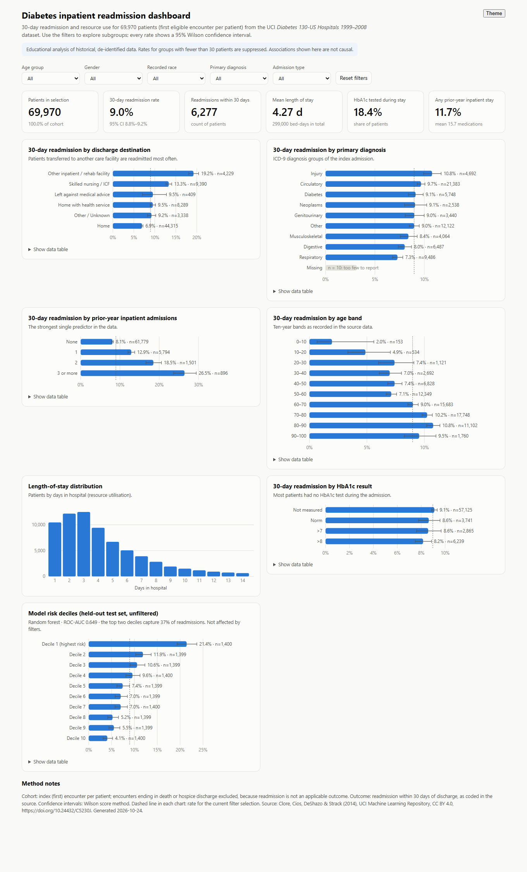
Figure 20. Interactive dashboard — desktop layout (1,360 px wide)

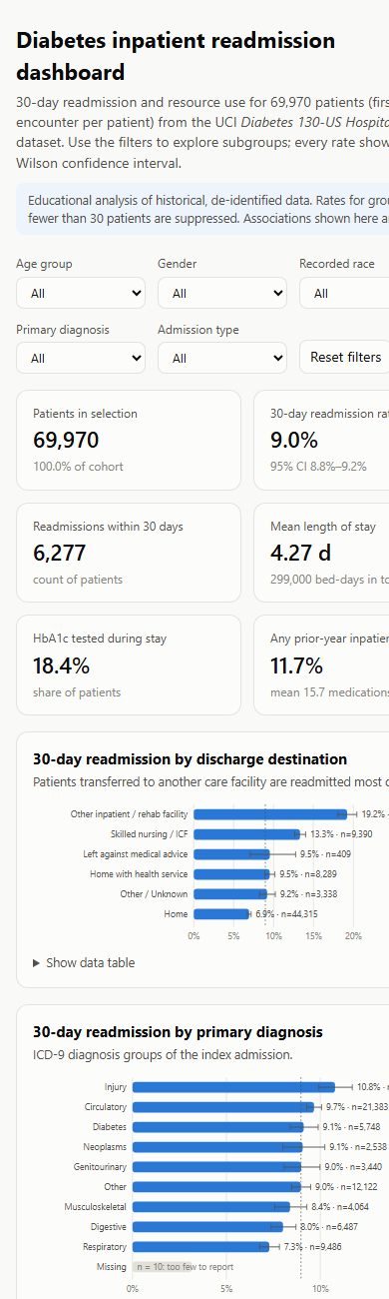
Figure 21. Interactive dashboard — mobile layout (390 px wide, first screen)

Appendix G: Reflective Self-Assessment
Part A critically assesses the approach and methods actually used, including the problems met during the project and how they were resolved. Part B is the intern's personal learning reflection, to be written in their own words.

G.A Assessment of approach and methodology
Table 43. Self-assessment of the approach
Area | What worked | Weakness | What to do differently
Dataset choice | Accessible, licensed, patient-level outcome; work could start in week 1 | Data are 17–26 years old; no dates or hospital IDs | Seek recent local data with dates under a data-sharing agreement
Data quality | 44 automated rules; every transformation logged | Accuracy could not be checked against source records | Add clinician spot-checks of sampled records
Cohort design | One index encounter per patient avoids dependence and train/test overlap | Later-encounter risk not modelled | Grouped cross-validation on all encounters as a sensitivity analysis
Statistics | Effect sizes, CIs and Holm correction rather than p-values alone | Observational design limits causal claims | Propensity-score or quasi-experimental analysis for HbA1c
Modelling | Baselines, single test-set use, calibration and fairness audit | Modest AUC (0.649); calibration slope 1.26 | Recalibrate; decision-curve analysis; richer predictors
Communication | Dashboard with suppression and plain-language report | No Power BI .pbix produced | Build the .pbix from the provided pack

Problems encountered and how they were resolved:
- Overstated data-quality improvement. The first completeness calculation counted the 'Unknown' fill value as complete, which made cleaning look more effective than it was. The metric was corrected to treat 'Unknown' as missing, so the reported gain reflects real information.
- Baseline evaluation error. The prior-admission baseline at first flagged every patient because many risk scores were tied at the cut-off. Switching to a strict threshold made the baseline equivalent to the intended 'any prior admission' rule.
- Repeated encounters. Some patients had up to 40 encounters; treating them as independent would have overstated precision and leaked patients between training and test data. The index-encounter cohort solved this.
- Unavailable tool. Power BI Desktop could not be automated, so a self-contained HTML dashboard and a Power BI build pack were delivered instead.
- Loss of working files. Project files were lost once during a change of storage location. Because every step is scripted and the raw data are checksummed, the full project was regenerated and verified to give identical results — a practical demonstration of why reproducibility matters.

G.B Personal learning reflection (to be completed by the intern)

G.1 Technical skills
- Which stage of the pipeline was most difficult for you, and why?
- Describe one error you found in your own work and how you detected it.
- Which statistical or machine-learning concept do you now understand better? Give an example.
Response: ____________________________________________________________

G.2 Healthcare domain knowledge
- What did you learn about readmissions, HbA1c or discharge planning?
- Which clinical terms were new to you, and how did you learn them?
Response: ____________________________________________________________

G.3 Ethics and responsibility
- Where did you have to balance usefulness against privacy or fairness?
- How would you explain the model's limitations to a clinician?
Response: ____________________________________________________________

G.4 Communication and teamwork
- How did you incorporate supervisor or peer feedback?
- Which chart or explanation worked best for a non-technical audience?
Response: ____________________________________________________________

G.5 Time management
- Compare your actual hours with the planned roadmap (Section 16). What caused differences?
Response: ____________________________________________________________

G.6 Overall
- Rate yourself (1–5) on Python, SQL, statistics, visualisation, ML, domain knowledge and communication, with one piece of evidence for each rating.
- What would you do differently if you repeated the project?
Response: ____________________________________________________________

Appendix H: Career Development Plan
A twelve-month plan building on the skills exercised in this project. Targets are suggestions to be adapted with the internship supervisor.
Table 44. Career development plan
Skill area | Current evidence | Next development step | Timeline | Evidence of progress
Python | pandas, scikit-learn pipelines | Write tests (pytest) for the cleaning functions; package the pipeline | 0–3 months | Tested, documented repository
SQL | Validation logic in pandas | Rebuild Week 2 validation in SQL (PostgreSQL/SQLite); learn window functions | 0–3 months | SQL scripts reproducing QA results
Statistics | Tests, CIs, logistic regression | Study causal inference basics (DAGs, propensity scores); regression diagnostics | 3–6 months | Short write-up applying propensity weighting to H3
Power BI | Data model and DAX designed | Build the .pbix from the provided pack; learn row-level security | 0–2 months | Published Power BI report
Machine learning | Tuning, calibration, fairness | Recalibration, decision-curve analysis, SHAP explanations, model monitoring | 3–9 months | Notebook with recalibrated model and decision curve
Healthcare terminology | ICD-9 groups, HbA1c, discharge dispositions | Learn ICD-10, SNOMED CT basics, FHIR resources, OMOP CDM | 3–9 months | Glossary; mapping exercise ICD-9 → ICD-10
Privacy and governance | DPDP Act, ABDM, ICMR AI guidelines | Complete a data-protection or research-ethics course; follow DPDP Rules commencement | 0–6 months | Certificate; DPIA template for a hospital project
Communication | Executive summary, dashboard | Present findings to a clinical audience; write a one-page brief | 0–3 months | Recorded 10-minute presentation
Portfolio | This project | Publish code, README and dashboard on GitHub (public data only) | 0–1 month | Public repository link on CV

References
Centers for Medicare & Medicaid Services. (2026). Hospital Readmissions Reduction Program [Data set]. Provider Data Catalog. https://data.cms.gov/provider-data/dataset/9n3s-kdb3
Clore, J., Cios, K., DeShazo, J., & Strack, B. (2014). Diabetes 130-US hospitals for years 1999–2008 [Data set]. UCI Machine Learning Repository. https://doi.org/10.24432/C5230J
Collins, G. S., Moons, K. G. M., Dhiman, P., Riley, R. D., Beam, A. L., Van Calster, B., Ghassemi, M., Liu, X., Reitsma, J. B., van Smeden, M., Boulesteix, A.-L., Camaradou, J. C., Celi, L. A., Denaxas, S., Denniston, A. K., Glocker, B., Golub, R. M., Harvey, H., Heinze, G., … Logullo, P. (2024). TRIPOD+AI statement: Updated guidance for reporting clinical prediction models that use regression or machine learning methods. BMJ, 385, e078378. https://doi.org/10.1136/bmj-2023-078378
Holm, S. (1979). A simple sequentially rejective multiple test procedure. Scandinavian Journal of Statistics, 6(2), 65–70.
Hunter, J. D. (2007). Matplotlib: A 2D graphics environment. Computing in Science & Engineering, 9(3), 90–95. https://doi.org/10.1109/MCSE.2007.55
Indian Council of Medical Research. (2023). Ethical guidelines for application of artificial intelligence in biomedical research and healthcare. https://www.icmr.gov.in/ethical-guidelines-for-application-of-artificial-intelligence-in-biomedical-research-and-healthcare
Jack, B. W., Chetty, V. K., Anthony, D., Greenwald, J. L., Sanchez, G. M., Johnson, A. E., Forsythe, S. R., O'Donnell, J. K., Paasche-Orlow, M. K., Manasseh, C., Martin, S., & Culpepper, L. (2009). A reengineered hospital discharge program to decrease rehospitalization: A randomized trial. Annals of Internal Medicine, 150(3), 178–187. https://doi.org/10.7326/0003-4819-150-3-200902030-00007
Jencks, S. F., Williams, M. V., & Coleman, E. A. (2009). Rehospitalizations among patients in the Medicare fee-for-service program. New England Journal of Medicine, 360(14), 1418–1428. https://doi.org/10.1056/NEJMsa0803563
Kahn, M. G., Callahan, T. J., Barnard, J., Bauck, A. E., Brown, J., Davidson, B. N., Estiri, H., Goerg, C., Holve, E., Johnson, S. G., Liaw, S.-T., Hamilton-Lopez, M., Meeker, D., Ong, T. C., Ryan, P., Shang, N., Weiskopf, N. G., Weng, C., Zozus, M. N., & Schilling, L. (2016). A harmonized data quality assessment terminology and framework for the secondary use of electronic health record data. eGEMs, 4(1), 1244. https://doi.org/10.13063/2327-9214.1244
Kansagara, D., Englander, H., Salanitro, A., Kagen, D., Theobald, C., Freeman, M., & Kripalani, S. (2011). Risk prediction models for hospital readmission: A systematic review. JAMA, 306(15), 1688–1698. https://doi.org/10.1001/jama.2011.1515
Leppin, A. L., Gionfriddo, M. R., Kessler, M., Brito, J. P., Mair, F. S., Gallacher, K., Wang, Z., Erwin, P. J., Sylvester, T., Boehmer, K., Ting, H. H., Murad, M. H., Shippee, N. D., & Montori, V. M. (2014). Preventing 30-day hospital readmissions: A systematic review and meta-analysis of randomized trials. JAMA Internal Medicine, 174(7), 1095–1107. https://doi.org/10.1001/jamainternmed.2014.1608
McKinney, W. (2010). Data structures for statistical computing in Python. In S. van der Walt & J. Millman (Eds.), Proceedings of the 9th Python in Science Conference (pp. 56–61). https://doi.org/10.25080/Majora-92bf1922-00a
Ministry of Electronics and Information Technology. (2025). Digital Personal Data Protection Rules, 2025 (G.S.R. notification of 14 November 2025). Government of India. https://www.meity.gov.in/
National Health Authority. (2020). Health data management policy: Ayushman Bharat Digital Mission. Government of India. https://abdm.gov.in/
Naylor, M. D., Brooten, D., Campbell, R., Jacobsen, B. S., Mezey, M. D., Pauly, M. V., & Schwartz, J. S. (1999). Comprehensive discharge planning and home follow-up of hospitalized elders: A randomized clinical trial. JAMA, 281(7), 613–620. https://doi.org/10.1001/jama.281.7.613
Obermeyer, Z., Powers, B., Vogeli, C., & Mullainathan, S. (2019). Dissecting racial bias in an algorithm used to manage the health of populations. Science, 366(6464), 447–453. https://doi.org/10.1126/science.aax2342
Pedregosa, F., Varoquaux, G., Gramfort, A., Michel, V., Thirion, B., Grisel, O., Blondel, M., Prettenhofer, P., Weiss, R., Dubourg, V., Vanderplas, J., Passos, A., Cournapeau, D., Brucher, M., Perrot, M., & Duchesnay, É. (2011). Scikit-learn: Machine learning in Python. Journal of Machine Learning Research, 12, 2825–2830.
Rajkomar, A., Hardt, M., Howell, M. D., Corrado, G., & Chin, M. H. (2018). Ensuring fairness in machine learning to advance health equity. Annals of Internal Medicine, 169(12), 866–872. https://doi.org/10.7326/M18-1990
Saito, T., & Rehmsmeier, M. (2015). The precision-recall plot is more informative than the ROC plot when evaluating binary classifiers on imbalanced datasets. PLOS ONE, 10(3), e0118432. https://doi.org/10.1371/journal.pone.0118432
Seabold, S., & Perktold, J. (2010). Statsmodels: Econometric and statistical modeling with Python. In Proceedings of the 9th Python in Science Conference (pp. 92–96). https://doi.org/10.25080/Majora-92bf1922-011
Strack, B., DeShazo, J. P., Gennings, C., Olmo, J. L., Ventura, S., Cios, K. J., & Clore, J. N. (2014). Impact of HbA1c measurement on hospital readmission rates: Analysis of 70,000 clinical database patient records. BioMed Research International, 2014, 781670. https://doi.org/10.1155/2014/781670
U.S. Department of Health and Human Services. (2012). Guidance regarding methods for de-identification of protected health information in accordance with the Health Insurance Portability and Accountability Act (HIPAA) Privacy Rule. https://www.hhs.gov/hipaa/for-professionals/special-topics/de-identification/index.html
Van Calster, B., McLernon, D. J., van Smeden, M., Wynants, L., & Steyerberg, E. W. (2019). Calibration: The Achilles heel of predictive analytics. BMC Medicine, 17, 230. https://doi.org/10.1186/s12916-019-1466-7
Virtanen, P., Gommers, R., Oliphant, T. E., Haberland, M., Reddy, T., Cournapeau, D., Burovski, E., Peterson, P., Weckesser, W., Bright, J., van der Walt, S. J., Brett, M., Wilson, J., Millman, K. J., Mayorov, N., Nelson, A. R. J., Jones, E., Kern, R., Larson, E., … Vázquez-Baeza, Y. (2020). SciPy 1.0: Fundamental algorithms for scientific computing in Python. Nature Methods, 17(3), 261–272. https://doi.org/10.1038/s41592-019-0686-2
Wilson, E. B. (1927). Probable inference, the law of succession, and statistical inference. Journal of the American Statistical Association, 22(158), 209–212. https://doi.org/10.1080/01621459.1927.10502953
World Health Organization. (2021). Ethics and governance of artificial intelligence for health: WHO guidance. https://www.who.int/publications/i/item/9789240029200

