SIX-WEEK HEALTHCARE DATA ANALYTICS INTERNSHIP · WEEK 5 SUBMISSION
Analytical Report and Evidence-Based Recommendations
Findings from a diabetic inpatient readmission analysis

Project: 30-day readmission and resource use among diabetic inpatients in 130 US hospitals (UCI Diabetes 130-US Hospitals dataset, 1999–2008)

Prepared by: Juluru Akshay
Internship organisation: Yuva
Date: 24 October 2026
Project repository: https://github.com/AJ1206/healthcare-readmission-analytics

Contents
1. Executive Summary 3
2. Introduction 4
3. Methodology 5
4. Results 6
4.1 Who is readmitted? 6
4.2 Care processes 7
4.3 Resource use 8
4.4 Adjusted analysis 8
4.5 Predicting readmission 9
5. Discussion 10
6. Evidence-Based Recommendations 11
7. Communicating the Findings 12
8. Limitations and Future Research 13
9. Conclusion 13
References 14

1. Executive Summary
We analysed 69,970 patients with diabetes admitted to 130 US hospitals (first eligible stay each). 9.0% were readmitted within 30 days — roughly one patient in eleven.
Key insights
- Patients discharged to a care facility return about twice as often (15.2% vs 7.5%).
- Patients admitted in the previous year return about twice as often (15.4% vs 8.1%).
- HbA1c was checked for only 18.4% of patients; testing is linked to slightly fewer readmissions.
- Average stay is 4.3 days; circulatory conditions use 29.8% of bed-days.
- A risk model can rank patients (the top 20% contain 36.8% of readmissions) but is not accurate enough for individual decisions.
Top recommendations
1. Strengthen hand-offs for patients discharged to care facilities.
2. Start discharge planning early and book follow-up within 7 days for patients with a prior-year admission.
3. Audit HbA1c testing and pilot a prompt with a controlled evaluation.
4. Improve recording of weight, specialty and payer.
5. Use any risk model only in a supervised, locally validated pilot.

2. Introduction
Readmissions within 30 days are costly, often avoidable and publicly reported (Jencks et al., 2009; CMS, 2026). This report answers four questions for a hospital quality team: how common early readmission is among diabetic inpatients; which factors are associated with it; where inpatient resources are used; and whether readmission risk can be predicted at discharge.

3. Methodology
Table 1. Methodology summary
Element | Approach
Data | UCI Diabetes 130-US Hospitals (1999–2008), 101,766 encounters, CC BY 4.0 (Clore et al., 2014)
Cohort | First eligible encounter per patient; deaths and hospice excluded → 69,970 patients
Quality assurance | 44 validation rules (all passed); documented cleaning; issue log
Outcome | Readmission within 30 days of discharge
Statistics | Rates with 95% Wilson CIs; χ² and Mann–Whitney tests with effect sizes and Holm correction; multivariable logistic regression
Prediction | Logistic regression, random forest, gradient boosting vs baselines; patient-level 60/20/20 split; test set used once
Tools | Python (pandas, SciPy, statsmodels, scikit-learn), HTML dashboard, Power BI build pack

How insights were derived: every finding below comes from a computed table, is shown with its uncertainty, and was checked against an adjusted model before being used for a recommendation. Effect sizes, not just p-values, determine importance, because with 70,000 patients even trivial differences are 'significant'.

4. Results
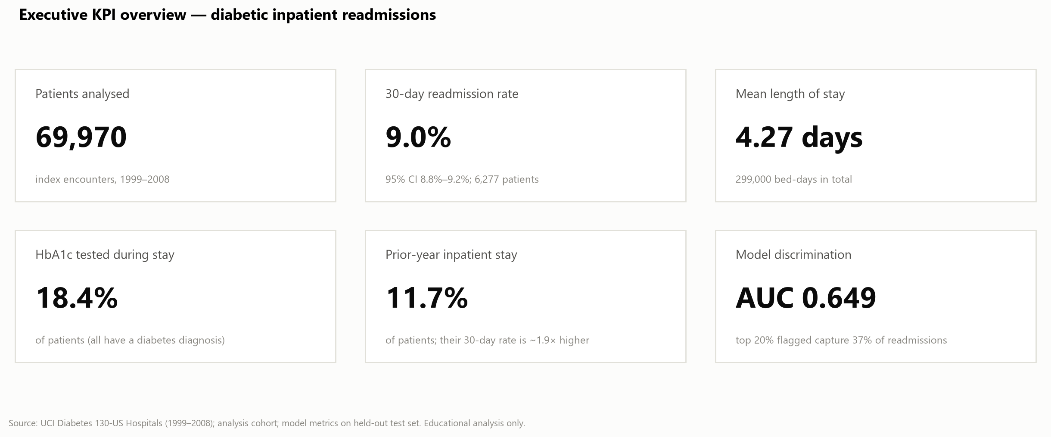
Figure 1. Headline indicators

4.1 Who is readmitted?
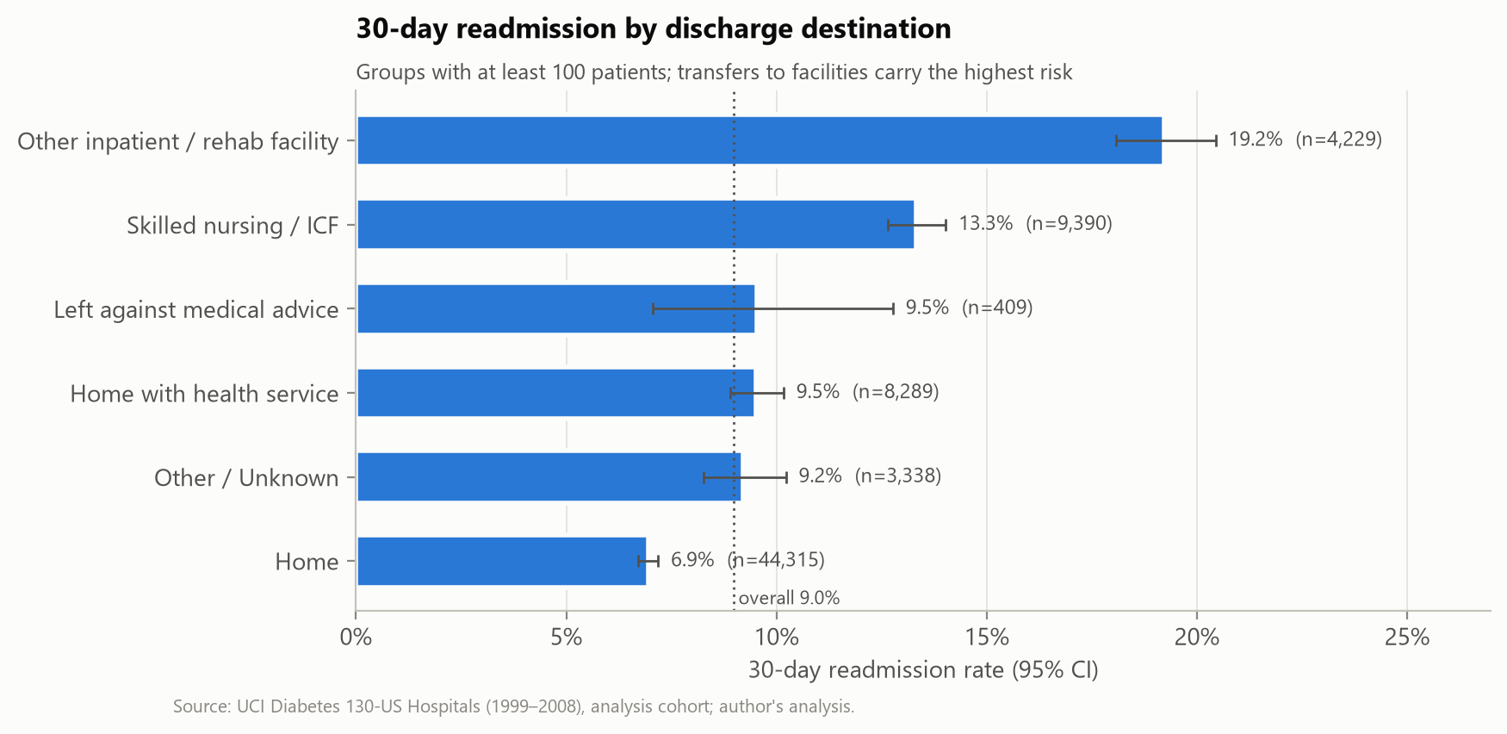
Figure 2. Readmission by discharge destination
Interpretation. Facility discharges carry the highest risk (19.2% rehab/other inpatient, 13.3% skilled nursing) versus 7.0% for home.
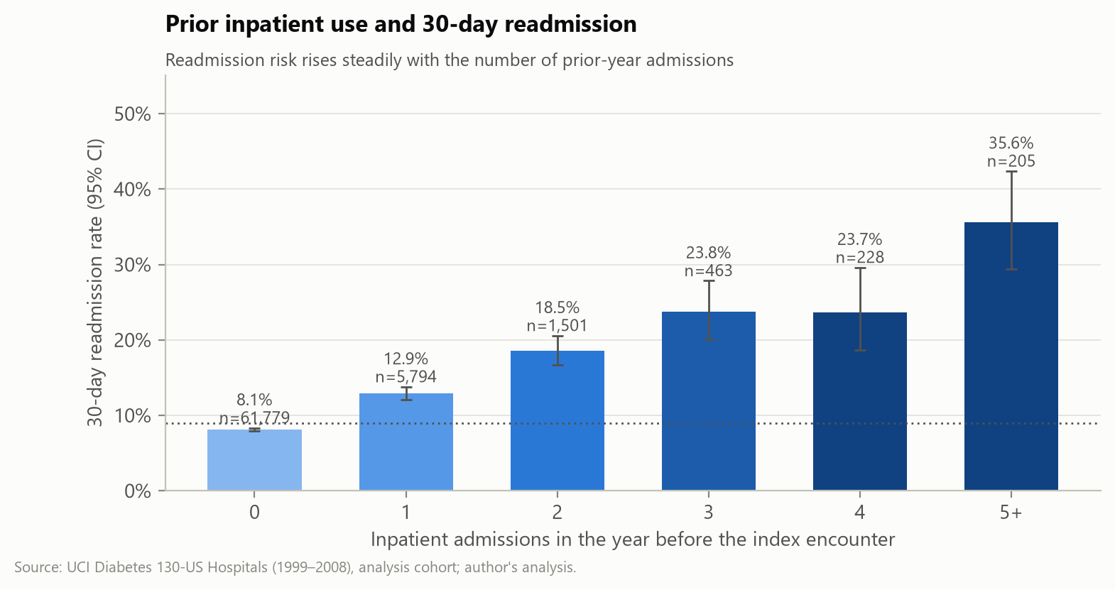
Figure 3. Readmission by prior-year admissions
Interpretation. Risk rises from 8.1% (none) to 35.6% (five or more).
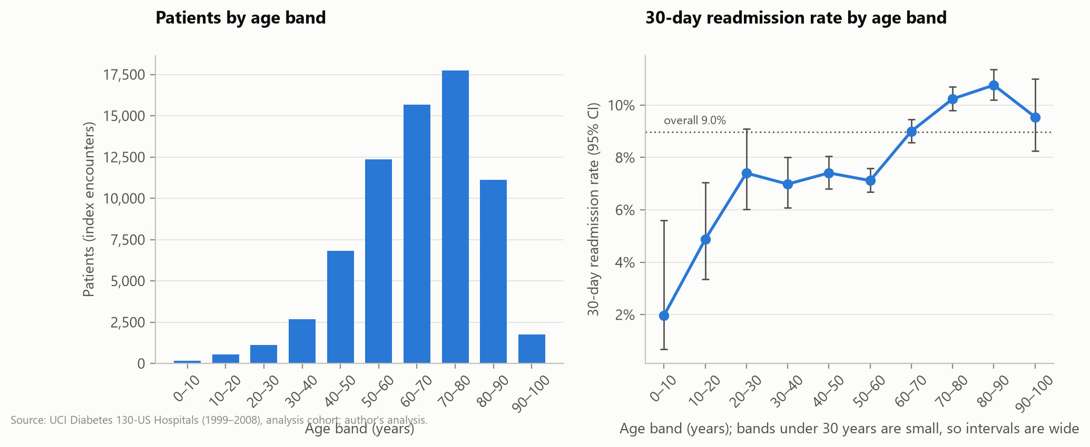
Figure 4. Age profile and readmission
Interpretation. Patients aged 60+ are readmitted more often (9.9% vs 7.1%).

4.2 Care processes
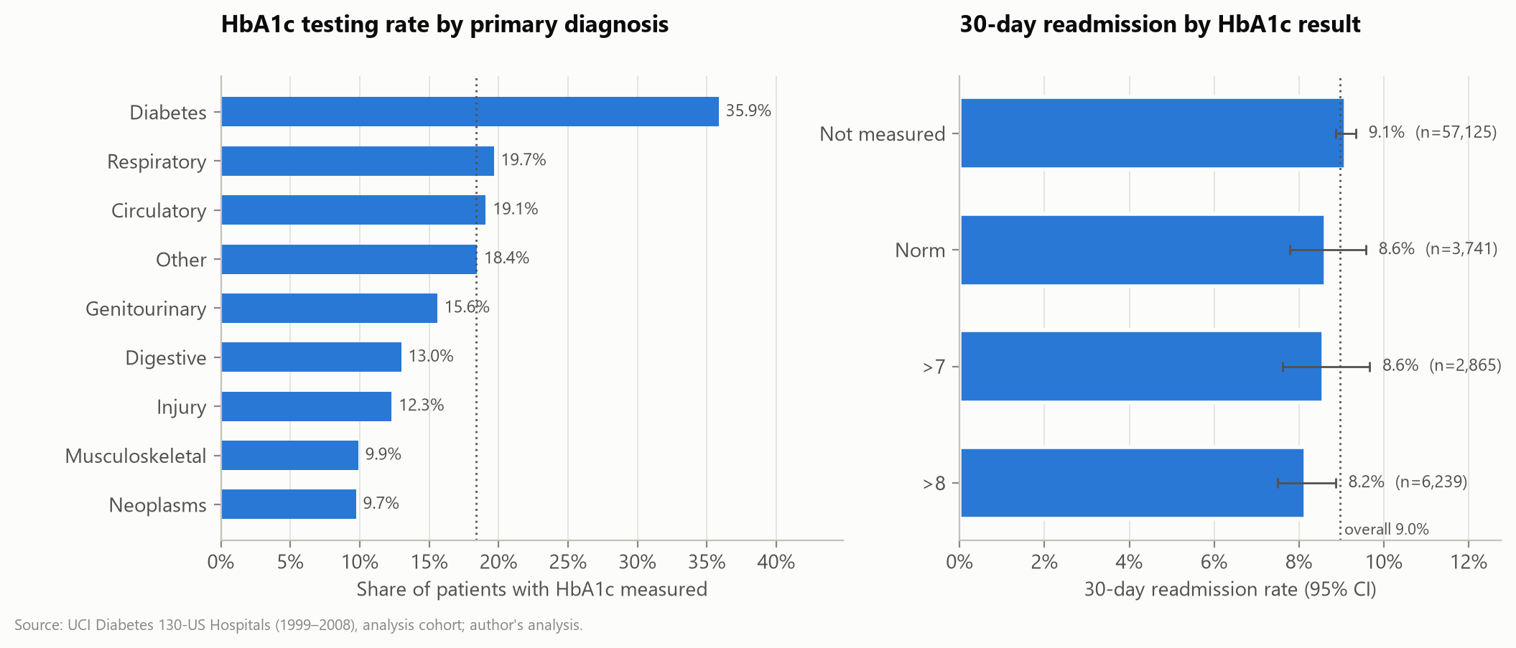
Figure 5. HbA1c testing and readmission
Interpretation. Adjusted OR for testing 0.92 (95% CI 0.85–0.99); varies by diagnosis.

4.3 Resource use
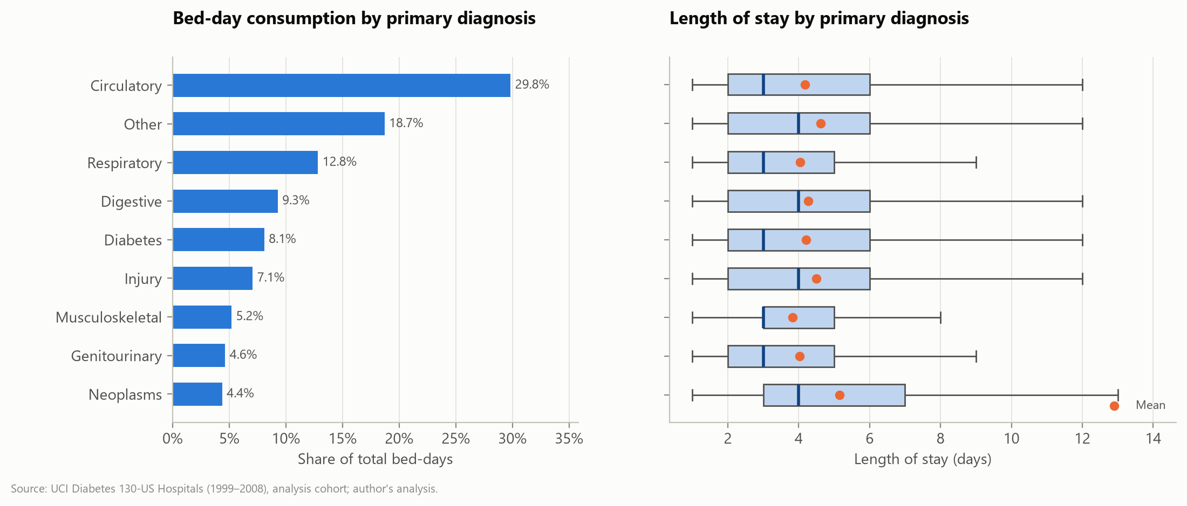
Figure 6. Bed-days and length of stay by diagnosis
Interpretation. Stays of 7+ days are linked to more readmissions (11.7% vs 8.3%).

4.4 Adjusted analysis
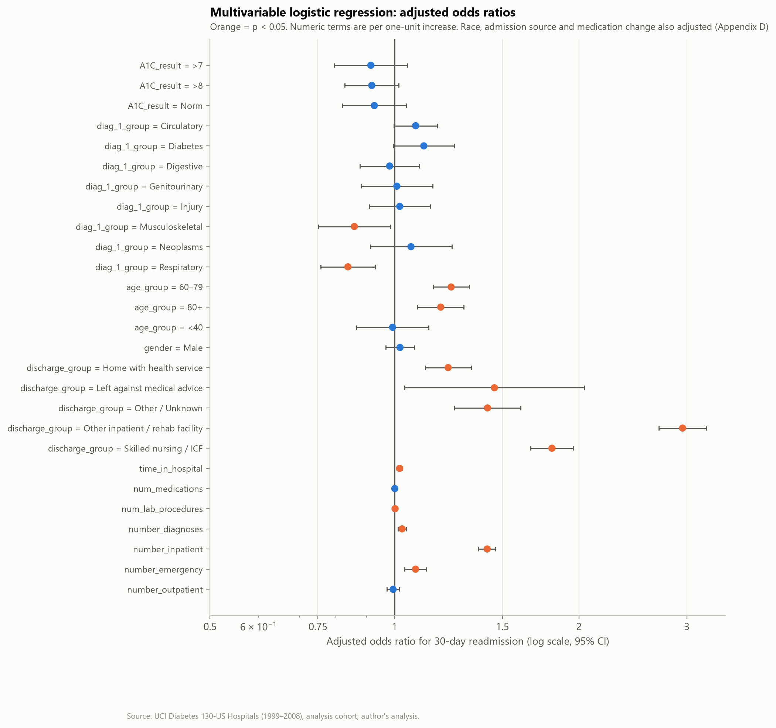
Figure 7. Adjusted odds ratios
Interpretation. Discharge destination (OR up to 2.95), prior admissions (OR 1.42 each) and age remain the strongest associations after adjustment.

4.5 Predicting readmission
Table 2. Observed readmission by predicted-risk decile (test set)
Risk decile (1 = highest) | Patients | Readmissions | Observed rate | Cumulative share of readmissions
1 | 1400 | 300 | 21.4% | 23.9%
2 | 1399 | 166 | 11.9% | 37.1%
3 | 1399 | 148 | 10.6% | 48.9%
4 | 1400 | 134 | 9.6% | 59.6%
5 | 1399 | 104 | 7.4% | 67.9%
6 | 1399 | 98 | 7.0% | 75.7%
7 | 1400 | 98 | 7.0% | 83.5%
8 | 1399 | 73 | 5.2% | 89.3%
9 | 1399 | 77 | 5.5% | 95.5%
10 | 1400 | 57 | 4.1% | 100.0%

The highest-risk tenth of patients is readmitted at 21.4%, five times the lowest tenth (4.1%). Overall discrimination is modest (ROC-AUC 0.649), typical of administrative-data models (Kansagara et al., 2011).

5. Discussion
Readmission risk concentrates in patients who are frailer and more dependent at discharge. These markers are mostly not levers a hospital can change directly, so their value is in targeting: directing follow-up to the groups that carry most of the risk. The HbA1c finding points to a care-process gap that is worth testing.
- Alternative explanations: facility discharge and prior admissions may stand in for unmeasured illness severity or social support.
- HbA1c testing may mark more attentive care rather than cause better outcomes.
- Readmissions to other hospitals may be missed, biasing rates downward.

6. Evidence-Based Recommendations
Table 3. Recommendations traced to evidence
Finding | Evidence | Action | Owner | Priority
Facility discharge = highest risk | 15.2% vs 7.5%; adj. OR 2.95 | Medication list and summary sent before transfer; 72-h call to facility | Case management | High
Prior admissions = steep gradient | 15.4% vs 8.1%; adj. OR 1.42 | Flag at admission; follow-up ≤ 7 days | Hospitalists | High
HbA1c rarely tested | 18.4% tested; adj. OR 0.92 | Audit; pilot testing prompt with evaluation | Diabetes team | Medium
Older patients higher risk | Age ≥ 60 RR 1.39 | Functional/caregiver assessment for ≥ 70 (to be tested) | Geriatrics | Medium
Documentation gaps | Weight 97%, specialty 49% missing | Mandatory structured fields; quality dashboard | HIM / IT | Medium
Model modest | AUC 0.649 | Supervised pilot only after local validation | Clinical governance | Medium

Supporting external evidence: structured discharge programmes reduced 30-day readmissions in randomised trials (Jack et al., 2009; Naylor et al., 1999; Leppin et al., 2014).

7. Communicating the Findings
Plain-language summary for patients and non-specialists:
About one in eleven patients with diabetes came back to hospital within a month of going home. People going to a nursing or rehabilitation facility, and people who had been in hospital before, came back about twice as often. Hospitals can use this to give these patients extra help when they leave — for example making sure the facility has the right medicines list and that a follow-up visit is booked.
- Executives: one-page brief + KPI dashboard (Figure 1).
- Case managers: discharge worklist with plain-language reasons.
- Quality committee: this report plus the interactive dashboard.

8. Limitations and Future Research
- Data are from 1999–2008 (ICD-9); rates may not reflect current care.
- No dates or hospital IDs: no trends or hospital comparisons.
- Observational data: associations, not causes.
- Model not externally validated; calibration needs adjustment.
- Future work: current local data, time-to-event models, decision-curve analysis, and controlled evaluation of the recommended interventions.

9. Conclusion
The analysis identifies clear, actionable concentrations of readmission risk and a care-process gap. Targeted transition support for facility discharges and frequent users, better diabetes assessment and better data capture are the evidence-based priorities.

References
Centers for Medicare & Medicaid Services. (2026). Hospital Readmissions Reduction Program [Data set]. Provider Data Catalog. https://data.cms.gov/provider-data/dataset/9n3s-kdb3
Clore, J., Cios, K., DeShazo, J., & Strack, B. (2014). Diabetes 130-US hospitals for years 1999–2008 [Data set]. UCI Machine Learning Repository. https://doi.org/10.24432/C5230J
Jack, B. W., Chetty, V. K., Anthony, D., Greenwald, J. L., Sanchez, G. M., Johnson, A. E., Forsythe, S. R., O'Donnell, J. K., Paasche-Orlow, M. K., Manasseh, C., Martin, S., & Culpepper, L. (2009). A reengineered hospital discharge program to decrease rehospitalization: A randomized trial. Annals of Internal Medicine, 150(3), 178–187. https://doi.org/10.7326/0003-4819-150-3-200902030-00007
Jencks, S. F., Williams, M. V., & Coleman, E. A. (2009). Rehospitalizations among patients in the Medicare fee-for-service program. New England Journal of Medicine, 360(14), 1418–1428. https://doi.org/10.1056/NEJMsa0803563
Kansagara, D., Englander, H., Salanitro, A., Kagen, D., Theobald, C., Freeman, M., & Kripalani, S. (2011). Risk prediction models for hospital readmission: A systematic review. JAMA, 306(15), 1688–1698. https://doi.org/10.1001/jama.2011.1515
Leppin, A. L., Gionfriddo, M. R., Kessler, M., Brito, J. P., Mair, F. S., Gallacher, K., Wang, Z., Erwin, P. J., Sylvester, T., Boehmer, K., Ting, H. H., Murad, M. H., Shippee, N. D., & Montori, V. M. (2014). Preventing 30-day hospital readmissions: A systematic review and meta-analysis of randomized trials. JAMA Internal Medicine, 174(7), 1095–1107. https://doi.org/10.1001/jamainternmed.2014.1608
Naylor, M. D., Brooten, D., Campbell, R., Jacobsen, B. S., Mezey, M. D., Pauly, M. V., & Schwartz, J. S. (1999). Comprehensive discharge planning and home follow-up of hospitalized elders: A randomized clinical trial. JAMA, 281(7), 613–620. https://doi.org/10.1001/jama.281.7.613
Strack, B., DeShazo, J. P., Gennings, C., Olmo, J. L., Ventura, S., Cios, K. J., & Clore, J. N. (2014). Impact of HbA1c measurement on hospital readmission rates: Analysis of 70,000 clinical database patient records. BioMed Research International, 2014, 781670. https://doi.org/10.1155/2014/781670

