SIX-WEEK HEALTHCARE DATA ANALYTICS INTERNSHIP · WEEK 1 SUBMISSION
Healthcare Data Analysis Strategic Plan
Planning, organisation and roadmap for a diabetic readmission analytics project

Project: 30-day readmission and resource use among diabetic inpatients in 130 US hospitals (UCI Diabetes 130-US Hospitals dataset, 1999–2008)

Prepared by: Juluru Akshay
Internship organisation: Yuva
Date: 24 October 2026
Project repository: https://github.com/AJ1206/healthcare-readmission-analytics

Contents
1. Executive Summary 3
2. The Role of Strategic Planning in Healthcare Data Analysis 4
3. Problem Statement and Business Case 5
4. Project Scope 6
4.1 Objectives (SMART) 6
4.2 Key questions and hypotheses 6
5. Stakeholders and Governance 7
5.1 Responsibilities (RACI) 7
5.2 Governance procedures 7
6. Data Strategy 8
7. Step-by-Step Analytical Strategy 9
7.1 Data acquisition 9
7.2 Data profiling and cleaning 9
7.3 Exploratory analysis 9
7.4 Statistical analysis 9
7.5 Predictive modelling 9
7.6 Visualisation and reporting 9
7.7 Tools and resources 10
8. Key Metrics (KPI Catalogue) 11
9. Deliverables 12
10. Roadmap and Timeline 13
10.1 Milestone definitions 13
11. Resource Allocation 14
12. Risk Management and Contingency Planning 15
12.1 Contingency triggers 16
13. Communication Plan 17
14. Quality and Success Criteria 18
15. Conclusion 18
References 19

This plan is self-contained: it defines the problem, the analytical strategy, the metrics, the roadmap and the risk controls needed to run the project. Baseline values quoted in the KPI and scope sections come from the project's own data, because the plan was subsequently executed (code and outputs: https://github.com/AJ1206/healthcare-readmission-analytics).

1. Executive Summary
Unplanned readmissions within 30 days of discharge are a recognised marker of care quality and a major cost for hospitals; in the US Medicare population about one in five discharged patients was rehospitalised within 30 days (Jencks et al., 2009). Patients with diabetes are a large, high-risk group. This plan sets out how a hospital analytics team would use routinely collected inpatient data to understand who is readmitted, how inpatient resources are used and whether readmission risk can be predicted early enough to act.
Vision:
To give clinical and operational leaders a transparent, reproducible and ethically governed evidence base on diabetic inpatient readmissions that can be refreshed with local data and used to target transition-of-care resources.
- Objective 1 – Baseline. Measure 30-day readmission, length of stay and care-process KPIs with 95% confidence intervals.
- Objective 2 – Drivers. Identify patient, clinical and discharge factors associated with early readmission, using pre-specified hypotheses and effect sizes.
- Objective 3 – Prediction. Build and honestly validate a risk model that beats a simple rule.
- Objective 4 – Communication. Deliver a dashboard and a report that non-technical stakeholders can act on.
- Objective 5 – Governance. Meet privacy, ethics and reproducibility standards throughout.
The project runs for six weeks (30–35 hours per week, 195 hours in total) with six milestone reviews. Its main deliverables are a quality-assured dataset, a statistical analysis, a validated predictive model, an interactive dashboard and an integrated report with evidence-based recommendations.

2. The Role of Strategic Planning in Healthcare Data Analysis
Healthcare data analysis differs from analytics in most other sectors in four ways that make up-front planning essential:
- Complex, imperfect data. Clinical and administrative data are collected for care and billing, not research. They contain coding conventions, missing values and repeated measurements that must be understood before analysis (Kahn et al., 2016; Weiskopf & Weng, 2013).
- High stakes. Findings can influence patient care. Errors such as data leakage or confusing association with causation can cause harm, so methods must be fixed before results are seen.
- Regulation and ethics. Personal health data are protected by law (for example India's Digital Personal Data Protection Act 2023 and Rules 2025; HIPAA in the US). Access, consent and retention must be planned, not retrofitted (MeitY, 2025; HHS, 2012).
- Many stakeholders. Clinicians, managers, data protection officers and patients have different questions; a plan aligns them on what will be delivered and how success is judged.
Big-data analytics can improve care quality and reduce costs only when it is organised around clear questions, governance and the right data (Raghupathi & Raghupathi, 2014). This plan follows the Cross-Industry Standard Process for Data Mining (CRISP-DM), whose six phases — business understanding, data understanding, data preparation, modelling, evaluation and deployment — provide a widely used structure for analytics projects (Wirth & Hipp, 2000). It is adapted here with explicit quality-assurance, ethics and communication stages (Figure 1).
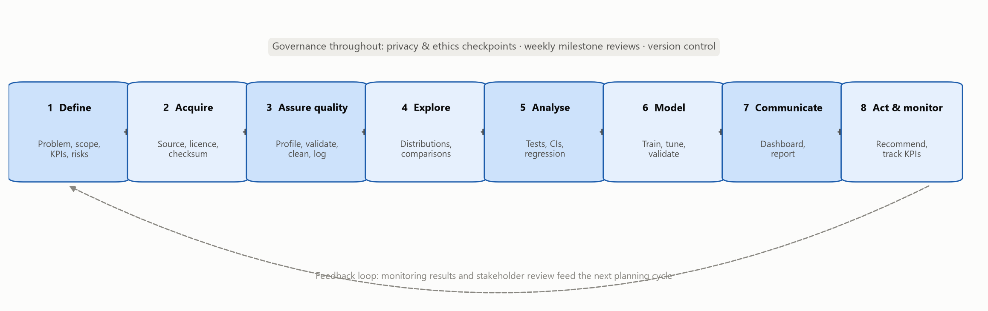
Figure 1. Analytical workflow used in this plan (adapted from CRISP-DM)
Interpretation. Each stage has defined inputs, outputs and acceptance criteria (Section 7), and feedback from monitoring returns to planning.

3. Problem Statement and Business Case
A hospital quality team needs to know how often diabetic inpatients return within 30 days, which factors are associated with early readmission, where inpatient bed-days are concentrated, and whether discharge data can rank patients by risk well enough to prioritise follow-up. Without this evidence, transition-of-care resources are spread evenly instead of targeted where risk is highest.
Table 1. Business case
Benefit | Rationale and evidence
Fewer avoidable readmissions | Structured discharge programmes reduced readmissions in randomised trials (Jack et al., 2009; Naylor et al., 1999; Leppin et al., 2014)
Freed bed capacity | Each avoided readmission releases an inpatient bed for a new admission
Financial and regulatory exposure | Readmission performance is publicly reported and payment-linked in several systems (CMS, 2026)
Better diabetes care | Inconsistent inpatient diabetes management is linked to readmission (Strack et al., 2014)
Reusable capability | A scripted pipeline turns a one-off study into a monitoring tool

4. Project Scope
Table 2. Scope statement
Element | Definition
In scope | Patient-level analysis of diabetic inpatient encounters; 30-day readmission; length of stay, bed-days, medications and laboratory use; care-process indicators (HbA1c testing); descriptive, inferential and predictive analysis; dashboard; governance and ethics review
Out of scope | Causal effect estimation; cost analysis; real-time deployment into clinical systems; individual patient decisions
Assumptions | A suitable public dataset with a patient-level readmission outcome exists and is licensed for reuse; readmission labels are coded correctly; standard laptop computing is sufficient
Constraints | Six weeks; public data only (no credentialed clinical databases); open-source tools; a single analyst with supervisor review
Dependencies | Dataset availability; supervisor reviews at each milestone; clinician input on variable definitions

4.1 Objectives (SMART)
Table 3. Objectives
ID | Objective | Measure of success | Deadline
O1 | Acquire and document a licensed healthcare dataset | Source, licence, checksum and schema recorded | End of week 2
O2 | Deliver an analysis-ready dataset | 100% of validation rules pass; issue log complete | End of week 2
O3 | Quantify readmission and resource-use KPIs | ≥ 10 KPIs with formulas and 95% CIs | End of week 3
O4 | Test pre-specified hypotheses | Effect sizes reported; multiplicity controlled | Mid week 4
O5 | Build and validate a risk model | Beats a simple baseline on an untouched test set; calibration and subgroups reported | End of week 4
O6 | Provide an interactive dashboard | Filters, KPI cards, confidence intervals, small-sample suppression | End of week 3
O7 | Produce traceable recommendations | Each linked to a result or cited source | End of week 5

4.2 Key questions and hypotheses
Table 4. Key questions and testable hypotheses
ID | Key question | Hypothesis / type
Q1 | What is the 30-day readmission rate, and how does it vary across patient groups? | Descriptive
Q2 | Is prior inpatient use associated with readmission? | H1: ≥ 1 prior-year admission → higher rate
Q3 | Does discharge destination matter? | H2: discharge to a care facility → higher rate
Q4 | Is inpatient HbA1c measurement associated with readmission? | H3: measurement → lower rate after adjustment; varies by diagnosis
Q5 | Are length of stay and age associated with readmission? | H4: longer stay and older age → higher rate
Q6 | Does resource use differ by primary diagnosis? | H5: length of stay differs across diagnosis groups
Q7 | Can discharge data rank risk better than a simple rule? | H6: multivariable model beats a prior-admission rule (ROC-AUC)

5. Stakeholders and Governance
Table 5. Stakeholder map
Stakeholder | Influence | Interest | Engagement approach
Executive leadership | High | High | Monthly one-page KPI brief
CMO / quality committee | High | High | Milestone reviews; sign-off of findings
Diabetes / endocrinology team | Medium | High | Clinical review of HbA1c analysis
Hospitalists, nurses, case managers | Medium | High | Co-design of dashboard and pilot
Health information management | Medium | Medium | Data-quality issue log
IT / data engineering | Medium | Medium | Pipeline hand-over
Data protection officer | High | Medium | Approval before any identifiable data is used
Patients and caregivers | Low | High | Plain-language summary via patient advisory group

5.1 Responsibilities (RACI)
Table 6. RACI matrix (R = responsible, A = accountable, C = consulted, I = informed)
Activity | Analyst (intern) | Supervisor | Clinical lead | IT | Data protection officer
Project plan and charter | R | A | C | C | I
Data acquisition and QA | R | A | I | C | C
Statistical analysis | R | A | C | I | I
Predictive model | R | A | C | C | C
Dashboard and visualisation | R | A | C | I | I
Recommendations | R | C | A | I | I
Privacy and ethics review | C | R | I | I | A

5.2 Governance procedures
- Weekly milestone review against acceptance criteria; decisions recorded in a change log.
- Analytical peer review: a second analyst re-runs the pipeline and checks key numbers.
- Clinical review of variable definitions (diagnosis grouping, discharge grouping).
- Privacy checkpoint before any non-public data is used (data-protection impact assessment).
- Model governance: no clinical use without validation, an accountable owner and monitoring.

6. Data Strategy
The data strategy prioritises sources that are accessible, licensed for reuse, well documented and contain a patient-level readmission outcome. Candidate sources are scored against nine criteria (detailed in the Week 2 plan). The selected source is the UCI Diabetes 130-US Hospitals dataset: 101,766 inpatient encounters of patients with diabetes (1999–2008), licensed CC BY 4.0, with a documented readmission outcome (Clore et al., 2014; Strack et al., 2014). Alternatives held in reserve are the CMS Hospital Readmissions Reduction Program data (hospital-level) and, for longer projects, credentialed databases such as MIMIC-IV.

7. Step-by-Step Analytical Strategy

7.1 Data acquisition
- Confirm access and licence; record source URL, DOI and access date.
- Download programmatically; store the untouched original and its SHA-256 checksum.
- Extract only expected files; never edit raw data.
Output: Raw data + provenance file.
Acceptance criterion: Checksum recorded; licence permits use.

7.2 Data profiling and cleaning
- Profile types, missingness, duplicates, invalid codes and outliers.
- Apply validation rules (ranges, domains, cross-field logic, uniqueness).
- Clean with documented, justified rules; log every transformation.
- Define the analysis cohort (one row per patient; exclude deaths and hospice).
Output: Clean dataset, data dictionary, QA report.
Acceptance criterion: All rules pass; issue log complete.

7.3 Exploratory analysis
- Describe distributions and group differences.
- Compute KPIs with 95% Wilson confidence intervals.
- Produce publication-quality figures with interpretations.
Output: Figure set and descriptive tables.
Acceptance criterion: Every chart titled, labelled and interpreted.

7.4 Statistical analysis
- Chi-square, Mann–Whitney and Kruskal–Wallis tests with effect sizes.
- Holm correction for multiple comparisons.
- Multivariable logistic regression for adjusted associations.
Output: Test results; adjusted odds ratios.
Acceptance criterion: Assumptions checked; effect sizes reported.

7.5 Predictive modelling
- Patient-level 60/20/20 train/validation/test split.
- Baselines, then logistic regression, random forest and gradient boosting.
- Tune with cross-validation on training data only; evaluate once on test data.
- Report discrimination, calibration and subgroup performance.
Output: Validated model + model card.
Acceptance criterion: Beats baseline; no leakage; test set used once.

7.6 Visualisation and reporting
- Interactive dashboard with filters and suppression of small groups.
- Analytical report with traceable recommendations.
Output: Dashboard; report.
Acceptance criterion: Stakeholder review passed.

7.7 Tools and resources
Table 7. Tools and their purpose
Tool | Purpose
Python (pandas, NumPy) | Data loading, profiling, cleaning (McKinney, 2010)
SciPy, statsmodels | Hypothesis tests, confidence intervals, regression
scikit-learn | Pipelines, model training, cross-validation, metrics (Pedregosa et al., 2011)
Matplotlib, seaborn | Static publication-quality charts
Power BI / HTML dashboard | Interactive dashboard for stakeholders
SQL | Validation rules and extracts when working with a hospital database
Git and GitHub | Version control and reproducibility
Microsoft Word | Reports and stakeholder documents

8. Key Metrics (KPI Catalogue)
Each KPI has a fixed formula so that it can be recalculated identically every reporting period. Baseline values are those measured when the plan was executed on the selected dataset (analysis cohort of 69,970 patients).
Table 8. KPI catalogue
KPI | Formula | Type | Baseline value (from project data)
30-day readmission rate | Readmissions < 30 days ÷ eligible index discharges | Quality outcome | 9.0%
Any-time readmission rate | Readmissions (any time) ÷ eligible discharges | Outcome | 40.7%
In-hospital mortality (encounters) | Expired dispositions ÷ all encounters | Outcome | 1.62%
Average length of stay | Σ inpatient days ÷ patients | Utilisation | 4.27 days
Total bed-days | Σ inpatient days | Utilisation | 299,000
Medications per stay | Σ distinct medications ÷ patients | Utilisation | 15.7
Laboratory procedures per stay | Σ lab procedures ÷ patients | Utilisation | 42.9
HbA1c testing rate | Patients with HbA1c measured ÷ patients | Care process | 18.4%
Discharge-to-home rate | Discharged home (± home health) ÷ patients | Patient flow | 75.2%
Prior-year inpatient share | Patients with ≥ 1 prior admission ÷ patients | Risk mix | 11.7%
Facility-discharge readmission rate | Readmissions < 30 d among facility discharges ÷ those discharges | Quality | 15.2%
Data completeness | Non-missing cells ÷ all cells | Data quality | 97.6%
Model discrimination (ROC-AUC) | Area under ROC curve on held-out patients | Model | 0.649
Readmissions captured (top 20% risk) | True positives ÷ all readmissions at threshold | Model | 36.8%

9. Deliverables
Table 9. Deliverables register
ID | Deliverable | Due | Audience
D1 | Strategic plan (this document) | Week 1 | Supervisor
D2 | Data collection and QA plan; clean dataset; data dictionary; QA report | Week 2 | Supervisor, HIM
D3 | Visualisation plan; figure set; interactive dashboard | Week 3 | Quality committee
D4 | Statistical and predictive modelling framework; model and evaluation | Week 4 | Clinical lead
D5 | Analytical report with recommendations | Week 5 | CMO, executives
D6 | Integrated final report, code repository, self-assessment | Week 6 | All stakeholders

10. Roadmap and Timeline
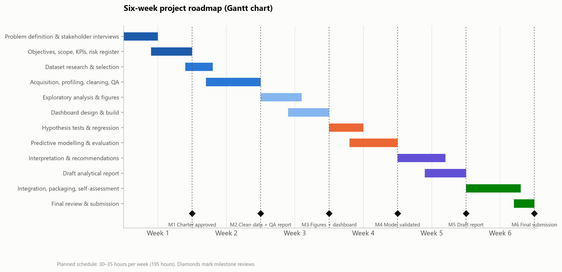
Figure 2. Six-week roadmap
Interpretation. Phases overlap slightly so that, for example, dashboard design starts while exploratory figures are being finalised. Each week ends with a milestone review.
Table 10. Weekly plan with hours, dependencies and milestones
Week | Phase | Main activities | Hours | Dependency | Milestone
1 | Strategic planning | Problem definition, stakeholder interviews, objectives, KPIs, risk register, roadmap | 32 | Supervisor availability | M1 Charter approved
2 | Data acquisition & QA | Source comparison, download, profiling, validation, cleaning, data dictionary | 34 | Dataset access | M2 Clean data + QA report
3 | EDA & visualisation | Descriptive statistics, figures, dashboard build, stakeholder feedback | 34 | Clean data | M3 Figures + dashboard
4 | Statistics & modelling | Hypothesis tests, regression, model training and validation | 35 | EDA findings | M4 Model validated
5 | Interpretation & reporting | Synthesis, recommendations, analytical report | 30 | Weeks 2–4 results | M5 Draft report
6 | Integration & reflection | Integrated report, packaging, self-assessment, final review | 30 | All outputs | M6 Final submission

10.1 Milestone definitions
Table 11. Milestone definitions
ID | Milestone | Completion criteria
M1 | Charter approved | Objectives, scope, KPIs and risks signed off by supervisor
M2 | Clean data + QA report | All validation rules pass; issue log and data dictionary complete
M3 | Figures + dashboard | Every figure interpreted; dashboard reviewed by one non-technical user
M4 | Model validated | Test-set metrics, calibration and subgroup audit reported; beats baseline
M5 | Draft report | All sections drafted; every recommendation traceable to evidence
M6 | Final submission | Integrated report, repository and self-assessment complete; numbers consistent

11. Resource Allocation
Table 12. Effort allocation (planned)
Work package | Hours | Share
Planning and stakeholder work | 32 | 16%
Data acquisition, QA and cleaning | 34 | 17%
Exploration and visualisation | 34 | 17%
Statistics and modelling | 35 | 18%
Interpretation and report writing | 30 | 15%
Integration, review and reflection | 30 | 15%
Total | 195 | 100%

Table 13. Resource plan
Resource | Allocation
People | 1 analyst (intern, ~32 h/week); supervisor (~1 h/week); clinical lead (2–3 h total); data protection officer (1 h)
Computing | Standard laptop (8–16 GB RAM); the full pipeline runs in under 15 minutes
Software | Open-source Python stack; Microsoft Word; optional Power BI Desktop (free)
Data | Public, CC BY 4.0 dataset (no cost); local data only after approval
Budget | No direct cost beyond staff time when open-source tools and public data are used

12. Risk Management and Contingency Planning
Risks are scored as likelihood × impact on 1–3 scales and reviewed at every milestone. High-impact risks have both a preventive mitigation and a contingency to apply if the risk occurs.
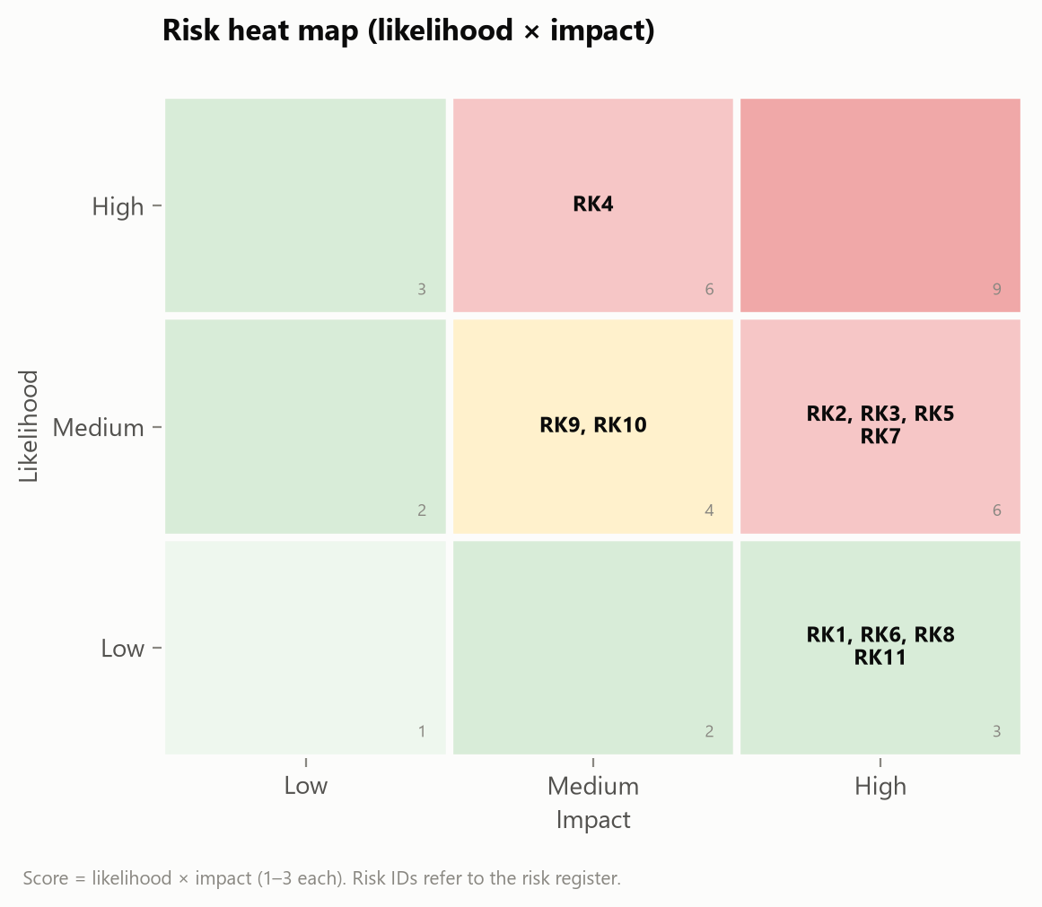
Figure 3. Risk heat map
Table 14. Risk register
ID | Risk | Likelihood (1-3) | Impact (1-3) | Score | Mitigation (preventive) | Contingency (if it occurs) | Owner
RK1 | Chosen dataset becomes inaccessible or licence changes | 1 | 3 | 3 | Download early; keep checksummed raw copy; record licence | Switch to verified alternative (CMS HRRP, hospital-level redesign) | Analyst
RK2 | Data quality too poor for the objectives | 2 | 3 | 6 | Profile in Week 2 before committing to analyses | Narrow scope; drop unusable fields; document | Analyst
RK3 | Target leakage inflates model performance | 2 | 3 | 6 | Exclude outcome-derived fields; pipelines; patient-level split | Re-run with stricter feature set; external review | Analyst / reviewer
RK4 | Repeated encounters violate independence | 3 | 2 | 6 | One index encounter per patient | Grouped cross-validation by patient | Analyst
RK5 | Associations misread as causes | 2 | 3 | 6 | Explicit causal caveats; alternative explanations | Clinical review before dissemination | Analyst / supervisor
RK6 | Model used for individual clinical decisions | 1 | 3 | 3 | 'Educational use' labels; deployment conditions | Withdraw artefact; escalate to governance | Supervisor
RK7 | Bias against patient subgroups | 2 | 3 | 6 | Exclude race/payer as predictors; subgroup audit | Re-weighting or adjusted thresholds after review | Ethics committee
RK8 | Privacy breach or re-identification | 1 | 3 | 3 | Aggregates only; small-cell suppression; no linkage | Incident response; notify data protection officer | Data protection officer
RK9 | Tool unavailable (e.g. Power BI licence) | 2 | 2 | 4 | Open-source alternatives identified in advance | HTML dashboard + Power BI build pack | Analyst
RK10 | Schedule overrun | 2 | 2 | 4 | Weekly milestones; scripted pipeline | Drop optional analyses (extra models) | Intern / supervisor
RK11 | Results not reproducible | 1 | 3 | 3 | Fixed seeds; pinned packages; scripted steps | Re-run from raw; compare checksums | Reviewer

12.1 Contingency triggers
- If the dataset cannot be accessed by the end of week 1 → switch to the next-ranked source and adjust scope.
- If more than 40% of a key variable is missing → exclude it and record the limitation.
- If the model does not beat the baseline → report this honestly and focus recommendations on the statistical findings.
- If a required tool is unavailable → use the documented open-source alternative.

13. Communication Plan
Table 15. Communication plan
Audience | Content | Format / channel | Frequency
Executive leadership | KPI headline, recommendations | One-page brief + dashboard link | Monthly
Quality committee | Findings, limitations, evidence | Presentation + report | Each milestone
Clinical teams | Risk factors, pilot design | Ward meeting, worklist mock-up | Weeks 3 and 5
Supervisor | Progress, risks, decisions | Weekly status note | Weekly
Patients | Plain-language summary | Patient advisory group | End of project

14. Quality and Success Criteria
- Reproducibility: the full analysis can be regenerated from the raw download with one command.
- Validity: no data leakage; test data used once; assumptions checked.
- Transparency: every number in the report traceable to code output.
- Usefulness: stakeholders can name at least one action they would take from the findings.
- Ethics: privacy controls applied; model limitations stated; no individual decisions from the model.

15. Conclusion
This plan turns a broad aim — reduce diabetic readmissions — into a sequence of concrete, checkable steps with named owners, measurable objectives, a realistic six-week roadmap and explicit controls for the main risks. Because each step has acceptance criteria and a contingency, a reader can follow the plan without additional material.

References
Centers for Medicare & Medicaid Services. (2026). Hospital Readmissions Reduction Program [Data set]. Provider Data Catalog. https://data.cms.gov/provider-data/dataset/9n3s-kdb3
Clore, J., Cios, K., DeShazo, J., & Strack, B. (2014). Diabetes 130-US hospitals for years 1999–2008 [Data set]. UCI Machine Learning Repository. https://doi.org/10.24432/C5230J
Jack, B. W., Chetty, V. K., Anthony, D., Greenwald, J. L., Sanchez, G. M., Johnson, A. E., Forsythe, S. R., O'Donnell, J. K., Paasche-Orlow, M. K., Manasseh, C., Martin, S., & Culpepper, L. (2009). A reengineered hospital discharge program to decrease rehospitalization: A randomized trial. Annals of Internal Medicine, 150(3), 178–187. https://doi.org/10.7326/0003-4819-150-3-200902030-00007
Jencks, S. F., Williams, M. V., & Coleman, E. A. (2009). Rehospitalizations among patients in the Medicare fee-for-service program. New England Journal of Medicine, 360(14), 1418–1428. https://doi.org/10.1056/NEJMsa0803563
Kahn, M. G., Callahan, T. J., Barnard, J., Bauck, A. E., Brown, J., Davidson, B. N., Estiri, H., Goerg, C., Holve, E., Johnson, S. G., Liaw, S.-T., Hamilton-Lopez, M., Meeker, D., Ong, T. C., Ryan, P., Shang, N., Weiskopf, N. G., Weng, C., Zozus, M. N., & Schilling, L. (2016). A harmonized data quality assessment terminology and framework for the secondary use of electronic health record data. eGEMs, 4(1), 1244. https://doi.org/10.13063/2327-9214.1244
Leppin, A. L., Gionfriddo, M. R., Kessler, M., Brito, J. P., Mair, F. S., Gallacher, K., Wang, Z., Erwin, P. J., Sylvester, T., Boehmer, K., Ting, H. H., Murad, M. H., Shippee, N. D., & Montori, V. M. (2014). Preventing 30-day hospital readmissions: A systematic review and meta-analysis of randomized trials. JAMA Internal Medicine, 174(7), 1095–1107. https://doi.org/10.1001/jamainternmed.2014.1608
McKinney, W. (2010). Data structures for statistical computing in Python. In S. van der Walt & J. Millman (Eds.), Proceedings of the 9th Python in Science Conference (pp. 56–61). https://doi.org/10.25080/Majora-92bf1922-00a
Ministry of Electronics and Information Technology. (2025). Digital Personal Data Protection Rules, 2025 (notified 14 November 2025). Government of India. https://www.meity.gov.in/
Naylor, M. D., Brooten, D., Campbell, R., Jacobsen, B. S., Mezey, M. D., Pauly, M. V., & Schwartz, J. S. (1999). Comprehensive discharge planning and home follow-up of hospitalized elders: A randomized clinical trial. JAMA, 281(7), 613–620. https://doi.org/10.1001/jama.281.7.613
Pedregosa, F., Varoquaux, G., Gramfort, A., Michel, V., Thirion, B., Grisel, O., Blondel, M., Prettenhofer, P., Weiss, R., Dubourg, V., Vanderplas, J., Passos, A., Cournapeau, D., Brucher, M., Perrot, M., & Duchesnay, É. (2011). Scikit-learn: Machine learning in Python. Journal of Machine Learning Research, 12, 2825–2830.
Raghupathi, W., & Raghupathi, V. (2014). Big data analytics in healthcare: Promise and potential. Health Information Science and Systems, 2, 3. https://doi.org/10.1186/2047-2501-2-3
Strack, B., DeShazo, J. P., Gennings, C., Olmo, J. L., Ventura, S., Cios, K. J., & Clore, J. N. (2014). Impact of HbA1c measurement on hospital readmission rates: Analysis of 70,000 clinical database patient records. BioMed Research International, 2014, 781670. https://doi.org/10.1155/2014/781670
U.S. Department of Health and Human Services. (2012). Guidance regarding methods for de-identification of protected health information in accordance with the Health Insurance Portability and Accountability Act (HIPAA) Privacy Rule. https://www.hhs.gov/hipaa/for-professionals/special-topics/de-identification/index.html
Weiskopf, N. G., & Weng, C. (2013). Methods and dimensions of electronic health record data quality assessment: Enabling reuse for clinical research. Journal of the American Medical Informatics Association, 20(1), 144–151. https://doi.org/10.1136/amiajnl-2011-000681
Wirth, R., & Hipp, J. (2000). CRISP-DM: Towards a standard process model for data mining. In Proceedings of the 4th International Conference on the Practical Applications of Knowledge Discovery and Data Mining (pp. 29–39).

