SIX-WEEK HEALTHCARE DATA ANALYTICS INTERNSHIP · WEEK 3 SUBMISSION
Data Visualisation and Insights Communication Plan
Turning healthcare data into decisions for non-technical stakeholders

Project: 30-day readmission and resource use among diabetic inpatients in 130 US hospitals (UCI Diabetes 130-US Hospitals dataset, 1999–2008)

Prepared by: Juluru Akshay
Internship organisation: Yuva
Date: 24 October 2026
Project repository: https://github.com/AJ1206/healthcare-readmission-analytics

Contents
1. Executive Summary 3
2. Audiences and Their Needs (User-Centred Design) 4
3. Key Metrics to Visualise 5
4. Tool Selection and Justification 6
5. From Raw Data to Visual: Process 7
5.1 Design and accessibility standards 7
6. Mock-ups and Wireframes 8
6.1 Implemented dashboard 10
7. Visualisations and the Decisions They Support 11
8. Communicating with Non-Technical Stakeholders 14
9. Evaluating the Visualisations 14
References 15

This plan defines what to visualise, for whom, with which tools and how. Mock-ups (wireframes) show the intended designs; the charts in Section 7 are real outputs produced when the plan was executed.

1. Executive Summary
Data only improves care when the people who make decisions understand it. This plan identifies the healthcare metrics that matter to four audiences, selects tools for each purpose, describes a repeatable process for turning raw records into accurate visuals, and provides three dashboard and report mock-ups. Design follows evidence on graphical perception (Cleveland & McGill, 1984), clarity (Tufte, 2001), narrative structure (Knaflic, 2015) and accessibility standards (W3C, 2023). Every visual is tied to a specific decision it supports.

2. Audiences and Their Needs (User-Centred Design)
Table 1. Audience personas
Persona | Key question | Context | What they need to see
Hospital executive | Are we improving? Where should we invest? | 5 minutes, monthly | Headline KPIs, trend vs target, top 3 messages
Discharge planner / case manager | Which of today's patients need extra support? | Daily, on the ward | Worklist with plain-language reasons and checklist
Quality committee | What drives readmissions? Is the evidence solid? | Quarterly, detailed | Rates with confidence intervals, adjusted results, data-quality status
Clinician (diabetes team) | Is HbA1c testing consistent? | Monthly | Testing rate by diagnosis and ward

Design principle: start from the decision, not the data. Each persona's key question defines the first thing they see; detail is available on demand (filters, tooltips, data tables).

3. Key Metrics to Visualise
Table 2. Metrics and visual encodings
Metric | Why it matters | Recommended visual | Audience
30-day readmission rate | Core quality outcome | KPI card with 95% CI; line chart over time | All
Rate by discharge destination | Identifies where transition support is needed | Sorted horizontal bars with CIs | Quality, case managers
Rate by prior admissions | Simple risk-stratification signal | Ordered bars (0, 1, 2, 3+) | Case managers
Rate by age and diagnosis | Targets clinical pathways | Bars / small multiples | Quality committee
Length of stay distribution | Resource use, outliers | Histogram; box plot by diagnosis | Executives, bed managers
Bed-day share by diagnosis | Where capacity goes | Sorted bars | Executives
HbA1c testing rate | Care-process gap | Bars by diagnosis; trend | Diabetes team
Data completeness | Trust in the numbers | Traffic-light list with text labels | Quality, HIM
Model risk deciles | Whether a risk score separates patients | Bars of observed rate by decile | Quality, analytics

4. Tool Selection and Justification
Table 3. Tool comparison
Tool | Strengths | Limitations | Role in this plan
Power BI | Interactive dashboards, DAX measures, row-level security, widely used in hospitals | Licence for sharing; Windows desktop authoring | Primary production dashboard
Tableau | Strong visual exploration | Licence cost | Alternative if already licensed
Python (Matplotlib, seaborn) | Exact control, reproducible, publication quality | Static; needs coding | Report figures
HTML + JavaScript | Runs offline in any browser; no licence | Development effort | Portable dashboard (delivered)
Excel | Familiar to all staff | Error-prone for complex logic; weak interactivity | Ad-hoc tables only

Choice: Python for the analytical figures (reproducible from code), a self-contained HTML dashboard for immediate use without licences, and a Power BI build pack (star-schema data model and DAX measures) for organisations that standardise on Power BI.

5. From Raw Data to Visual: Process
1. Start from the quality-assured analysis cohort (never from raw data).
2. Aggregate to the level of the decision (e.g. rate per discharge group).
3. Compute uncertainty: 95% Wilson confidence intervals for every rate (Wilson, 1927).
4. Suppress groups with fewer than 30 patients (privacy and stability).
5. Choose the encoding by the question: position and length are read most accurately (Cleveland & McGill, 1984).
6. Apply the design system: one colour per series, colour-blind-safe palette, no dual axes.
7. Write a title that states the finding and an interpretation sentence.
8. Validate: check every number against the source table; test with one target user.
9. Publish with method notes and a data-table alternative.

5.1 Design and accessibility standards
Table 4. Design and accessibility standards
Aspect | Standard
Colour | Colour-vision-deficiency-safe palette; never rely on colour alone (add labels or icons)
Contrast | Text contrast at least 4.5:1 (WCAG 2.2)
Alternatives | Every chart has a data table and alt text
Keyboard and screen readers | Filters usable by keyboard; charts labelled for assistive technology
Language | Plain-language titles; avoid jargon such as 'AUC' on executive views
Uncertainty | Show confidence intervals; grey out small groups
Integrity | Zero-based bars; no 3-D; no dual axes; consistent scales between periods

6. Mock-ups and Wireframes
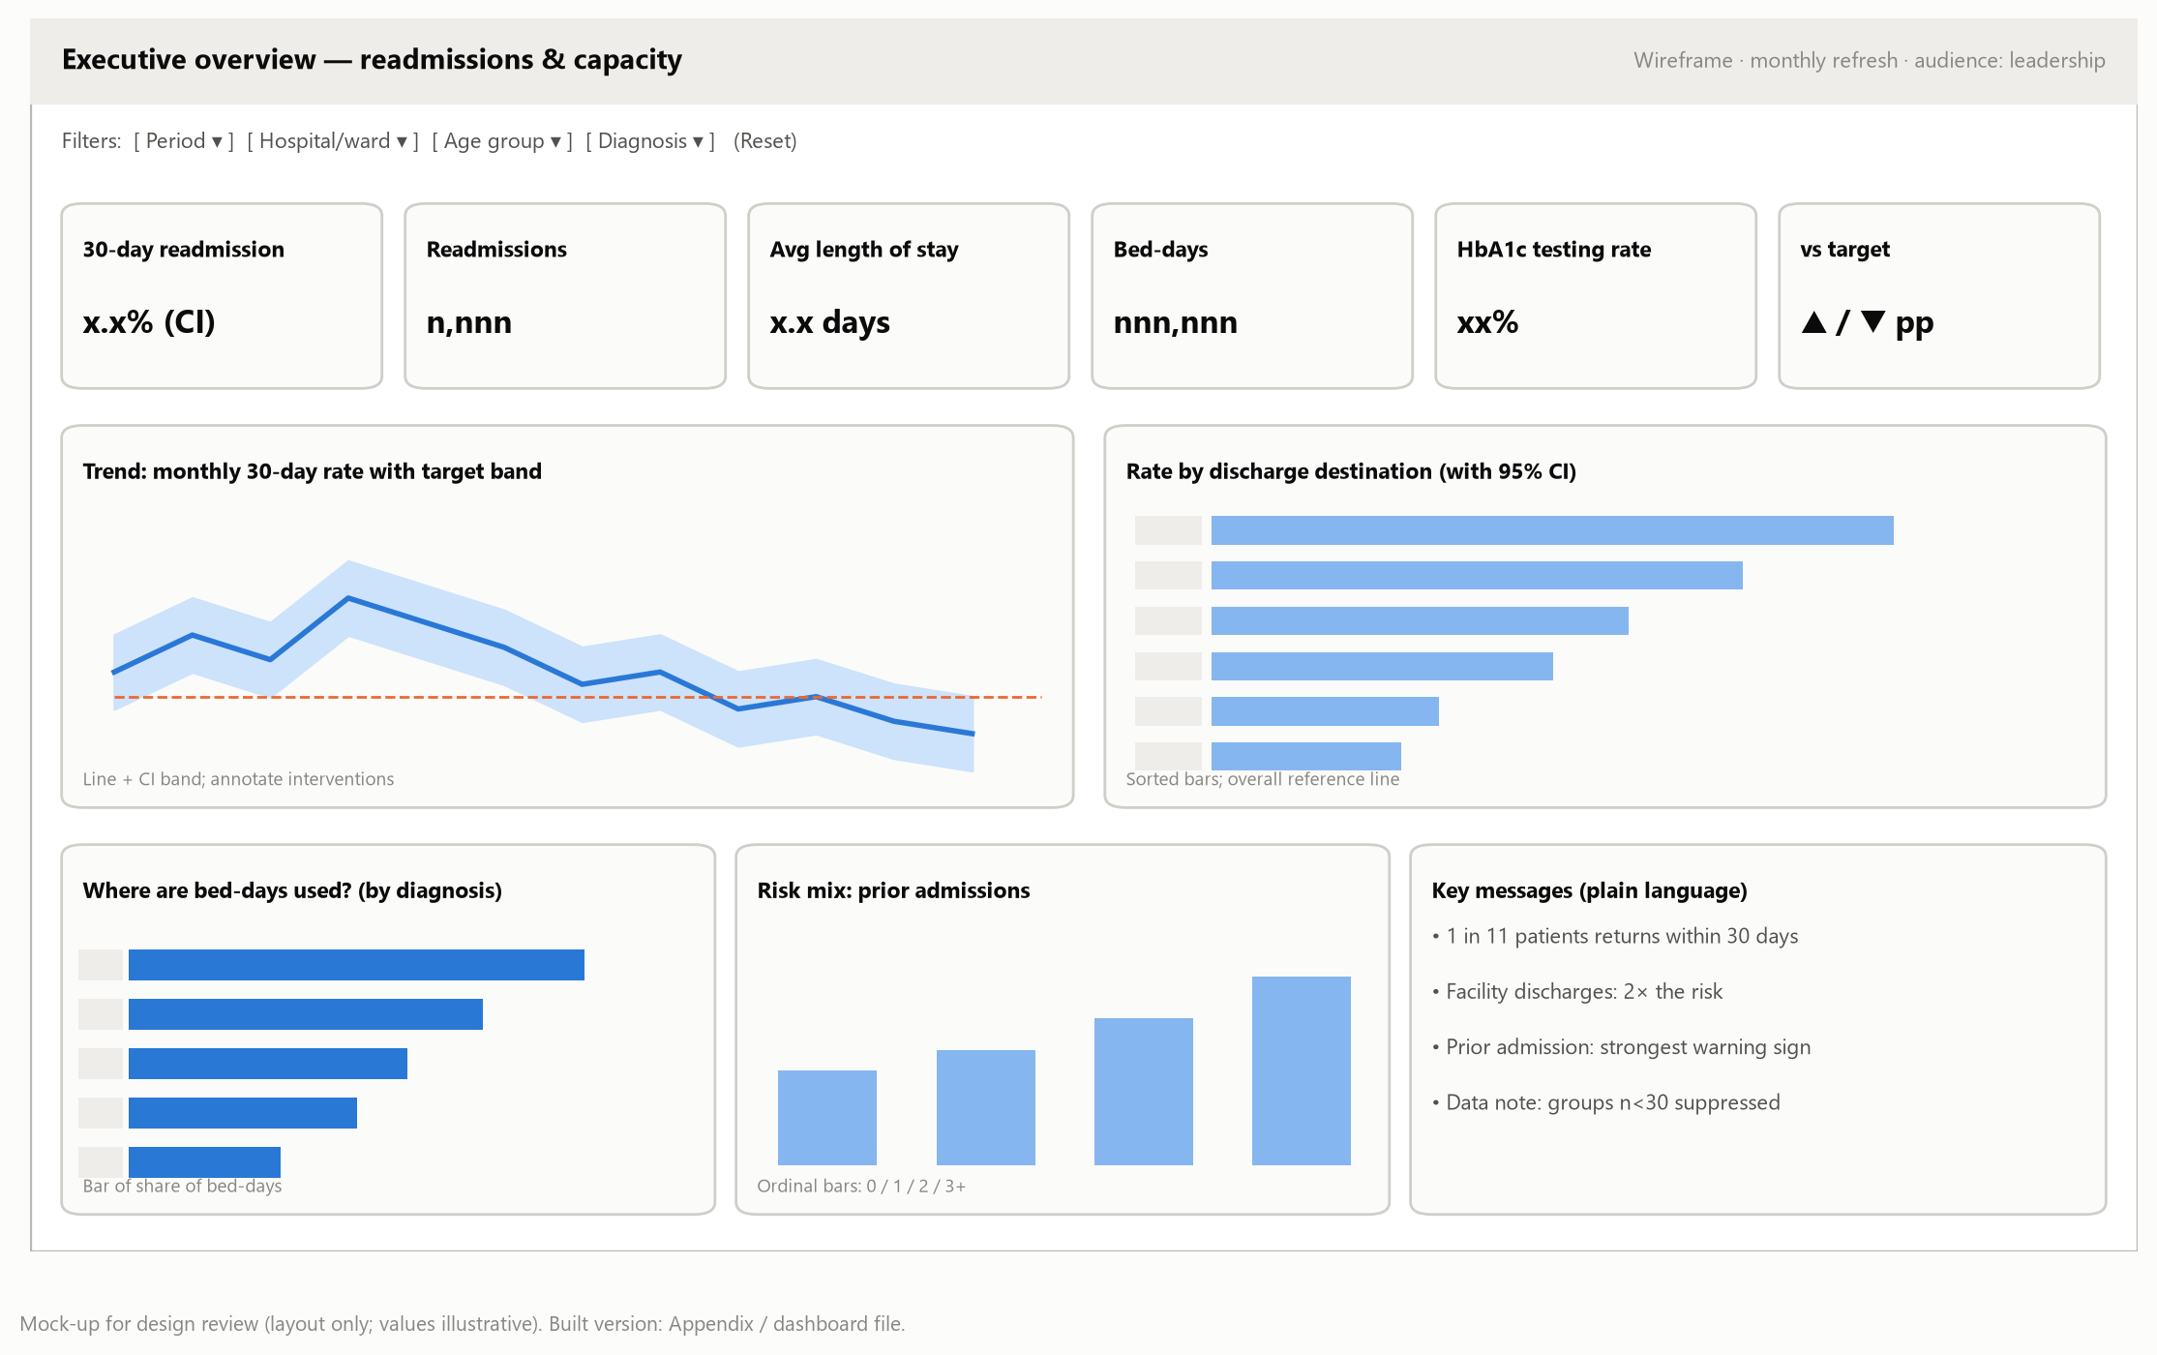
Figure 1. Wireframe: executive overview dashboard
Interpretation. Answers 'are we improving and where should we act?' in under five minutes: KPI cards on top, trend against target, the main driver (discharge destination) and plain-language key messages.
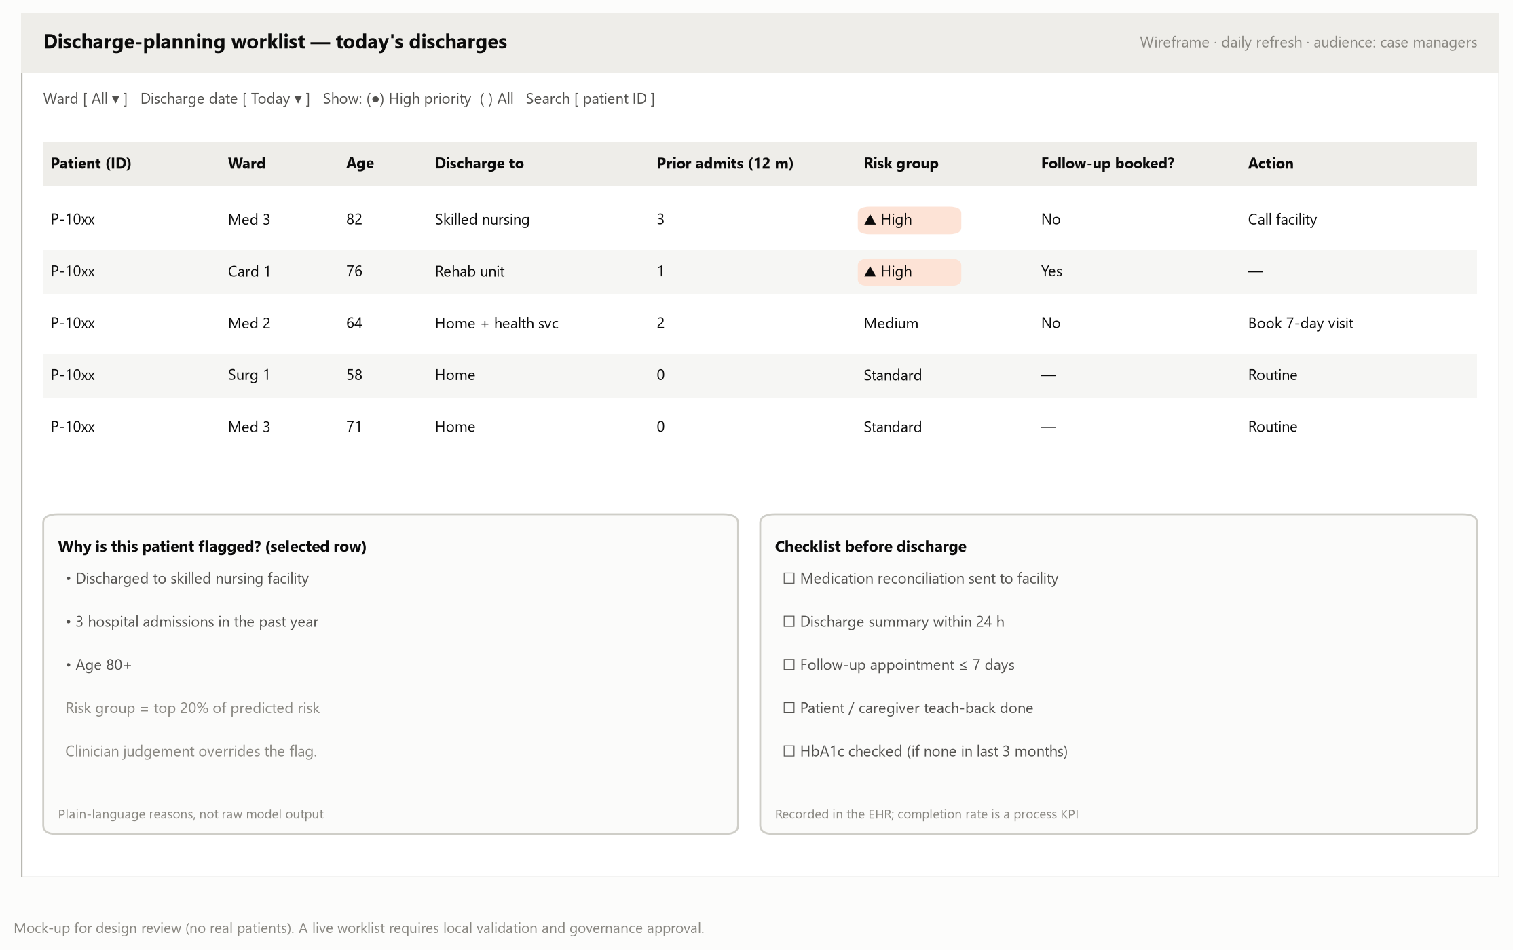
Figure 2. Wireframe: discharge-planning worklist
Interpretation. Turns analysis into daily action: patients ranked into priority groups, with reasons in plain language and a discharge checklist. Clinician judgement always overrides the flag.
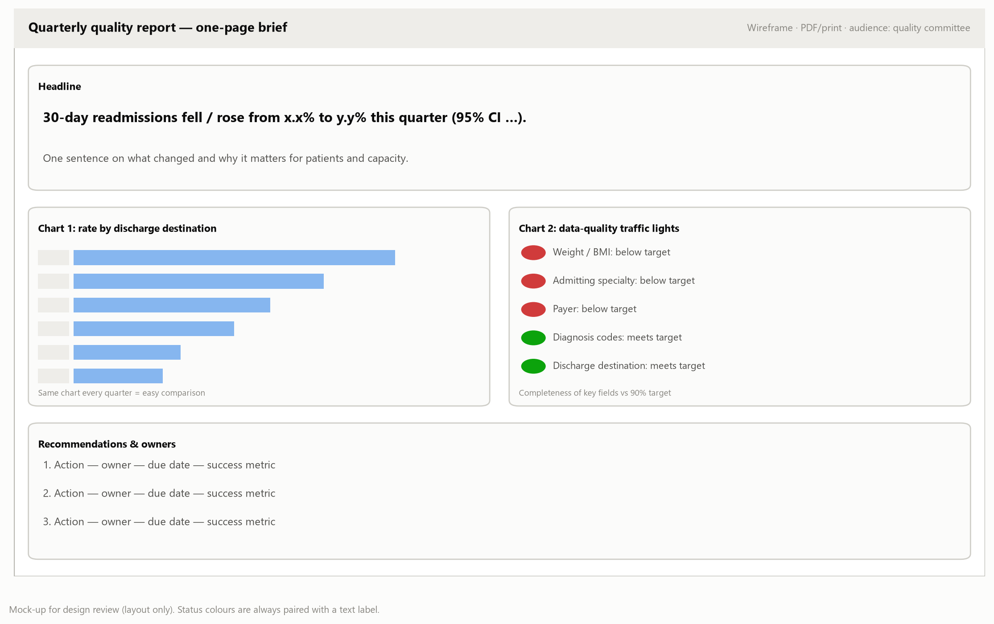
Figure 3. Wireframe: quarterly one-page quality brief
Interpretation. A printable page with a headline sentence, two consistent charts, a data-quality traffic light (with text labels) and owned actions.

6.1 Implemented dashboard
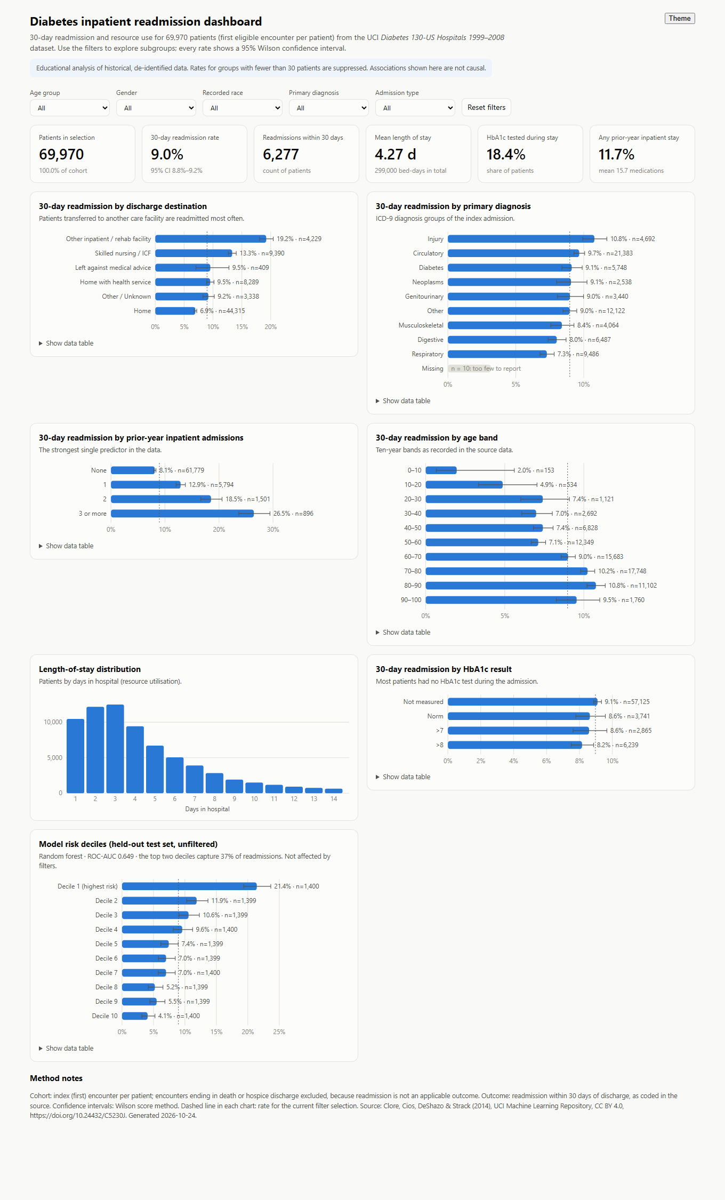
Figure 4. Implemented interactive dashboard (desktop view)
Interpretation. The executed version includes five filters, six KPI cards with confidence intervals, six charts with tooltips and data tables, and automatic suppression of small groups.

7. Visualisations and the Decisions They Support
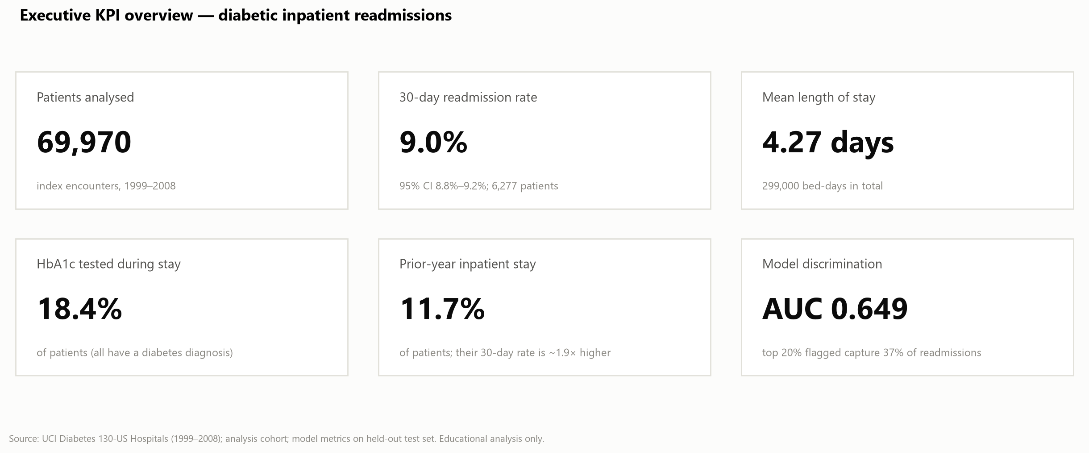
Figure 5. Executive KPI overview
Interpretation. Sets the baseline: 9.0% of patients readmitted within 30 days; supports target setting.
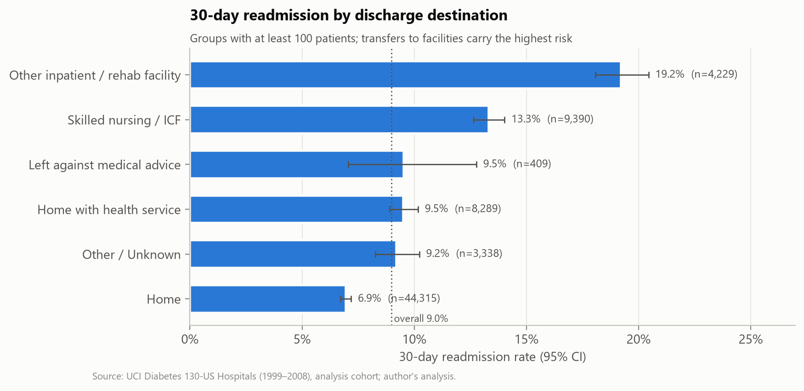
Figure 6. Readmission by discharge destination
Interpretation. Problem identified: facility discharges are readmitted at 15.2% vs 7.5%. Decision: prioritise facility hand-offs.
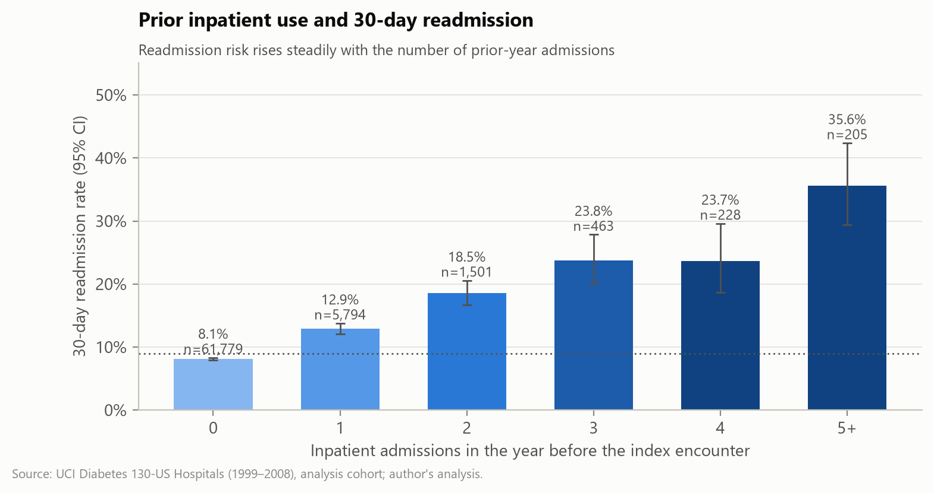
Figure 7. Readmission by prior admissions
Interpretation. Problem identified: a steep risk gradient. Decision: flag patients with prior admissions for early discharge planning.
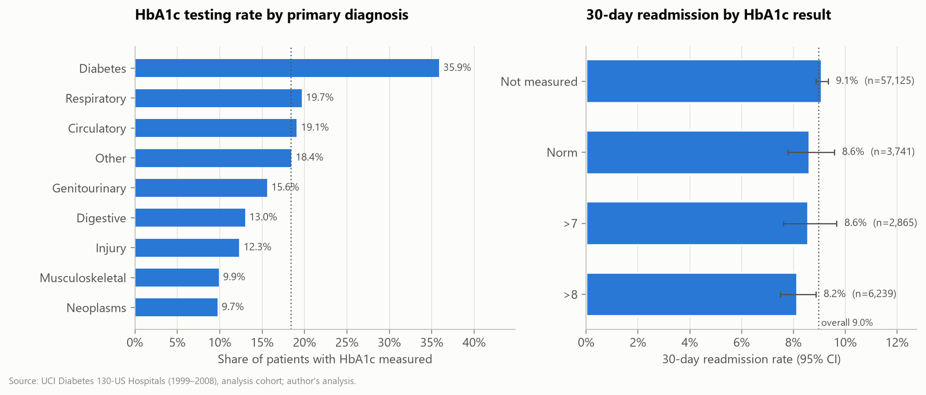
Figure 8. HbA1c testing and readmission
Interpretation. Problem identified: only 18.4% tested. Decision: audit and pilot consistent testing.
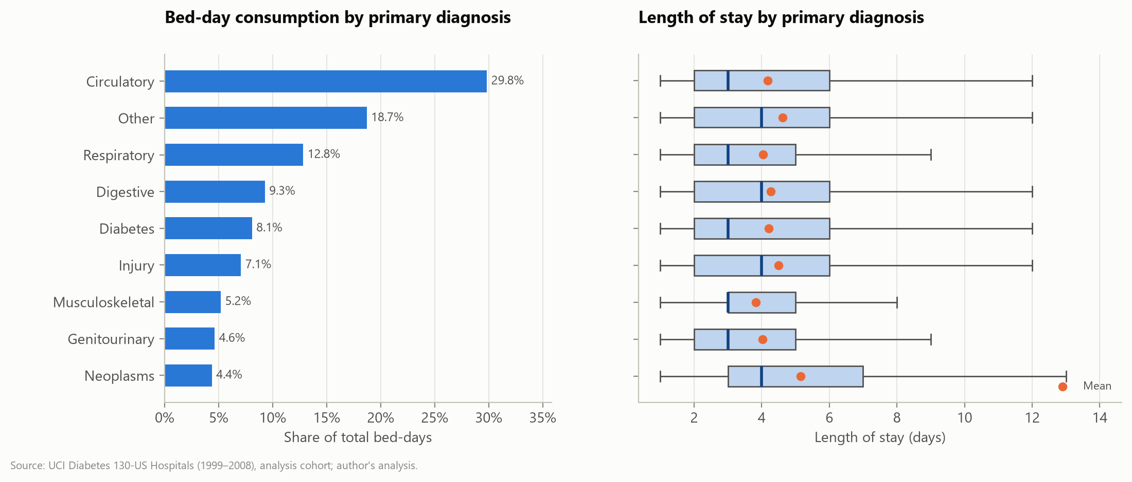
Figure 9. Bed-day consumption by diagnosis
Interpretation. Supports capacity planning: circulatory conditions use the most bed-days.
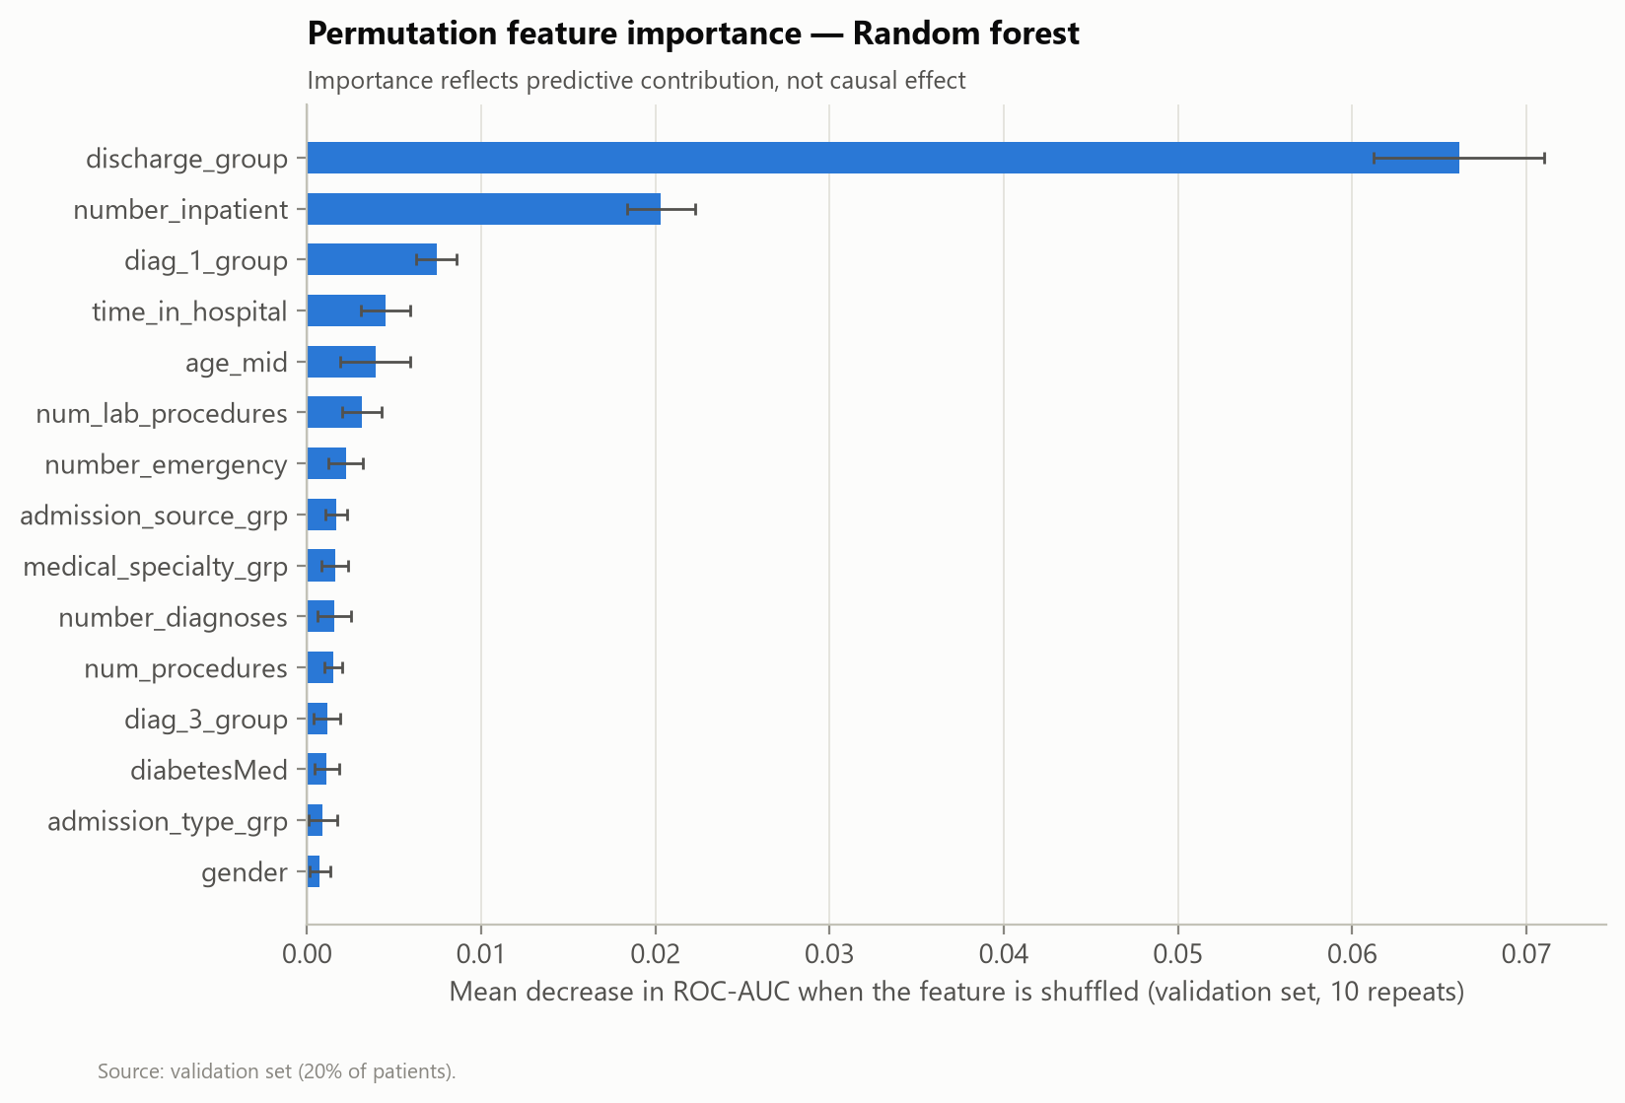
Figure 10. What the risk model relies on
Interpretation. Builds trust: clinicians can see the model uses clinically sensible signals.

8. Communicating with Non-Technical Stakeholders
- Lead with the answer: a headline sentence before any chart (e.g. 'One in eleven patients returns within 30 days').
- Use a story arc: context → problem → evidence → recommended action → expected benefit (Knaflic, 2015).
- Translate statistics: 'about twice the risk' rather than 'RR 2.03 (95% CI 1.93–2.13)'; keep exact numbers in the appendix.
- Show uncertainty simply: error bars plus a sentence such as 'the true value is very likely between x and y'.
- Be explicit about limits: associations, not causes; old data; model not for individual decisions.
- Close the loop: every dashboard page names an owner and an action.
Table 5. Communication products
Product | Format | Cadence
Executive brief | One page + dashboard link | Monthly
Quality committee pack | Report + live dashboard walk-through | Quarterly
Ward huddle | Worklist + 3 key messages | Weekly
Patient advisory group | Plain-language summary | Twice yearly

9. Evaluating the Visualisations
- Usability test with one user per persona: can they state the main finding in 30 seconds?
- Accuracy check: every displayed number reconciles with the analysis tables.
- Accessibility check: contrast, keyboard use, screen-reader labels, colour-blind simulation.
- Adoption metrics: dashboard visits, actions logged from the worklist, feedback scores.

References
Cleveland, W. S., & McGill, R. (1984). Graphical perception: Theory, experimentation, and application to the development of graphical methods. Journal of the American Statistical Association, 79(387), 531–554. https://doi.org/10.1080/01621459.1984.10478080
Clore, J., Cios, K., DeShazo, J., & Strack, B. (2014). Diabetes 130-US hospitals for years 1999–2008 [Data set]. UCI Machine Learning Repository. https://doi.org/10.24432/C5230J
Knaflic, C. N. (2015). Storytelling with data: A data visualization guide for business professionals. Wiley.
Strack, B., DeShazo, J. P., Gennings, C., Olmo, J. L., Ventura, S., Cios, K. J., & Clore, J. N. (2014). Impact of HbA1c measurement on hospital readmission rates: Analysis of 70,000 clinical database patient records. BioMed Research International, 2014, 781670. https://doi.org/10.1155/2014/781670
Tufte, E. R. (2001). The visual display of quantitative information (2nd ed.). Graphics Press.
Wilson, E. B. (1927). Probable inference, the law of succession, and statistical inference. Journal of the American Statistical Association, 22(158), 209–212. https://doi.org/10.1080/01621459.1927.10502953
World Wide Web Consortium. (2023). Web Content Accessibility Guidelines (WCAG) 2.2 (W3C Recommendation). https://www.w3.org/TR/WCAG22/

