Abstract
MediCare is a comprehensive, production-grade web application developed as an internship project at Hindalco Industries Limited. It addresses the common challenge of patient scheduling bottlenecks and long waiting times at healthcare facilities. The system is built on a 3-Tier Layered Architecture using Spring Boot 4.0, Java 21, and PostgreSQL 15 on the backend, paired with a modern, responsive HTML5/CSS3/JS frontend. Key features include an asynchronous SMTP email notification pipeline (for bookings, login alerts, and reschedule notifications), a physician-directed reschedule dashboard, and a dynamic live queue status card that polls every 5 seconds. To guide patient routing, the platform employs two core AI modules: an NLP-based symptom triage assistant that recommends specializations and a queue length-aware wait-time prediction algorithm. This project adheres to rigorous software engineering standards, including 3NF database normalization, Single Responsibility principles, robust Exception handling, and credential safety practices (gitignore and classpath separation).

Index (Table of Contents)
1. Executive Summary ............................................................................................ 4
2. Technical Stack & Justifications ................................................................................ 4
3. System Architecture & Use Case ................................................................................... 5
4. Initial Scope & Requirements (SRS) .............................................................................. 6
5. Security & Secret Management (SMTP Safe-Guards) ............................................................. 7
6. AI Feature & Triage Algorithms ................................................................................... 7
7. Database Schema Design (3NF) .................................................................................... 8
8. System Walkthrough & Screenshots .............................................................................. 9
9. Software Engineering Best Practices ........................................................................... 11
10. Conclusion .................................................................................................... 11

AI-Assisted Medical Appointment and Queue Management System
Institution: Hindalco Industries Limited (Internship Project)
Author: Ajitesh Sharma
Duration: 2026-06-01 to 2026-06-21
Repository: Appointment-system

1. Executive Summary
MediCare is a production-grade full-stack web platform designed to solve patient scheduling congestion, consultation bottlenecks, and long clinic wait times. Developed as a major project during a Hindalco Industries internship, the platform allows patients to register, search for medical specialists, book appointments, receive real-time queue tokens, and track their estimated wait times dynamically.

Key Enhancements & New Features:
- Asynchronous Email Notification Pipeline: Automatic confirmation messages are sent on booking, security alerts are sent on successful logins (Patients, Doctors, and Admins), and update notifications are sent on scheduling adjustments.
- Doctor Rescheduling Facility: Built-in slot management for doctors to rearrange patient appointments dynamically based on availability.
- Automated Dashboard Live Queue Tracking: The patient dashboard now has a prominent "Live Queue Status" card on the main Overview page that updates every 5 seconds, eliminating manual lookup forms.

2. Technical Stack & Justifications
The application is built on modern web engineering standards chosen for speed, decoupling, and high scalability:
- Presentation Tier: HTML5, CSS3 Custom Properties, and Vanilla JS.
- Justification: By avoiding heavy JS frameworks (like React or Angular), we achieved a zero-build-step frontend that loads instantaneously. Vanilla CSS variables (CSS Custom Properties) provide an elegant, cohesive dark-mode design system with smooth CSS micro-animations. Google Fonts (Inter) provides clean typography.
- Application Tier: Spring Boot 4.0, Java 21, Spring Data JPA, JavaMailSender.
- Justification: Java 21 brings modern concurrency features. Spring Boot offers a robust, 3-tier layering separating REST Controllers, Service logic, and JPA Repositories. JavaMailSender facilitates quick integration with SMTP services, and Spring DevTools speeds up code updates.
- Persistent Storage: PostgreSQL 15.
- Justification: A robust, ACID-compliant relational database. PostgreSQL efficiently manages 3NF relations between tables (specializations, doctors, appointments, queue positions) and ensures referential integrity via foreign key constraints.

3. System Architecture & Use Case
The application follows a clean 3-Tier Layered Architecture separating presentation, business logic, and persistent storage layers:

Layered Architecture Diagram
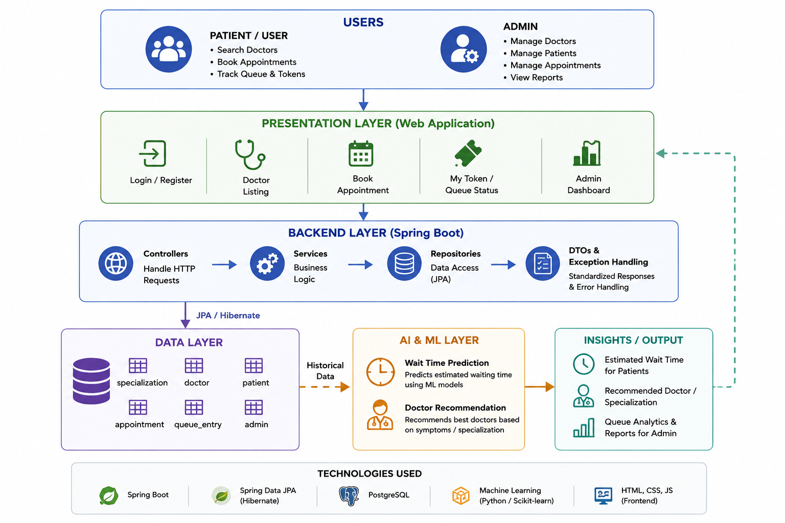
Figure: System Architecture

System Use Case Diagram
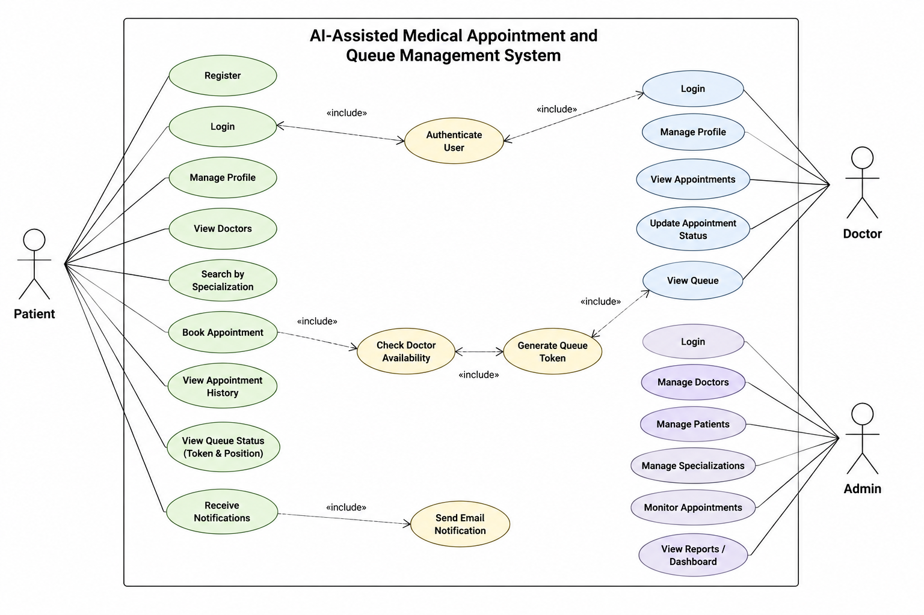
Figure: System Use Case
graph TD
subgraph Presentation Tier
A[HTML5 / CSS3 / Vanilla JS]
end
subgraph Application Tier
B[Spring Boot Controller] --> C[Spring Boot Service]
end
subgraph Persistent Storage
C --> D[(PostgreSQL Database)]
end

4. Initial Scope & Requirements (SRS)

4.1 In-Scope Features
- Patient Module: Registration, login, profile management, view doctors/specializations, book consultations, and view queue token information.
- Doctor Module: Login, profile dashboard, view assigned appointments, update appointment status, and view patient queue statistics.
- Admin Module: Manage doctor profiles, patient accounts, clinical specializations, system-wide analytics, and live queue overviews.
- Triage & Queue System: Active queue token numbers, live position counters, and dynamic wait-time indicators.

4.2 Out-of-Scope Features
- Online payment processing gateways.
- In-app telemedicine video consultation rooms.
- Electronic Health Record (EHR) management.
- Insurance claim processing integrations.

4.3 Functional Requirements (FR)
- User Management:
- FR-1: Allow patients to register an account.
- FR-2: Allow patients to log in and out securely.
- FR-3: Allow doctors to log in and access their dashboard.
- FR-4: Allow administrators to log in and access administrative tools.
- Patient Management:
- FR-5: Patients view/update profile information.
- FR-6: Patients browse doctors by clinical specialization.
- FR-7: Patients view individual doctor details.
- Appointment Management:
- FR-8: Patients book appointments with available doctors.
- FR-9: Patients cancel appointments.
- FR-10: System stores appointment details in the database.
- FR-11: Doctors view their scheduled appointments.
- FR-12: Doctors update appointment status.
- Queue Management:
- FR-13: System auto-generates a unique queue token for each appointment.
- FR-14: System maintains order of patients in the queue.
- FR-15: Patients view their queue position.
- FR-16: System calculates estimated waiting times.
- Administration:
- FR-17: Admins add, update, and remove doctor records.
- FR-18: Admins manage specializations.
- FR-19: Admins monitor appointments.
- Notification Management:
- FR-20: System sends email confirmations after booking.
- FR-21: System sends appointment status notifications.

4.4 Non-Functional Requirements (NFR)
- Performance:
- NFR-1: Response time under 3 seconds.
- NFR-2: Support multiple concurrent users.
- Security:
- NFR-3: User passwords stored with SHA-256 secure hashing.
- NFR-4: Only authenticated users access protected resources.
- NFR-5: Role-based authorization implemented.
- Reliability & Consistency:
- NFR-6: Data consistency maintained.
- NFR-7: Appointment info persistent, no lost transactions.
- Availability:
- NFR-8: Available 24/7 except scheduled maintenance.
- Usability & Maintainability:
- NFR-9: Provide user-friendly, responsive interface.
- NFR-10: Support modern web browsers (Chrome, Safari, Firefox).
- NFR-11: Follow modular architecture for future enhancements.
- NFR-12: Git version control for code changes.
- Scalability:
- NFR-13: Support future integration of AI wait time prediction and doctor recommendation algorithms.

5. Security & Secret Management (SMTP Safe-Guards)
To comply with professional software engineering safety practices, SMTP credentials are not hardcoded or checked into Git:
- Ignored Configuration File: Created a classpath resource application-secret.properties to house the username and SMTP password.
- Properties Import: Added a dynamic configuration import rule inside application.properties:
spring.config.import=optional:classpath:application-secret.properties
- Git Ignore Rule: The pattern **/application-secret.properties is appended to .gitignore, preventing credentials from being staged.
- Git Purge: Used soft resets to clear previous credential-bearing commits from version history, completing a force push to scrub history logs completely.

6. AI Feature & Triage Algorithms

6.1 Wait Time Prediction
- Location: QueueService.predictWaitTime(doctorId)
- Algorithm Description: Wait times are calculated using doctor-specific average consultation times, current waiting list length, and a dynamic load coefficient adjusting for queue congestion:
$$\text{Predicted Wait Time} = \text{Queue Length} \times \text{Average Consult Duration} \times \text{Load Factor}$$
Where:
- Queue Length: Count of waiting entries for the doctor on that date.
- Average Consult Duration: Default 15 minutes (configurable per doctor).
- Load Factor:
- $1.0$ (when Queue Length $\le 5$)
- $1.1$ (when Queue Length $\le 10$)
- $1.2$ (when Queue Length $> 10$, modelling delay overheads)

6.2 NLP Triage & Specialty Recommender
- Location: DoctorService.runTriageAnalysis(symptoms)
- Algorithm Description: Regular expression keyword mapping matches patient-described symptoms directly to corresponding specialties and priority levels:
:--- | :--- | :--- | :---
chest, heart, cardiac, palpitation | Cardiology | High | Immediate specialist booking
seizure, stroke, headache, neuro | Neurology | High / Medium | Book neurological consultation
fracture, broken bone, ortho, joint | Orthopedics | High / Medium | Orthopedic consultation soon
skin, rash, acne, derma | Dermatology | Low | Schedule standard appointment
child, infant, pediatric | Pediatrics | Medium | Schedule pediatric appointment
eye, vision, ophthal | Ophthalmology | Medium | Standard vision exam
teeth, dental, tooth | Dentistry | Medium | Dental appointment
stomach, gastro, digestion | Gastroenterology | Medium | Digestive checkup
kidney, bladder, urology | Urology | Medium | Urology consult
No Match / General Symptoms | General Medicine | Low | Primary care consultation

7. Database Schema Design (3NF)
All PostgreSQL tables are fully normalized to the Third Normal Form (3NF) to eliminate transitive dependencies and update anomalies:

Entity-Relationship Diagram (ERD)
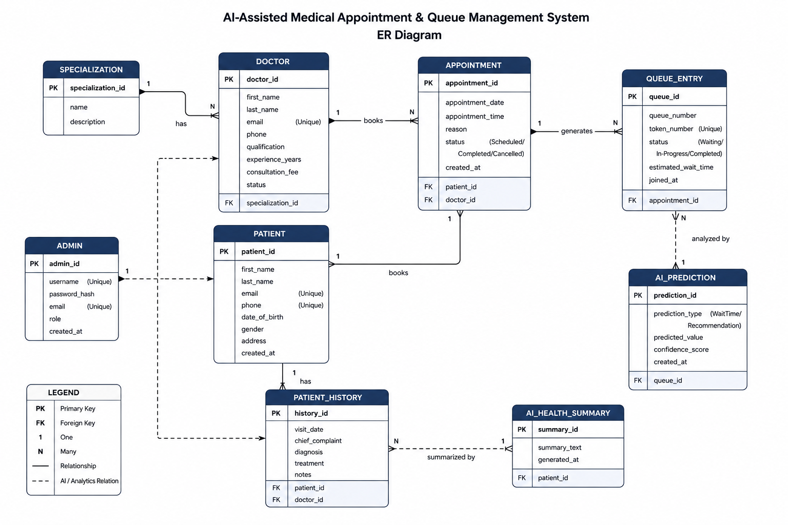
Figure: Entity-Relationship Diagram
specialization (1) ─── (N) doctor
patient (1) ─── (N) appointment
doctor (1) ─── (N) appointment
appointment (1) ─── (1) queue_entry
doctor (1) ─── (N) doctor_availability

Table Dictionary:
- specialization: List of clinical specialties.
- doctor: Healthcare provider details.
- patient: Registered patient profile data.
- admin: Administrative dashboard user.
- appointment: Booking transactions, diagnosis notes, and triage flags.
- queue_entry: Live queue positions, wait predictions, and status.
- doctor_availability: Doctor time slot configurations.

8. System Walkthrough & Screenshots

8.1 Landing Page (index.html)
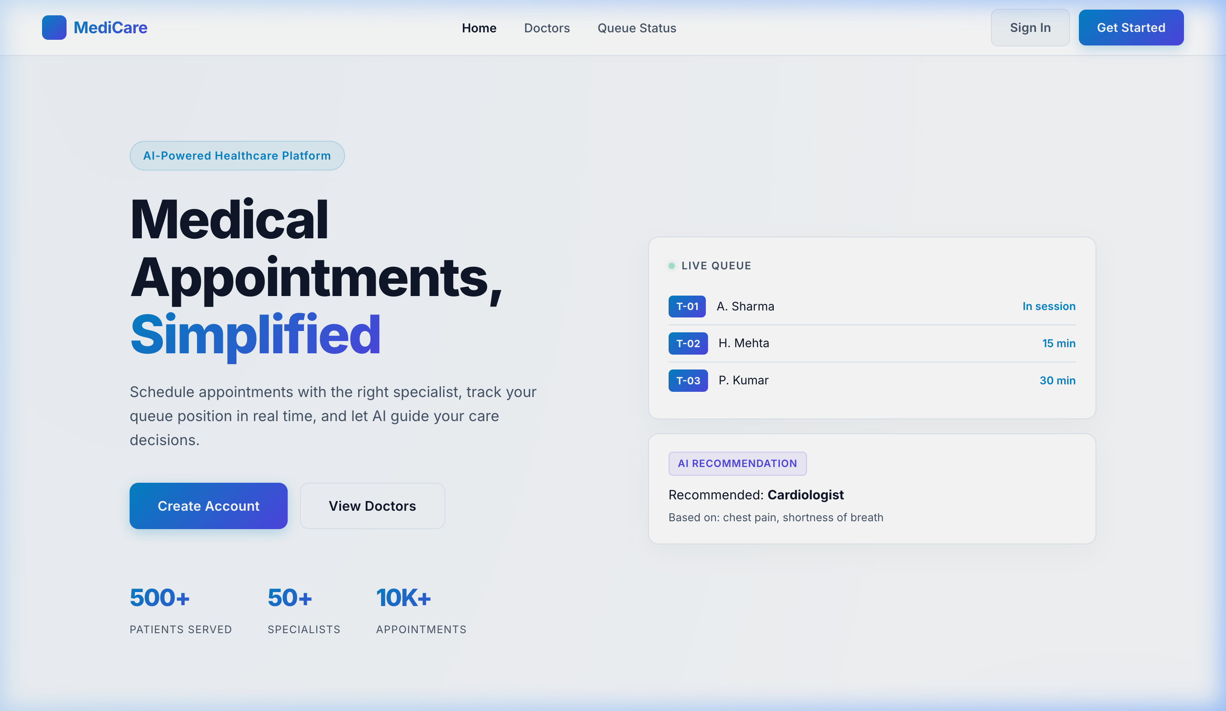
Figure: Landing Page
Medicare landing page showing system benefits, live statistic mockups, and symptom search recommendations.

8.2 Patient Registration (register.html)
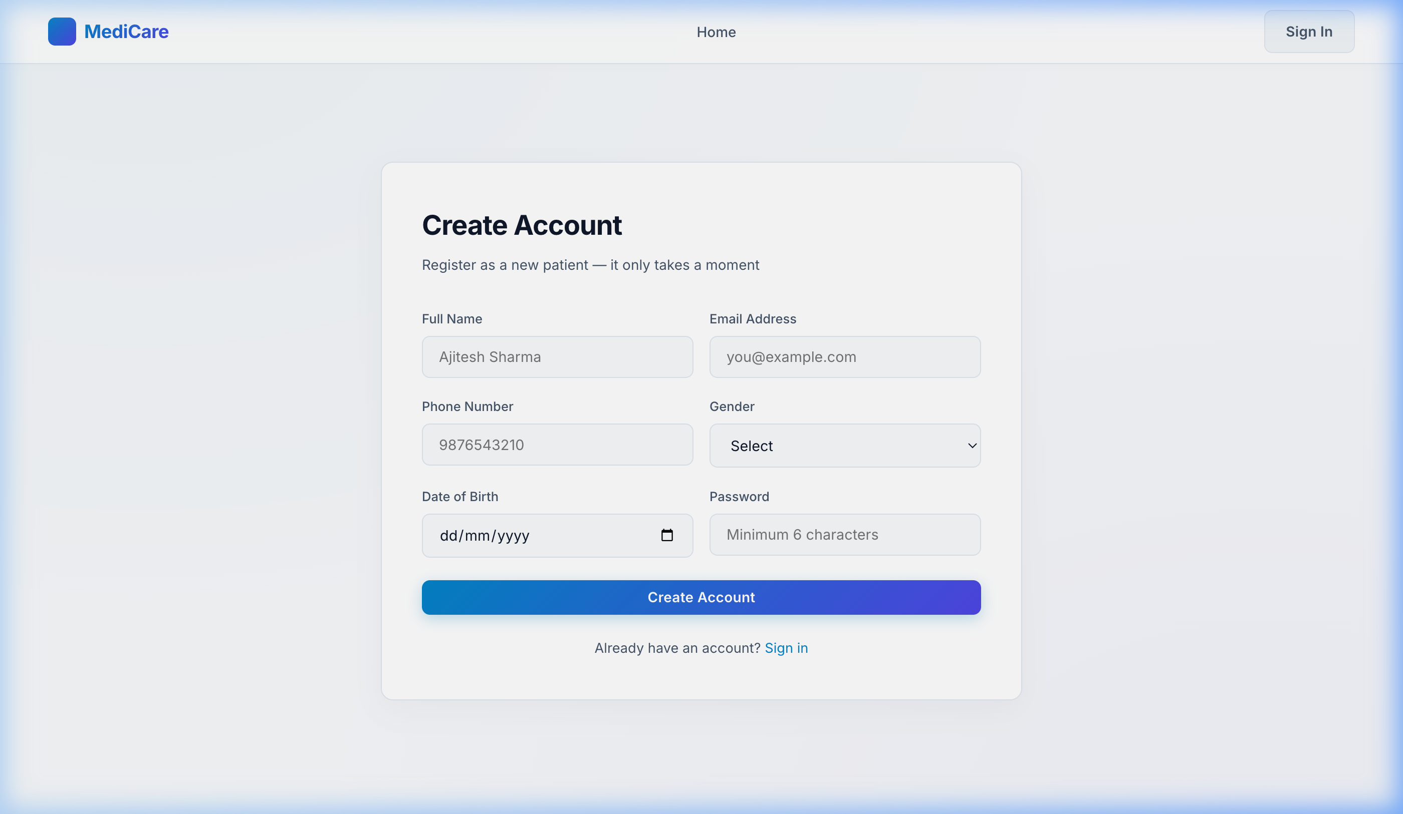
Figure: Patient Registration
Secure registration form gathering name, email, phone number, gender, date of birth, and password.

8.3 Sign In Portal (login.html)
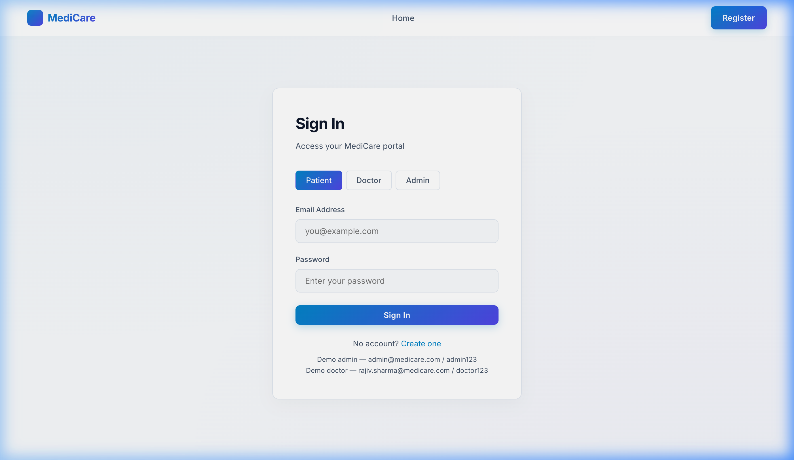
Figure: Sign In
Unified sign-in interface allowing role selection (Patient/Doctor/Admin) with tab switches.

8.4 Patient Overview Dashboard (dashboard.html)
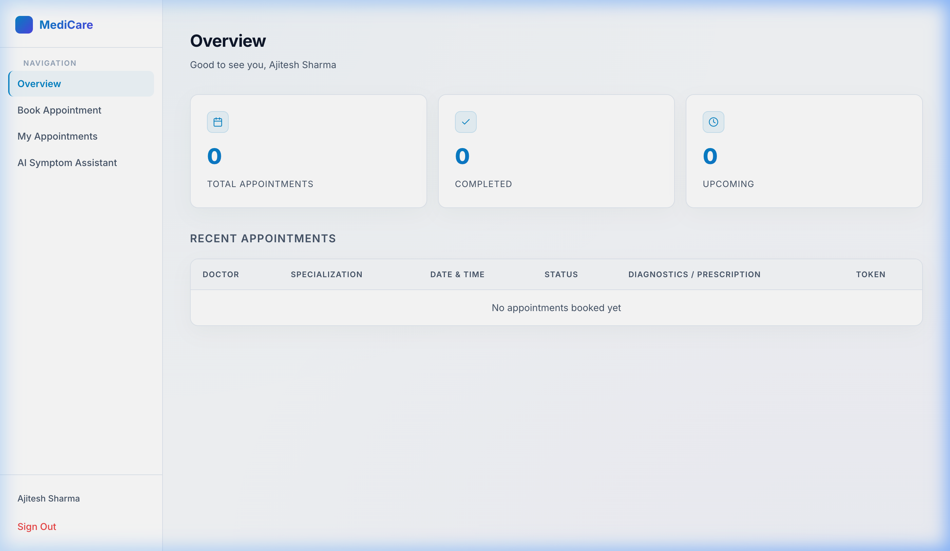
Figure: Patient Dashboard
Initial overview screen indicating system statistics and recent consultation logs.

8.5 Automated Live Queue Card
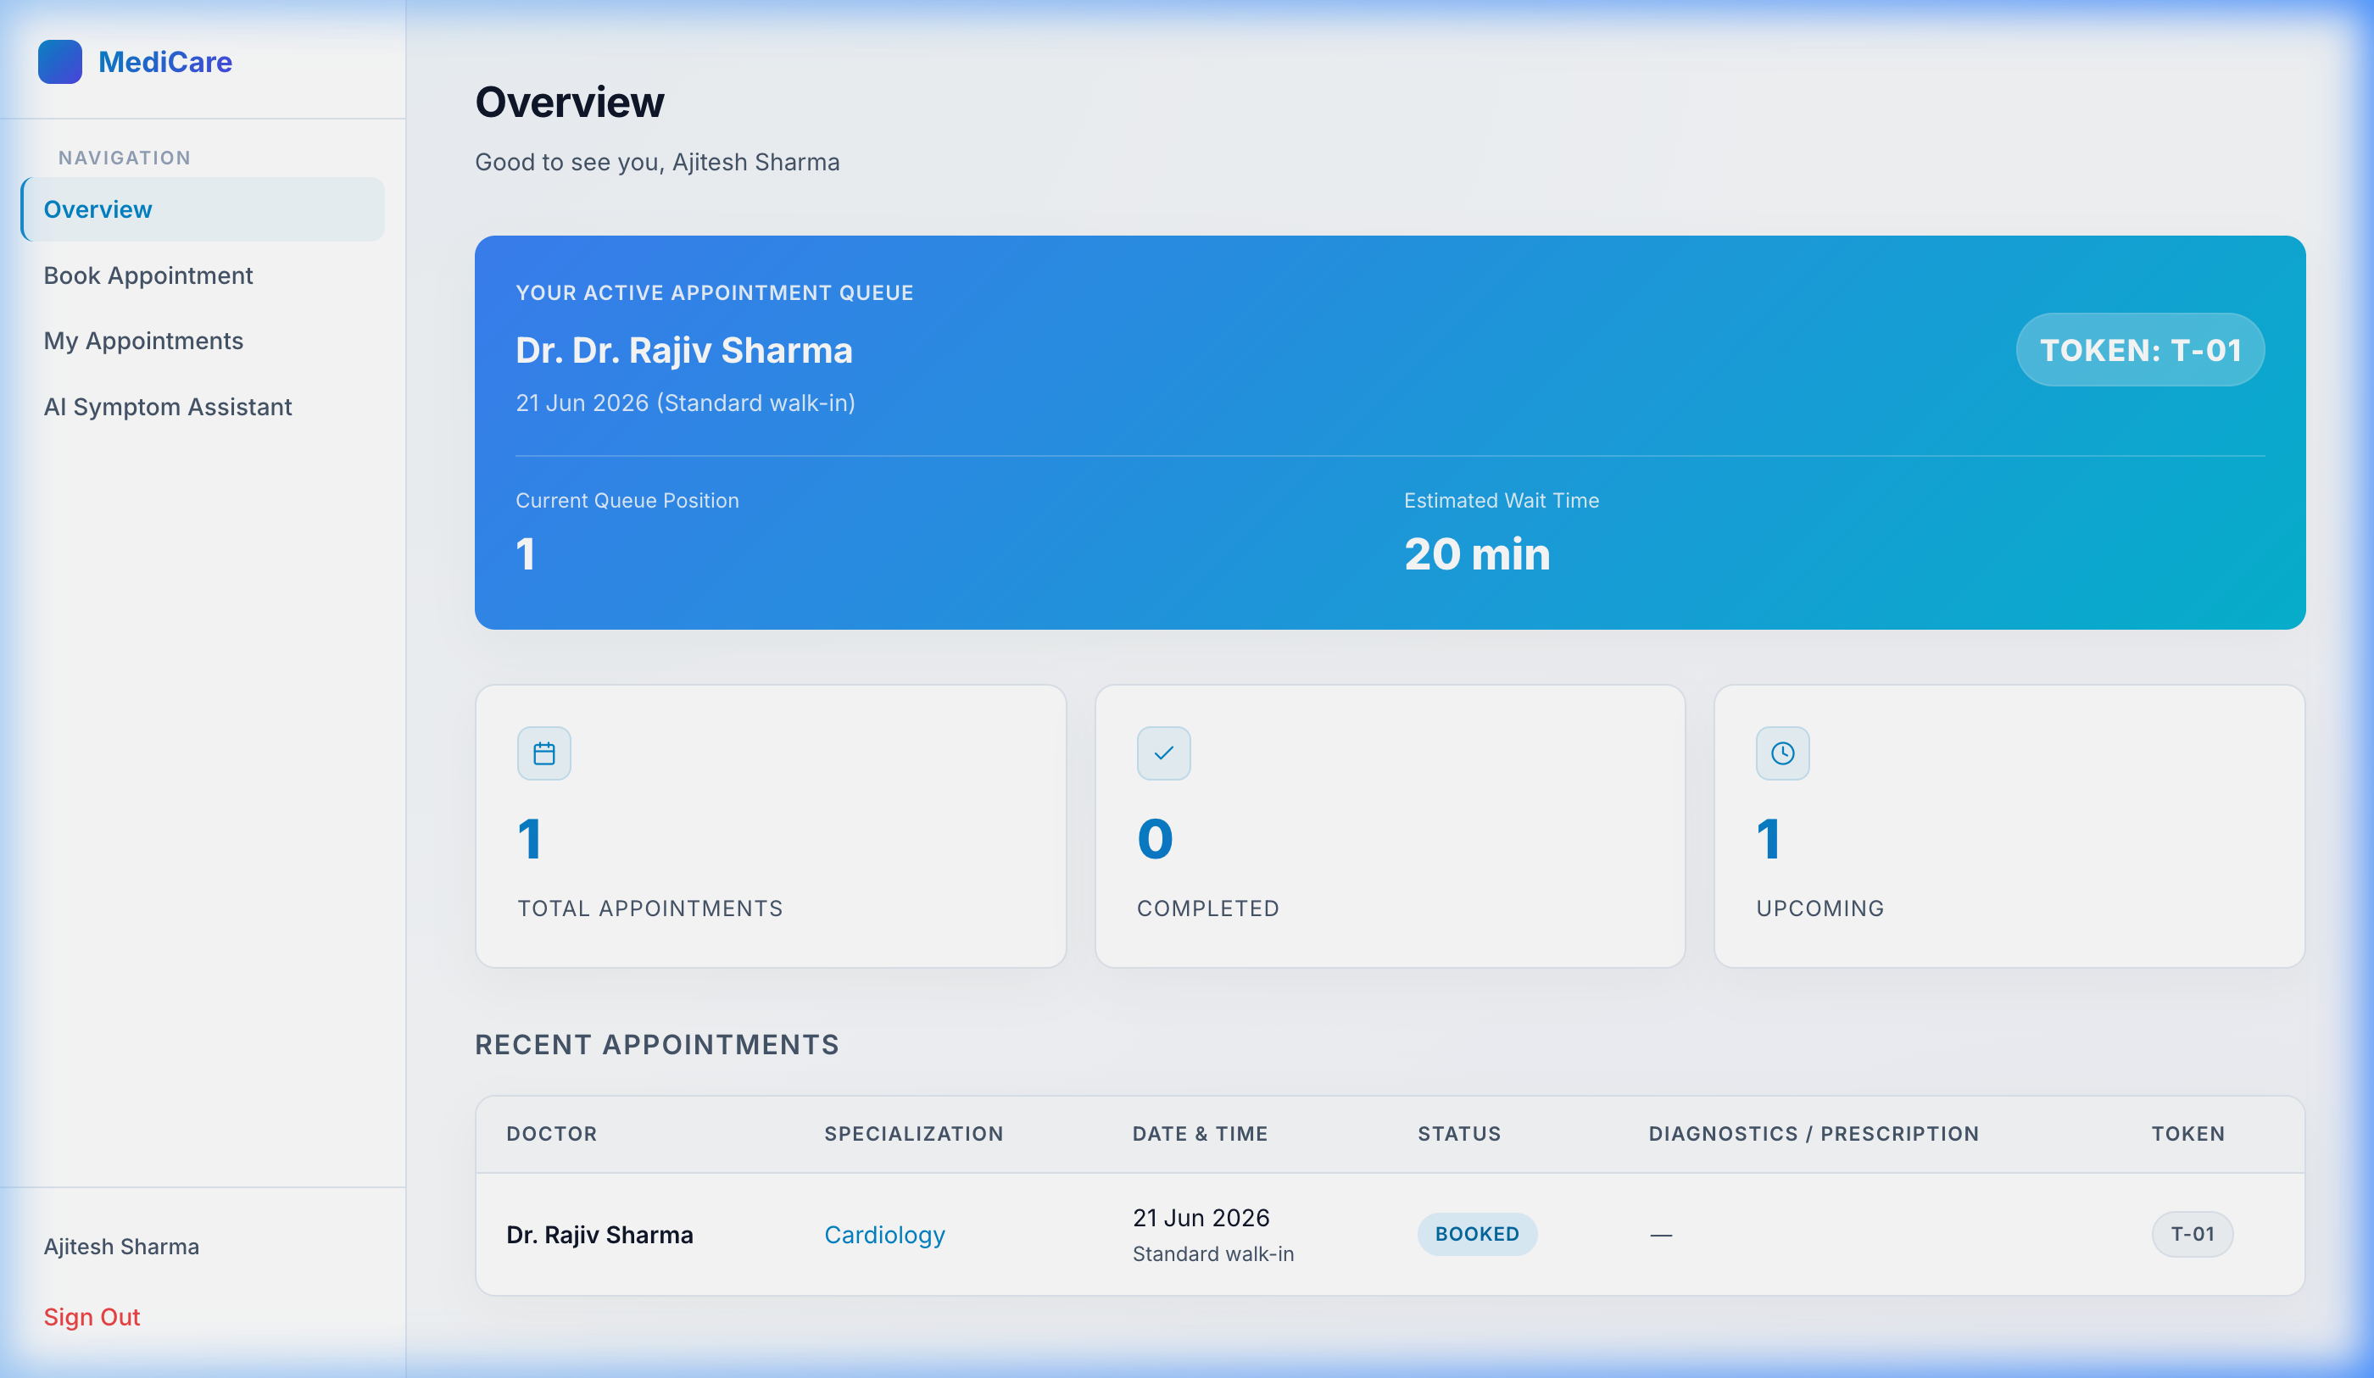
Figure: Dashboard with Queue card
Overview dashboard with the automated Live Queue Status card that updates every 5 seconds.

8.6 Doctor Appointments & Actions (doctor.html)
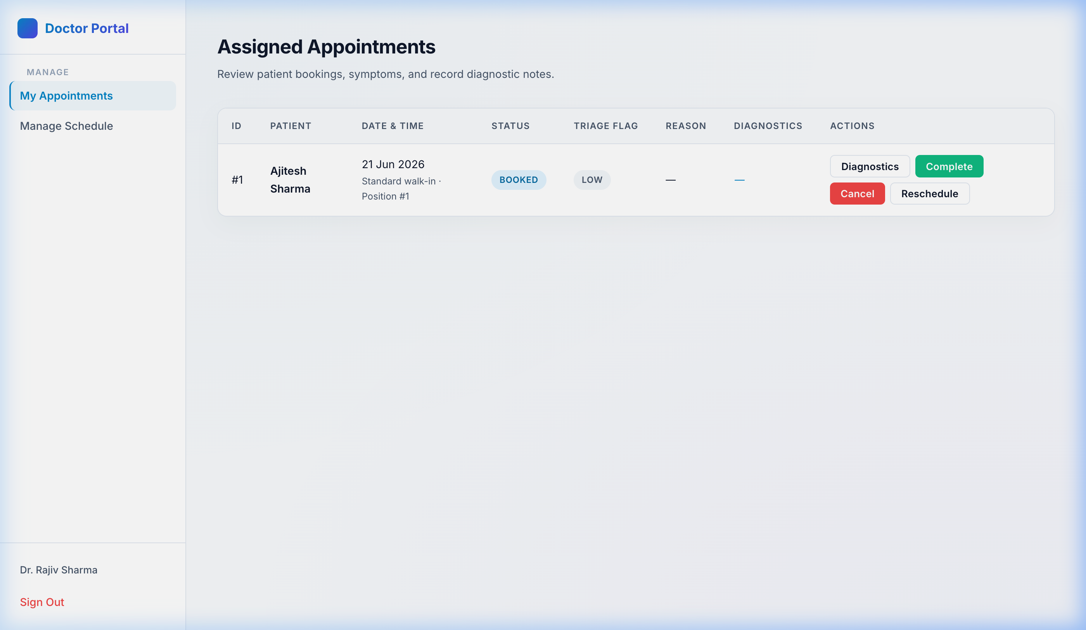
Figure: Doctor Dashboard
Doctor portal displaying active consultations, triage alerts, and diagnostic controls.

6.7 Doctor Reschedule Modal
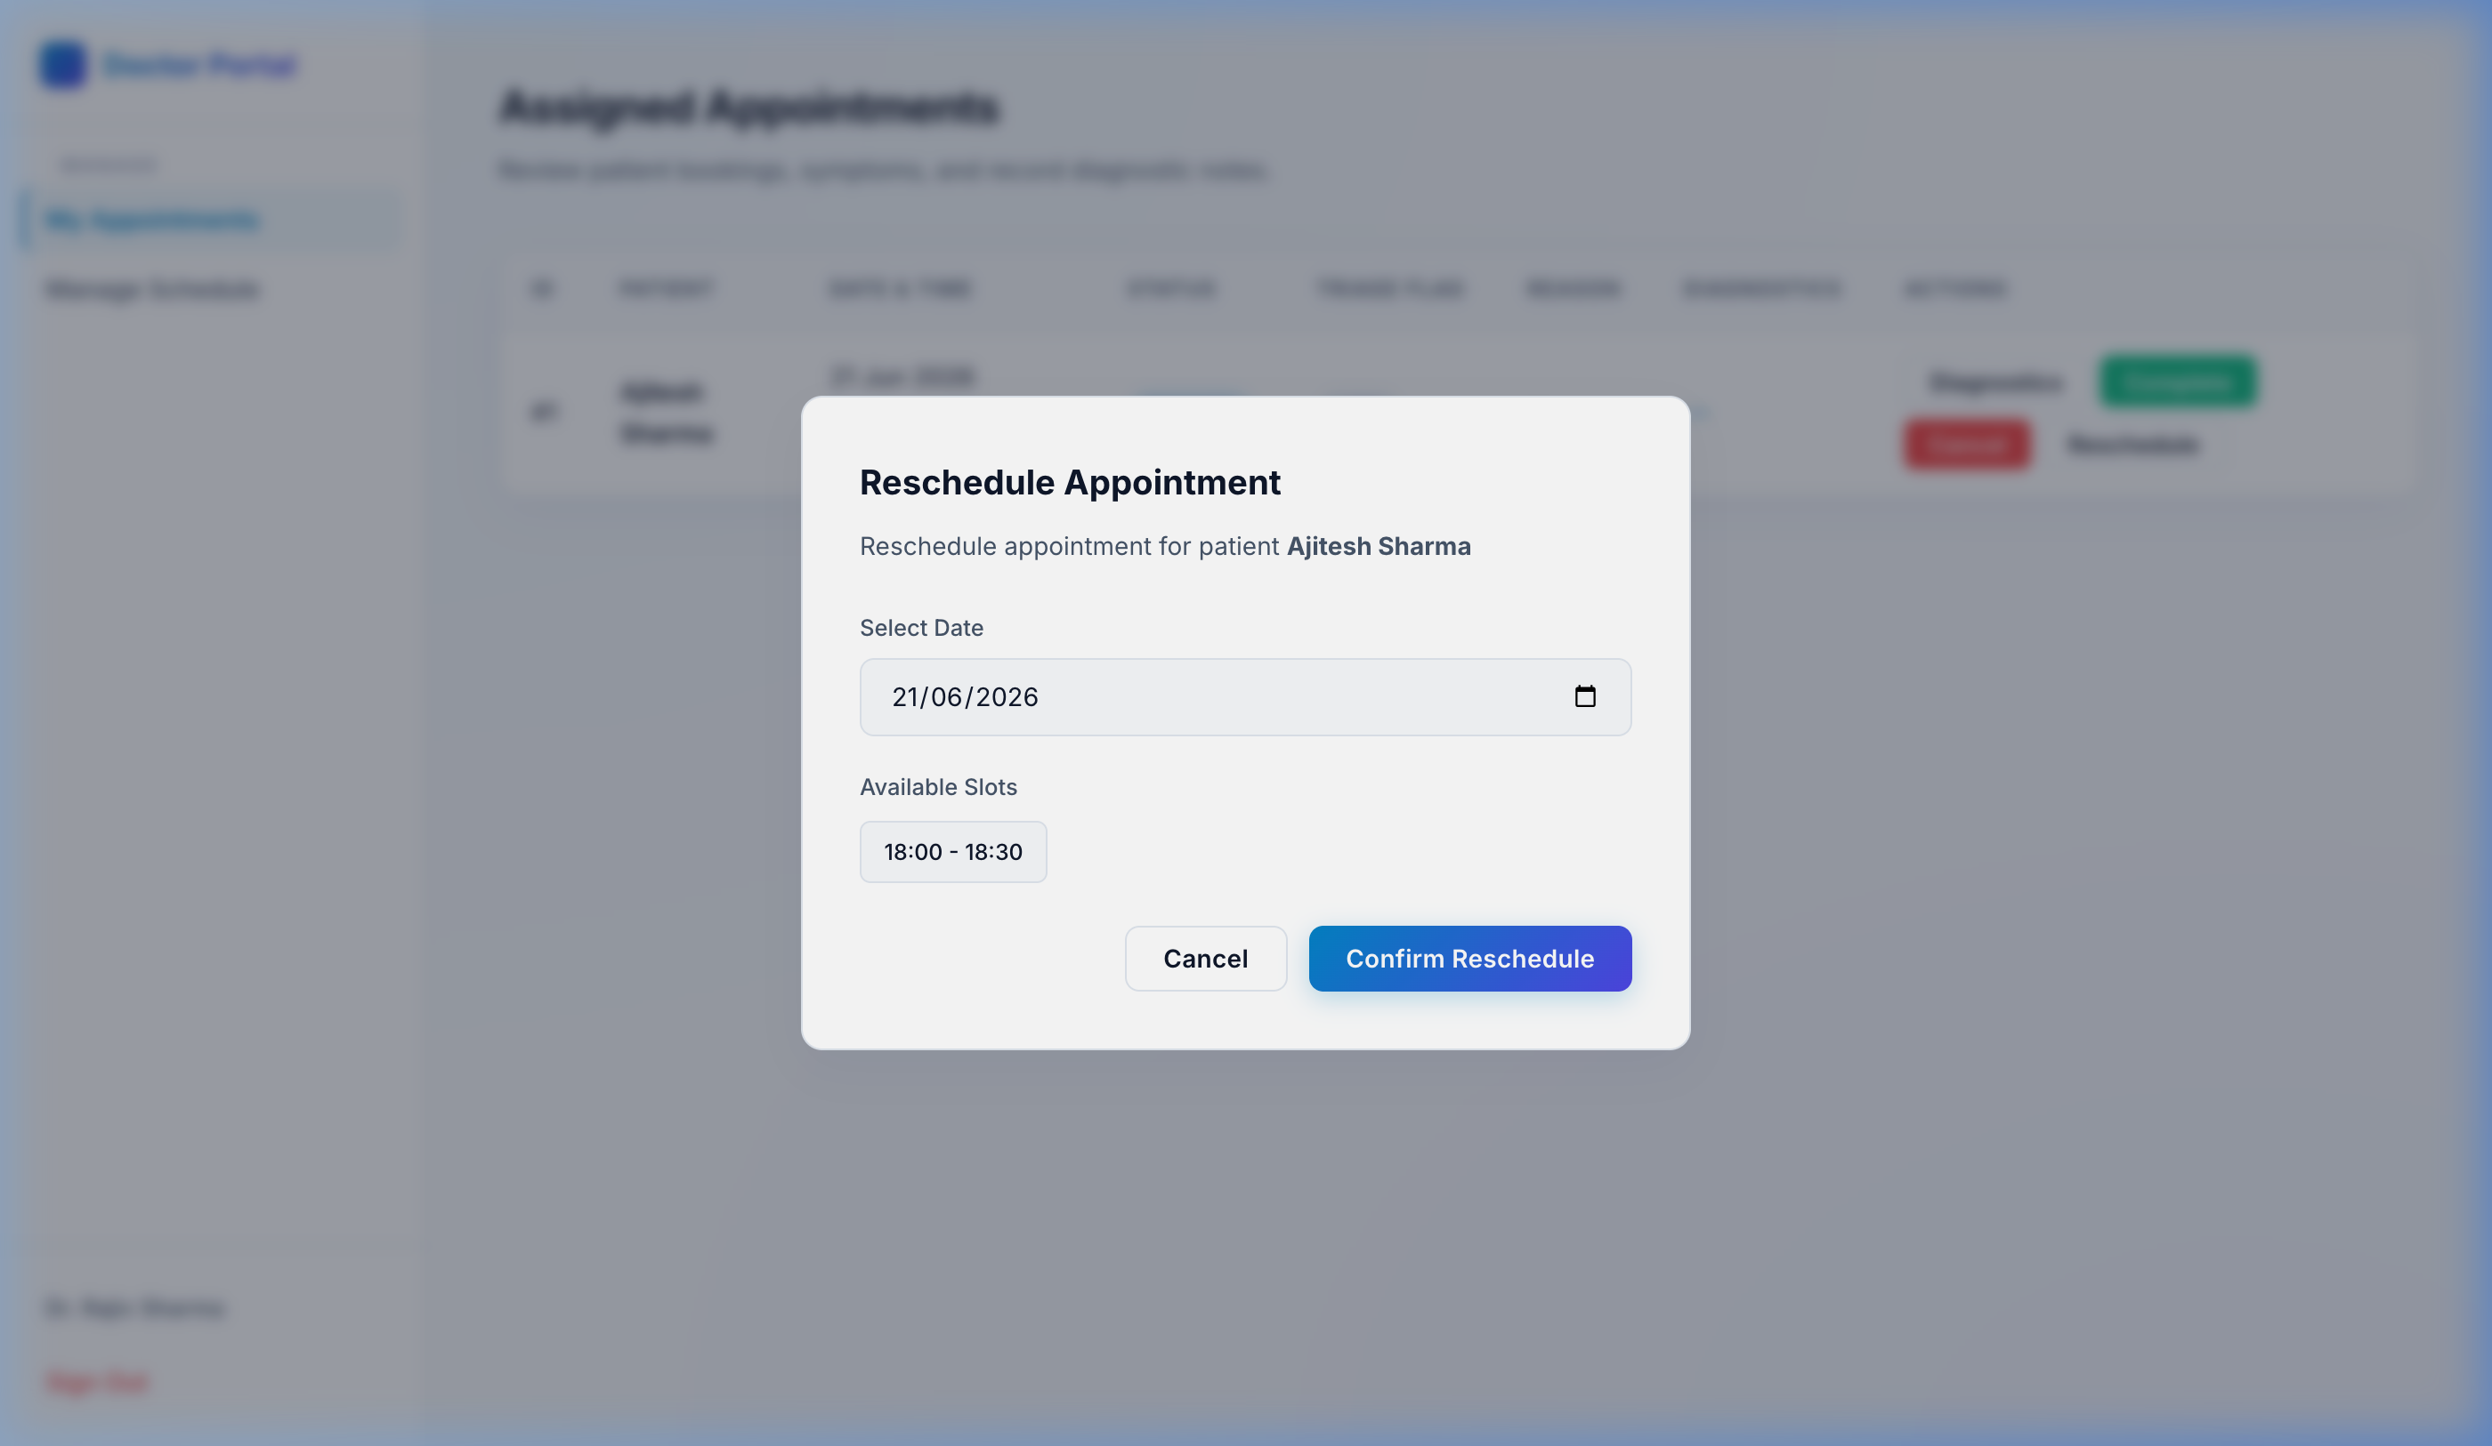
Figure: Reschedule Modal
Rescheduling window displaying slot availabilities. Confirming frees the previous slot and updates the queue.

8.8 System Admin Dashboard (admin.html)
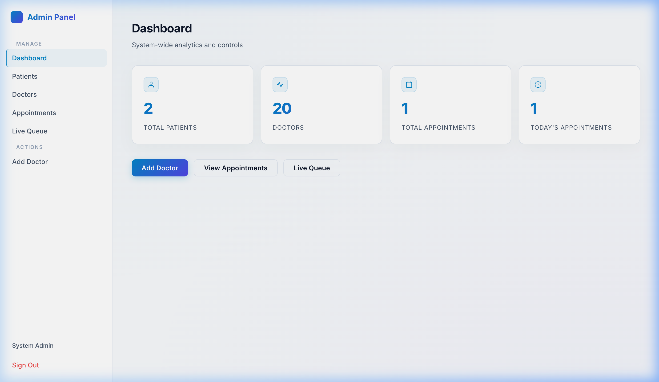
Figure: Admin Dashboard
Control panel for platform administrators showing system analytics, doctor registration, and queue oversight.

9. Software Engineering Best Practices
- Single Responsibility Principle (SRP): Separated REST endpoints, service orchestration, database mapping, and mail dispatch into independent layers.
- DRY (Don't Repeat Yourself): Shared utilities (formatting, API handling) centralized in app.js.
- CORS Middleware: Dynamic configurations allowed secure cross-origin HTTP operations from localhost:3000 to localhost:8080.
- Global Exception Advice: Unified error responses prevent backend stack traces from being exposed to the client.

10. Conclusion
MediCare successfully resolves clinic wait inefficiencies by merging scheduling, queue optimization, and automated communications. The rule-based NLP triage and predicted wait time algorithm provide automated primary routing. Completed during a Hindalco internship, this platform establishes a standard framework for modern, patient-first clinical queue tracking.

