**Assignment No. __2__**

**Student Name : Ashlesha Vikas Joshi MIS:** 111903022

**Course Teacher :** Rohini Sarode Ma’am

**Course Coordinator :** Rohini Sarode Ma’am

**Aim:** Installation and Study Of Debian Operating System.

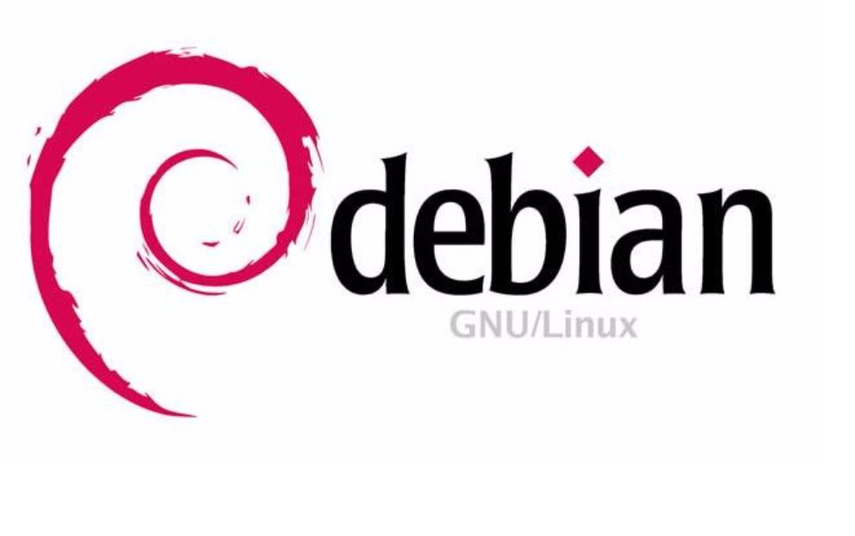

**INTRODUCTION TO DEBIAN OPERATING SYSTEM**

1. Debian is an Operating System which can work on various types of devices like laptops, desktops and servers.
2. It is a Linux Distribution having free and open-source software.
3. It’s first version was released on 15 September, 1993.
4. Debian is currently available in 75 different languages.
5. Debian’s latest release was on August 14, 2021.
6. The repository for Debian OS is available on sources.debian.org
7. APT is the Package Manager(front-end) for Debian.
8. The Kernel type of Debian is Linux Kernel.

**INSTALLATION OF DEBIAN OPERATING SYSTEM**

**REQUIREMENTS**

* 15-20 GB Hard Drive Space
* Bootable Medium (USB/DVD)
* Stable Internet Connection
* Sufficient RAM Space (>2GB)
* Dual Core Processor (or maybe a higher one)

**INSTALLATION STEPS**

* Firstly, Download the ISO of a particular version from Debian’s official website - <https://www.debian.org/CD/http-ftp/>
* To create a bootable USB, Download **Rufus** by going to the link https://rufus.ie/

Download the rufus-3.15.exe file by clicking on Rufus 3.15

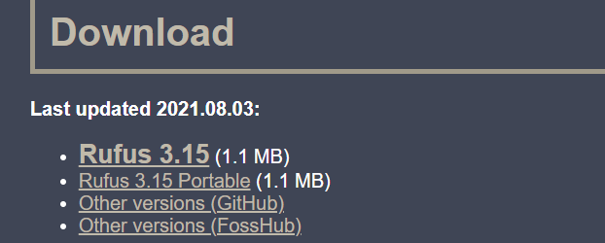

In case you find any compatibility issue, then you can download some other version.

* Insert your pen drive into the PC. Run the .exe file that you downloaded.
* In the **Device** section of pop up window your pen drive name will be visible. In the boot selection menu, select the appropriate ISO file of Debian that you downloaded. Keep all other parameters same and click on the START button. After execution, remove the pen drive.
* Backup all your necessary files
* While your computer is in shutdown, inject the Bootable Pen drive
* Start your computer by pressing power button and press the Corresponding key to access the BIOS setup. Use your USB as the Bootable Medium. Once the system boots, the following screen will appear.
* Choose the Graphical Install Option.

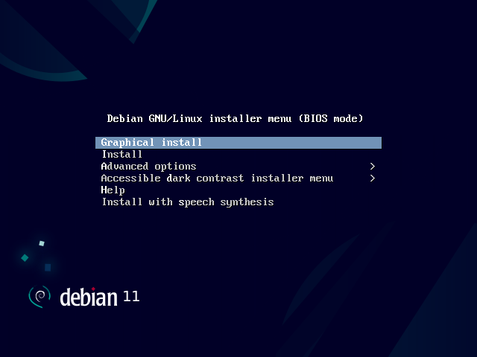

* Choose your Language and click continue.
* Choose your preferred location and click continue.
* Select the Keyboard Layout and click continue.
* Set your Hostname and Domain name and click continue.
* Set Root User password and click Continue.
* Set local User and configure the password and click Continue.
* In this step, carefully and accurately choose the partition type. There are following option for creating partitions-:

1. Guided (-use entire disk) - It will use the entire Disk space.
2. Guided (-use entire disk and set up LVM) – It will create LVM based partitions.
3. Manual – You can create your own custom partition.
4. Guided (-use entire disk and set up encrypted LVM) – It will create LVM based partitions and will encrypt the disk.

Choose the particular option according to your requirements

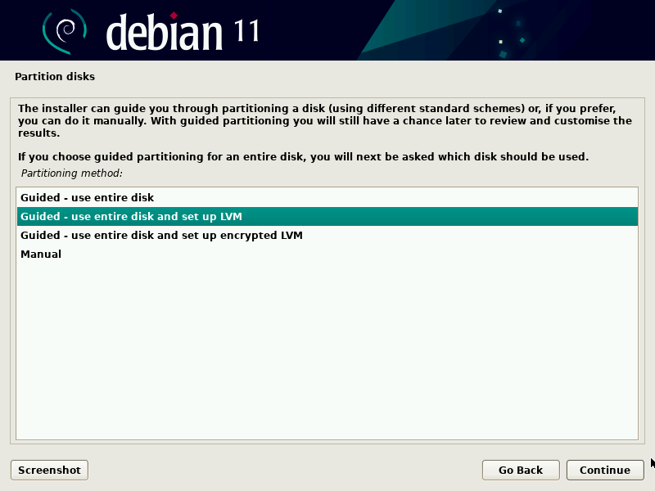

According to the partition type that you have chosen, appropriately select the further options and click Continue. At the end, partition summary will be displayed. Confirm whether all the options and parameters are correct, Click on Yes to apply changes to the disk

Click Continue so that the installation will now start. A window asking to scan installation media will appear, select the No option.

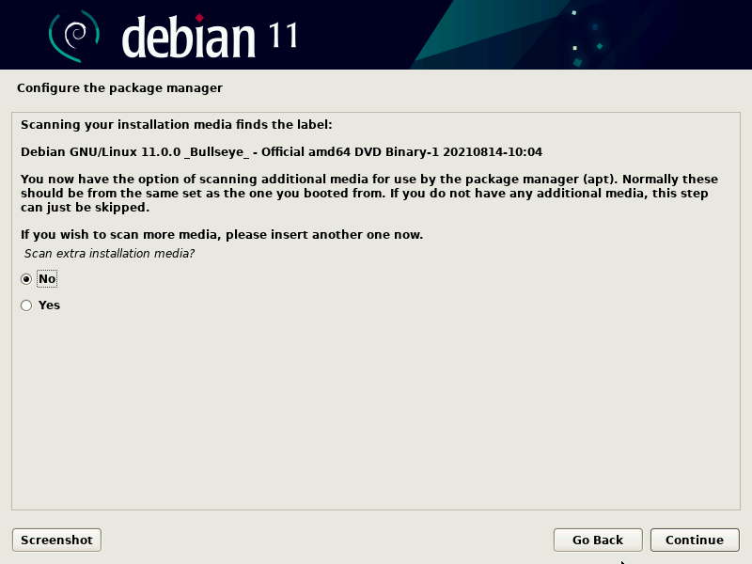

* In the next step, configure the network mirror by selecting Yes option.
* Now, choose the Debian Archive Mirror Country appropriately and click on continue. Configure the package manager in the next step by selecting deb.debian.org and click Continue.
* In this step, if your system uses a proxy server, enter it’s name or else click continue.
* In this step, you will be asked to participate in an package survey. Click Yes or No according to your wish.

Now choose the software that you want to install like Desktop environment and servers, make the selection which best suits your architecture and requirements.

Generally, Debian Desktop Environment, GNOME, SSH Server and standard system utilities are selected.

In this step, choose ‘Yes’ for installing Grub Bootloader on your primary drive.

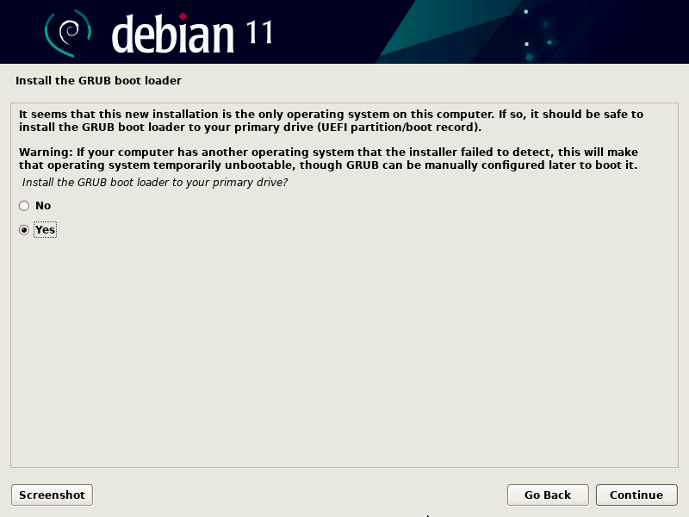



In the next window, appropriately choose the disk on which grub loader will now be installed. You can also enter it manually.

Choose continue, in the next step the installation process will be completed.

After the installation is complete, the Login screen will now appear.

Enter your username and password.

You can now access all the features of Debian OS!

**FEATURES OF DEBIAN OPERATING SYSTEM**

1. Debian Operating System is stable and Dependable one.
2. Debian Operating System is ideal for servers and it supports many kinds of PC Architectures,
3. Debian Operating System is a LINUX Distribution.
4. It is an open-source and free software. It has access to online repositories that contain over 51, 000 packages.
5. It is one of the Oldest Operating System based on LINUX Kernel.
6. It includes popular free programs such as LibreOffice, Firefox Web Browser, VLC Media Player and Evince Document Viewer.
7. It is an Operating system component of LAMP Stack.
8. It is currently available in over 75 Languages.

**CONCLUSION**

1. Debian is a free and open source software.
2. It can be installed in various types of PC Architectures.
3. It is ideal for Servers.
4. Each Version Of Debian can be used for a long time.
5. Debian is Desktop Agnostic.
6. Debian is the largest community run Distribution.
7. Debian can be easily installed by following all the above steps.

**REFERENCES**

1. <https://www.debian.org/>
2. https://www.youtube.com/watch?v=GNCwot8byqE
3. <https://en.wikipedia.org/wiki/Debian>
4. <https://www.youtube.com/watch?v=V1y-mbWM3B8>