**Assignment No. __3__**

**Student Name :** Ashlesha Joshi **MIS:** 111903022

**Course Teacher :**  Rohini Sarode Ma’am

**Course Coordinator :**  Rohini Sarode Ma’am

**Aim:** Installation and Study of CentOS Operating System



**INTRODUCTION TO CentOS OPERATING SYSTEM**

1. CentOS stands for Community Enterprise Operating System.
2. It is one of the Linux Distributions started by Gregory Kurtzer.
3. It is a Open Source Operating System.
4. The initial release of CentOS was on 14 May 2004, roughly seven years ago.
5. It is a free Computing Platform.
6. The Kernel type of CentOS is Linux Kernel.
7. It was developed by the CentOS Project which is affiliated with Red Hat.
8. It is forked from Red Hat Enterprise Linux.

**INSTALLATION OF CentOS OPERATING SYSTEM**

**REQUIREMENTS**

1. Minimum 10 GB Hard Drive Space
2. Bootable Medium (USB/DVD)
3. Stable Internet Connection.

**INSTALLATION STEPS**

1. Download the required CentOS ISO File from <https://www.centos.org/download/> according to your PC Architecture.
2. To create a bootable USB, Download **Rufus** by going to the link https://rufus.ie/

Download the rufus-3.15.exe file by clicking on Rufus 3.15

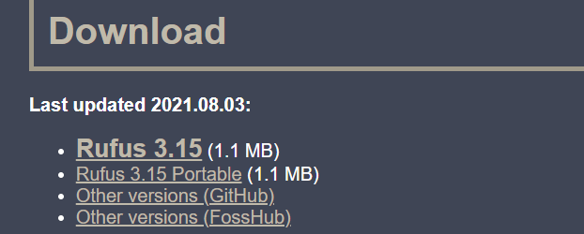

1. Insert your pen drive into the PC. Run the .exe file that you downloaded.
2. In the **Device** section of pop up window your pen drive name will be visible. In the boot selection menu, select the appropriate ISO file of Debian that you downloaded. Keep all other parameters same and click on the START button. After execution, remove the pen drive. Backup all the necessary files.
3. While your computer is in shutdown, inject the Bootable Pen drive
4. Start your computer by pressing power button and press the Corresponding key to access the BIOS setup. Use your USB as the Bootable Medium. Once the system boots, the following screen will appear.
5. 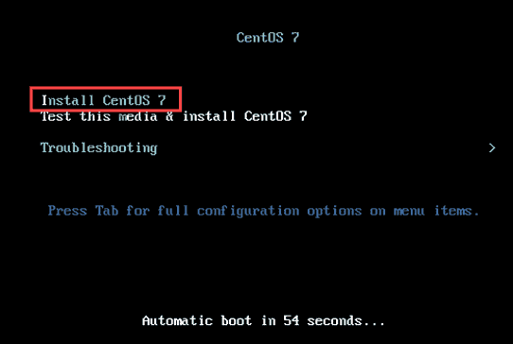Click on the Install CentOS Option.
6. In this step, select the language in which you want to proceed with your installation.

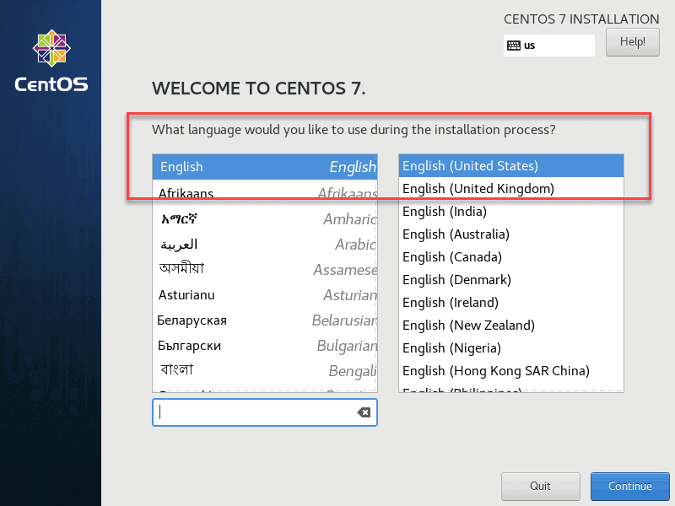

1. Set the correct Date, Time and Region. Select the required Keyboard Layout and also select the System Language.
2. This is the Software Selection Step. A list of predefined Base Environment options and optional add-ons is present. Minimal Install is the most flexible and least resource-demanding option. You can choose from Predefined server Options. GNOME Desktop and KDE Plasma Workspaces include full GUIs.
3. 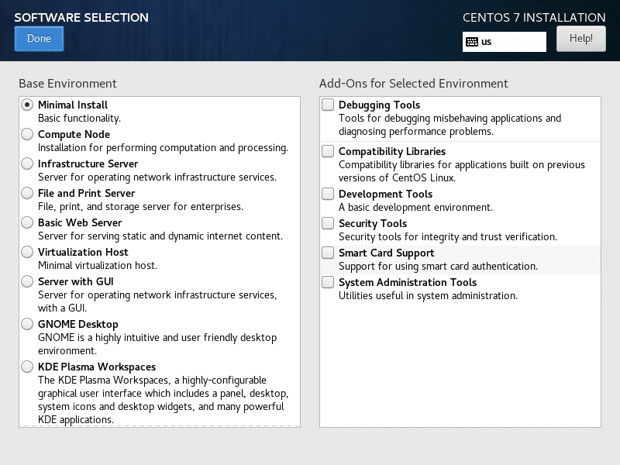In this important step, you will have to select the Installation Destination. Check your Machine’s Storage before. Now, wisely choose the Partitioning Option.
4. Automatic Partitioning : It will automatically create the partitions in the disk. A LVM Logical Volume in the XFS File System will be created.
5. Manual Partitioning : In this way, you can create all the partitions by your own by appropriately selecting the options.

KDUMP is enabled by default. It is an advanced setting option that depends on your requirements. KDUMP reserves portion of system’s memory. It captures system information at the time of crash.

1. In this step, you have to select and configure your **Network** and **Hostname**.

In the Hostname field, type fully qualified domain name of your system.

Using the configure option, select to add

1. IPv4 Settings, or
2. IPv6 Settings
3. Add Static IP Addresses to help identify your computer on the network.
4. Enter the information about IP Address, Netmask Address, Gateway Address and DNS Server Address for your network domain
5. Click Save to confirm your changes.
6. Also Enable the Ethernet Connections.
7. Select the Security Policy option under the System Heading. Choose a profile from the list and click on Select Profile. Click on the Done button to confirm your selection.
8. Now, all the setup is complete. Start the Installation Process by selecting the Begin Installation Option. The process will now start.
9. You will have to define the Root Password and perform the User Creation Step as well.

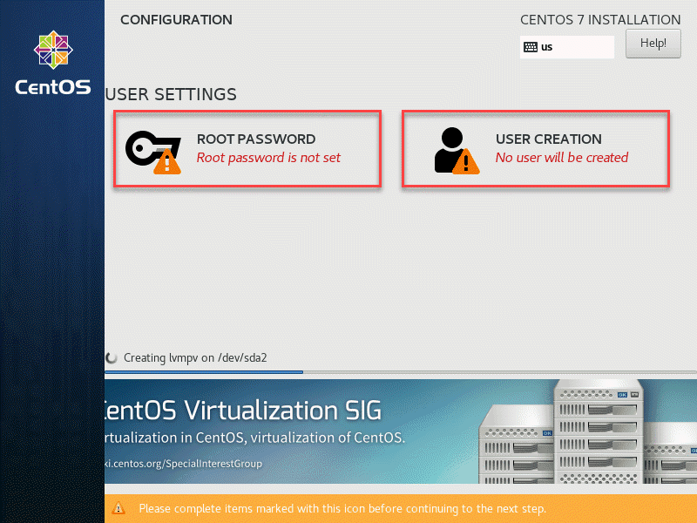

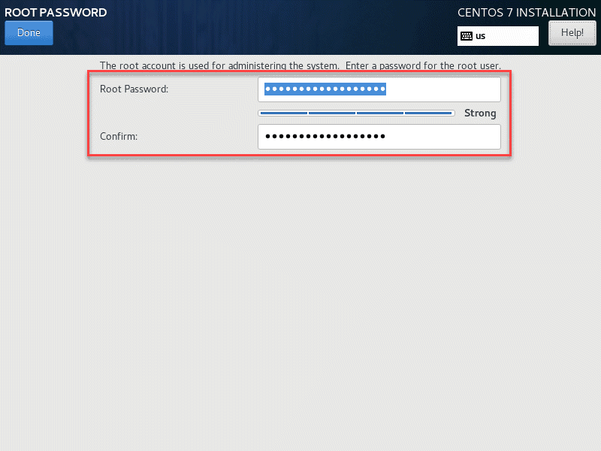

1. The Installation is now complete. Before you start using your new CentOS Operating System, reboot the system. Select the **Reboot** button.

**FEATURES OF CentOS OPERATING SYSTEM**

1. It is an free and Open Source Operating System.
2. It is available on various platforms like- x86-64, ARM64 and POWER*.
3. It’s default User Interface is Bash, GNOME Shell.
4. The Latest release on CentOS was 8.4.2105 on 3 June, 2021 i.e. 3 months ago.
5. It has a 5-level paging feature, extending the size of virtual addresses and increasing the addressable virtual memory.
6. It is a stable Linux Distribution.
7. It has high performance and availability.
8. It provides high level of security.
9. It has regular updates and support.
10. It has s strong Stability.
11. CentOS is based on RedHat System Core.
12. CentOS Package Management is through YUM.
13. CentOS Virtualization is through OpenNebula, OpenStack , CloudStack.
14. The most recent CentOS version incorporates Xen, Docker.

**CONCLUSION**

1. CentOS is free and Open Source Software.
2. It can be installed on various types of PC Architectures.
3. CentOS has a Linux Kernel and is a Linux Distribution.
4. It is ideal for enterprises.
5. CentOS can be easily installed by following the above steps.
6. CentOS has high Security and Stability.

**REFERENCES**

1. [**https://linuxhint.com/everything-you-want-to-know-about-centos-as-linux-distribution/#9**](https://linuxhint.com/everything-you-want-to-know-about-centos-as-linux-distribution/#9)
2. [**https://www.youtube.com/watch?v=Mi6GUcSW5xs**](https://www.youtube.com/watch?v=Mi6GUcSW5xs)
3. [**https://www.hostinger.in/tutorials/centos-vs-ubuntu#:~:text=The%20biggest%20difference%20between%20the,the%20apt%2Dget%20package%20manager.&text=CentOS%20is%20considered%20to%20be%20a%20more%20stable%20distribution%20compared%20to%20Ubuntu**](https://www.hostinger.in/tutorials/centos-vs-ubuntu#:~:text=The%20biggest%20difference%20between%20the,the%20apt%2Dget%20package%20manager.&text=CentOS%20is%20considered%20to%20be%20a%20more%20stable%20distribution%20compared%20to%20Ubuntu)**.**
4. [**https://www.blackdown.org/centos-linux-review/**](https://www.blackdown.org/centos-linux-review/)
5. [**https://en.wikipedia.org/wiki/CentOS**](https://en.wikipedia.org/wiki/CentOS)