Unit Quote Header File: This file pulls information from the Unit Quote Header File.

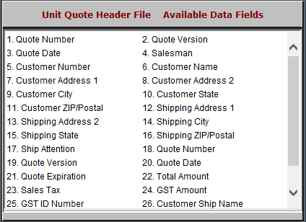

- Quote Number: This field shows the quote number.
- Quote Version: This field shows the quote version.
- Quote Date: This field shows the quote date.
- Salesman: This field shows the salesman’s number or initials.
- Customer Number: This field shows the customer number.
- Customer Name: This field shows the customer’s name.
- Customer Address 1: This field shows the customer’s address.
- Customer Address 2: This field provides an extra line for the customer’s address, should it require one.
- Customer City: This field shows the customer’s city.

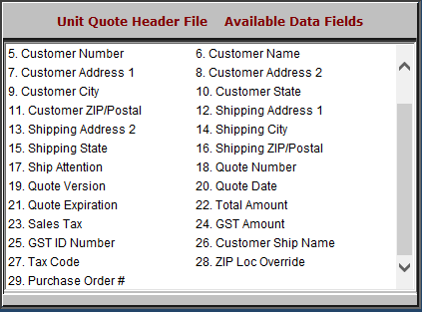

- Customer State: This field shows the customer’s state.
- Customer ZIP/Postal: This field shows the customer’s zip or postal code.
- Shipping Address 1: This field shows the shipping address.
- Shipping Address 2: This field gives an extra line for the shipping address, should it require one.
- Shipping City: This field shows the shipping city.
- Shipping State: This field shows the shipping state.
- Shipping ZIP/Postal: This field shows the shipping zip or postal code.
- Ship Attention: This field shows exactly who is being shipped to, especially if shipping to a business.
- Quote Number: This field shows the quote number.
- Quote Version: This field shows the quote version.
- Quote Date: This field shows the quote date.
- Quote Expiration: This field shows the quote expiration date.
- Total Amount: This field shows the total amount of the quote.
- Sales Tax: This field shows the sales tax.
- GST Amount: This field shows the GST amount.
- GST ID Number: This field shows the GST ID number.
- Customer Ship Name: This field shows the customer’s shipping name.
- Tax Code: This field shows the tax code.
- ZIP Loc Override: This field shows a 4-digit sales tax override, which is limited to SST states.
- Purchase Order #: This field shows the purchase order number.

