Unit Quote Detail File: This file pulls information from the Unit Quote Detail File.

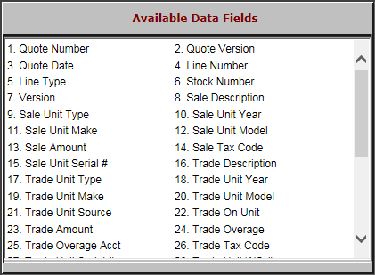

- Quote Number: This field shows the quote number.
- Quote Version: This field shows the quote version.
- Quote Date: This field shows the quote date.
- Line Number: This field shows the line number.
- Line Type: This field shows the line type.
- Stock Number: This field shows the stock number.
- Version: This field indicates the version number of the quote.
- Sale Description: This field describes the sale.
- Sale Unit Type: This field shows the sale unit’s type.
- Sale Unit Year: This field shows the sale unit’s year.
- Sale Unit Make: This field shows the sale unit’s make.
- Sale Unit Model: This field shows the sale unit’s model.
- Sale Amount: This field shows the sale amount.
- Sale Tax Code: This field shows the sale tax code.
- Sale Unit Serial #: This field shows the sale unit’s serial number.
- Trade Description: This field describes the trade.
- Trade Unit Type: This field shows the trade unit’s type.
- Trade Unit Year: This field shows the trade unit’s year.
- Trade Unit Make: This field shows the trade unit’s make.
- Trade Unit Model: This field shows the trade unit’s model.
- Trade Unit Source: This field shows the trade unit’s source.
- Trade On Unit: This field shows the stock number where the trade was applied.
- Trade Amount: This field shows the trade’s amount.
- Trade Overage: This field shows the trade over-allowance amount.
- Trade Overage Acct: This field shows the account where the trade over-allowance was applied.
- Trade Tax Code: This field shows the trade tax code.

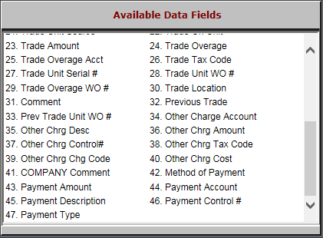

- Trade Unit Serial #: This field shows the trade unit’s serial number.
- Trade Unit WO #: This field shows the trade unit’s washout number.
- Trade Overage WO #: This field shows the over-allowance for the washout number.
- Trade Location: This field shows the location where the trade resides.
- Comment: This field shows any comments.
- Previous Trade: This field is reserved for future use.
- Prev Trade Unit WO #: This field is reserved for future use.
- Other Charge Account: This field shows the other charge account.
- Other Chrg Desc: This field shows the other charge description.
- Other Chrg Amount: This field shows the other charge amount.
- Other Chrg Control#: This field shows the other charge control number.
- Other Chrg Tax Code: This field shows the other charge tax code.
- Other Chrg Chg Code: This field is reserved for future use.
- Other Chrg Cost: This field shows the other charge cost.
- COMPANY Comment: This field is reserved for future use.
- Method of Payment: This field shows the payment method.
- Payment Amount: This field shows the payment amount.
- Payment Account: This field shows the ledger where the account is applied.
- Payment Description: This field shows the payment’s description.
- Payment Control #: This field shows the payment control number.
- Payment Type: This field shows the payment type.

