Service Open RO Detail File: This file pulls information from the Service Open RO Detail File.

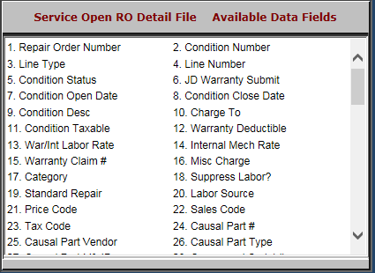

- Repair Order Number: This field shows the repair order number.
- Condition Number: This field shows the condition number.
- Line Type: This field shows the line type.
- Line Number: This field shows the line number.
- Condition Status: This field shows the condition status.
- JD Warranty Submit: This field shows a flag if the warranty has been submitted to John Deere.
  - This field can be used for manual entry by other companies.
- Condition Open Date: This field shows the condition open date.
- Condition Close Date: This field shows the condition close date.
- Condition Desc: This field describes the condition.
- Charge To: This field is reserved for future use.
- Condition Taxable: This field shows whether or not the condition is taxable.
- Warranty Deductible: This field shows the warranty deductible amount.
- War/Int Labor Rate: This field shows either the warranty labor rate or the internal labor rate.
- Internal Mech Rate: This field shows the mechanic’s billing rate, if it’s an internal repair.
- Warranty Claim #: This field shows the warranty claim number.
- Misc Charge: This field shows any miscellaneous charges.
- Category: This field is reserved for future use.
- Suppress Labor?: This field shows:
  - “Y” if the labor detail is suppressed
  - “N” if all details are shown.
- Standard Repair: This optional field can show the standard repair code.
- Labor Source: This field is reserved for future use.
- Price Code: This field shows the price code.
- Sales Code: This field shows the sales code.
- Tax Code: This field shows the tax code.
- Causal Part #: This field shows the causal part number.
- Causal Part Vendor: This field shows the causal part vendor.
- Causal Part Type: This field shows the causal part type.

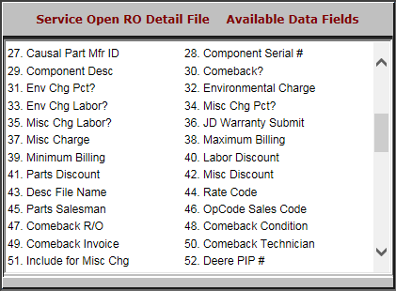

- Causal Part Mfr ID: This field shows the causal part manufacturer ID.
- Component Serial #: This field shows the component serial number.
- Component Desc: This field shows the component’s description.
- Comeback?: This field shows:
  - “Y” if the repair is a comeback
  - “N” if it’s not.
- Env Chg Pct?: This field shows:
  - “Y” if there is an environmental charge percentage
  - “N” if there isn’t
- Environmental Charge: This field lists the environmental charge.
- Env Chg Labor?: This field shows whether or not there is an environmental charge for the labor.
- Misc Chg Pct?: This field shows:
  - “Y” if there is a miscellaneous charge percentage
  - “N” for “No” if there isn’t.
- Misc Chg Labor?: This field shows:
  - “Y” if the miscellaneous charges apply to the labor
  - “N” if the charges do not apply.
- JD Warranty Submit: This field shows a flag if the warranty has been submitted to John Deere.
  - This field can be used for manual entry by other companies.
- Misc Charge: This field shows any miscellaneous charges.
- Maximum Billing: This field shows the maximum billing amount.
- Minimum Billing: This field shows the minimum billing amount.
- Labor Discount: This field shows any labor discounts.
- Parts Discount: This field shows any parts discounts.
- Misc Discount: This field shows any miscellaneous discounts.
- Desc File Name: This field shows a description of the file name.
- Rate Code: This field shows the rate code.
- Parts Salesman: This field shows the parts salesman’s number or initials.
- OpCode Sales Code: This field shows the Op Code sales code.
- Comeback R/O: This field shows the repair order number if the repair is a comeback.
- Comeback Condition: This field shows the condition number if the repair is a comeback.
- Comeback Invoice: This field shows the comeback invoice number.
- Comeback Technician: This field shows the technician who worked on the comeback.
- Include for Misc Chg: This field is to be included for miscellaneous charges.
- Deere PIP #: This field shows the PIP number for John Deere.
  - It can be used for manual entry by other companies.

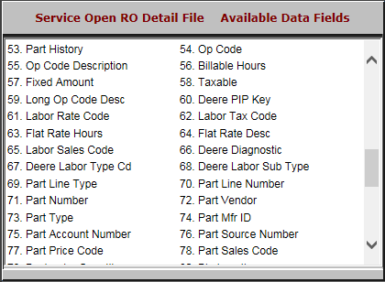

- Part History: This field shows:
  - “Y” if the invoice shows in Part History
  - “N” if it does not.
- Op Code: This field shows the Op code.
- Op Code Description: This field shows the Op code’s description.
- Billable Hours: This field indicates the billable hours.
- Fixed Amount: This field shows the fixed amount.
- Taxable: This field is reserved for future use.
- Long Op Code Desc: This field shows the Long Op code description.
- Deere PIP Key: This field holds the PIP key for John Deere.
  - It can be used for manual entry by other companies.
- Labor Rate Code: This field shows the labor rate code.
- Labor Tax Code: This field shows the labor tax code.
- Flat Rate Hours: This field shows the flat rate hours.
- Flat Rate Desc: This field shows the flat rate’s description.
- Labor Sales Code: This field shows the labor sales code.
- Deere Diagnostic: This field shows the diagnostic code for John Deere.
  - It can be used for manual entry by other companies.
- Deere Labor Type Cd: This field shows the labor type code for John Deere.
  - It can be used for manual entry by other companies.
- Deere Labor Sub Type: This field shows the labor sub type for John Deere.
  - It can be used for manual entry by other companies.
- Part Line Type: This field shows the part line type.
- Part Line Number: This field shows the part line number.
- Part Number: This field shows the part number.
- Part Vendor: This field lists the part vendor.
- Part Type: This field lists the part type.
- Part Mfr ID: This field lists the part manufacturer ID.
- Part Account Number: This field lists the part account number.
- Part Source Number: This field lists the part source number.
- Part Price Code: This field lists the part price code.
- Part Sales Codes: This field lists the part sales codes.

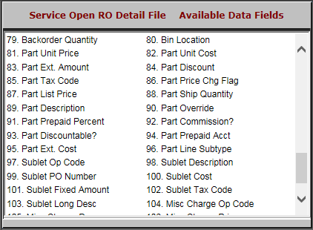

- Backorder Quantity: This field lists the backorder quantity.
- Bin Location: This field lists the bin location.
- Part Unit Price: This field shows the part unit price.
- Part Unit Cost: This field shows the part unit cost.
- Part Ext. Amount: This field shows the part’s extended list price.
- Part Discount: This field shows the part discount amount.
- Part Tax Code: This field shows the part tax code.
- Part Price Chg Flag: This field is reserved for future use.
- Part List Price: This field shows the part list price.
- Part Ship Quantity: This field shows the part ship quantity.
- Part Description: This field shows the part’s description.
- Part Override: This field shows the part tax override.
- Part Prepaid Percent: This field lists the percent of the part’s price that was prepaid.
- Part Commission?: This field lists if the part is a commission or not.
- Part Discountable?: This field lists if the part is discountable or not.
- Part Prepaid Acct: This field is reserved for future use.
- Part Ext. Cost: This field shows the part’s extended cost.
- Part Line Subtype: This field shows the part line subtype.

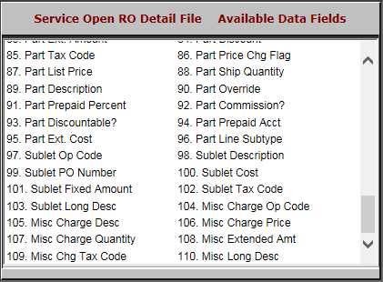

- Sublet Op Code: This field shows the sublet op code.
- Sublet Description: This field shows the sublet’s description.
- Sublet PO Number: This field shows the sublet purchase order number.
- Sublet Cost: This field shows the sublet cost.
- Sublet Fixed Amount: This field shows the sublet fixed amount.
- Sublet Tax Code: This field shows the sublet tax code.
- Sublet Long Desc: This field shows an extended description of the sublet.
- Misc Charge Op Code: This field is reserved for future use.
- Misc Charge Desc: This field describes miscellaneous charges.
- Misc Charge Price: This field shows the selling price of the miscellaneous charges.
- Misc Charge Quantity: This field shows the quantity of the miscellaneous charges.
- Misc Extended Amt: This field shows the extended selling miscellaneous price.
- Misc Chg Tax Code: This field shows the tax code for the miscellaneous charges.
- Misc Long Desc: This field shows an extended description of the miscellaneous charges.

