Service Invoice Header File: This file pulls information from the Service Invoice Header File.

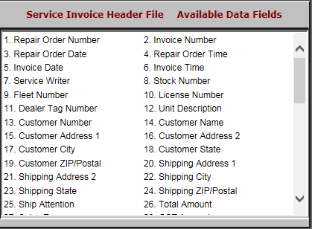

- Repair Order Number: This field shows the repair order number.
- Invoice Number: This field shows the invoice number.
- Repair Order Date: This field shows the repair order date.
- Repair Order Time: This field shows the repair order time.
- Invoice Date: This field shows the invoice date.
- Invoice Time: This field shows the invoice time.
- Service Writer: This field shows the service writer.
- Stock Number: This field shows the stock number.
- Fleet Number: This field shows the unit’s customer-assigned fleet number.
- License Number: This field shows the unit’s customer-assigned license number.
- Dealer Tag Number: This field shows the unit’s customer-assigned dealer tag number.
- Unit Description: This field shows the unit description.
- Customer Number: This field shows the unit description.
- Customer Name: This field shows the customer’s name.
- Customer Address 1: This field shows the customer’s address.
- Customer Address 2: This field provides an extra line for the customer’s address, should it need one.
- Customer City: This field shows the customer’s city.
- Customer State: This field shows the customer’s state.
- Customer ZIP/Postal: This field shows the customer’s zip or postal code.
- Shipping Address 1: This field shows the shipping address.
- Shipping Address 2: This field provides a second line for the shipping address, should it need one.
- Shipping City: This field shows the shipping city.
- Shipping State: This field shows the shipping state.
- Shipping ZIP/Postal: This field shows the shipping zip or postal code.
- Ship Attention: This field shows who specifically is being shipped to, particularly if it’s being sent to a business.
- Total Amount: This field shows the total amount of the invoice.

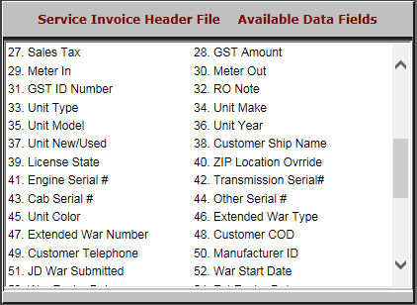

- Sales Tax: This field shows the sales tax.
- GST Amount: This field shows the GST amount.
- Meter In: This field shows the meter reading, if any, when the repair was opened.
- Meter Out: This field shows the meter reading, if any, when the repair was closed.
- GST ID Number: This field shows the GST ID number.
- RO Note: This field holds any notes on the repair order.
- Unit Type: This field shows the unit’s type.
- Unit Make: This field shows the unit’s make.
- Unit Model: This field shows the unit’s model.
- Unit Year: This field shows the unit’s year.
- Unit New/Used: This field shows whether the unit is:
  - New (N)
  - Used (U).
- Customer Ship Name: This field shows the name of the customer getting shipped to.
- License State: This field shows the state of the customer’s license.
- ZIP Loc Override: This field shows the zip code location override, a 4-digit tax override only available in SST states.
- Engine Serial #: This field holds the engine serial number.
- Transmission Serial#: This field holds the transmission serial number.
- Cab Serial #: This field holds the cab serial number.
- Other Serial #: This field holds any other relevant serial numbers.
- Unit Color: This field shows the unit’s color.
- Extended War Type: This field shows the extended warranty type.
- Extended War Number: This field shows the extended warranty number.
- Customer COD: This field shows:
  - “Y” if the customer is on COD
  - “N” if the customer is not on COD
- Customer Telephone: This field shows the customer’s telephone number.
- Manufacturer ID: This field shows the manufacturer ID.
- JD Warranty Submit: This field shows a flag if the warranty has been submitted to John Deere.
  - This field can be used for manual entry by other companies.
- War State Date: This field shows the warranty start date.

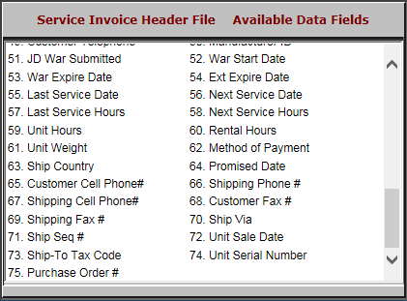

- War Expire Date: This field shows the warranty expiration date.
- Ext Expire Date: This field shows the extended warranty expiration date.
- Last Service Date: This field shows the last service date.
- Next Service Date: This field shows the next service date.
- Last Service Hours: This field shows the last service hours.
- Next Service Hours: This field shows the next service hours.
- Unit Hours: This field shows the unit hours.
- Rental Hours: This field shows the rental hours.
- Unit Weight: This field shows the unit’s weight.
- Method of Payment: This field shows the method of payment.
- Ship Country: This field shows the shipping country.
- Promised Date: This field shows the repair’s promised completion date.
- Customer Cell Phone#: This field shows the customer’s cell phone number.
- Shipping Phone #: This field shows the shipping phone number.
- Shipping Cell Phone#: This field shows the shipping cell phone number.
- Customer Fax #: This field shows the customer’s fax number.
- Shipping Fax #: This field shows the shipping fax number.
- Ship Via: This field shows the shipping method.
- Ship Seq #: This field is reserved for future use.
- Unit Sale Date: This field shows the unit’s sale date.
- Ship-To Tax Code: This field shows the ship-to tax code.
- Unit Serial Number: This field shows the unit’s serial number.
- Purchase Order #: This field shows the purchase order number.

