Service Invoice Print Details: This file pulls information from the Service Invoice Print Details file.

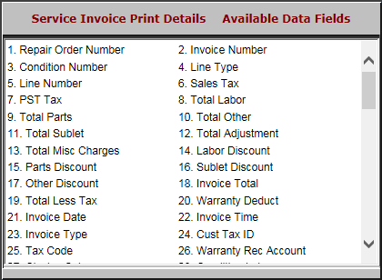

- Repair Order Number: This field shows the repair order number.
- Invoice Number: This field shows the invoice number.
- Condition Number: This field shows the condition number.
- Line Type: This field shows the line type.
- Line Number: This field shows the line number.
- Sales Tax: This field shows the sales tax.
- PST Tax: This field shows the PST tax.
- Total Labor: This field shows the total amount of labor charges.
- Total Parts: This field shows the total amount of parts charges.
- Total Other: This field shows the total of any other charges on the invoice.
- Total Sublet: This field shows the total amount of the sublet charges.
- Total Adjustment: This field shows the total amount of the adjustment charges.
- Total Misc Charges: This field shows the total amount of any miscellaneous charges.
- Labor Discount: This field shows the labor discount amount.
- Parts Discount: This field shows the parts discount amount.
- Sublet Discount: This field shows the sublet discount amount.
- Other Discount: This field shows the amount of any other discounts that apply.
- Invoice Total: This field shows the total amount of the invoice.
- Total Less Tax: This field shows the total amount of the invoice without tax.
- Warranty Deduct: This field shows the warranty deductible amount.
- Invoice Date: This field shows the invoice date.
- Invoice Time: This field shows the invoice time.
- Invoice Type: This field shows the invoice type.
- Cust Tax ID: This field shows the customer’s tax ID.
- Tax Code: This field shows the tax code.
- Warranty Rec Account: This field shows the General Ledger account number for warranty receivables.

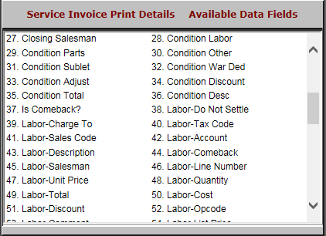

- Closing Salesman: This field shows the ID for the salesman who closed the invoice.
- Condition Labor: This field shows the dollar amount for labor costs on this condition.
- Condition Parts: This field the dollar amount for parts costs on this condition.
- Condition Other: This field the dollar amount for any other costs on this condition.
- Condition Sublet: This field the dollar amount for sublet costs on this condition.
- Condition War Ded: This field the dollar amount for this condition’s warranty.
- Condition Adjust: This field shows the dollar amount adjusted on this condition.
- Condition Discount: This field shows the discount amount, if any, for this condition.
- Condition Total: This field shows the total dollar amount of the condition’s charges.
- Condition Desc: This field gives a description of the condition.
- Is Comeback?: This field shows:
  - “Y” if the repair is a comeback.
  - “N” if it’s not a comeback.
- Labor-Do Not Settle: This field is reserved for future use.
- Labor-Charge To: This field indicates whether the labor should be charged to an internal warranty or the customer.
- Labor-Tax Code: This field shows the labor tax code.
- Labor-Sales Code: This field shows the labor sales code.
- Labor-Account: This field shows the General Ledger account number where the labor is posted.
- Labor-Description: This field provides a description of the labor.
- Labor-Comeback: This field shows the amount for labor on a comeback, if any.
- Labor-Salesman: This field shows the ID for the salesman who opened the condition.
- Labor-Line Number: This field is reserved for future use.
- Labor-Unit Price: This field shows the hourly rate for the labor on this condition.
- Labor-Quantity: This field shows the number of hours of labor performed on the condition.
- Labor-Total: This field shows the extended billing price for the labor.
- Labor-Cost: This field shows the extended labor cost.
- Labor-Discount: This field shows the amount of any discounts on the labor costs.
- Labor-Opcode: This field shows the labor Op code.

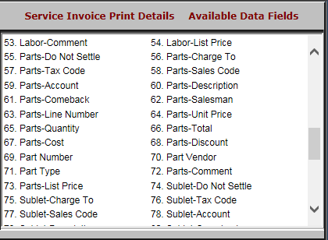

- Labor-Comment: This field provides a space for any comments on the labor.
- Labor-List Price: This field shows the labor list price.
- Parts-Do Not Settle: This field is reserved for future use.
- Parts-Charge To: This field shows whether the parts expenses are charged to an internal warranty or to the customer.
- Parts-Tax Code: This field shows the parts tax code.
- Parts-Sales Code: This field shows the parts sales code.
- Parts-Account: This field shows the General Ledger account where the parts is posted.
- Parts-Description: This field provides a description of the parts.
- Parts-Comeback: This field shows the amount of the parts for a comeback, if any.
- Parts-Salesman: This field shows the ID of the salesman who opened the parts invoice.
- Parts-Line Number: This field is reserved for future use.
- Parts-Unit Price: This field shows the unit price of the parts.
- Parts-Quantity: This field shows the quantity of parts.
- Parts-Total: This field shows the extended billing price for the parts.
- Parts-Cost: This field shows the extended parts cost.
- Parts-Discount: This field shows the amount of any discounts on the parts.
- Part Number: This field shows the part number.
- Part Vendor: This field lists the vendor who sold the parts.
- Part Type: This field shows the part’s type, which could be:
  - New (N)
  - Used (U)
  - Remanufactured (R)
  - Memo (M)
  - Core (C)
- Parts-Comment: This field can hold any comments made on the parts invoice.
- Parts-List Price: This field shows the parts’ list price.
- Sublet-Do Not Settle: This field is reserved for future use.
- Sublet-Charge To: This field shows which of the following the sublet is charged to:
  - An internal warranty
  - The customer.
- Sublet-Tax Code: This field shows the sublet tax code.
- Sublet-Sales Code: This field shows the sublet sales code.
- Sublet-Account: This field shows the General Ledger account where the sublet is posted.

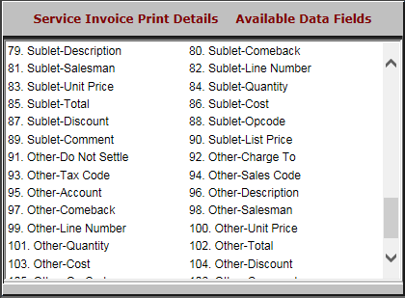

- Sublet-Description: This field describes the sublet.
- Sublet-Comeback: This field shows the amount of the comeback sublet, if any.
- Sublet-Salesman: This field shows the ID of the salesman who opened the sublet invoice.
- Sublet-Line Number: This field is reserved for future use.
- Sublet-Unit Price: This field shows the sublet’s unit price.
- Sublet-Quantity: This field shows the quantity of the sublet.
- Sublet-Total: This field shows the extended billing price for the sublet.
- Sublet-Cost: This field shows the sublet’s extended cost.
- Sublet-Discount: This field shows the amount of any discounts on the sublet.
- Sublet-Opcode: This field shows the sublet Op code.

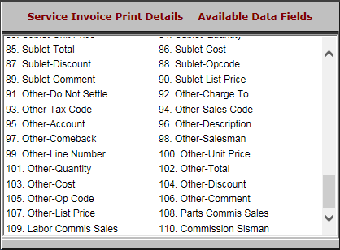

- Sublet-Comment: This field shows any comments made on the sublet invoice.
- Sublet-List Price: This field shows the sublet’s list price.
- Other-Do Not Settle: This field is reserved for future use.
- Other-Charge To: This field shows which of the following any other charges on the service are charged to:
  - An internal warranty
  - The customer
- Other-Tax Code: This field shows any other tax codes.
- Other-Sales Codes: This field shows any other sales codes.
- Other-Account: This field shows the General Ledger account where any other charges are posted.
- Other-Description: This field describes any other expenses on the invoice.
- Other-Comeback: This field shows the amount of any other charges on a comeback, if any.
- Other-Salesman: This field shows the ID of the salesman who opened the invoice for the other charges.
- Other-Line Number: This field is reserved for future use.
- Other-Unit Price: This field shows the hourly rate for any other services performed on the unit.
- Other-Quantity: This field shows the number of hours of any other services performed on the unit.
- Other-Total: This field shows the extended billing price for any other services performed on the unit.
- Other-Cost: This field shows any other extended costs on the unit repair.
- Other-Discount: This field shows the amount of any other discounts available on the service.
- Other-Op Code: This field shows the Op code for any other services performed.
- Other-Comment: This field provides comments on any other aspects of the service invoice not already covered.
- Other-List Price: This field shows the list price of any other services.
- Parts Commis Sales: This field shows the amount of parts eligible for commissions.
- Labor Commis Sales: This field shows the amount of the labor eligible for commissions.
- Commission Slsman: This field shows the ID of the salesman who is eligible to receive the commission.

