Service Technician File: This file pulls information from the Service Technician File.

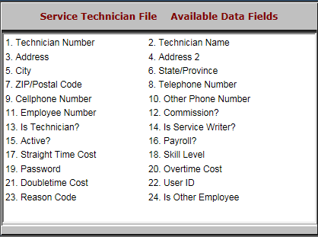

- Technician Number: This field shows the technician number.
- Technician Name: This field shows the technician’s name.
- Address: This field shows the technician’s address.
- Address 2: This field gives an extra line for the technician’s address, in case more room is needed.
- City: This field shows the technician’s city.
- State/Province: This field shows the technician’s state or province.
- ZIP/Postal Code: This field lists the technician’s zip or postal code.
- Telephone Number: This field lists the technician’s telephone number.
- Cellphone Number: This field lists the technician’s cellphone number.
- Other Phone Number: This field shows any other phone number the technician may have.
- Employee Number: This field shows the technician’s employee number.
- Commission?: This field shows:
  - “Y” if the item is eligible for commission.
  - “N” if it is not eligible.
- Is Technician?: This field shows:
  - “Y” if the employee is a billable technician.
  - “N” if the employee is not.
- Is Service Writer?: This field shows:
  - “Y” if the employee is a service writer.
  - “N” if the employee is not.
- Active?: This field shows:
  - “Y” if the technician is active.
  - “N” if the technician is inactive.
- Payroll?: This field shows:
  - “Y” if the technician is paid for their time.
  - “N” if the technician is not paid.
- Straight Time Cost: This field shows the technician’s base hourly pay.
- Skill Level: This optional field shows a number that indicates the technician’s skill level.
- Password: This field is reserved for future use.
- Overtime Cost: This field lists the technician’s overtime pay rate.
- Doubletime Cost: This field lists the technician’s doubletime pay rate.
- User ID: This field lists the technician’s user ID.
- Reason Code: This field lists the code that indicates time the technician worked other than on the repair order.
- Is Other Employee: This field lists:
  - “Y” if the employee is not a technician, and thus an “other” type of employee.
  - “N” if the employee is a technician.

