Wholegoods Categories: This file pulls information from the Wholegoods (Units) Categories file.

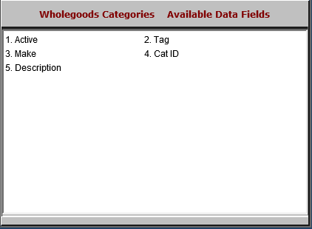

- Active: This field indicates if the category is active or inactive.
- Tag: This field holds any tags applied to the category.
- Make: This field holds any make ID the category is linked to.
- Cat ID: This field holds the category ID.
- Description: This field holds the category description.

