Unit Financial History: This database pulls unit financial history information from the system.

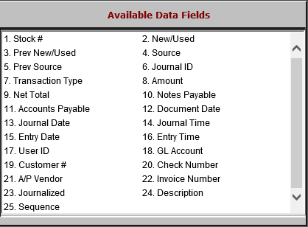

- Stock #: This field holds the unit stock number.
- New/Used: This field shows if the unit’s status is New or Used.
- Prev New/Used: This field shows if the unit’s status was previously New or Used.
- Source: This field holds the Unit source for the stock number.
- Prev Source: This field holds the previous Unit source for the stock number.
- Journal ID: This field holds the Journal ID that posts the transactions applied to the unit.
- Transaction Type: This field shows the type of transaction that occurred on the unit.
- Amount: This field shows the amount of the unit transaction.
- Net Total: This field shows the net total amount of the unit transaction.
- Notes Payable: This field shows the notes payable amount for the unit.
- Accounts Payable: This field shows the unit’s Accounts Payable amount.
- Document Date: This field holds the date of the transaction document (likely an invoice).
- Journal Date: This field holds the date when the transaction was journaled.
- Journal Time: This field holds the time the Journal was run on the Journal date.
- Entry Date: This field holds the date the transaction was entered into the system.
- Entry Time: This field holds the time the transaction was entered into the system.
- User ID: This field holds the ID of the user who entered the transaction into the system.
- GL Account: This field holds the General Ledger account for the transaction.
- Customer #: This field holds the customer number for the transaction.
- Check Number: This field holds the number of the check used to make a payment on the unit.
- A/P Vendor: This field identifies the A/P vendor who the check was issued to.
- Invoice Number: This field holds the invoice number.
- Journalized: This field indicates if the transaction was journalized or not.
- Description: This field describes the transaction.
- Sequence: This field holds the sequence number for the transaction.

