Accounts Payable Header: This database pulls A/P invoice header information from the system.

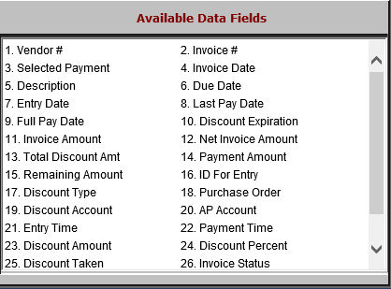

- Vendor #: This field holds the vendor number.
- Invoice #: This field holds the invoice number.
- Selected Payment: This field holds the dollar amount of the invoice currently selected for payment.
- Invoice Date: This field holds the invoice date.
- Description: This field holds the invoice’s header description.
- Due Date: This field holds the invoice’s due date.
- Entry Date: This field holds the date the invoice was entered into the system.
- Last Pay Date: This field holds the last date that a payment was made on the invoice.
- Full Pay Date: This field holds the date the invoice was fully paid off.
- Discount Expiration: This field holds the date the invoice’s discount expires on, i.e. the date that the invoice has to be paid by in order to get the discount.
- Invoice Amount: This field holds the original gross amount of the invoice.
- Net Invoice Amount: This field holds the net invoice amount.
- Total Discount Amount: This field holds the total discount amount for the invoice.
- Payment Amount: This field holds the invoice payment amount.
- Remaining Amount: This field holds the invoice’s remaining amount after the payment.
- ID For Entry: This field holds the ID of the user who entered the invoice in the system.
- Discount Type: This field holds the discount’s type:
  - Percentage
  - Amount
- Purchase Order: This field holds a purchase order number tied to the invoice, if applicable.
- Discount Account: This field holds the discount account for the invoice.
- AP Account: This field holds the A/P account for the invoice.
- Entry Time: This field holds the time that the invoice was entered into the system.
- Payment Time: This field holds the time the invoice was paid.
- Discount Amount: If the discount type is Amount, this field holds the flat discount dollar amount.
- Discount Percent: If the discount type is Percentage, this field holds the discount percentage.
- Discount Taken: This field holds the actual discount amount taken by the invoice.
- Invoice Status: This field holds the invoice’s status (Entered, Journaled, Paid, Selected, etc.).

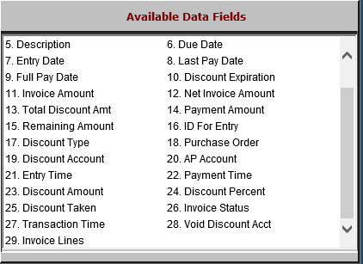

- Transaction Time: This field shows the invoice’s transaction time.
- Void Discount Acct: This field shows the invoice’s void discount account.
- Invoice Lines: This field shows the number of lines on the invoice.

