Accounts Payable History Detail: This database pulls A/P historical invoice detail information from the system.

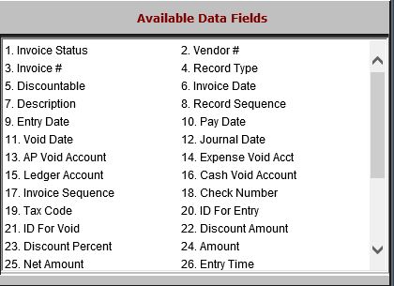

- Invoice Status: This field holds the invoice’s status, which in this case will likely be Historical.
- Vendor #: This field holds the vendor number.
- Invoice #: This field holds the invoice number.
- Record Type: This field holds the record type, which indicates the type of action recorded as performed on an invoice line: entry, payment, selection, void, etc.
- Discountable: This field indicates whether or not an invoice line is eligible for a discount.
- Invoice Date: This field holds the invoice date.
- Description: This field holds the invoice’s header description.
- Record Sequence: This field holds a number identifier for the invoice line record.
- Entry Date: This field holds the date the invoice was entered into the system.
- Pay Date: This field holds the date the invoice line was paid, if applicable.
- Void Date: This field holds the date the invoice line was voided, if applicable.
- Journal Date: This field holds the date the invoice line was journaled, if applicable.
- AP Void Account: This field holds the line’s A/P Void account, if applicable.
- Expense Void Acct: This field holds the line’s Expense Void account, if applicable.
- Ledger Account: This field holds the line’s G/L account.
- Cash Void Account: This field holds the line’s Cash Void account, if applicable.
- Invoice Sequence: This field holds a number identifier which points back to the Record Sequence number every time an action is performed on that invoice line.
- Check Number: This field holds the check number used to pay off the line, if applicable.
- Tax Code: This field holds the tax code for the line, if applicable.
- ID For Entry: This field holds the ID of the user that entered the invoice line into the system.
- ID For Void: If the invoice line gets voided, this field holds the ID of the user who performed the void.
- Discount Amount: If the line has a flat dollar amount discount, this field holds the dollar amount.
- Discount Percent: If the line has a discount percentage applied, this field holds the percentage.
- Amount: This field holds the gross dollar amount of the invoice line.
- Net Amount: This field holds the net amount of the invoice line.

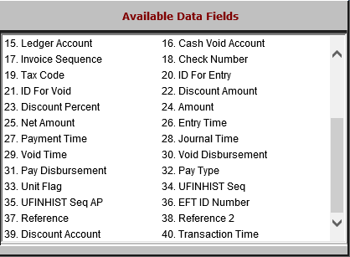

- Entry Time: This field holds the time the invoice line was entered.
- Payment Time: This field holds the time the invoice line was paid, if applicable.
- Journal Time: This field holds the time the invoice line was journaled, if applicable.
- Void Time: This field holds the time that the invoice line was voided, if applicable.
- Void Disbursement: If the invoice line is voided, this field holds the method of disbursement for the void.
- Pay Disbursement: If the invoice line is paid, this field holds the method of disbursement used for the payment.
- Pay Type: This field shows how the invoice line was paid: EFT, check, etc.
- Unit Flag: This field indicates whether or not the control number for the line is a unit stock number.
- UFINHIST Seq: This field holds a number identifier for the line that links its unit activity to the UFINHIST database.
- UFINHIST Seq AP: This field holds a second number identifier for the line that links the A/P activity on the unit to the UFINHIST database.
- EFT ID Number: This field is reserved for future use.
- Reference: This field holds the line’s reference/control number, if applicable.
- Reference 2: This field holds a second reference/control number, if applicable.
- Discount Account: This field holds the line’s discount account, if applicable.
- Transaction Time: This field holds the line’s transaction time.

